المملكة العربية السعودية
وزارة التعليم
الإدارة العامة للتعليم ب
مكتب التعليم ب
مدرسة
الصف الأول ثانوي مسارات
Mega Goal 1.3
اختبار الاستماع النهائي للفصل الدراسي الثالث لعام 1444هـ

بسم الله الرحمن الرحيم

المجموع
Total / 5

الرقم: ...
الشعبة: ...
……………………………………………………………………………………
اسم الطالب:

Listen and then answer
- Choose the correct answer: (½ mark each)

1. The factory waste and fertilizer flows into…. .
A | lakes | B | rivers | C | seas

2. There are ……. Major sources of noise pollution.
A | 2 | B | 3 | C | 4

3. Airports are one of the sources of ……………… pollution.
A | Air | B | Water | C | Noise

4. Toxic chemicals in the air are ……………. to breathe.
A | safe | B | harmless | C | harmful

5. If the soil is polluted, it is not suitable for …………. purposes.
A | agricultural | B | cultural | C | industrial

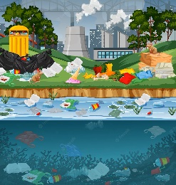
Listening

- Write (T) for true And (F) for False:
1. Water pollution is often caused by waste from factories. | (……)
2. Noise pollution can cause people backaches and mental stress. | (……)
3. Cars are a source of air pollution, but increases in car traffic have not made air pollution worse. | (……)
4. Throwing away plastic bottles cannot cause soil pollution. | (……)
5. Biodegradable means things disappear into the soil like plastic. | (……)

Mohsen ALShareef

https://drive.google.com/file/d/16KCTkhatfdlV9Apj8WqGP8jOfSBeZUxr/view?usp=sharing

