المملكة العربية السعودية مادة اللغة الإنجليزية
وزارة التعليم الصف الابتدائي
إدارة التعليم بـ ................... اختبار تشخيصي ( قبلي)
مدرسة ........................... الدرجة : ........... \ 20

الأسـم : …………………………………………………………………… الصـف : ………………………….

A- Match
My name is Ali |  | what is your name ? | 1
Nice to meet you, too. |  | hello | 2
I am fine , thank you. |  | Do you like ice cream? | 3
Hi |  | Nice to meet you. | 4
Yes, I like ice cream. |  | How are you ? | 5

B- Choose the correct answer
1- Where do you live ? - ( I live in Jeddah – thank you – good morning ).
2- I………. a blue bag - ( are – has - have ).
3-What's the weather like today? - (Good night - It's sunny – welcome ).
4-it is ………orange. -( a - an - some ).
7-I am …………………….
…..cap is red. 6-
5-How many books do you have?

a-I have 3 books
b-I have 5 books
c- I have 10 books
a-his
b-she
c- our
a-happy
b-sad
c- sleepy

D- complete
10 , 20 , 30 , ……… , …………, 60, 70 , 80 , ……….. , 100.

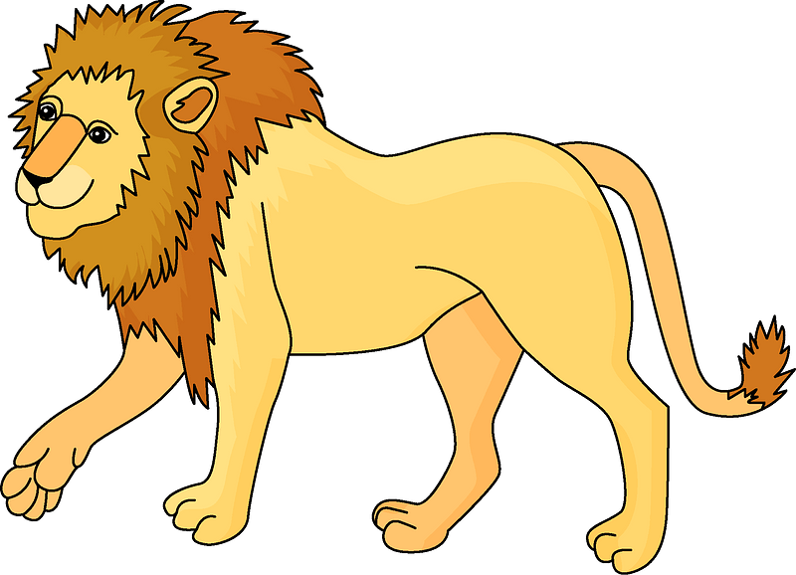
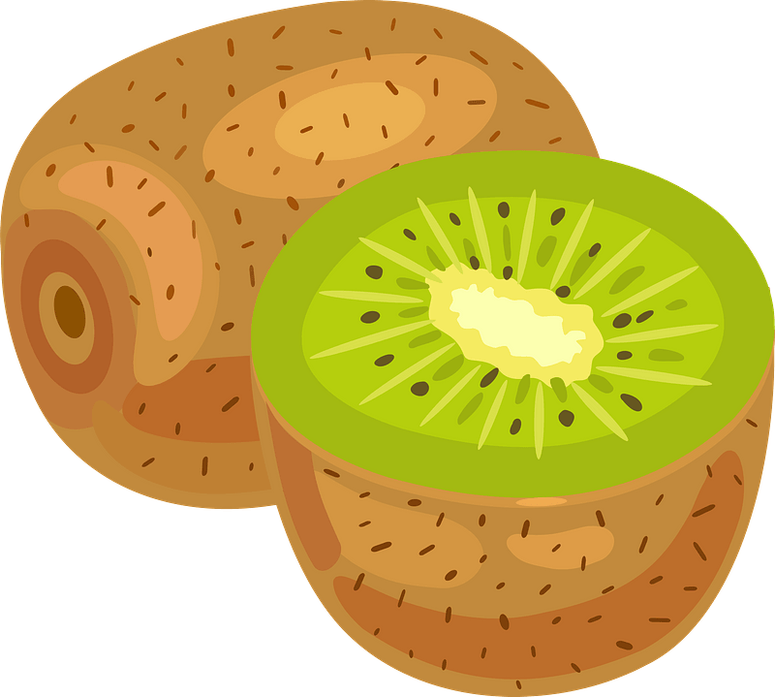
E- Write the missing letters.

…ase
……iwi
….ion

F- choose the correct answer.
1-………….. is an apple. 2-it's a ………………
a-This
b-Those
c- They
a-car
b-bus
c-school
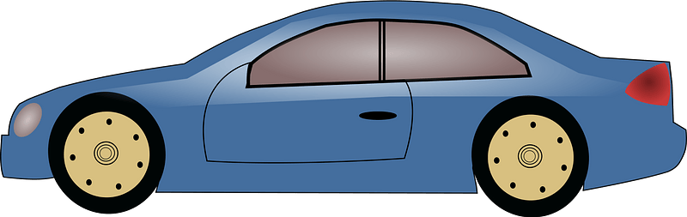
Good luck
Your Teacher ………………..

