

**المملكة العربية السعودية مادة اللغة الإنجليزية**

**وزارة التعليم الصف : الثاني الابتدائي**

**إدارة التعليم بـ ................... اختبار تشخيصي ( قبلي)**

**مدرسة ........................... الدرجة : ........... \ 20**

الأسـم : …………………………………………………………………… الصـف : ………………………….

**A- Match**

|  |  |  |  |
| --- | --- | --- | --- |
| My name is Ahmad. |  | what is your name ? | 1 |
| Nice to meet you, too. |  | Good bye. | 2 |
| Good bye. |  | What’s this color? | 3 |
| Hi |  | Nice to meet you. | 4 |
| It's blue. |  | hello | 5 |

**B- Choose the correct answer**

1- This is ( a – an - are ) apple.

2-How are you? – ( I'm fine - good morning – welcome)

3- That is ( a – is - an ) flower.

4-What shape is it ? it is…….

5- What color is it ?

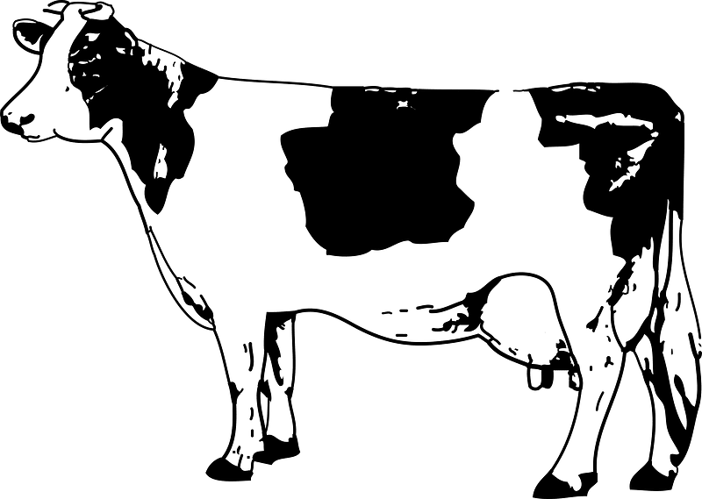

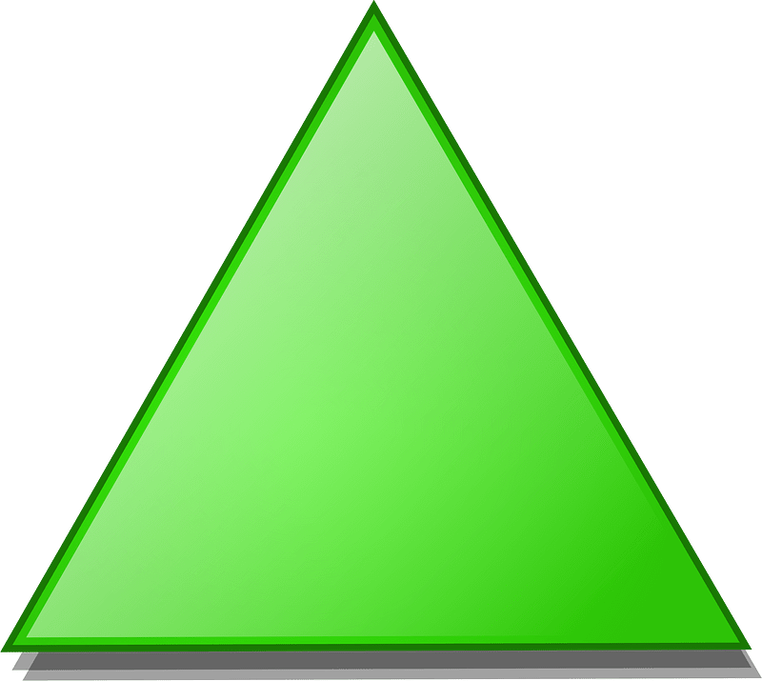

a- it's black and white.

b- it's red and pink.

a- Triangle

b- Square

**C- Complete.**

1 , 2 , …….… , ………, 5 , 6 , 7 , 8 , ………. , 10.

2- A , B , ……… , D , E , …….. , ……….. , H

**D- Complete the missing letters**

f d g b

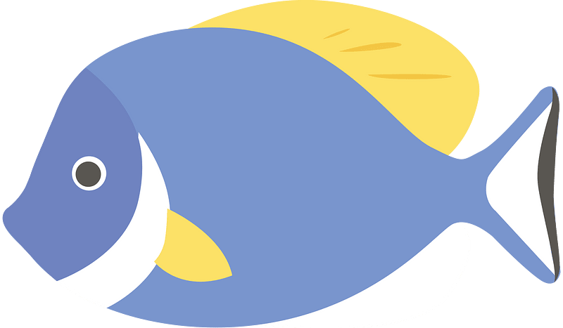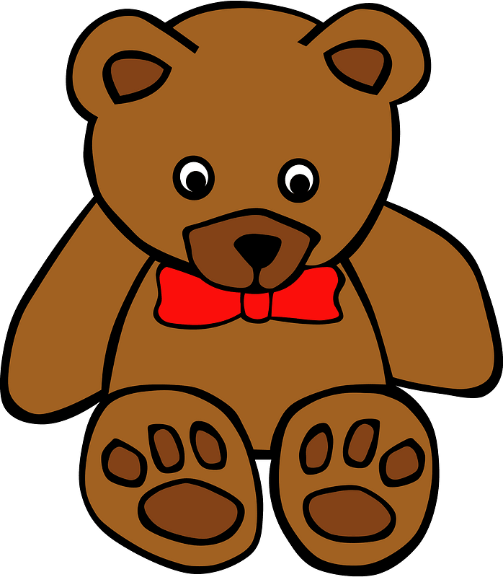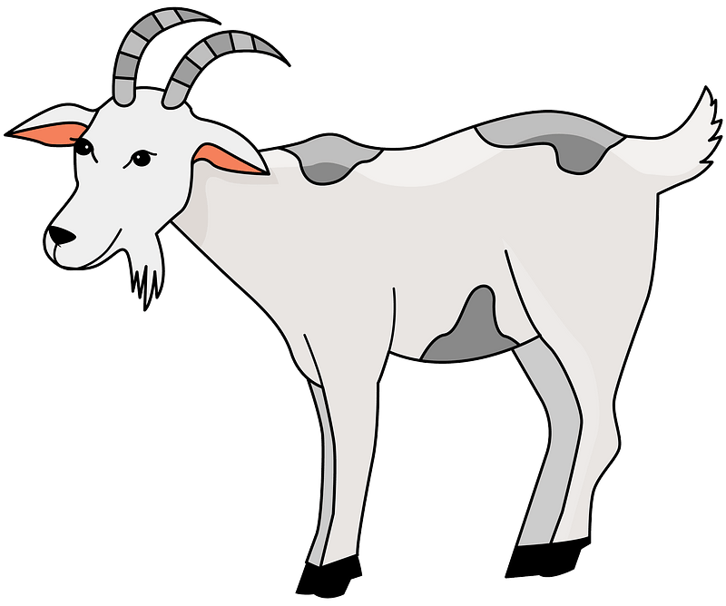

1-….ish 2- ……oat 3- …..ad 4- ……ear

Good luck

Your Teacher ………………..

|  |  |  |
| --- | --- | --- |
| Name:………………………… |  | Class: |

**اختبار تشخيصي للصف الثاني ابتدائي - WE CAN**

**1- Listen and circle:**

|  |  |  |  |
| --- | --- | --- | --- |
|  | **7** | **8** | **9** |
|  | **brother** | **sister** | **Dad** |
|  | **a** | **e** | **o** |
|  | **head** | **hand** | **Nose** |
|  | **board** | **bag** | **Pencil** |

**2- - Listen and number:**

|  |  |  |  |
| --- | --- | --- | --- |
| Cow Clip Art Images - Free Download on Freepik | Lion - Leo Panthera - African Lion | **What does your cat mean by 'miaow'? Let Japan's pet guru Yuki Hattori  explain | Cats | The Guardian** | **How To Draw A Fish - Step By Step Instructions - Busy Little Kiddies** |

**3- Match:**

|  |  |  |
| --- | --- | --- |
|  | **Hi** | **Good morning** |
|  | **Good morning** | **Hi** |
|  | **Goodbye** | **Goodbye** |
|  | **Hello** | **Fine thanks** |
|  | **How are you ?** | **Hello** |

**4- Find and circle:**

|  |  |  |  |  |
| --- | --- | --- | --- | --- |
| **7** | **7** | **8** | **8** | **7** |
| **c** | **A** | **c** | **A** | **a** |
| **E** | **E** | **a** | **a** | **e** |
| **g** | **ل** | **O** | **O** | **o** |
| **a** | **a** | **B** | **B** | **b** |

**5-Complete:**

|  |  |  |  |  |  |  |  |  |  |
| --- | --- | --- | --- | --- | --- | --- | --- | --- | --- |
| **10** |  | **8** |  |  | **5** | **4** |  |  | **1** |

**6-Look and write:**

**( baby - bag - Dad - hand - book )**

|  |  |  |  |  |
| --- | --- | --- | --- | --- |
| Dad and son Royalty Free Vector Image - VectorStock | **With One Slip, a Hand Injury Could Ruin Your Winter | Live Science** | School bag cartoon character Stock Vector | Adobe Stock | Newborn Baby Cartoon Images - Free Download on Freepik |  |
| …………….. | …………….. | …………….. | ……………. | …………….. |

**7- Count and write:**

|  |
| --- |
| **+  =** |
| **+ =** |
|  |
|  |
|  |

**8- Copy:**

**3**

|  |
| --- |
| a a a |
| t t t |
| b b b |
| **9- Match:**   |  |  | | --- | --- | |  | **2** |  |  |  | | --- | --- | |  |  | |



**5**