Name :…………………………………………………………………… Class:…….……….
Super Goal 2 - Test unit 1 & 2

Reading
2 Marks
- Read the text and answer the questions. Write T or F at the end of each question/statement.
I like to go to the sports center. I go there every weekend. At the sports center, you can do many things. For example, you can play golf or tennis. There is a pool, so you can also swim or relax by the pool. There is a beach next to the sports center. You can swim, water-ski, or windsurf in the ocean. You can also sail on windy days. There aren’t any fish near the beach, so you can’t snorkel. When I go to the sports center, I like to play volleyball on the beach. I also like to jog on the beach. I can’t swim well, so I don’t like to water-ski or windsurf.
- At the sports center, you can do many things. ( )
- You can swim in the pool or in the ocean. ( )
- People can windsurf in the pool. ( )
- You can sail on windy days in the ocean. ( )
Grammar
5 Marks
- Choose the best answer to fill in the blank in each question.
- Who _____ that girl?
a. am b. is c. are d. i
- John: _____ your friend? - Adnan: He is in the restaurant.
a. How’s b. What’s c. When’s d. Where’s
- It _____ a beautiful day today.
a. is b. are c. not d. am
- _____ in that new TV film?
a. He acting b. He is acting c. Is acting d. Is he acting
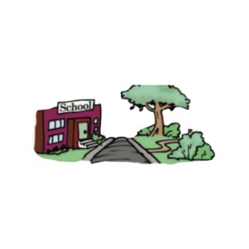
- What is he eating ? - he's ________ an apple .
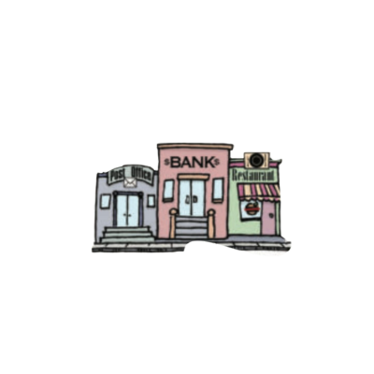
a. eat b. is eat c. eating d. ate
1.5 Marks
- Use ( across from – next to – between )
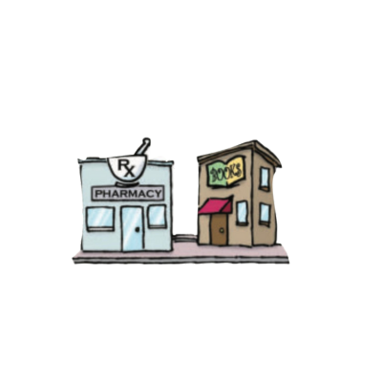
- The park is ____________________ the school .
- The bank is ______________ the post office and the restaurant .
- The pharmacy is ______________ the bookstore .

- Write the imperative sentence.
1.5 Marks
- Will you clean up this mess? ________________________________________
- Why aren’t you eating your vegetables? _______________________________
- You can’t take photographs. _________________________________________

Vocabulary
- Choose the best answer to fill in the blank in each question.
5 Marks
- Thank you !
a. You’re welcome. b. He’s from Muscat. c. That’s all right. d. Hi
- What is your country ?
a. Fine thank you b. I'm 13 years old c. Nice to meet you d. I'm from Saudi Arabia
- Many young people traveling around the world are ________ .
a. old people b. backpackers c. teachers d. business men
- What is Ali doing ? - He’s _______ soup .
a. making b. breaking c. writing d. talking
- ________ sometimes use webcams in the classroom.
a. Students b. Teachers c. Farmers d. business men

- Write the correct word under the picture.
3 Marks
coffee shop – Webcam – Turn Right

…………………………………………….

…………………………………………….
…………………………………………….

- Choose the correct letter.
2 Marks
- See you tomorr…..w. ( o – y – r )
- I don't he….r anything. ( t – a – r )

English Language
Intermediate Grade 2nd
1st period Exam
Kingdom of Saudi Arabia
Ministry of Education
………………… School
Student's Name : class:

5
5
1-Read the following e-mail then answer the questions below:
Dear Salem,
I would like to tell you about my last winter vacation. I travelled to Morocco with my family. Morocco is a wonderful country in North Africa. It is famous for its high mountains. My family booked a hotel in a small village in Al-Atlas Mountains. We stayed there for a week. The views were wonderful. We watched the snow falling. After that, we went skiing in the mountains. On the next day, we went to the market to buy some presents for our friends. We bought some colorful wool rugs. The people were so friendly there. I advise you to visit Morocco soon.
Yours sincerely,
Rashid

1- The best title for this email is:
c- The weather in Jordan | b- The weather in Oman | a- The weather in Morocco
2- I travelled to Morocco with my …………………..
c-cousins | b- family | a-friends
3- Morocco is a wonderful country in ………….
c- North Africa | b- South Africa | a- East Africa
4- We stayed in Morocco for ………….
c- a year | b- a month | a- a week
5- The meaning of the word "friendly" in the last line is:
c- sad | b-hungry | a- welcoming

2-Choose the correct answer
5
5
1- I ( isn't – aren't – am n't ) doctor.
2- Sara is ( make – makes – making ) a cake.
3- Who ( is – are – am ) your teacher?
4-(open – opening – opened ) the book please.
5- Aisha and Fadwa ( is -are – am ) at the mall.
6-( How – what – where ) old are you?
7- The pizza ( smell – smells - smelling ) good.
8- Riyadh(is – are – am )in Saudi Arabia
9- I (liking – likes - like )martial arts films.
10- Don't ( eat – eats – eating ) junk food.
3. Do as shown between brackets.
5
5
A-( Correct )
1- when is your name? …………………….……
2-I wanting a new cell phone. …………………
B-(Give a short answer)
a- is he a doctor ?
No,………………………………………………………...…..
C-(make a Yes or No question)
1-They are working now.
………………………………………………………………....…..?
a-Mahmoud isn’t in the kitchen.
…………………………………………………..………….………?

D-(Choose)
a- Nora is (on – near – across from ) the tree

b-The thieves are getting (in front of – away ) in a fast car.

4-choose the missing letter
1-During his summer ……acation, he visited Dubai. ( v - a - d )
5

2-I had just returned from the Cannes Film Fe….tival. ( q - s - w )

5- write the correct word under each picture.
Webcam elevator volcano castle

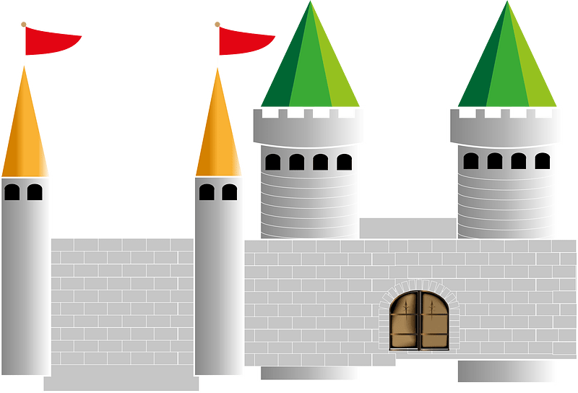
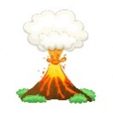
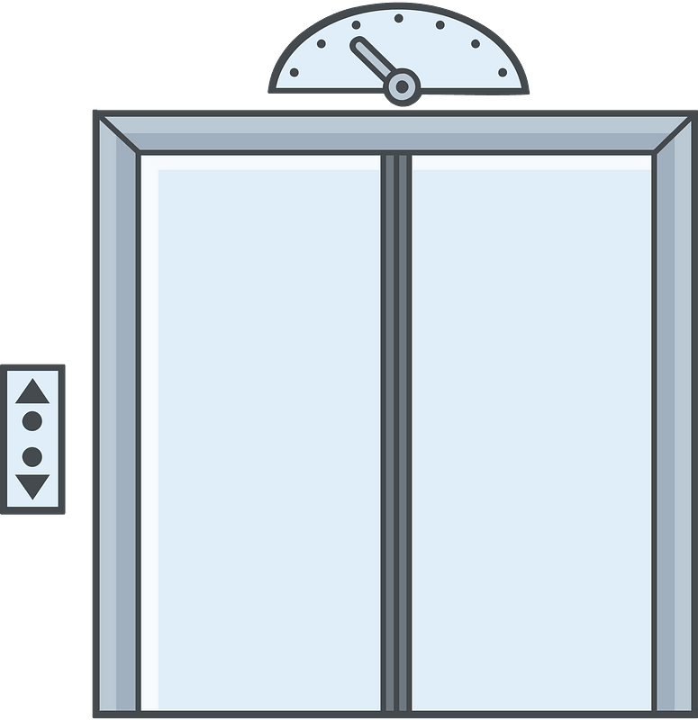

……………….
……………….
……………….
……………….

Best of luck
Your teacher:

Your teacher:

20
English Language
Midterm Exam
\3\1445
King of Saudi Arabia
Ministry of Education
2nd Intermediate Grade

Class\ |  | Student's name

Section A: Read and answer the following questions:_
4
This is Salwa. She lives in a house. It is a big house. There are 4 bedrooms upstairs. There is a living room downstairs. They have a garage, they keep the car inside it. They have a beautiful garden. The garden has flowers and trees. Her family is nice. She has 2 sisters and I brother. His name is Ali. Her mother works in the kitchen and her father works in the garden.
A) Choose the right answer
1-The living room is [ downstairs - behind – upstairs ]
2-The garden has [ beds - cars – flowers ]
B) Put ( √ ) or ( x )
1-Salwa's father works in the garden. [ ]
[ ] 2-They keep the car in the garage.
5
------------------------------------------------------------------------------------------
Section B: _ "Grammar"

1) …………………. the book please.
a) open b) opening c) opened d) opens

2) Sara is …………… a cake now
a) make b) makes c) making d) makes

3) A: ……………..is Ali from? B: He is from Jordon.
a) What B) How c) When d) Where

4) She is English teacher . ( make yes- no question )
………………………………………………………………………………………..

5) He is playing football . ( make negative )
………………………………………………………………………..
8
-------------------------------------------------------------------------------------
Section C: Vocabulary" Write the correct word under each picture:
 | 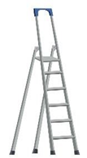 | 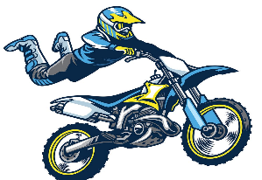 | 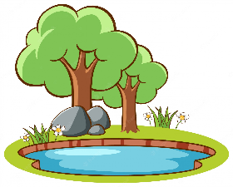
 | 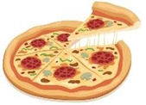 |  | 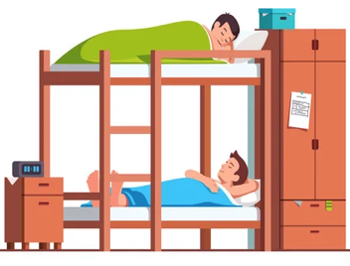
1-gostel 2- turn right 3- pizza 4- cameraman
5-pond 6-stantman 7-ladder 8-credit car 9- Webcam

3
-------------------------------------------------------------------------------------------------
Section D: Match the conversations.
1. Are you here for vacation? |  | a. S-a-a-d
2. Where is your house? |  | b. yes, I am .
3. How do you spell your name? |  | c. It is between the bank and the park.

Good luck

