

##### 

##### وزارة التعليم

**الإدارة العامة للتعليم بمنطقة ---------------**

**مجمع مدارس ------------------ ( بنين )**

**اختبارات نهاية الفصل الدراسي الأول 1445هـ**

|  |  |  |
| --- | --- | --- |
| **المادة:**  **لغة انجليزية** | **الصف: الأول الثانوي رقم الجلوس : ( )** | **الزمن:**  **3 ساعات** |
| **اسم الطالب: ................................................................................................................................................** |

|  |  |  |  |  |  |  |  |
| --- | --- | --- | --- | --- | --- | --- | --- |
| **Total**  **written** | **5**  **Vocabulary** | **4**  **Grammar** | **3**  **Free Compositio** | **2**  **Guided Composition** | | **1 Comprehension** | **Q. NO.** |
|  |  |  |  |  | |  | **Mark Given** |
| **30** | **6** | **6** | **6** | **6** | | **6** | **Mark** |
| **6** | | | **Reviser** | |  | | **Corrector** |
|  | |

**1)** **Comprehension**

**Read the following passage then answer the questions:**

**A VISION OF THE FUTURE**

**The French writer Jules Verne wrote several books in the late 1800s. In *them*, he wrote about the future. He asked, “What will life be like at the end of the 20th century-one hundred years from now?” In one of his adventure novels (From the Earth to the Moon), his characters traveled to the moon in a rocket. In another novel (20,000 Leagues Under the Sea), his characters dove through the depths of the ocean in a submarine in the shape of a whale. In a novel titled Paris in the Twentieth Century, Verne described a city with skyscrapers of glass and steel, high-speed trains, gas-powered automobiles, and a global communications network. Space rockets and submarines and other things in his novels didn’t exist in Verne’s time, but many of the inventions that Verne imagined became reality by the end of the 1900s.**

***A)* Answer the following questions*:*  
1. Who is the passage talking about? ---------------------------------------------------------------.**

**2. What was the nationality of Jules Verne? ---------------------------------------------------------.**

**3. When did he write his books? ----------------------------------------------------------------.**

**4. What did he write about? ----------------------------------------------------------------.**

***B)* Put ( √ ) or ( X ):  
5. Jules Verne wrote about the past. ( )  
6. All Jules Verne’s imaginations were wrong. ( )**

**7.**  **In one of his novels, his characters traveled to the moon. ( )**

**8. The submarine was in the shape of a whale. ( )  
*C)* Complete*:*  
9. The title of his novel about a submarine was “-------------------------------------------------".  
10. Jules Verne described a city with skyscrapers of --------------- and ---------------.**

***D)* Choose the correct answer*:***

**11. Jules Verne was [** a teacher – a writer – an engineer**].**

**12. Line 1: the underlined word (them) refers to his: (**books – rockets – submarines)

**2) Guided Composition**

**6**

**You want to buy a new story. There are many advertisements about stories.**

**Write a paragraph about: “Your Favorite story”**

**You may use the Guiding words:**

(story – characters – actions – places – price …)

-------------------------------------------------------

-----------------------------------------------------------------------------------------------------------------------------------------------------------------------------------------------------------------------------------------------------------------------------------------------------------------------------------------------------------------------------------------------------------------------------------------------------------------------------------------------------------------------------------------------------------------------------------------------------------------------------------------------------------------------------------------------------------------------------------------------------------------------------------------------------------------------------------------------------------------------------------------------------------------------------------------------------------------------------------------------------------------------------------------------------------------------------------------------------------------------------------------------------------------------------------------------------------------------------------------------------------------------------------------------------------------------------------------------------------------------------------------------------------------------------------------------------------------------------------------------------------------------------------------------------------------------

**3) Free Composition**

**6**

**Choose one topic from the following to write about.**

**1. Write an email to STC asking for a job. Present your Education, Experience, Skills…**

**2. Write a paragraph about: “Your Dream Intelligent Home”.**

-------------------------------------------------------

-----------------------------------------------------------------------------------------------------------------------------------------------------------------------------------------------------------------------------------------------------------------------------------------------------------------------------------------------------------------------------------------------------------------------------------------------------------------------------------------------------------------------------------------------------------------------------------------------------------------------------------------------------------------------------------------------------------------------------------------------------------------------------------------------------------------------------------------------------------------------------------------------------------------------------------------------------------------------------------------------------------------------------------------------------------------------------------------------------------------------------------------------------------------------------------------------------------------------------------------------------------------------------------------------------------------------------------------------------------------------------------------------------------------------------------------------------------------------------------------------------------------------------------------------------------------------

**4) Grammar**

**4**

**A: Choose the correct answer:**

**1. He (is living – live – lives) with his uncle until he can find his own place.**

**2. The scientists (aren’t understanding – don’t understand – understands) the problem.**

**3. I’m interested in (worked – works – working) outdoors.**

**4. Hanan has been (reading – read – reads) a book for two hours.**

**5. Maybe I (am going to – will – was) go to Abha.**

**6. Our products have been (using – uses – used) by travelers all over the world.**

**Do as shown between brackets:**

**1. Currently, the number of immigrants in our country (increase).** (Correct the verb)

-------------------------------------------------------------------------------------------------.

**2. I’m not very good ------- speaking in public. (Insert a preposition)**

-------------------------------------------------------------------------------------------------.

**3. Adnan has been (write) books for years (Correct the verb)**

-------------------------------------------------------------------------------------------------.

**4. I’m going to spend a month in Abha. (Make Negative)**

-------------------------------------------------------------------------------------------------.

**5. Ali is tall. Hassan is tall. (use: as…as)**

-------------------------------------------------------------------------------------------------.

**6. Karl Benz made the first car in 1886. (Make Passive)**

-------------------------------------------------------------------------------------------------.

**6**

**5) vocabulary:**

**A- Match the words with the pictures:**

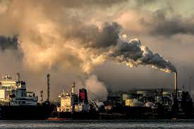**ice cream – hair cut – Masmak Fort – artist – pollution – suitcase**

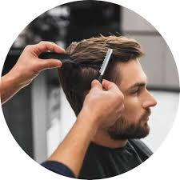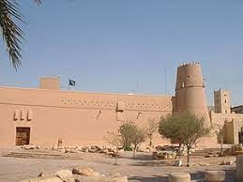

**---------- -----=---- -------- -------- --------- ----------**

**A) Match to form new words or expressions:**

**1. launch ---- a. come together**

**2. fast food ---- b. set up**

**3. gather ---- c. restaurant**

**4. By the way ---- d. Used to say “Yes”.**

**5. day after day ---- e. Introduce new topic.**

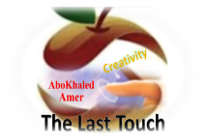**6. Certainly ---- f. Following the same pattern**

**End of Questions**

**Best of Luck**



##### 

##### وزارة التعليم

**الإدارة العامة للتعليم بمنطقة -----**

**مجمع ------------------------- ( بنين )**

**اختبارات نهاية الفصل الدراسي الأول 1445 هـ**

|  |  |  |
| --- | --- | --- |
| **المادة:**  **لغة انجليزية** | **الصف: الأول الثانوي رقم الجلوس : ( )** | **الزمن:**  **ساعتان ونصف** |
| **اسم الطالب: ................................................................................................................................................** |

|  |  |  |  |  |  |  |  |
| --- | --- | --- | --- | --- | --- | --- | --- |
| **Total**  **written** | **5**  **Vocabulary** | **4**  **Grammar** | **3**  **Free Compositio** | **2**  **Guided Composition** | | **1 Comprehension** | **Q. NO.** |
|  |  |  |  |  | |  | **Mark Given** |
| **30** | **6** | **6** | **6** | **6** | | **6** | **Mark** |
| **6** | | | **Reviser** | |  | | **Corrector** |
|  | |

**1)** **Comprehension**

**Read the following passage then answer the questions:**

**King Abdul-Aziz, a gifted leader and dedicated warrior for the cause of Islam, was responsible for the legendary event that marked the beginning of modern Saudi Arabia.**

**In 1902, he regained Riyadh, beat the city garrison, took the Masmak Fortress, and established his headquarters in the city. He expanded Saudi Arabia to include all of the Hijaz, Makkah and Madinah and united all the tribes into one nation. On September 23, 1932, the Kingdom of Saudi Arabia was officially established ,as a unified Islamic state, with Arabic as the national language and the Holy Qur'an as its constitution.**

***A)* Answer the following questions*:*  
1. Who is the passage talking about?**

**---------------------------------------------------------------.**

**2. What did King Abdul-Aziz expand Saudi Arabia to include?**

**----------------------------------------------------------------.**

**3. When was the Kingdom of Saudi Arabia officially established?**

**----------------------------------------------------------------.**

**4. Was King Abdul-Aziz responsible for the legendary event that marked the beginning of modern Saudi Arabia?**

**----------------------------------------------------------------.**

***B)* Put ( √ ) or ( X ):  
5.** Arabic is the national language in Saudi Arabia**. ( )  
6.** King Abdul-Aziz regained Riyadh in 1908.**( )**

**7.** Kingdom of Saudi Arabia was established as a unified Islamic state**. ( )**

**8.** The Holy Qur'an id the Kingdom’s constitution. **( )  
*C)* Complete*:*  
9. He regained Riyadh, beat the city garrison, took the Masmak ---------------------.  
10. -------------------- is the Kingdom’s national language.**

***D)* Choose the correct answer*:***

**11. King Abdulaziz a gifted** [ teacher / leader / doctor ]

**12. Line 3: the underlined word (he) refers to: (**Riyadh – King AbdulAziz – Arabic)

**2) Guided Composition**

**6**

**You want to buy a new car. There are many advertisements about cars.**

**Write a paragraph about: “Your Dream Car”**

**You may use the Guiding words:**

(cars – shape – size – cost – speed – options - …)

-------------------------------------------------------

------------------------------------------------------------------------------------------------------------------------------------------------------------------------------------------------------------------------------------------------------------------------------------------------------------------------------------------------------------------------------------------------------------------------------------------------------------------------------------------------------------------------------------------------------------------------------------------------------------------------------------------------------------------------------------------------------------------------------------------------------------------------------------------------------------------------------------------------------------------------------------------------------------------------------------------------------------------------------------------------------------------------------------------------------------------------------------------------------------------------------------------------------------------------------------------------------------------------------------------------------------------------------------------------------------------------------------------------------------------------------------------------------------------------------------------------------------------------------------------------------------------------------------------------------------------------------

**3) Free Composition**

**6**

**Choose one topic from the following to write about.**

**1. Write an email to STC asking for a job. Present your Education, Experience, Skills…**

**2. Write a paragraph about: “Your Dream Intelligent Home”.**

-------------------------------------------------------

---------------------------------------------------------------------------------------------------------------------------------------------------------------------------------------------------------------------------------------------------------------------------------------------------------------------------------------------------------------------------------------------------------------------------------------------------------------------------------------------------------------------------------------------------------------------------------------------------------------------------------------------------------------------------------------------------------------------------------------------------------------------------------------------------------------------------------------------------------------------------------------------------------------------------------------------------------------------------------------------------------------------------------------------------------------------------------------------------------------------------------------------------------------------------------------------------------------------------------------------------------------------------------------------------------------------------------------------------------------------------------------------------------------------------------------------------------------------------------------------------------------------------------------------------------------------------------------------------------------------------------------------------------------------------------------------------------------------------------------

**4) Grammar**

**6**

**A: Choose the correct answer:**

**1. The water (**boiling – boils – is boiling**). Please turn it off.**

**2. The moon (**go – goes – is going**) around the earth.**

**3. I am good at (**using – used – uses**) computers.**

**4. Saeed (**played – plays – has been playing**) football since he was ten.**

**5. Computers (**perform – will perform – performs**) many functions in the future.**

**6. The suitcase was (**developed – develops – developing**) in the Netherlands.**

**Do as shown between brackets:**

**1. He (live) with his uncle until he can find his own place. (Correct the verb)**

-------------------------------------------------------------------------------------------------.

**2. I’m not interested ------- working in the computer industry. (Insert a preposition)**

-------------------------------------------------------------------------------------------------.

**3. How long have you been (play) football? (Correct the verb)**

-------------------------------------------------------------------------------------------------.

**4. Machines are going to control us. (Make Negative)**

-------------------------------------------------------------------------------------------------.

**5. Ali is tall. Hassan is tall. (Comparative)**

-------------------------------------------------------------------------------------------------.

**6. People will drive smaller cars. (Make Passive)**

-------------------------------------------------------------------------------------------------.

**6**

**5) vocabulary:**

**A- Match the words with the pictures:**

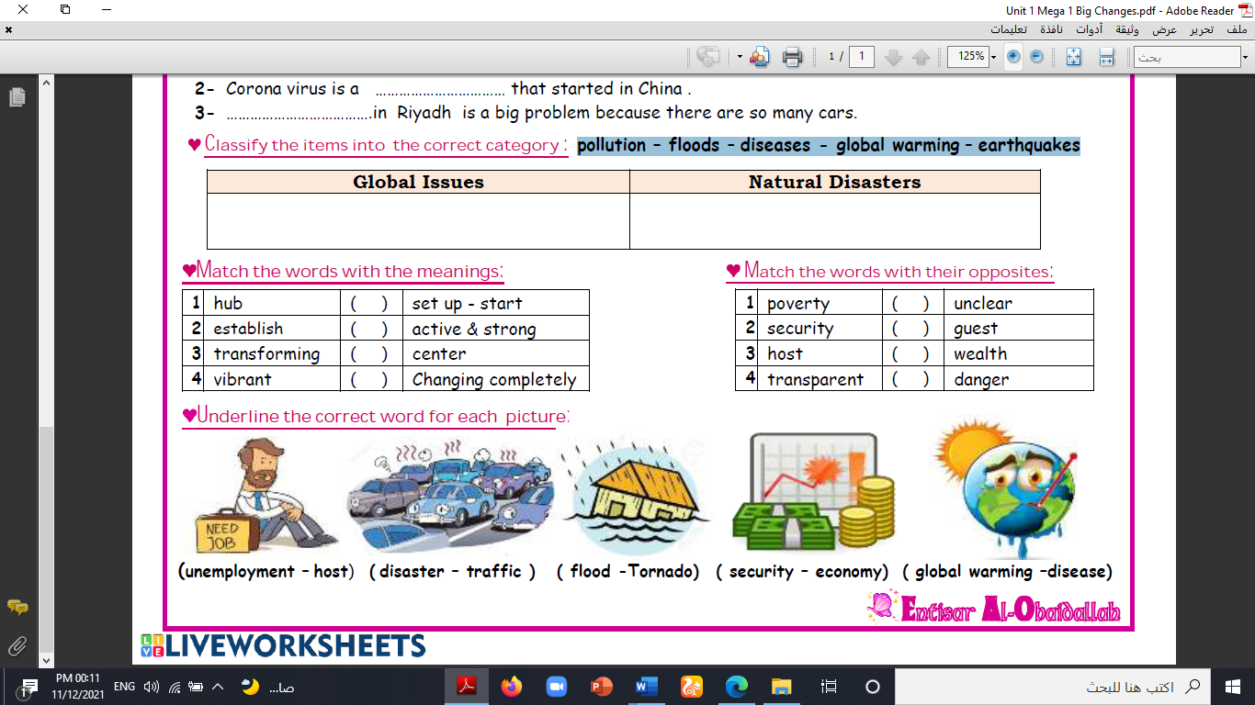**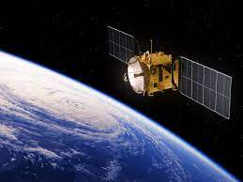microscope – alarm – submarine – sculptor – satellite – global warming**

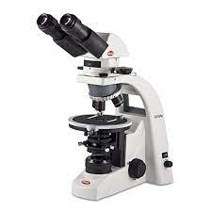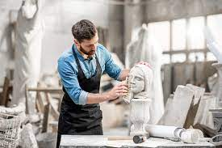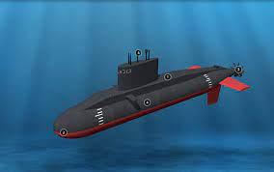

**------ --------- ----------- ---------- --------- --------**

**A) Match to form new words or expressions:**

**1. launch ---- a. come together**

**2. fast food ---- b. send into space**

**3. gather ---- c. restaurant**

**4. By the way ---- d. Used to say “Yes”.**

**5. day after day ---- e. Introduce new topic.**

**6. Certainly ---- f. Following the same pattern**

**End of Questions**

**Best of Luck**



English Language Final Exam

Term: 1 – 1444 Session: 1

Time: 2:30 hrs

Grade: 1 - Mega Goal 1.1

Kingdom of Saudi Arabia

Ministry of Education

__________ Gen. Dept. of Education

__________ Secondary School

|  |  |  |  |
| --- | --- | --- | --- |
| Graded by: | ________________________________________  ________________________________________ |  | Mark out of  30 |
| Revised by: |

**اختبار مادة (اللغة الإنجليزية 1.1- الفصل الدراسي الأول - الدور الأول) للصف الأول ثانوي - للعام الدراسي 1445هـ - نظام المسارات**

**اسـم الطالب : ___________________________________________________________ رقم الجلوس : ________ اللجنة : ________**

**اللَّهمَّ لا سَهلَ إلَّا ما جَعَلتَه سَهلًا، وأنتَ تَجعَلُ الحَزْنَ إذا شِئتَ سَهلًا**

1. **Reading Comprehension**  (1 mark each)

**6**

**Read the following text, and then answer the questions below:**

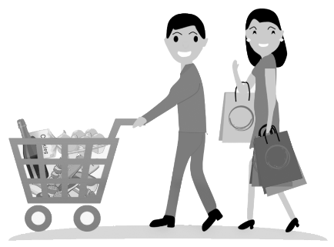Today, hypermarkets are found in almost every city in the world. Panda, AlOthaim, Carrefour and LuLu are one of the famous hyper markets in Saudi Arabia. Euromarche was the first hypermarket opened in Saudi Arabia in 1981. A hypermarket is different from mini markets or other shops.

People prefer shopping in hypermarket because it is convenient, international and one-stop-shopping. Besides, there are special offers that most customers like. In hypermarkets, goods are placed on open shelves. The customers help themselves to choose what they want and put them in the shopping basket, then take them to the check–out counter. There are usually special shelves in hyper markets for inexpensive items just in front of the check – out counter: such as chocolate, sweets, gum and so on.

When customers reach the check – out counter, they can pay cash or with a bank card. Customers feel glad because their shopping is finished. To give comfort to customers, hypermarkets provide parking areas and stay open until very late at night. Nowadays, many of the hypermarkets become huge shopping centers and malls.

1. *(choose)* **The best title for this article is …..**

a) History of Panda c) AlOthaim Mall b) Hypermarkets d) Mini Markets

1. **When was the first hypermarket opened in KSA?** _________________________
2. **Why do people prefer shopping in hyper markets?** (*Write only 1 reason)*

__________________________________________________________________________

1. **Choose the correct answer**

* The _________ help themselves to choose their goods.

a) customers b) malls c) shelves d) check-out counters

1. **Put ( T ) for true or ( F ) for false sentences :**
2. Hypermarkets stay open until very late at night. [______]
3. Nowadays, many of the hyper markets become mini shops. [______]

Page: 1 out of 4

**P.T.O**

1. **Vocabulary** (½ mark each)

**6**

1. **Fill the blanks with the correct words**

quality(iess) - treasure – plastic – motivation – disease

1. I read a story of the discovery of hidden___________________ in the ocean.
2. Please don’t throw away ___________________ bottles. Recycle them.
3. He has a real ___________________ to work. He wants to buy a car.
4. Khaled has different ___________________ . He is organized and reliable.
5. **Match word with its meaning**

|  |  |  |
| --- | --- | --- |
| **Word** |  | **Meaning** |
| 1. to cash in |  | 1. to come together |
| 1. to witness |  | 1. to be strong |
| 1. to establish |  | 1. to set up; to start |
| 1. to gather |  | 1. to make money from |
|  |  | 1. to see an event |

1. **Write the correct word and its picture**

**submarine - robot – bike - economy - cell phone**

|  |  |  |  |
| --- | --- | --- | --- |
|  |  |  |  |
| ____________ | ____________ | ____________ | ____________ |

Page: 2 out of 4

**P.T.O**

1. **Grammar** (½ mark each)

**6**

1. **Circle the correct answers**

|  |  |  |  |  |  |  |  |
| --- | --- | --- | --- | --- | --- | --- | --- |
| **1)** | Hey Jinan. _____________ lessons has she explained? ⦁ Sara: I guess 6. | | | | | | |
| a- | How long | b- | How much | c- | How many | d- | How often |
| **2)** | This is the shirt _____________ I bought yesterday. | | | | | | |
| a- | who | b- | which | c- | where | d- | when |
| **3)** | When _____________ they watch the movie? | | | | | | |
| a- | do | b- | does | c- | is | d- | are |
| **4)** | The food will _____________ by my mother soon. | | | | | | |
| a- | cook | b- | cooked | c- | be cooked | d- | been cooking |
| **5)** | The store won't close soon, _____________ . | | | | | | |
| a- | will it? | b- | it won't? | c- | it will? | d- | won't it? |
| **6)** | Bader: _____________ bag did you buy? ⦁ Ali : the black one | | | | | | |
| a- | who | b- | whose | c- | which | d- | who's |
| **7)** | He is interested _____________ reading novels. | | | | | | |
| a- | at | b- | in | c- | on | d- | of |
| **8)** | This coffee is hot _____________ . I can drink it | | | | | | |
| a- | very | b- | too | c- | enough | d- | many |

1. **Unscramble the sentence**

* new car / expensive / is not as / as the / the used car

________________________________________________________________

1. **Make it** *Negative*

* My grandparents visited us last night.

*My grandparents* _____________________________ *last night*.

1. **Put the word in a correct** *Comparative form*

* Water is ______________________ (*healthy*) than soda. Everybody knows that.

1. **Make** a Question **about the underlined**

* They will go (***to Dubai***) tomorrow morning

______________________ will they go tomorrow morning?

Page: 3 out of 4

**P.T.O**

1. **Composition**
2. **GUIDED COMPOSITION** (6 Marks)

**6**

* **Of no less than (70) words, write about: Teaching the Great Career.**
* The followings words may help you.

*dream – job – students - pass – knowledge – moral – values – educate – study*

_____________________________________________________________________

_____________________________________________________________________

_____________________________________________________________________

_____________________________________________________________________

_____________________________________________________________________

_____________________________________________________________________

_____________________________________________________________________

_____________________________________________________________________

_____________________________________________________________________

1. **FREE COMPOSITION** (6 Marks)

**6**

* **Choose ONE topic and write a paragraph about it of no less than (50) words.**

1. Saudi Vision 2030
2. My Favorite Gadget

_____________________________________________________________________

_____________________________________________________________________

_____________________________________________________________________

_____________________________________________________________________

_____________________________________________________________________

_____________________________________________________________________

_____________________________________________________________________

_____________________________________________________________________

Finished & Good Luck

Regards - ___________________

Page: 4 out of 4

Done by: Essa Al Hussaini

|  |  |  |  |  |  |
| --- | --- | --- | --- | --- | --- |
| الدرجة | | | | C:\Documents and Settings\user\Desktop\1444823505lnha01401002015ha0016-800x500.jpgC:\Users\Dar Altarbia\Desktop\شعار مدرستي.jpgنتيجة بحث الصور عن شعار رؤية المملكة 2030  =======================================  اسم الطالب ( ------------------------------------)  رقم الجلوس (------------------------------)  المادة ( اللغة الانجليزية Mega Goal 1.1 )  زمن الإجابة ( ساعتان ونصف)  التاريخ / / 5144 هـ | المملكة العربية السعودية  **وزارة التعليم**  **ثانوية**    **الفصل الدراسي الأول**  **الدور الأول**  **العام الدراسي**    **1444 / 1445**  **الصف الأول الثانوي** |
| الدرجة | السؤال | | |
|  | 6 | **التعبير** | 1 |
|  | 6 | **التعبير** | 2 |
|  | 6 | **القواعد** | 3 |
|  | 6 | **المفردات** | 4 |
|  | 6 | **القطعة** | 5 |
|  | 30 | 30 | **المجموع** |

وطننا بيتنا...فلنحافظ عليه

**Q. 1 ( Writing )**

A) **Write a paragraph – not less than 100 words - about ( Yourself ). Mention the following:( name – age – nationality – city – hobby – family )**

6

**Myself**

-----------------------------------------------------------------------------------------------------------------------------------------------------------

-----------------------------------------------------------------------------------------------------------------------------------------------------------

-----------------------------------------------------------------------------------------------------------------------------------------------------------

-----------------------------------------------------------------------------------------------------------------------------------------------------------

-----------------------------------------------------------------------------------------------------------------------------------------------------------

----------------------------------------------------------------------------------------------------------------------------------------------------

-----------------------------------------------------------------------------------------------------------------------------------------------------------

-----------------------------------------------------------------------------------------------------------------------------------------------------------

-----------------------------------------------------------------------------------------------------------------------------------------------------------

-----------------------------------------------------------------------------------------------------------------------------------------------------------

-----------------------------------------------------------------------------------------------------------------------------------------------------------

-----------------------------------------------------------------------------------------------------------------------------------------------------------

-----------------------------------------------------------------------------------------------------------------------------------------------------------

-----------------------------------------------------------------------------------------------------------------------------------------------------------

----------------------------------------------------------------------------------------------------------------------------------------------------

6

**B) Write a paragraph about one of the following ( MY FAVORITE CITY) or ( MY hobby )**

---------------------------------------------------------------------------------------------------------------------------------------------------------------------------------------------------------------------------------------------------------------------------------------------------------------------------------------------------------------------------------------------------------------------------------------------------------------------------------------------------------------------------------------------------------------------------------------------------------------------------------------------------------------------------------------------------------------------------------------------------------------------------------------------------------------------------------------------------------------------------------------------------------------------------------------------------------------------------------------------------------------------------------------------------------------------------------------------------------------------------------------------------------------------------------------------------------------------------------------------------------------------------------------------------------------------------------------------------------------------------------------------------------

follow

6

1. 2 ( Grammar )

***Choose the correct answer*** ( half for each one )

1. I ………………………………………………..………hard yesterday.
2. **work b) works c) am working d) worked**
3. My friends ……………………………..…..sleeping when I called them.
4. **was b) were c) is d) be**
5. Ahmed ………………………………………………go to school yesterday.
6. **didn’t b) doesn’t c) isn’t d) don’t**
7. It doesn’t rain in summer,………………..……………………?
8. **does it b) it does c) doesn’t it d) it doesn’t**
9. He has been reading a book …………………………………………..two years.
10. **since b) for c) to d) ago**
11. Ahmed is as……………………..………………………… Ali.
12. **old b) older c) oldest d) old as**
13. ……………………………………………….….car is this? It is my car.
14. **Who’s b) Whose c) Where d) How’s**
15. Many countries …………………………………………..launched satellites into space
16. **has b) will c) are d) have**
17. You are from Riyadh, ……………………..………………….you?
18. **are b) aren’t c) is d) does**
19. They ……………………………..………….to Dubai tonight.
20. **flew b) is flying c) has flown d) are flying**
21. By the year 3000, people …………………………..………………..to the age of 120.
22. **will b) will be living c)lived d) living**
23. The Russians …………………………………………the first artificial satellite in 1957.
24. **launched b) will launch c) launch d) are launching**

6

Q. 3 ( Vocab. )

1. To ………………………………………….….means to provide a place for.
2. **affect b) launch c) host d) establish**
3. To …………………………………….……..means to send into the space.
4. **affect b) launch c) take d) give**
5. We go to school ……………………………………………………….Sunday.
6. **in b) on c) at d) for**
7. Saudi Arabia has a ……………………………………………………..for the future 2030.
8. **vision b) video c) audio d) problem**
9. The tiny classic car is back. The word “ tiny” means very …………………………….……….
10. **small b) big c) large d) mega**
11. Perfumes …………………………………………………….……..like flowers.
12. **smell b) look c) sound d) taste**
13. When I’m very bored, it means I’m bored to ………………….………………………..
14. **life b) dead c) death d) live**
15. The twins………………………………………………………….just like their mother, don’t you think?
16. **look b) smell c) taste d) show**
17. To …………………………………………………..…….means to come together.
18. **gather b) separate c) throw d) divide**
19. ………………………………………………………is a place where we can eat in.
20. **Novel b) car c) Restaurant d) Appliance**
21. ………………………………………………………is a global issue.
22. **School b) Hospital c) Pollution d) Tigers**
23. Enterprises has the same meaning as …………………………………….……………….
24. **businesses b) schools c) ideas d) books**

Q. 4 (Reading )

6

***Read this passage and then answer the questions below:***

In the last seventy-five years, *air travel* has become the important means of long distance transportation around the world. The airplane was adopted for passenger service in Europe in 1919. Later in 1927, people in the United States began to travel by air. On 14 March 1947 in Saudi Arabia, a new airline started with a fleet of five, 24-seat Douglas DC-3s. On those days, a DC-3 ***took off*** from Jeddah for Riyadh, Hofuf and Dhahran. The 1,200 km trip took four hours and a half . The same journey by land took about two months at that time. No matter where you travel by plane, the process is usually the same. You arrive at the airport at least two hours before the plane is scheduled to leave. Right away , you show your passport and ticket to the agent. Then he gives you a seat number and checks your suitcases. After that you go to the gate where you will board your plane. Finally, an agent announces that it is time to board your plane, and you are on your way.

1. ***Put ( T ) for true and ( F ) for false* (a mark for each one )**
2. You should arrive at the airport two hours before the plane is scheduled to leave. ( )
3. You show your passport and ticket to the agent. ( )
4. Air travel isn’t important nowadays. ( )
5. Douglas DC-s has 20 seats only. ( )
6. People in the United States began to travel by air in 1947. ( )
7. The opposite of the underlined word is landed. ( )

Best Wishes

End of Questions

English Department