1st Grade Unit 1 **My Friends**

Name …………………………………………………….. Class………...

I can match the letter with the picture . . .

**What is the first letter of the following :**

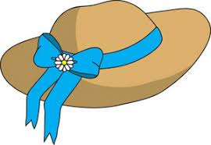

1. **C**



1. **E**

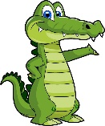

1. **D**

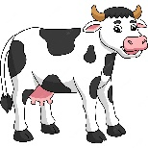

1. **A**

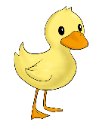

1. **H**

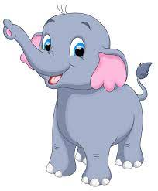

1. **B**

I can complete & tell the colors

**Complete** :

1-( A – B - ……… _ ………… _ E _ ………._ G _ ……… )

**Color** :

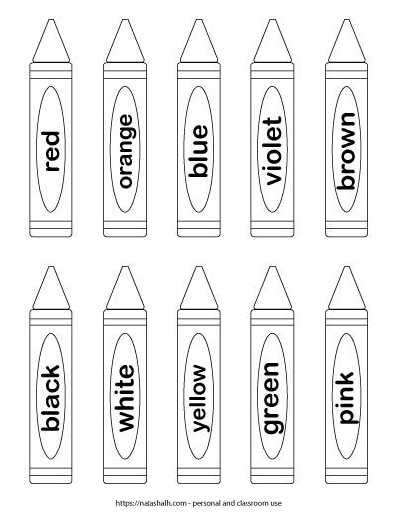

1st Grade Unit 2 **My Body**

Name …………………………………………………….. Class………...

I can match the letter with the picture . . .

**What is the first letter of the following :**

**I- J – K – L – M - N – O – P**

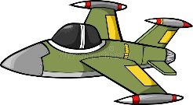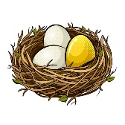

1.  **4- 7-**

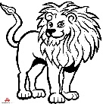

1. **5- 8-**

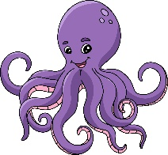



1. **6-**

I can complete & Match the body parts

**Complete** :

1-( I – J - ……… _ ………… _ M _ ………._ O _ ……… _ …………. )

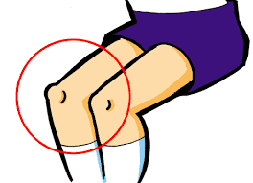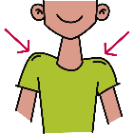**Match**

1-Head

2-Shoulders

3-Knees

4-Eyes

I can tell some body actions. . .

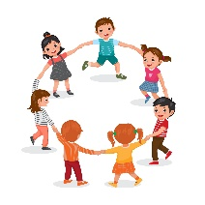

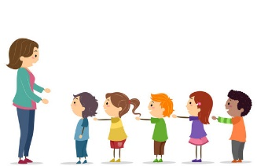1-Sit down 2-Raise your hand

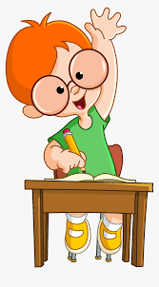3-Make a circle 4-Make a line

1st Grade Unit 3 **Family**

Name …………………………………………………….. Class………...

I can match the letter with the picture . . .

**What is the first letter of the following :**

**Q- R – S – T – U - V – W – X**

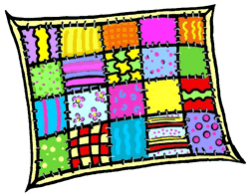

1. **4- 7-**

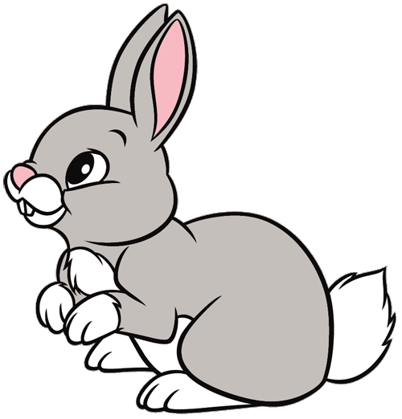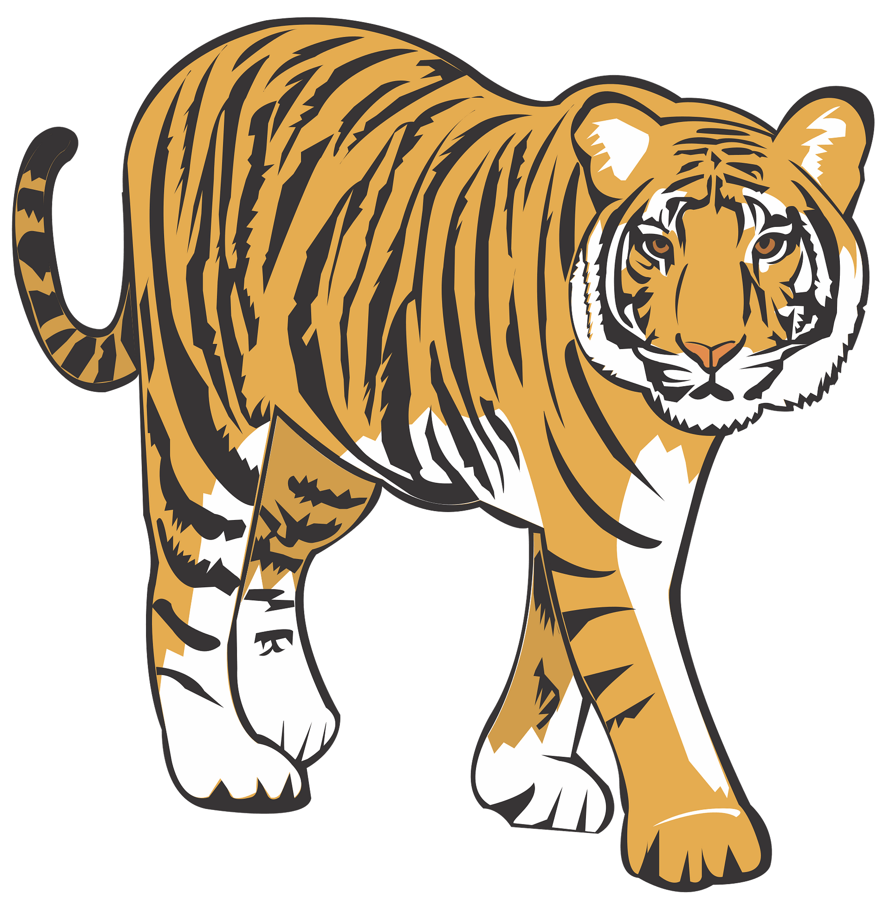

1. **5- 8-**

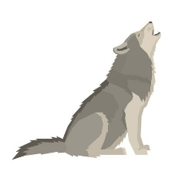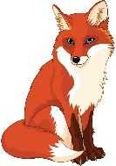

1. **6-**

I can complete & Match the family members

**Complete** :

1-( ……… – R - ……… _ T _ u _ ………._ W _ …………. )

**Match**

1-Brother

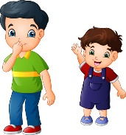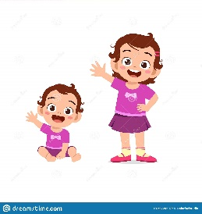2-Mom

3-Sister

4-Dad

I can tell the numbers. . .

**Match**

**A**- **B**-

**C**- **D**-