KINGOM OF SAUDI ARABIA …………………………………. Education directorate
MINISTRY OF EDUCATION ……………………………. Elementary school

12/5 _ 16/5 1st week |  |  |  | Unit 1  Yesterday  and  Today
P4 | P3 | P2 | Finding Out Time, Grammar
2nd week 19/5 _ 23/5
P6 | P34 | P5 | Grammar, Ph pr & Rhythms
3rd week 26/5 _ 1/6
P35 | P8,9 | P7 | Rhythms ,Phonics & Phonics Pr
Sunday 4th week 4/6 _ 8/6 |  |  |  | Unit 2  Jobs
P12 | P11 | P10 | Finding Out Time, Grammar
11/6 _ 15/6 5th week
P14 | P36 | P13 | Grammar Ph pr & Rhythms
18/6 _ 22/6 6th week
P37 | P16,17 | P15 | Rhythms ,Phonics & Phonics Pr
7th week 2/7 _ 6/7 |  |  |  | Unit 3  Fun on the Weekend
P20,21 | P19 | P18 | Finding Out Time, Grammar
8th week 9/7 _ 13/7
P38,39 | P24,25 | P22.23 | Rhythms, Phonics & Phonics Pr
9th week 16/7 _ 20/7 Sunday |  |  |  | Unit 4  Life’s Ups and Downs
P28,29 | P27 | P26 | Finding Out Time , Grammar
10th week 23/7 _ 27/7
P40,41 | P32,33 | P30.31 | Rhythms, Phonics & Phonics Pr
11th week 1/8 _ 5/8

Remedial Plans
12th week 8/8 _ 12/8
Final Exams
Thursday
SYLLABUS DISTRIBUTION FOR 3rdELEMENTARY GRADE (WE CAN 3) (SECOND TERM) 1445

إجازة مطولة يوم التأسيس

Teacher…………….… Headmaster………………. Supervisor ……………….

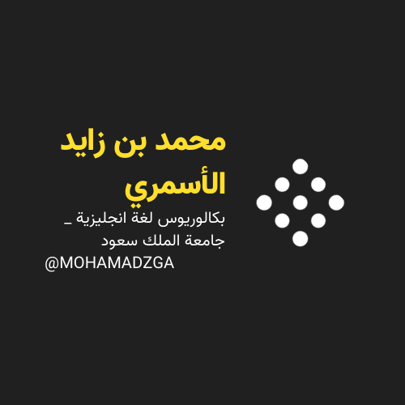

MOHAMADZGA M_zaid0

لا تنسوني من صالح دعائكم

