KINGOM OF SAUDI ARABIA …………………………………. Education directorate
MINISTRY OF EDUCATION ……………………………. Elementary school

12/5 _ 16/5 1st week |  |  |  |  | Unit 5  Yesterday  and  Today
P36 | P35 | P34 |  | Finding Out Time, Grammar
2nd week 19/5 _ 23/5
P38,39 | P106 | P37 |  | Grammar, Ph pr & Rhythms
3rd week 26/5 _ 1/6
P107 | P41 | P40 |  | Phonics, Phonics Pr
Sunday 4th week 4/6 _ 8/6 |  |  |  |  | Unit 6  Jobs
P44 | P43 | P42 |  | Finding Out Time, Grammar
11/6 _ 15/6 5th week
P46 | P108 | P45 |  | Grammar Ph pr & Rhythms
18/6 _ 22/6 6th week
P109 | P48,49 | P47 |  | Rhythms ,Phonics & Phonics Pr
7th week 2/7 _ 6/7 |  |  |  |  | Unit 7  Fun on the Weekend
P52,53 | P51 | P50 |  | Finding Out Time, Grammar
8th week 9/7 _ 13/7
P110,111 | P56,57 | P54,55 |  | Rhythms, Phonics & Phonics Pr
9th week 16/7 _ 20/7 Sunday |  |  |  |  | Unit 8  Life’s Ups and Downs
P60,61 | P59 | P58 |  | Finding Out Time , Grammar
10th week 23/7 _ 27/7
P112,113 | P64,65 | P62,63 |  | Rhythms, Phonics & Phonics Pr
11th week 1/8 _ 5/8

Remedial Plans |  |  | Oral exam
12th week 8/8 _ 12/8
Final Exams

Thursday
SYLLABUS DISTRIBUTION FOR 4^{th ,} 5th & 6th ELEMENTARY GRADE
(WE CAN 3) (SECOND TERM) 1445

إجازة مطولة يوم التأسيس

Teacher…………….… Headmaster………………. Supervisor ……………….

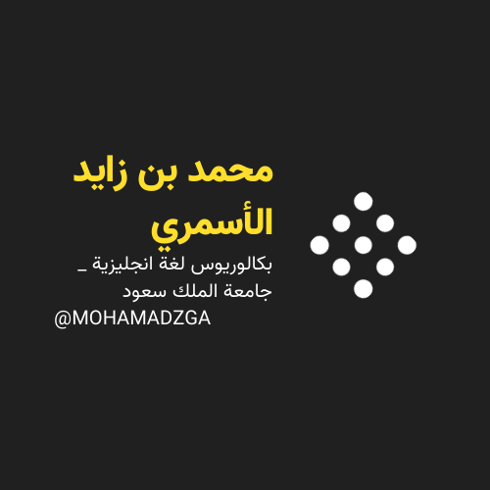

MOHAMADZGA M_zaid0

لا تنسوني من صالح دعائكم

