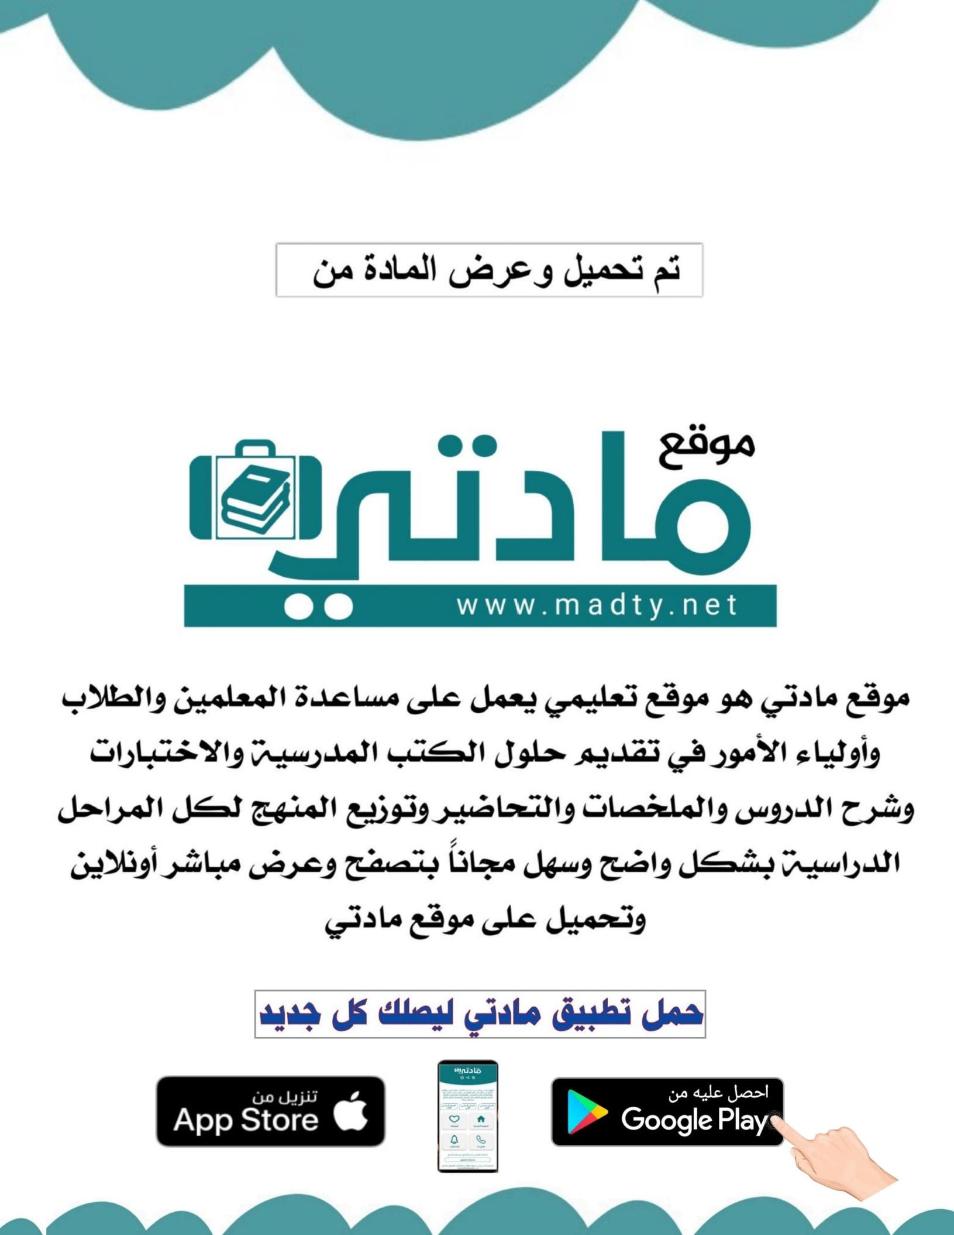
Kingdom of Saudi Arabia
Ministry of Education
………… Education Directorate
……………….. Intermediate School

Super Goal 3 - Test unit 5 & 6

Name :………………………………………………………………………… Class:…….……….

Comprehension
2 Marks
- Read the text and answer the questions. Write T or F at the end of each question/statement.
For Rent
1. Large, two-bedroom apartment on safe, quiet street. Two blocks from train station. Near park. $800 a month. Call 701-555-7847.
2. Small room near university. Fully furnished. Perfect for male, single student. Fully-equipped kitchen available. Parking available. $300 a month. Call 823-555-4865.
3. Studio apartment, excellent location. One block from city center, close to restaurants, a sports center, and public transportation. Call 701-555-2532.
- These are housing ads. ( )
- The studio apartment is fully furnished. ( )
- The two-bedroom apartment is near public transportation. ( )
- The studio apartment is in a quieter location than the two-bedroom apartment. ( )
Grammar
- Choose the best answer to fill in the blank in each question.
5 Marks
- We _____ friends since first grade.
a. has been b. have been c. been d. being
- I have had my new car _______________ September.
a. since b. for c. are d. none
- A thief stole my bike my bike was _______ .
a. steel b. steeling c. stolen d. stole
- This ring is ______________ in the shop.
a. a. the expensivest b. more expensive c. the most expensive d. expensive
- In Europe, August is ____________ than February.
a. hot b. hotter c. hottest d. hottest are
1.5 Marks
- complete the sentences with for or since:
- Nora has had the same TV________________ 15 years.
- I have had my laptop____________________ last June.
- We have worked on this project____________ a month

1.5 Marks
- Write a or an or the to fill in the blank:
- I bought ________ new TV set yesterday.
- Are you coming to _________party next Saturday?
- He is __________ engineer.
Vocabulary
- Choose the best answer to fill in the blank in each question.
5 Marks
- 'Digital' is a word that relates to______.
a. technology b. history c. playing d. shopping
- I cooked the burgers on the ______ .
a. radio b. printer c. stove d. watch
- Hanan needs paper for the _________ .
a. stove b. radio c. printer d. microwave
- ____________ are green areas.
a. Buildings b. Roads c. Parking lots d. Parks
- I An apartment is a type of __________ .
a. recreation b. transportation c. housing d. hospital

- Write the correct word under the picture.
3 Marks
1 | stove | 2 | bus | 3 | bicycle
A |  | B |  | C
…………………………….. |  | …………………………….. |  | ……………………………..

Orthography
- Choose the correct letter.
2 Marks
- He buys a new compu….er
a. ( p ) b. ( t ) c. ( m )
- Bus tic…et is expensive
a. ( m ) b. ( k ) c. ( b )

Good luck !

Kingdom of Saudi Arabia
Ministry of Education
………………… School
English Language
Intermediate Grade 3rd
1st period Exam

Student's Name : class:

1-Read the following passage and answer the questions below:
Jeddah is the second largest city after Riyadh, it is the main port of the Kingdom on the Red Sea and main gate through which most of the pilgrims arrive by air and sea to perform Umrah , Haj or to visit the two holy mosques. Area inhabited is more than 1,500 km, and population is more than one and half million . It is an important tourism center, with an eighty-kilometer-long beautiful corniche on the Red Sea coast.
A) Choose the correct answer :
1- A suitable title for the passage
a) Jeddah b) Dammam c) Abha
2-The underlined “……it..….” refers to
a) Jeddah b) Riyadh c) Red Sea
3) population is more than …………….
a) thousand b) one and half million c) five hundred
B) Find from the passage the following
1)Two cities: ………………………………………….……………….
2)sea: ……………………………………………..…………………….
2-choose the correct answer.
1- I have ( play – playing – played ) football since I was 10.
2-Ali is ( tall – taller – tallest ) than Ahmad.
3-Jake gets the ( good – better – best ) grade in the class.
4-The fish has been ( eat -eaten -ate )by the cat.
5-How long has Ali ( know – knows- known )his friend?
6-you are as ( smart – smarter – smartest ) as your brother.
7- I read ( a – an – the ) Holy Quran everyday .
8- Hameed has had the same TV ( for - since – to )15 years.
9- Omar has the ( expensive – most expensive – more expensive ) car in the city.
10-She has ( study – studied – studying ) English for five years.

3. Do as shown between brackets.
A-(Correct)
a-I’ve had my laptop for last June. ………………….
b-The room is clean by Sara ……….……..
c- He is in the Dubai in business . ……………
d- your grade is bad than me. …………..
2-Use (How long)
a-They / use / this laptop
……………………………………………………………………………?
3-(change into passive).
a- The boys broke the window..
…………………………………………………………………………..
4-(add -er )
a-cute …………. b- happy…………….

a small mode |  | miniature | 1
actions or events in a particular order |  | sequence | 2
a person who travels to a holy place |  | technique | 3
a way of doing things |  | pilgrim | 4
features |  | getaway | 5
an entrance |  | aspects | 6
4- Match

5- Write the correct word for each picture.
Printer microwave oven camera

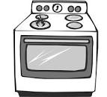

………………..
………………..
………………..
………………..

Your teacher:

Kingdom of Saudi Arabia
Ministry of Education
………… Education Directorate............
…………..……………….. Intermediate School

20
Total

Midterm Test
Third Intermediate Grade

Name ………………………………… Class ………………………………
__________________________________________________________________________________________
/ 5
Comprehension

Read the following then answer the questions:

Saad is interested in Geography books. He has already read many books about India,
Indonesia, Bangladesh and Japan. Saad visits the school library almost every day where he can read a lot of Geography books. Last week, Saad wrote a very good note in the school Magazine and the headmaster was happy to read that note. He gave him some books as a present.
A- Put (√ ) for true or ( ᵡ ) for false :

( ) | 1. Saad read many books about Pakistan.
( ) | 1. Saad visits the school library almost every day.
( ) | 2. The headmaster gave him some money as a present.

B- Choose the right answer:
English | History | Math | Geography | - Saad is interested in ________ books .
father | headmaster | student | teacher | 2- The ____ was happy to read his note.

_____________________________________________________________________________________________________
/ 5
Grammar

A-Choose the right answer:
1. I ____ there two years ago.
A . am B. were C. have D. was
2. He ______ studied English since third grade.
A . was B. has C. have D. is
3. Trains are ______ than buses.
A . big B. fastest C. fast D. faster B-Do as shown between brackets:
1. I have played football______ three years. ( Choose ) [since / for]
( Choose ) [the / a ] 2- You can see ___ moon in the sky .

Vocabulary
/ 3

A- Choose the best answer to fill in the blank:
1. I flew on a ______ on my vacation.
A. car B. bus C. taxi D. plane
2. She cooked the pizza on the _____.
A. shower B. stove C. printer D. washer
3- The apartment was a bit run down, so I had to _________ it.
A. renovate B. clean C. wash D. recycle
B- Put the right word under its picture:
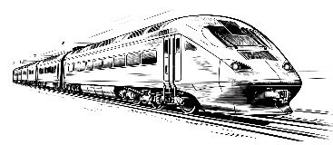 |  | 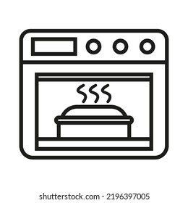
/ 4
Microwave - Pasta – Camera – Train

_______________________________________________________________________________
/ 3
Orthography

Choose the correct letter:
C. ( o ) | B. ( u ) | A. ( c ) | 1. They are watching televisi__n .
C. ( c ) | B. ( s ) | A. ( t ) | 2. Let’s play tenni__ after lunch .
B. ( v ) C. ( l ) |  | A. ( r ) | 3. Saudi Arabia has many natural resou__ces .

Good luck T.

Kingdom of Saudi Arabia
Ministry of Education
………… Education Directorate
……………….. Intermediate School

Super Goal 3 - Test unit 5 & 6

Name :………………………………………………………………………… Class:…….……….

Comprehension
2 Marks
- Read the text and answer the questions. Write T or F at the end of each question/statement.
For Rent
1. Large, two-bedroom apartment on safe, quiet street. Two blocks from train station. Near park. $800 a month. Call 701-555-7847.
2. Small room near university. Fully furnished. Perfect for male, single student. Fully-equipped kitchen available. Parking available. $300 a month. Call 823-555-4865.
3. Studio apartment, excellent location. One block from city center, close to restaurants, a sports center, and public transportation. Call 701-555-2532.
- These are housing ads. ( )
- The studio apartment is fully furnished. ( )
- The two-bedroom apartment is near public transportation. ( )
- The studio apartment is in a quieter location than the two-bedroom apartment. ( )
Grammar
- Choose the best answer to fill in the blank in each question.
5 Marks
- We _____ friends since first grade.
a. has been b. have been c. been d. being
- I have had my new car _______________ September.
a. since b. for c. are d. none
- A thief stole my bike my bike was _______
a. steel b. steeling c. stolen d. stole
- In Europe, August is ____________ than February.
a. hot b. hotter c. hottest d. hottest are
- Our neighborhood isn't ________our old one.
a. as noisy as b. as noisy c. noisy as d. noisy

- complete the sentences with for or since.
1.5 Marks
- Nora has had the same TV___________ 15 years.
- I have had my laptop________________ last June.
- We have worked on this project________ a month.

1.5 Marks
- Write a or an or the to fill in the blank:
- I bought _________ new TV set yesterday.
- Are you coming to ___________party next Saturday?
- He is ________ engineer.

Vocabulary
- Choose the best answer to fill in the blank in each question.
5 Marks
- Digital' is a word that relates to______.
a. technology b. history c. playing d. shopping
- I cooked the burgers on the ______.
a. radio b. printer c. stove d. watch
- 'Interrupted' means __________.
a. fast b. good c. fly d. stopped
- A bus, a train, and a taxi are all kinds of ______________.
a. air quality b. public transportation c. crime rate d. culture and recreation
- _________ is The bride of the red sea.
a. Riyadh b. Dammam c. Abha d. Jeddah

- Write the correct word under the picture.
3 Marks
Train – Camera - Printer

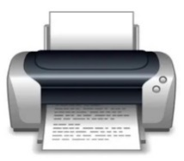
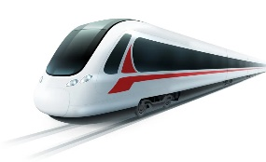
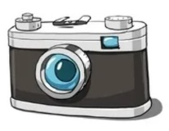

………………………………………….

………………………………………….

………………………………………….

Orthography
- Choose the correct letter.
2 Marks
- He buys a new compu….er ( v – t – r )
- Bus tic…et is expensive ( v – u – k )

