

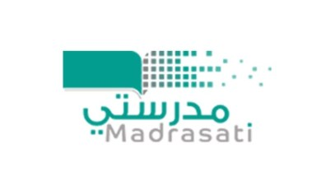

**المملكة العربية السعوديـــة**

**وزارة التعليم**

**الإدارة العامة لتعليم البنات بالمنطقة الشرقية**

|  |  |  |  |
| --- | --- | --- | --- |
| اختبار الفترة الثانية | المادة : اللغة الانجليزية | الصف : الأول | الدرجة النهائية |
| اسم الطالب / ة :.................................................. | | الشعبة :.................... |  |

Choose the correct answer:

1. **How old are you ?**

* **I am 7 years old .**
* **Fine thanks .**

1. 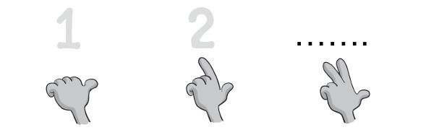**Count 1 , 2 , …**

* **5**
* **3**

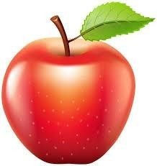

1. **It is …. Apple .**

* **an**
* **a**

1. 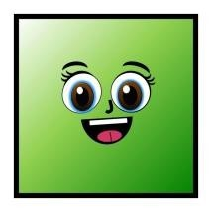**What shape is it ? it is ……..**

* **Triangle**
* **Square**

1. 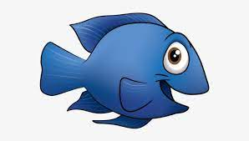**…ish**

* **F**
* **X**

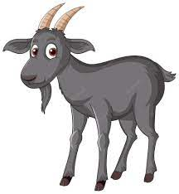 **_____________________________________________________________**

**6- …oat**

* **X**
* **G**

**______________________________________________________________**

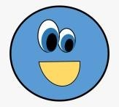 **7- What shape is it ? it is ……..**

* **Circle**
* **Diamond**

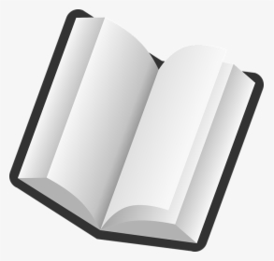**_____________________________________________________________**

**8- It is … book.**

* **an**
* **a**

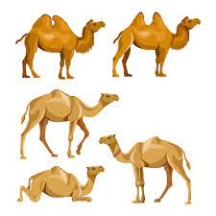**___________________________________________________________**

**9- ( 4 little , … little camels )**

* **5**
* **1**

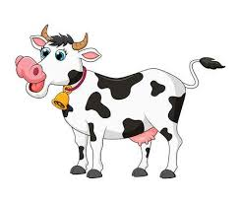 **_______________________________________________________________**

**10- What color is it ? It is ……..**

* **Yellow and orange .**
* **Black and white .**