English Language Final Exam |  | Kingdom of Saudi Arabia
The Second Trimester,1st Session, 1444 |  | Ministry of Education
The 1.2 Secondary Grade |  | General Directorate of Education in Makkah
Time: 2.30 hours |  | South Education Office
No. of pages: 3 |  | 14th Secondary School
مستعينة بالله أجيبي عن الأسئلة التالية:
I- Composition:
6
A- Guided Composition:

Write an email to advice Nasir that has problem in his new school
Guided words: great school- feeling down- sorry- accepted - new student- short conversation- participate- football team- get better
Dear Nasir
…………………………………………………………………………………………………………………………………………………………………………………………………………………………………………………………………………………………………………………………………………………………………………………………………………………………………………………………………………………………………………………………………………………………………………………………………………………………………………………………………………………………………………………………………………………………………………………………………………………………………………………………………………………………………………………………………………………………………………………………………………………………………………………………………………………………………………………………………………………………………………………………………………………………………………………………………………………………………………………………………………………………………………………………………………………………………………………………………………………………………………………………………………………………………………………………………………………………………………………………………………………………………………………………………………………………………………………………………………………………………………………………………………………………………………………………………………………………………………………………………………………………………………………………………………………………………………………………………………………………………………………………………………………………………………………………………………………………………………………………………………………………………………………………………………………………………………………………………………………………………………………………………………………………………………………………………………………………………………..………………………………………………………………………………………………………………………………………… hope to see you soon
…………….
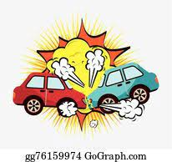
+++++++++++++++++++++++++++++++++++++++++++++++++++++++++++++++++++++++++++++++
B- Free Composition:
Write an essay about( accidents )
………………………………………………………………………………………………………………………………………………………………………………………………………………………………………………………………………………………………………………………………………………………………………………………………………………………………………………………………………………………………………………………………………………………………………………………………………………………………………………………………………………………………………………………………………………………………………………………………………………………………………………………………………………………………………………………………………………………………………………………………………………………………………………………………………………………………………………………………………………………………………………………………………………………………………………………………………………………………………………………………………………………………………………………………………………………………………………………………………………………………………………………………………………………………………………………………………………………………………………………………………………………………………………………………………………………………………………………………………………………………………………………………………………………………………………………………………………………………………………………………………………………………………………………………………………………………………………………………………………………………………………………………………………………………………………………………………………………………………………………………………………………………………………
1
6

II -Grammar:
6
A-Choose the correct answers:
1- He bought ( himself – herself-ourselves ) a new tablet.
2-​I went to the doctor ( because – so-no ) I was sick. -
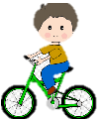
3-How (many - much -any) cell phones have you bought ?
4-When I was young, I _(used to- would-could) have a lot of energy. I was always outside playing
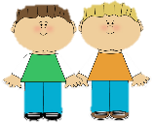
or riding my bike.
5-Ali and Ahmad were (boy-a boy-boys) who we saw them at the local school
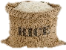
6- I bought ( some- any-not) rice.
B-Do as shown between brackets:
1-projector - no - There - is - in the class [Unscramble to make a sentence]
----------------------------------------------------------------------------------------------
2- You __________ eat while driving. [ Give advice]
3- You ought to ignore speed limits. [Make it negative]
-----------------------------------------------------------------------------------------------
III- Vocabulary:
6
A-Match between the words and their pictures:
1-
1-feeling down 2- drums 3- ostrich 4- telegraph 5-junkfood
( ) ( ) ( ) ( )
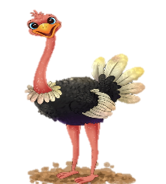
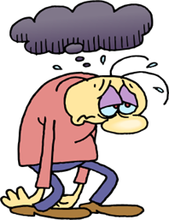

2- Match the words with the meanings:
1-challenge | ( ) being in good health
2- recover | ( ) a period in the history
3-stone age | ( ) get better
4- keep fit | ( ) "fight against
5-Of course
3- Circle the Odd words :
a- money - prize - tea - news b- ankle – eye – finger – kneepad

4-Give the antonyms for the words:
a- healthy #..................................... b-gain weight #...............................

2

IV-Reading
6
Read the following passage and answer the questions below:

The Eiffel Tower
The Eiffel Tower is one of the most famous building in the world. It is a 324m high structure in the center of Paris, France. Over the years, it has become a symbol of the city and the country. When they built it, The Eiffel Tower was the tallest building in the world. The tower got its name from its designer, Gustave Eiffel, and it build, from 1887 to 1889. The tower opened to the public on 6 May 1889. Today, it is without doubt one of the most recognizable memorial in Europe, one that can be compared to the Statue of Liberty in New York, and the Big Ben in London.

However, soon after opening, newspapers were full of angry letters from people saying how much they hated the new building. This soon changed, and today it is very popular with millions of tourists who visit it every year. You can even find smaller copies of the structure in many cities around the world.

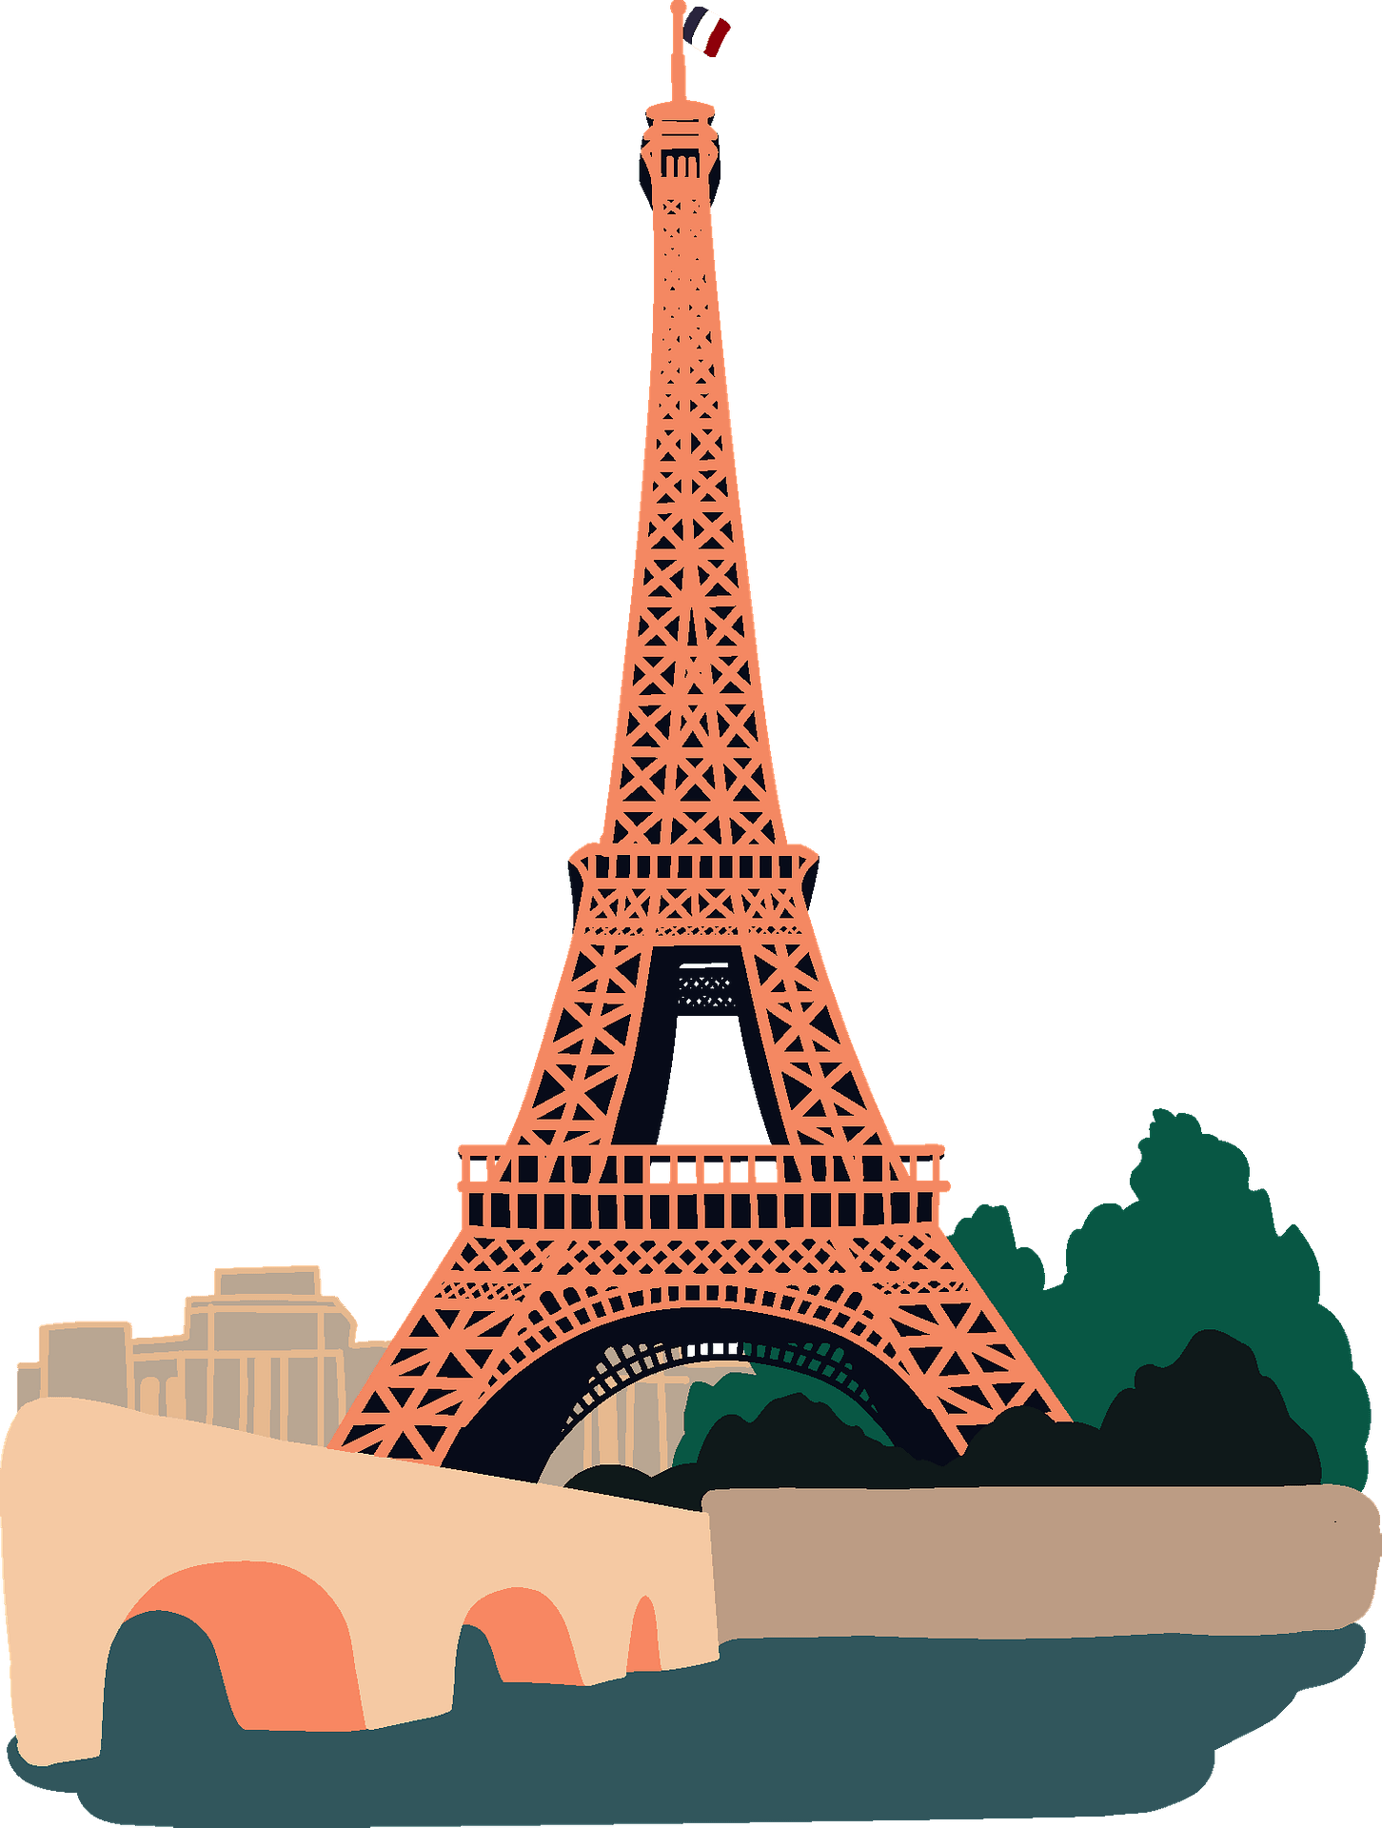
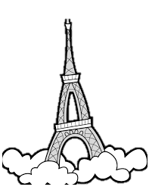

A-Answer these question:
1 – What is of the most famous building in the world.?
………………………………………………………………………………………………………………………………………………………………………………
2 - Was it the tallest building in the world?
………………………………………………………………………………………………………………………………………………………………………………
3- Where can you find smaller copies of Eiffel Tower?
……………………………………………………………………………………………………………………………………………………………………………

B- Write [ T ] for True or [ F ] for False :
- The tower got its name from its designer,.
- At present, it is without doubt one of the most recognizable memorial in Europe.
C- Choose the right answer :
1. The tower opened to the public on
a-5 May 1889 b-6 May 1889 c-7 May 1889
2. Eiffel Tower is a ,,,,,,,,,, high
a-324m b-325m c- 326m
D-Find the antonym :
a- bigger #..................................... b- shorter #......................
3

English Language Final Exam |  | Kingdom of Saudi Arabia
The Second Trimester,1st Session, 1444 |  | Ministry of Education
The 1.2 Secondary Grade |  | General Directorate of Education in Makkah
Time: 2.30 hours |  | South Education Office
No. of pages: 3 |  | 14th Secondary School
مستعينة بالله أجيبي عن الأسئلة التالية:
I- Composition:
Model Answer
6
A- Guided Composition:

Write an email to advice Nasir that has problem in his new school
Guided words: great school- feeling down- sorry- accepted - new student- short conversation- participate- football team- get better
Dear Nasir
………………………………………………………………………………………………………………………………………………………………………………………………………………………………………………………………………………………………………………………………………………………………………………………………………………………………………………………………………………………………………………………………………………………………………………………………………………………………………………………………………………………………………………………………………………………………………………………………………………………………………………………………………………………………………………………………………………………………………………………………………………………………………………………………………………………………………………………………………………………………………………………………………………………………any possible answer
……………………………………………………………………………………………………………………………………………………………………………………………………………………………………………………………………………………………………………………………………………………………………………………………………………………………………………………………………………………………………………………………………………………………………………………………………………………………………………………………………………………………………………………………………………………………………………………………………………………………………………………………………………………………………………………………………………………………………………………………………………………………………………………………………………………………………………………………………………………………………………………………………………………………………………………………………………………………..……………………………………………………………………………………………… hope to see you soon
…………….
+++++++++++++++++++++++++++++++++++++++++++++++++++++++++++++++++++++++++++++++
B- Free Composition:
Write an essay about( accidents )
…………………………………………………………………………………………………………………………………………………………………………………………………………………………………………………………………………………………………………………………………………………………………………………………………… any possible answer ………………………………………………………………………………………………………………………………………………………………………………………………………………………………………………………………………………………………………………………………………………………………………………………………………………………………………………………………………………………………………………………………………………………………………………………………………………………………………………………………………………………………………………………………………………………………………………………………………………………………………………………………………………………………………………………………………………………………………………………………………………………………………………………………………………………………………………………………………………………………………………………………………………………………………………………………………………………………………………………………………………………………………………………………………………………………………………………………………………………………………………………………………………………………………………………………………………………………………………………………………………………………………………………………………………………………………………………………………………………………
1
6

II -Grammar:
½ for each
6
A-Choose the correct answers:
1- He bought ( himself – herself-ourselves ) a new tablet.
2-​I went to the doctor ( because – so-no ) I was sick. -
3-How (many - much -any) cell phones have you bought ?
4-When I was young, I _(used to- would-could) have a lot of energy. I was always outside playing
or riding my bike.
5-Ali and Ahmad were (boy-a boy-boys) who we saw them at the local school
6- I bought ( some- any-not) rice.
1 for each
B-Do as shown between brackets:
1-projector - no - There - is - in the class [Unscramble to make a sentence]
There is no projector in the class.
2- You _should_ eat while driving. [ Give advice]
3- You ought to ignore speed limits. [Make it negative]
You ought not to ignore speed limits.
III- Vocabulary:
½ for each
6
A-Match between the words and their pictures:
1-
1-feeling down 2- drums 3- ostrich 4- telegraph 5-junkfood
( 4 ) ( 3 ) ( 2 ) ( 1 )

2- Match the words with the meanings:
1-challenge | ( 4 ) being in good health
2- recover | ( 3 ) a period in the history
3-stone age | ( 2 ) get better
4- keep fit | ( 1 ) "fight against
5-Of course
3- Circle the Odd words :
a- money - prize - tea - news b- ankle – eye – finger – kneepad

4-Give the antonyms for the words:
a- healthy #.....unhealthy b-gain weight #. lose weight.

2

IV-Reading
6
Read the following passage and answer the questions below:

The Eiffel Tower
The Eiffel Tower is one of the most famous building in the world. It is a 324m high structure in the center of Paris, France. Over the years, it has become a symbol of the city and the country. When they built it, The Eiffel Tower was the tallest building in the world. The tower got its name from its designer, Gustave Eiffel, and it build, from 1887 to 1889. The tower opened to the public on 6 May 1889. Today, it is without doubt one of the most recognizable memorial in Europe, one that can be compared to the Statue of Liberty in New York, and the Big Ben in London.

However, soon after opening, newspapers were full of angry letters from people saying how much they hated the new building. This soon changed, and today it is very popular with millions of tourists who visit it every year. You can even find smaller copies of the structure in many cities around the world.

1 for each
A-Answer these question:
1 – What is of the most famous building in the world.?
The Eiffel Tower
2 - Was it the tallest building in the world?
Yes, it was.
3- Where can you find smaller copies of Eiffel Tower?
in many cities around the world.
½ for each
B- Write [ T ] for True or [ F ] for False :
- The tower got its name from its designer,. T | t
- At present, it is without doubt one of the most recognizable memorial in Europe.T
C- Choose the right answer :
½ for each
1. The tower opened to the public on
a-5 May 1889 b-6 May 1889 c-7 May 1889
2. Eiffel Tower is a ,,,,,,,,,, high
a-324m b-325m c- 326m
D-Find the antonym :
½ for each
a- bigger #....smaller b- shortest #....tallest
3

