2nd term الفصل الثاني

Name : ………………………………………………….………………………………
الاسم: ………………………………………………….………………………………..
الصف: ………………………………………………….………………………………

Units :4-5-6-7

for We Can 2

General Revision

General Questions
A. Match "A" with "B":
"A" |  | "B"
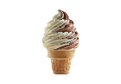  1.Is it cold or hot? |  |  | Nice to meet you, too.
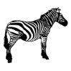  2.What's like ? |  |  | It is a lion.
3.Nice to meet you Amal! |  |  | I walk.
4.What animal is this? |  |  | It is cold .
5.How do you go to school? |  |  | It is black and white. It has stripes..
6.Whose hat is this? |  |  | They are big. They have trunks.
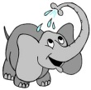  7. What are they like? |  |  | It is Sara's.
8.Do you have apples? |  |  | It is over there.
9. Where is the snake? |  |  | Yes, I have.
10.Let's go to bed! |  |  | It is yellow.
 |  |  | Goodnight!
B. Answer the following:
1 How many seasons are there in the year ?
………………………………………………………………………………………
2- What is the opposite of (long)?
………………………………………………………………………………………
3-How do you go to school?
………………………………………………………………………………………
4-Good morning!
………………………………………………………………………………………
C-Choose the correct answer:
1.Good morning !
d. Good afternoon! | c. Good bye! | b. Good morning! | a. Goodnight
2.Where is he?
d. We're at home | d. They're at home | d. I'm at home | d. He is at home
3. How do you go to school?
d. Turn right. | d. Turn left | d. I walk. | d. It is yellow.
4.Where is the lion?
d. We are there. | d. They are here. | d. I'm here. | d. It is here.
Controlling Writing
A. Reorder to make a correct sentence or question:
1- lions - ? - Where - the - are
…………………………………………………………………………………………………………………………………
...............................................................................................................................................
2- snakes - . - are – They
…………………………………………………………………………………………………………………………………
...............................................................................................................................................
B. Classifying months and seasons

Fall –March- Winter – January – February- Spring - July -April
Months | seasons
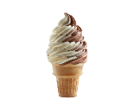
C. unscramble the words:
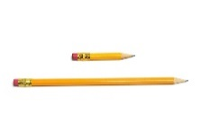
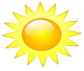
toh: …… cdol: ………
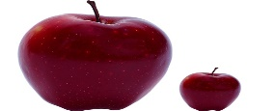
bgi: ……… hstor: ………

Reading Short Sentences:
A.Read and match:
1- The snake is long. | 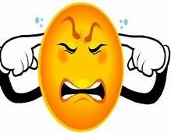
2- Look! It’s a beautiful flower.
3- It’s noisy.
4- Good morning. |  |  | 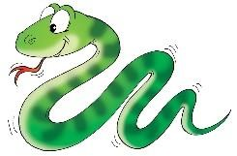
5- My soup is hot.
6- Good night.
7.It's ugly!

B.Choose √ or ×
1.Turn left. | √ | ×
2.This is a motorbike. | √ | ×
3.Apples are sour! | √ | ×
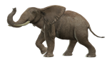  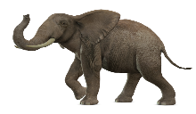  4. Elephants are big! | √ | ×
Grammar A.Choose the correct answer:
1- The sound of ( s) in mountains is like ………
a./s/ | b./z/ | C./iz/ | d./is/
2. The sound of ( s) in noses is like ………
a./s/ | b./z/ | C./iz/ | d./is/
3. The sound of ( s) in cats is like ………
a./s/ | b./z/ | C./iz/ | d./is/
4. Is he standing?
a.Yes,she isn’t. | b. No, They are. | c.Yes,he is. | d. No, we are.
5. Snakes ______ long.
a. are | b. am | c. is | d. it
6. I have apple _____ banana.
a. and | b. but | c. or | d. no
7. I have oranges ______ I don’t have cherries.
a. and | b. but | c. or | d. no
8. They ____ smart.
a. is | b. am | c. are | d. it
9. Whose hat is this ? It's _______
a. Ali's | b. Ali | c. ali | d. he
10. They ______ trunks.
a. has | b. have | c. is | d. am
11. - She ______ playing .
a. is | b. am | c. are | d. I
12. She has a pen ______ she doesn’t have a book.
a. and | b. but | c. or | d. no
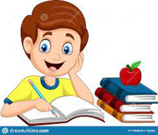
B.Write the correct answer:
1. Is he playing?
____________________________________________________________
2. Is she eating?
___________________________________________________________
C.Complete:
1.They are playing.
…………… …………… playing? Yes, …………… ………………
2. It is tasty.
…………… …………… tasty? No, …………… ……………
D. Match :
A | B
1. Are they playing? | ……… No, she isn’t.
2. Is he walking? | ……… No, they aren’t.
3. Is she talking? | …….. Yes, he is.
4. Is it sweet?

Vocabulary A.Write the correct answer under each picture:
tiger – book – cup – bus – rose - feather
 | 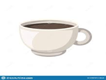 |  | 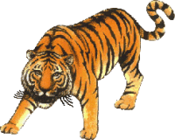
…………………… | …………………… | …………………… | …………………… | ……………………
B.Match the picture with the words :
1.Chimpanzee
2.elephant
3.hippo
4.crocodile
5. giraffe
6.bear
7.snake

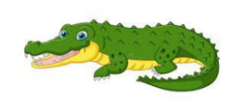
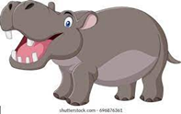
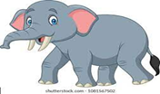
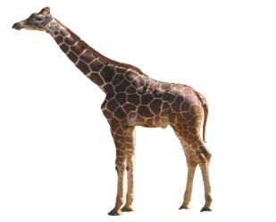
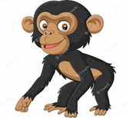

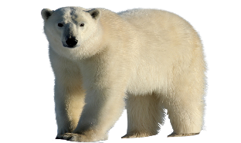

C.Write the opposite:
long X ...........
weak X ...........
big X ...........
noisy X ............
quiet Small
short Strong beautiful

D.Choose the correct answer:
1- Elephants are _____________ ( big – small – long )
2- _____________ are white and black .(bear - zebras – snake )
3- Hippos have big _____________ ( head- ear – mouth)
4- Chimpanzees are _____________ ( scary – smart – strong)
5- Elephants have _____________ ( arms – legs – trunk)
Orthography
A.Write ( sn- st– o-sh- fl- pl-oo-sl-u ) in the suitable blanks:
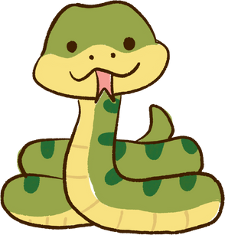 |  |  |  |  | 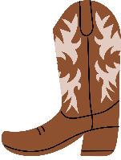
....ake | ....op | ...ctopus | ....ag | ....ate | b....t
 | 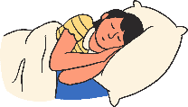 | 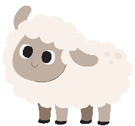
f....d | ....eep | .....eep | b....k | b...s | .....y
B .Choose the correct answer :
 |  |  |  | 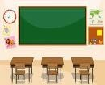 |  |  |  | 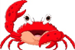
H _ ad |  |  |  | _ ass |  |  |  | _ ab |  |  |  | m _ _ t
e | ea | i | o | ch | cl | gl | s | cr | p | bl | ea | o | ea | pl | i
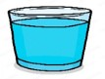 |  |  |  |  |  |  |  | 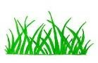 |  |  |  | 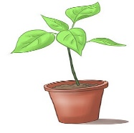
_ _ ass |  |  |  | F_ _ ther |  |  |  | _ _ ass |  |  |  | _ _ ant
gl | ch | cl | pl | e | ea | i | o | cl | gr | pl | c | pl | g | cr | gl

Done by: Zahra Mohammed
More practice reordering : :
A. Reorder to make a correct sentence:
1- is - a - beautiful - ! - It
…………………………………………………………………………………………………………………………………
...............................................................................................................................................
2- friend - . - my – This - , - Omar- is
…………………………………………………………………………………………………………………………………
...............................................................................................................................................
3- go - . - school – bus – I - by
…………………………………………………………………………………………………………………………………
...............................................................................................................................................

B. Reorder to make a correct Question :
1- is - ? - Where - he
…………………………………………………………………………………………………………………………………
...............................................................................................................................................
2- this- What - ? – animal - is
…………………………………………………………………………………………………………………………………
...............................................................................................................................................

3- go - school - you – How - ? – to – do
…………………………………………………………………………………………………………………………………
...............................................................................................................................................
\

Done by: Zahra Mohammed

