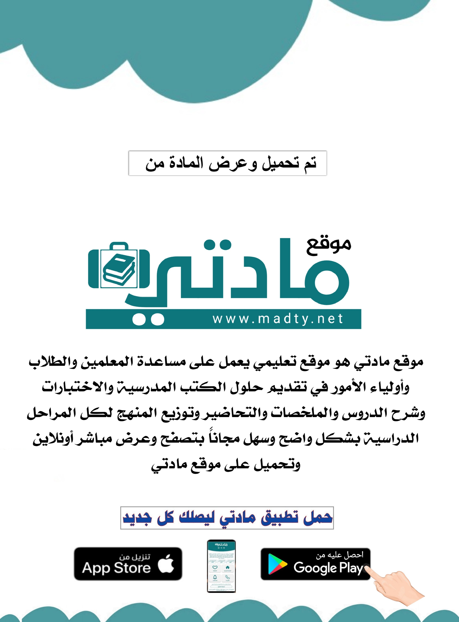

|  |  |  |  |  |
| --- | --- | --- | --- | --- |
| **المملكة العرية السعودية**  **وزارة التعليم**  **ادارة التعليم بمنطقة مكة المكرمة**  **مكتب التعليم**  **مدرسة** |  | | | **المادة:** اللغة الإنجليزية  **الصف:** ثاني متوسط  ا**لزمن:** ساعة ونصف |
| **اسم المصحح:** | اختبار ثاني متوسط الفصل الدراسي الثاني  [ الدور الاول ]  لعام 1445ه | | | **اسم المراجع:** |
| **التوقيع:** | **التحريري** | **الاستماع** | **المجموع** | **التوقيع:** |
|  |  |  |
| **اسم الطالب:.................................................................................................................. رقم الجلوس: ( )** | | | | |

**Q1-Vocabulary:**

**A-Match the correct word for each picture:**

**1. vomiting – 2.sunglasses - 3. belt – 4.navigation – 5.happy – 6.scared**

|  |
| --- |
|  |

**( ) ( ) ( ) ( ) ( ) ( )**

|  |
| --- |
|  |
| **6** |

**B-Choose the missing letters:**

|  |
| --- |
| **v - t - s - f - p** |

|  |
| --- |
|  |
| **5** |

**1.** fe…..er 2. foo…….. 3. Du…t 4 stu….f 5.sho……

**Q2-Grammer :**

**A-Choose the correct words:**

1. **( whose - how– where ) toothbrush is this?**

|  |
| --- |
|  |
| **7** |

1. **He was the (fastest – fast – faster ) runner in 2017.**
2. **May I ( has – have – were ) a bigger bag, please?**
3. **My sister did not ( does – do – doing) her homework.**
4. **Let's ( to drink – drinking – drink ) some water.**
5. **They have to ( wearing – wore – wear ) uniform at school.**
6. ***Tom* likes football.**

**( he – she – it ) likes football.**

**Q3-Composition:**

**Write a paragraph about ( your friend ) use the answers of these questions:**

1-What is his name? 2-How is he ?

3-what he look like? 4-What color is his hair?

**My friend**

**………………………………………………………………………………………………………………………………………………………………………………………………………………………………………………………………………………………………………………………………………………….**

|  |
| --- |
|  |
| **6** |

**Q4-Reading:**

**Read the passage and answer the questions:**

My day at school

I usually arrive at school before 7 a.m. Assembly is at 6:45, and we always sing the Saudi national anthem. After assembly, we go straight to the classroom. We have six classes a day. Each one lasts 45 minutes. We only leave our classroom for subjects like computer, PE, and art. School finishes at 1 p.m. There are after-school clubs. I’m a member of the football club, so I sometimes stay after school and play football.

[](https://t.me/madtyy8)

**Q3.Answer the following questions:  
A – Choose the correct answer:**

1-He arrives at school before (7 a.m - 6 a.m – 5 a.m – 4 a.m)

2- We have six classes a day. Each one lasts ( 10- 30 – 25 - 45) minutes

3- we always sing the( Saudi – Hindi – Egyptian – Tunisian ) national anthem

**B- Write ( yes** **) or ( no** **) at end of each statement:**

1- School finishes at 5 p.m ( )

2- He sometimes stays after school and plays football ( )

3- We leave our classroom for subjects like computer, PE, and art ( )

|  |
| --- |
|  |
| **6** |

**Best of luck**

|  |  |  |  |  |
| --- | --- | --- | --- | --- |
| **المملكة العربية السعودية**  **وزارة التعليم**  **الإدارة العامة للتعليم .........** | **http://tabuk2day.com/wp-content/uploads/IMG_3362.jpg**  **اختبار الفصل الدراسي الثاني**  **للعام الدراسي ١٤٤٥هـ** | **المادة** | لغة انجليزية | |
| **الصف** | الثاني المتوسط | |
| **الزمن** | ساعة ونصف | |
| **الدور** | الأول | |
| **الاسم: .............................................................................................................** | | | | |

**30**

1. **Composition**

***Write a paragraph about (* yourself *) not less than 6 sentences using the following words .***

**6**

***( name – age – favorite sport – live –like )***

…………………………………………………………………………………………………………………………………………………………………………………………………………………………………………………………………………………………………………………………………………………………………………………………………………………………………………………………………………………………………………………………………………………………………………………………………………………………………………………………………………………………………………………………………….

**6**

**2. Reading Comprehension**

**Read the passage and answer the questions below :**

**Every Thursday, Mr. Saleh goes shopping. He likes to buy things from the supermarket near his house. It is a big supermarket. He buys meat, fruit, milk and vegetables for the week. Today, two of his children are going with him, Maram and Basil. Maram wants to buy biscuits for her sister Hanan. Basil wants to buy ice-cream. Basil does not have much money. He asks his father to give him some money.**

**Answer :**

**1- What does Mr. Saleh like to buy ? .....................................................................**

**2- Where is the supermarket ? ...............................................................**

**Choose :**

**3- Mr. Saleh likes to…………… things from a supermarket. ( buy - drink - eat )**

**4- Basil asks his father to give him some ( money - milk - ice-cream )**

**5- Today, two of his ……… are going with him. (children - friends teachers)**

**6- It is a ……………… supermarket. ( good - big - small )**

**7**

**3. GRAMMAR**

**Choose the correct words :**

**1- Where ( was - were - am ) the football game ?**

**2- ( What - Why - Who ) are you warried ?**

**3- He didn't see the stop sign ( so - and - because ) he caused an accident .**

**4- He ( go - went - goes ) swimming three times a week .**

**5- Why ( don't - doesn't – doing ) you put on a sweater ?**

**6- You ( should - must - well ) stop at the traffic light .**

**7- The jacket is ( too - to - two ) small for me .**

**7**

**4. Vocabulary**

**A-Match the meaning and the responses to the situations :**

|  |  |  |  |
| --- | --- | --- | --- |
| **1** | **stuff** |  | **Things in general** |
| **2** | **Let down** |  | **Disappoint someone** |
| **3** | **Nothing much** |  | **Not a great amount** |
| **4** | **Why are you warried ?** |  | **Because I have a test tomorrow** |

**B-Match the picture with words:**

**( Sleepy - Scared - Angry )**



………………………………. ………………………… ....................................

**5. orthography**

**Write the missing letters :**

**4**

**1-e_e ( y – a ) 2- d_st ( u - m )**

**3- be_ts ( l- m) 4- n_se ( o - f)**

**انتهت الاسئله**

|  |  |
| --- | --- |
| **رؤية 2030» تدعم حيوية الاقتصاد السعودي... و2018 شهد أعلى ميزانية إنفاق |  الشرق الأوسطKingdom of Saudi Arabia**    **Ministry of Education**  **…………… Intermediate**  **School in ………………..** | **English Language**  **2nd Intermediate Grade**  **2nd Term Exam 1443 -2022**  **Time: 2 hours**  **The first session** |
| **Name/** …………………………………………………………… | **Seat No**./ ……………………… |

( اللهم لا سهل إلا ماجعلته سهلا وأنت تجعل الحزن إذا شئت سهلا )

|  |  |  |  |  |
| --- | --- | --- | --- | --- |
| **Student’s Mark Written** | **Student’s Mark Number** | **Question** | | **Number** |
| **Mark** | **Question** |
|  |  | **6** | **Writing** | **Q1** |
|  |  | **6** | **Reading Comprehension** | **Q2** |
|  |  | **7** | **Grammar** | **Q3** |
|  |  | **7** | **Vocabulary** | **Q4** |
|  |  | **4** | **Orthography** | **Q5** |
|  |  | **30** | **Total Written Tasks** | |

عدد الصفحات : 4 صفحات

|  |  |
| --- | --- |
| **اسم المصحح وتوقيعه :** |  |
| **اسم المراجعوتوقيعه :** |  |
| **اسم المدقق وتوقيعه :** |  |

***Q : 1 ( Writing )***

6

***Write a paragraph about (* your best friend*) using the following words .***

***( name – age – math – science –green – rice )***

**My best friend is …………………… .She is ………… years old. She likes …………… subject, but she doesn`t like ………………… .Her favorite colour is ………….. . She likes to eat …………… . I love my friend.**

6

***Q : 2 ( Reading )***

**Read the following passage then answer the questions :**

Mahais a student. She is 13 years old. She likes shopping. Her favorite mall is Al-Obaikan shopping center . It is in Taif . It is very big and there is a large parking. There are many dresses, flowers , and toy shops. Every Thursday, Maha and her family go shopping.

In the coffee shop , they drink cappuccino and have their lunch in the restaurant. She likes to eat beef burger. Shopping in Al-Obaikan mall is easy and interesting .

**A - Answer:**

**1 – Is Maha a student ?**

**a –** Yes, she is. **b –** Yes, it is. **c –** Yes, he is.

**2 – How old is she ?**

**a –**She is 10 years old. **b –** She is 13 years old. **c –** She is 15 years old.

**B – Choose :**

1 – She likes ( **shopping – swimming – watching TV** ).

2 – Her favorite mall is ( **Al-Rashed – Riyadh – Al-Obaikan**) mall .

3 – It is in ( **Taif – Tabouk – Jeddah** ).

4 – They drink ( **coffee – cappuccino – tea** ) in the coffee shop.

5 – They have their ( **breakfast – lunch – dinner** ) in the restaurant .

6 – She likes to eat ( **chicken burger – beef burger** ).

**C – Put ( T ) or ( F ) :**

1 – There are many dresses, flowers and toy shops. ( )

2 – Shopping in Al-Obaikan mall is not easy. ( )

***Q : 3 ( Grammar )***

7

**A – Choose :**

1 – The driver was sleepy, ( **because – so** ) he didn`t see the stop sign.

2 – You **should**( **stay – staying** ) home.

3 – **They** have a house. It is ( **our – their** ) house.

4 – Ahmad goes ( **swim – swimming** ) three times a week.

5 – You ( **should – must** ) see a doctor.

6 – Are these ( **your – yours** ) socks.

7 – Ali is ( **tall – taller** ) than Imad.

8 – I have ( **so many – so much** ) books on my desk.

**B – Answer the questions :**

***1 – Whose backpack is this ?***

**a –** It is my .**b –** It is mine.

**2 – *Which coat do you like ?***

**a –** The green one. **b –** The green ones.

**C – Put ( T ) or ( F ) :**

1 – I have to **do** my homework. ( )

2 – I was scared, **so** he was driving too fast. ( )

***Q : 4 ( vocabulary )***

7

***A – Put the feeling under its reaction:***

( happy – sad – sleepy – angry – scared – worried )

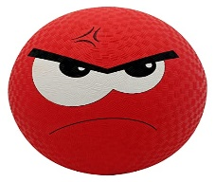

………………….. …………………… …………………… ………………….. ………………….. ……………………..

______________________________________________________________________________

***B – Match the words with their meanings :***

a – Witness. () 1 – payment for costs of an accident.

b – Insurance. () 2 – someone who saw an event.

c – Intersection. ()3 – hurt from an accident.

d – Injury. () 4 – Where two roads cross.

***C – Match the illness with its symptom:***

**( headache – stomachache – earache – toothache )**

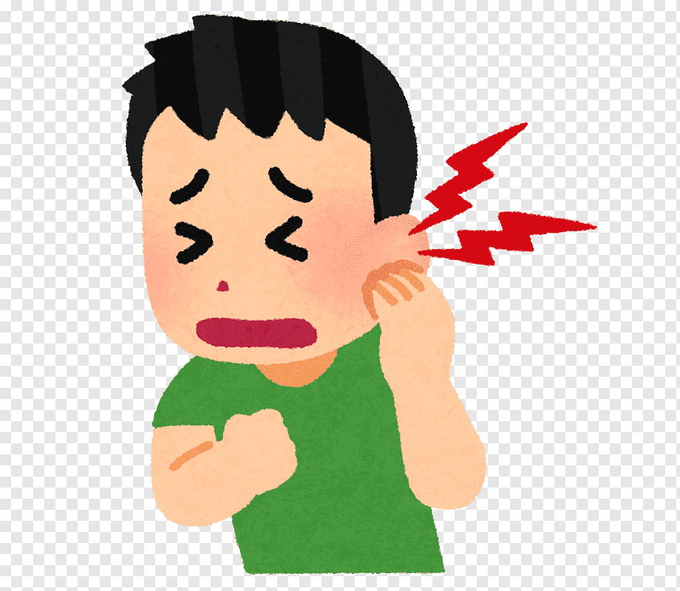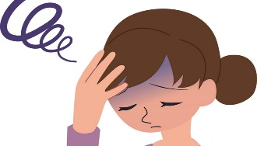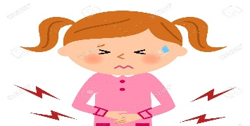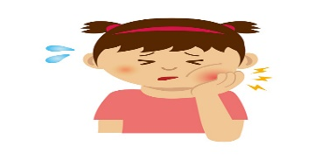

………………………………. ………………………………… …………………………….. …………………………….

-------------------------------------------------------------------------------------------------------------------------------

4

***Q : 5 ( Orthography )***

**A : Write the missing letter :**

**1 -** ……..ark. ( sh – ch – ph ). **2 –** banan…. ( d – t – a ) .

**3 -** ……ale. ( n – s – q ) . **4 –**bo…..ts . ( o – r – m ).

-------------------------------------------------------------------------------------------------------------------------------

**B : Copy :**

1 – You can break a diamond with a hammer.

……………………………………………………………………………………………………………………….

2 – The great star of Africa weighs over 540 karats.

………………………………………………………………………………………………………………………..

**Good luck….**

**T.**

**(إجعل دقائق الإنتظار مليئة بالإستغفار )**