

**Kingdom of Saudi Arabia**

**Ministry of Education**

**………… Education Directorate............**

**…………..……………….. Intermediate School**

|  |
| --- |
|  |
| **20** |

**Total**

**Midterm Test units 12 & 13**

|  |
| --- |
| First Intermediate Grade |

**Name ………………………………… Class ………………………………**

__________________________________________________________________________________________

/ 4

**Comprehension**

**Read the following then answer the questions:**

My favorite mall is Al-Othaim shopping Centre. It is in Riyadh. It is very big and it has two floors. There are many shops. It also has a large supermarket. There are many places that sell tasty food. Shopping in Al-Othaim is easy.

**A- Put (√ ) for true or ( ᵡ ) for false :**

|  |  |
| --- | --- |
| **( )** | **1. Shopping in Al-Othaim is easy**. |
| **( )** | **2. There aren't any restaurant**. |

**B- Choose the right answer:**

|  |  |  |  |  |
| --- | --- | --- | --- | --- |
| **Tabuk** | **Abha** | **Jeddah** | **Riyadh** | **1-**The shopping Centre is in ______. |
| **five** | **three** | **two** | **four** | **2-**It has ___ floors. |

_________________________________________________________________

/ 5

**Grammar**

**Choose the right answer:**

|  |
| --- |
| 1- I _____ play volleyball, but I can play tennis . |
| A. am B. can't C. can D. do |
| 2 - Do they like to relax on the beach? Yes, ____ ___. |
| A. I can . B. I do . C. they do. D. he does. |
| 3 - I’d like _____ a new laptop . |
| A. to buy B. buying C. buy D. buys |
| 4 - We are _________ go to the zoo tomorrow. |
| A. doing B. going C. going to D. go to |
| 5 - Sara ____ going to wear a dress in the wedding . |
| A. am B. are C. is D. she |

/ 4

**Vocabulary**

**A- Choose the best answer to fill in the blank:**

|  |  |  |  |
| --- | --- | --- | --- |
| 1. Jack can _____ a boat. | | | |
| D. sail | C. **water-ski** | B. **kite surf** | A. **swim** |
| 2. A place you can fly to places. | | | |
| D. **park** | C. **Bus station** | B. **Airport** | A. **Train station** |
| 3- I need to put on my ____________. My feet are cold. | | | |
| D. **shorts** | C. **shirt** | B. **shoes** | A. **coat** |
| 4- You need_____clothes. It’s cold in Abha. | | | |
| D. **formal** | C. **warm** | B. **cold** | A**. hot** |

**B- Put the right word under its picture:**

|  |  |  |  |
| --- | --- | --- | --- |
| 840+ Pair Of Ice Skates Stock Photos, Pictures & Royalty-Free Images -  iStock | Pair of ice skates icon | Gym Room stock vector. Illustration of lifestyle, equipment - 34028667 | tie | ‪Dress Cartoon Images – Browse 468,137 Stock Photos, Vectors, and Video |  Adobe Stock‬‏ |
|  |  |  |  |

**Gym , Tie , Dress , Ice-skate**

/ 4

_______________________________________________________________________________

/ 3

**Orthography**

**Choose the correct letter:**

|  |  |  |  |
| --- | --- | --- | --- |
| **g** | **k** | **v** | 1. Fred plays bas__etball. |
| **r** | **b** | **d** | 2. I’m going to a we__ding on the weekend. |
| **n** | **h** | **f** | 3. The weat__er is very hot. |

Good luck T.



**Kingdom of Saudi Arabia**

**Ministry of Education**

**………… Education Directorate............**

**…………..……………….. Intermediate School**

|  |
| --- |
|  |
| **20** |

**Total**

**Midterm Test units 12 & 13**

|  |
| --- |
| First Intermediate Grade - |

**model answer**

__________________________________________________________________________________________

/ 4

**Comprehension**

**Read the following then answer the questions:**

My favorite mall is Al-Othaim shopping Centre. It is in Riyadh. It is very big and it has two floors. There are many shops. It also has a large supermarket. There are many places that sell tasty food. Shopping in Al-Othaim is easy.

**A- Put (√ ) for true or ( ᵡ ) for false :**

|  |  |
| --- | --- |
| **(√ )** | **1. Shopping in Al-Othaim is easy**. |
| **( ᵡ )** | **2. There aren't any restaurant**. |

**B- Choose the right answer:**

|  |  |  |  |  |
| --- | --- | --- | --- | --- |
| **Tabuk** | **Abha** | **Jeddah** | **Riyadh** | **1-**The shopping Centre is in ______. |
| **five** | **three** | **two** | **four** | **2-**It has ___ floors. |

_________________________________________________________________

/ 5

**Grammar**

**Choose the right answer:**

|  |
| --- |
| 1- I _____ play volleyball, but I can play tennis . |
| A. am B. can't C. can D. do |
| 2 - Do they like to relax on the beach? Yes, ____ ___. |
| A. I can . B. I do . C. they do. D. he does. |
| 3 - I’d like _____ a new laptop . |
| A. to buy B. buying C. buy D. buys |
| 4 - We are _________ go to the zoo tomorrow. |
| A. doing B. going C. going to D. go to |
| 5 - Sara ____ going to wear a dress in the wedding . |
| A. am B. are C. is D. she |

**Vocabulary**

/ 4

**A- Choose the best answer to fill in the blank:**

|  |  |  |  |
| --- | --- | --- | --- |
| 1. Jack can _____ a boat. | | | |
| D. sail | C. **water-ski** | B. **kite surf** | A. **swim** |
| 2. A place you can fly to places. | | | |
| D. park | C. **Bus station** | B. **Airport** | A. **Train station** |
| 3- I need to put on my ____________. My feet are cold. | | | |
| D. shorts | C. **shirt** | B. **shoes** | A. **coat** |
| 4- You need_____clothes. It’s cold in Abha. | | | |
| D. formal | C. **warm** | B. **cold** | A**. hot** |

**B- Put the right word under its picture:**

|  |  |  |  |
| --- | --- | --- | --- |
| 840+ Pair Of Ice Skates Stock Photos, Pictures & Royalty-Free Images -  iStock | Pair of ice skates icon | Gym Room stock vector. Illustration of lifestyle, equipment - 34028667 | tie | ‪Dress Cartoon Images – Browse 468,137 Stock Photos, Vectors, and Video |  Adobe Stock‬‏ |
| **Ice-skate** | **Gym** | **Tie** | **Dress** |

**Gym , Tie , Dress , Ice-skate**

/ 4

_______________________________________________________________________________

/ 3

**Orthography**

**Choose the correct letter:**

|  |  |  |  |
| --- | --- | --- | --- |
| **g** | **k** | **v** | 1. Fred plays bas__etball. |
| **r** | **b** | **d** | 2. I’m going to a we__ding on the weekend. |
| **n** | **h** | **f** | 3. The weat__er is very hot. |

Good luck T.

**English Language**

**1st Grade**

**Midterm Exam**

**King of Saudi Arabia**

**Ministry of Education**

**3rd Term 1444/2023**

Student's name/ ....................................................................... Class/ 1 /

Section A / Reading Comprehension

**(A) Read and answer the questions.**

Tariq usually gets up at 7:00 a.m. and gets to work at 8:00. Before work, he always drinks two cups of coffee. At 11:00, Tariq reads his email, and at 12:00 he eats lunch. He never goes to a restaurant for lunch on Sunday through Friday, but on Saturday he always eats lunch or dinner in a restaurant. On Fridays, he eats a big dinner with his family and goes to sleep early.

(B) Put **(T)** for True or **(F)** for (False):

|  |  |
| --- | --- |
| **1. Tariq goes to a restaurant On Sunday for lunch.** |  |
| **2. He eats dinner with his family and sleeps late.** |  |
| **3. He reads his email at 11:00.** |  |

Section B / Grammar

(1) He can ................ well.

**a) swims b) swimming c) swim**

(2) Sarah _________ like to listen to music.

**a) isn't b) doesn't c) don't**

(3) I and my father love ________ football.

**a) watching b) watch c) watches**

(4) We are _____________ wear thobe.

**a) going to b) going c) go**

(5) ________ clothes are you going to take to Abha?

**a) Where b) What c) How**

(6) _______ Ahmed and Ali going to wear jeans?

**a) Do b) Is c) Are**

Section C / Vocabulary

|  |  |
| --- | --- |
| 1. We wear formal uniforms in schools. **( )** | **(a)** casual clothes |
| 2. I can save my money in a **( )** | **(b)** wear |
| 3. You can go shopping in **( )** | **(c)** malls |
| 4. Put on means: **( )** | **(d)** bank |
| 5. Jeans, shorts, and a hat are **( )** | **(e)** thobe |
| 6. You can fly to different places **( )** | **(f)** airport |

Section D / Writing " Write each word under each picture."

**Laptop_ bike_ motorcycle_ shirt _ skirt**

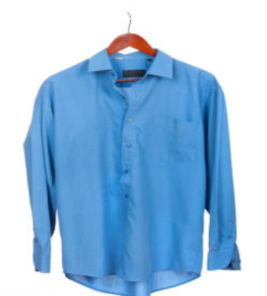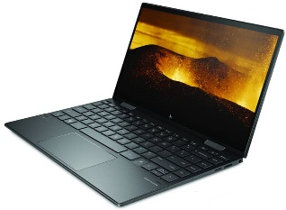

صورة تحتوي على دراجة, المواصلات, متوقفة, عجلة

تم إنشاء الوصف تلقائياً

.................... .......................... ...................

Section E / Orthography " Spelling"

**(A)** Choose the correct letter: _

(1) I always wear a ja__ket **( q _ c_ k)**

(2) She likes to wear co__**t ( e _ i _ a )**



English Language

Intermediate Grade 1st

period Exam

Kingdom of Saudi Arabia

Ministry of Education

……………… intermediate school

Student's Name : class:

|  |
| --- |
|  |
| 5 |

1-Read the following passage and answer the questions below:

My favorite mall is Al-Othem shopping Centre . It is in Riyadh .It is very big and it has two floors. There are many shops . It also has a large supermarket . There are many places that sell tasty food. Shopping in Al-Othem is easy .

**A-Choose the correct answer:**

1-Al-Otheim shopping Centre is in …………………………..

a- Riyadh b-Jeddah c- Abha

2-There is a large ………….. in AL-Otheim shopping Centre .

a-bookstore b-bank c-supermarket

3- It is very big it has ………………………. floors.

a- two b-five c-three

**B) Put (√ ) or (×):**

1- Shopping in AL-Othem is easy . ( )

2- There aren't any restaurant . ( )

|  |
| --- |
|  |
| 5 |

**2-choose the correct answer**

1- We like to ( goes – going – go) shopping.

2- I'm going to ( wear – wearing – wears ) jeans.

3-( Are – Am – Is ) you going to go to Dubai?

4- I can ( play – plays – playing ) chess.

5- Amal is( book – books – booking) the restaurant tonight.

6- They enjoy ( swim – swims – swimming) in the summer.

7- He’s going to ( taking – takes – take) light clothes.

8- John ( isn't – don't – doesn't ) like to ride horses.

9- We are (watch - watching – watched )a film on TV this evening.

10- She can't stand ( cook – cooking – cooks ).

|  |
| --- |
|  |
| 6 |

**3. Do as shown between brackets.**

**A-(Correct)**

1-You can **speaks** English. …………………….

2- He is **wash** his car on Wednesday. ……………………

3- I would like to **buying** a new laptop. …………………

4- I’m going to **meeting** my friends. ………………..……

**B-(answer )**

a- Can Fred drive a bus?

No, …………………………………………………….

**C- ( Give the negative ).**

a-Omar likes to fish.

…………………………………………………………

**D-(reorder)**

a- She / going / a new dress / is / to buy

………………………………………………………………………………………………………………..…….

b- -Ali wears a ( lovely , leather , black ) shoes .

……………………………………………………………………………………………………………………….

|  |
| --- |
|  |
| 4 |

4- **choose the correct answer.**

a- a place you can fly to places. ( airport - bus station – park)

b- Saudi men wear ( thobe- suit – tie ).

**5-Write the missing letters.**

1- mu…….eum 2- restaura……t.

6-**write the correct word for each picture.**

pants boots socks skirt

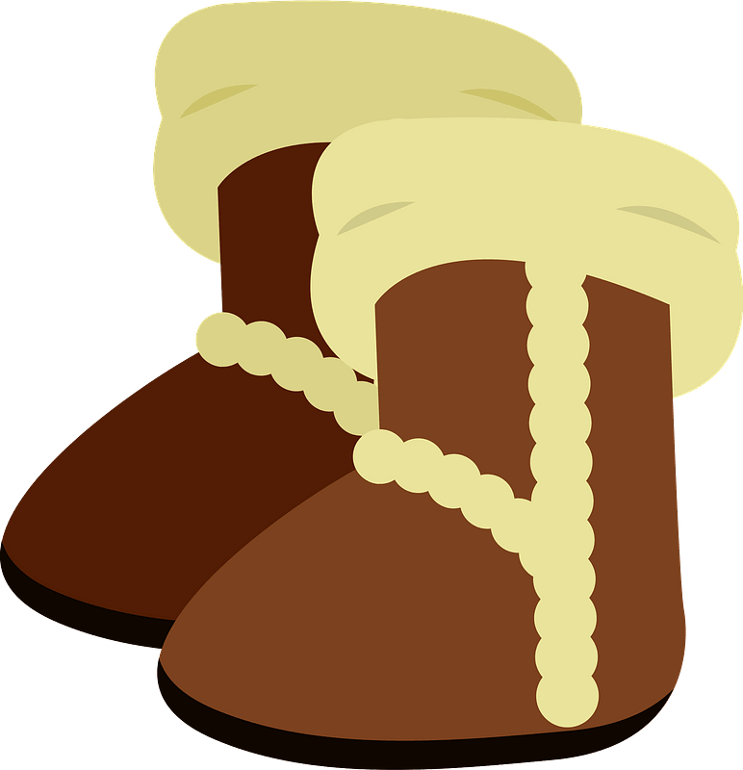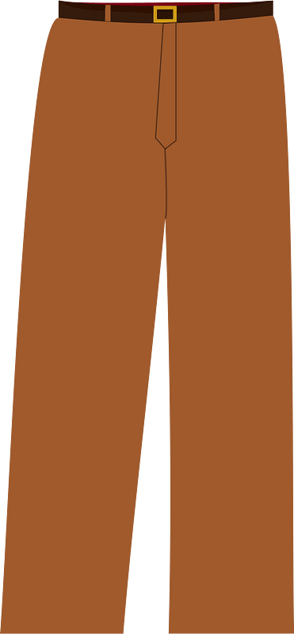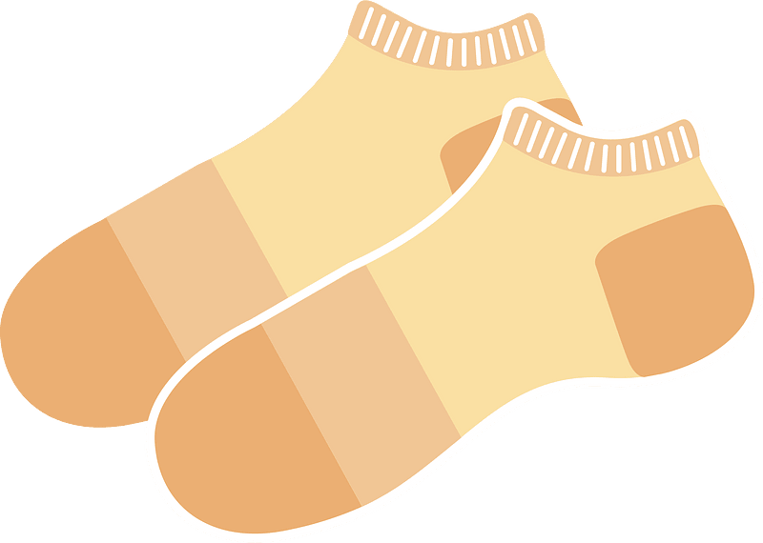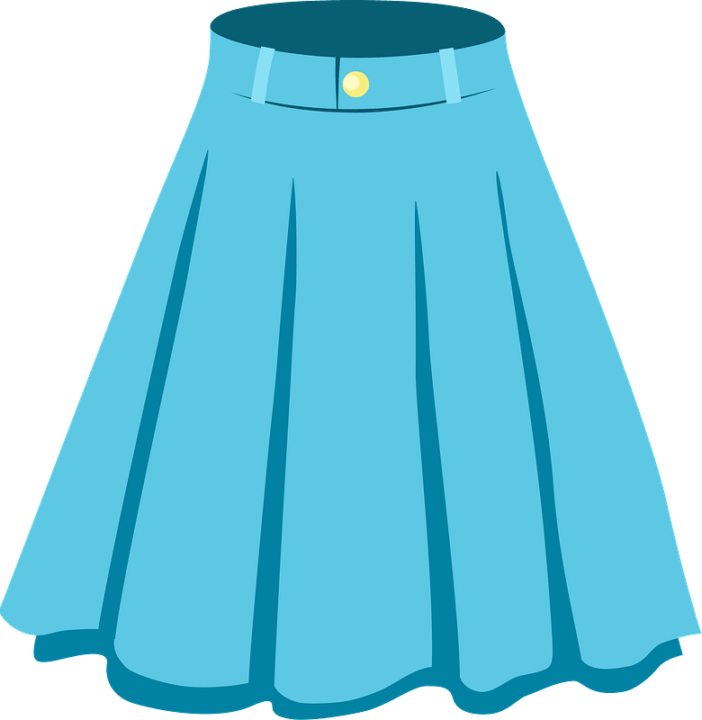

………………..

………………..

………………..

………………..

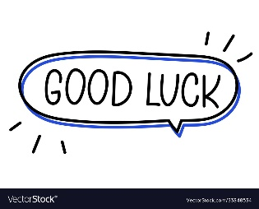

Your teacher



Kingdom of Saudi Arabia

Ministry of Education

………… Education Directorate

……………….. Intermediate School

**Super Goal 1** - **Test** unit 12 & 13

By **Rashed Alsulami** | **Telegram:** https://t.me/iRashed

Name :………………………………………………………………………… Class:…….……….

**Comprehension**

2 Marks

* **Read the text and answer the questions. Write T or F at the end of each question/statement.**

I like to go to the sports center. I go there every weekend. At the sports center, you can do many things. For example, you can play golf or tennis. There is a pool, so you can also swim or relax by the pool. There is a beach next to the sports center. You can swim, water-ski, or windsurf in the ocean. You can also sail on windy days. There aren’t any fish near the beach, so you can’t snorkel. When I go to the sports center, I like to play volleyball on the beach. I also like to jog on the beach. I can’t swim well, so I don’t like to water-ski or windsurf.

1. The writer likes the sports center. ( )
2. You can swim in the pool or in the ocean. ( )
3. People can windsurf in the pool. ( )
4. You can’t use a boat in the ocean.( )

**Grammar**

* **Choose the best answer to fill in the blank in each question.**

5 Marks

1. He can’t surf, but he _____ water-ski.

**a**. can’t **b**. can  **c**. not can **d.** don’t can

1. **Jill:** Does she like to cook? **Kate:** No, _____.

**a**. she does **b**. she don’t  **c**. she doesn’t **d.** doesn’t she

1. I’d like _____ a new laptop, but I can’t afford one. (buy)

**a**. to buy **b**. buy  **c**. buy to  **d.** bought

1. I’m not going to buy jeans. ____________ pants.

**a**. I buying **b**. I’m going to buy **c**. I’m going buying **d.** I going to buy

1. He ____________ a big wedding.

**a**. is have **b**. having **c**. going to have **d.** is going to have

**اقلب الصفحة**



* **Write the gerund or infinitive of the verb in parentheses to fill in the blank.**

1. I’d like _________ a new laptop, but I can’t afford one. (buy(

1.5 Marks

1. Hameed enjoys ____________ volleyball at the beach. (play)
2. Amal spends her free time _________________ books. (read)

* **Write the correct answer to fill in the blank.**

1.5 Marks

1. **Mei:** _______________ you going buy a new dress? **Lisa:** No, I’m not.
2. **Ella:** _____________ are you going to wear?  **Laura:** A black skirt.
3. **Tim:** Are they going to wear jackets? **Harry:** Yes, ______.

**Vocabulary**

* **Choose the best answer to fill in the blank in each question.**

5 Marks

1. You can _____ at the pool.

**a**. swim **b**. surf  **c**. rollerblade **d.** sail

1. I sometimes _____ my bike to work.

**a**. ride **b**. drive  **c**. go **d.** get up

1. Do you need to buy new ____________ to play basketball.

**a**. suit **b**. shirt  **c**. sneakers  **d.** blouses

1. It’s hot. Are you going to wear ____________?

**a**. jeans  **b**. shorts **c**. coat **d.** jacket

1. Women should wear a formal _______to a wedding.

**a**. tie **b**. suit **c**. thobe  **d.** dress

* **Write the correct word under the picture.**

3 Marks

Skirt – Boots – Gym



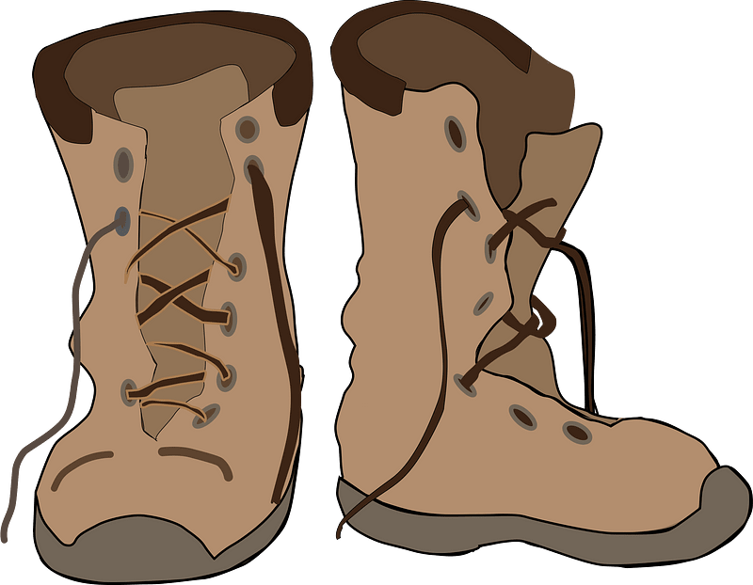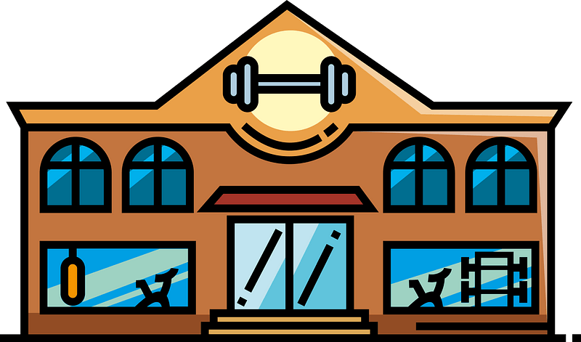

………………………………………….

………………………………………….

………………………………………….

**Orthography**

* **Choose the correct letter.**

2 Marks

* You can go sho…..ping and meet friends. ( v – p – r)
* You need warm clothes it’s …..old in Abha ( n – o – c)

**انتهت الأسئلة....**

**التوفيق والنجاح دوماً في طريقكم أبنائي.. تذكروا دائماً بأنني فخور بكم فأنتم مستقبل هذا الوطن الغالي إن شاء الله ونجاحكم هو نجاحي..**

**الأستاذ / راشد السلمي**