

**Kingdom of Saudi Arabia**

**Ministry of Education**

**………… Education Directorate............**

**…………..……………….. Intermediate School**

|  |
| --- |
|  |
| **20** |

**Total**

**Midterm Test units 12 & 13**

|  |
| --- |
| Second Intermediate Grade |

**Name ………………………………… Class ………………………………**

__________________________________________________________________________________________

/ 4

**Comprehension**

**Read the following then answer the questions:**

The winter months are December, January and, February. It's cold and rains in winter. We wear

heavy clothes in winter. The summer months are June, July and August. It's hot in summer. People wear light clothes. They go to the to the park or to the sea, some children like to play football and fly their kites.

**A- Put (√ ) for true or ( ᵡ ) for false :**

|  |  |
| --- | --- |
| **( )** | 1. The winter months are June , July and August . |
| **( )** | 2**.**  They go to the to the park or to the sea in summer. |

**B- Choose the right answer:**

|  |  |  |  |  |
| --- | --- | --- | --- | --- |
| **spring** | **autumn** | **winter** | **summer** | **1-** It is hot in _______. |
| **jacket** | **clothes** | **glasses** | **shoes** | **2-** We wear light ____in summer. |

_________________________________________________________________

/ 5

**Grammar**

**Choose the right answer:**

|  |  |  |  |
| --- | --- | --- | --- |
| 1- _____ old is Ali ? | | | |
| D. **Where** | C. **How** | B. **Who** | A. **When** |
| 2 - I am _________ travel to Jeddah next month . | | | |
| D. **going** | C. **going to** | B. **will** | A. **go** |
| 3 - Riyadh is _____ _____. | | | |
| D. **beautiful a city** | C. **a beautiful** | B. **a city beautiful** | A. **a beautiful city** |
| 4 - Maybe I_________ drive. | | | |
| D. **am going to** | C. **go** | B. **will** | A. **am going** |
| 5 . **Jane:** Will it be sunny tomorrow?  **Amira:** No, ___ ____ . | | | |
| D. **it will** | C. **won't it** | B. **will it** | A. **it won't.** |

**Vocabulary**

/ 4

**A- Choose the best answer to fill in the blank:**

|  |  |  |  |
| --- | --- | --- | --- |
| 1. This place is ____. You can learn about traditions from around the world here. | | | |
| D. **unique** | C. **peaceful** | B. **exotic** | A. **cultural** |
| 2. This place is ____. It was built thousands of years ago . | | | |
| D. **modern** | C. **historical** | B.  **adventurous** | A. **noisy** |
| 3- It’s __________ today. Hold on to your hat! | | | |
| D. **hot** | C. **cold** | B. **windy** | A. **funny** |
| 4- ______ is usually sunny, really hot, and very dry | | | |
| D. **cloud** | C. **summer** | B. **rain** | A**. winter** |

**B- Put the right word under its picture:**

|  |  |  |  |
| --- | --- | --- | --- |
| buck, cartoon, deer - Stock Illustration [60865260] - PIXTA | Mosquitoes Stock Illustration - Download Image Now - Mosquito, Insect,  Cartoon - iStock | Weather Forecast Reporter, illustration, png | PNGWing | Cute cartoon happy sun with face isolated on white background. Summer  shadowed clip art sunshine icon in kid's style. Sunny weather symbol.  17675035 Vector Art at Vecteezy |
|  |  |  |  |

**sunny , forecast , buck , mosquitoes**

/ 4

_______________________________________________________________________________

/ 3

**Orthography**

**Choose the correct letter:**

|  |  |  |  |
| --- | --- | --- | --- |
| **g** | **s** | **v** | 1. I live on an i__land . |
| **r** | **t** | **d** | 2. We’re staying in a comfortable ho__el . |
| **n** | **h** | **m** | 3. The cli__ate in the city of Jazan is very hot . |

Good luck T.



**Kingdom of Saudi Arabia**

**Ministry of Education**

**………… Education Directorate............**

**…………..……………….. Intermediate School**

|  |
| --- |
|  |
| **20** |

**Total**

**Midterm Test units 12 & 13**

|  |
| --- |
| Second Intermediate Grade |

**Model answer**

__________________________________________________________________________________________

**Comprehension**

/ 4

**Read the following then answer the questions:**

The winter months are December, January and, February. It's cold and rains in winter. We wear

heavy clothes in winter. The summer months are June, July and August. It's hot in summer. People wear light clothes. They go to the to the park or to the sea, some children like to play football and fly their kites.

**A- Put (√ ) for true or ( ᵡ ) for false :**

|  |  |
| --- | --- |
| **( ᵡ )** | 1. The winter months are June , July and August . |
| **( √ )** | 2**.**  They go to the to the park or to the sea in summer. |

**B- Choose the right answer:**

|  |  |  |  |  |
| --- | --- | --- | --- | --- |
| **spring** | **autumn** | **winter** | **summer** | **1-** It is hot in _______. |
| **jacket** | **clothes** | **glasses** | **shoes** | **2-** We wear light ____in summer. |

_________________________________________________________________

/ 5

**Grammar**

**Choose the right answer:**

|  |  |  |  |
| --- | --- | --- | --- |
| 1- _____ old is Ali ? | | | |
| D. **Where** | C. **How** | B. **Who** | A. **When** |
| 2 - I am _________ travel to Jeddah next month . | | | |
| D. **going** | C. **going to** | B. **will** | A. **go** |
| 3 - Riyadh is _____ _____. | | | |
| D. beautiful a city | C. a beautiful | B. a city beautiful | A. **a beautiful city** |
| 4 - Maybe I_________ drive. | | | |
| D. am going to | C. go | B. will | A. am going |
| 5 . **Jane:** Will it be sunny tomorrow?  **Amira:** No, ___ ____ . | | | |
| D. it will | C. won't it | B. will it | A. it won't. |

**Vocabulary**

/ 4

**A- Choose the best answer to fill in the blank:**

|  |  |  |  |
| --- | --- | --- | --- |
| 1. This place is ____. You can learn about traditions from around the world here. | | | |
| D. **unique** | C. **peaceful** | B. **exotic** | A. **cultural** |
| 2. This place is ____. It was built thousands of years ago . | | | |
| D. **modern** | C. **historical** | B.  **adventurous** | A. **noisy** |
| 3- It’s __________ today. Hold on to your hat! | | | |
| D. hot | C. **cold** | B. **windy** | A. **funny** |
| 4- ______ is usually sunny, really hot, and very dry | | | |
| D. **cloud** | C. **summer** | B. **rain** | A**. winter** |

**B- Put the right word under its picture:**

|  |  |  |  |
| --- | --- | --- | --- |
| buck, cartoon, deer - Stock Illustration [60865260] - PIXTA | Mosquitoes Stock Illustration - Download Image Now - Mosquito, Insect,  Cartoon - iStock | Weather Forecast Reporter, illustration, png | PNGWing | Cute cartoon happy sun with face isolated on white background. Summer  shadowed clip art sunshine icon in kid's style. Sunny weather symbol.  17675035 Vector Art at Vecteezy |
| **buck** | **mosquitoes** | **forecast** | **sunny** |

**sunny , forecast , buck , mosquitoes**

/ 4

_______________________________________________________________________________

/ 3

**Orthography**

**Choose the correct letter:**

|  |  |  |  |
| --- | --- | --- | --- |
| **g** | **s** | **v** | 1. I live on an i__land . |
| **r** | **t** | **d** | 2. We’re staying in a comfortable ho__el . |
| **n** | **h** | **m** | 3. The cli__ate in the city of Jazan is very hot . |

Good luck T.

**King of Saudi Arabia**

**Ministry of Education**

**3rd Term 1444/2023**

**English Language**

**2nd Grade**

**Midterm Exam**

Student's name/ ....................................................................... Class/ 2 /

**Section A / Reading**

Read the following passage and answer the questions **below.**

Hi, my name is Eyad. Every morning I go to the gym and read in the afternoons. But I still have a lot of free time. Going to the gym takes me about two hours, including the road time and the post-gym shower. And I usually read for one hour. Another activity that I do is watching documentaries. I study history, and I love historical documentaries. I learn a lot from them. I watch documentaries for one and a half hours four or five times a week.

***A)*** Put (T) for True **OR** (F) for False: _

|  |  |
| --- | --- |
|  | **1. Eyad always reads for one hour.** |
|  | **2. He likes to watch wild documentaries.** |
|  | **3. The time to arrive at the club is Tow hours.** |

**Section B / Grammar**

(1) Ali speaks ______

**a) loud b) loudly c) slow**

(2) **A:** _________ is he going to travel? **B:** He's going to travel by bus.

**a) What b) Where c) How**

(3) She will ______ her room.

**a) cleans b) clean c) cleaning**

(4) If heat the water to 100 C, it _____

**a) boiling b) boils c) boil**

(5) They are going to _____ a movie at a home.

**a) watching b) watch c) watches**

(6) **A:** ________ he go to a bank? **B:** No, he won't

**a) Does b) Will c) Is**

Do as shown between brackets: _

**A- (Correct).**

(1) Ali plays **good** " ........................"

**B- (Give the negative for each sentence)**

(1) We are going to swim. .........................................................................................................

(2) They will go to a park. ..........................................................................................................

**Section C/ Vocabulary**

**A) Choose the correct answer from column (B)**

|  |  |
| --- | --- |
| **B** | **A** |
| **(a) relaxing** | 1. A way to introduce news. ( ) |
| **(b) I hear** | 2.They have a______ life in the village. ( ) |
| **(c) winter** | 3. This quiet beach is _________ ( ) |
| **(d) peaceful** | 4. I’ll probably go ice-skating or skiing this _______ ( ) |

**Section D / Write each word under each picture.**

|  |  |  |  |
| --- | --- | --- | --- |
| Party cloud | Rainy | Cloud | Sunny |



.......................... ......................................

**Section E/ Orthography**

A) Choose the correct letter: _

(1) He needs to play football on Tu_sday ( **i _ e _ a )**

(2) This street is very noi_y **( c _ s_ z)**

**Kingdome of Saudi Arabia Super Goal 4 Exam 1**

**Ministry of Education First Period**

**English Language Department Year _____ H**

|  |  |  |
| --- | --- | --- |
| **Name : ………………………………………………….** | **Class : …………………….** | **Total : 20 /** |

**Reading**

**Reading comprehension: Read the following passage:**

I live in Riyadh .I have 4 children. They sleep at 8 o'clock .They keep their clothes in the closet. They brush their teeth in the bathroom. The house has a garden. My children play in the garden. They have a cat. It's name is Dan. Dan is 2 years old . The cat is naturally safe and sweet .

**A-answer the following questions:**   
1-Where do they live ?

................................................................................................

2-How many children does she have ? ............................................................................

**B-Choose (True √ ) or ( False ×)**

1- They brush their teeth in the kitchen . ( )

2- They have a dog .( )

**C-Choose :**

1-The house has a (**yard – garden – balcony – garage** ).

2- Dan is( **two – three – four – five** ) years old .

**Vocabulary**

**-Write the correct word under the picture: ( sunny –noisy – fall –rainforest-relaxing )**

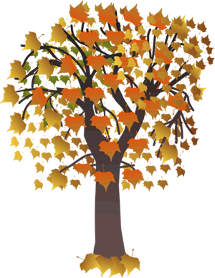

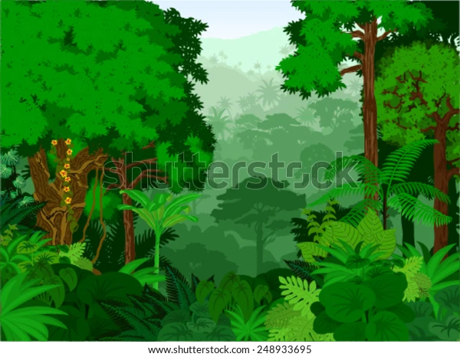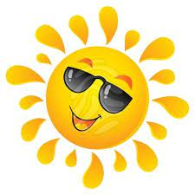

………………… …………… …………………… ………….. …………

**B-Find the odd words:**

1. dry – hot – ball .
2. winter - August – summer .
3. forecast -warm – humidity .

**Grammar**

**-A- Choose the correct answer to fill in the blank.**

1- I am ( go – going – goes ) to travel to Makkah .

2- Omar drives ( slow -slows – slowly ) .

3- They ( isn’t – are – am ) going to go by plane .

4- I will ( travel -travelling – travels ) to Jeddah .

5- If you heat the weather to 100C, it ( boil -boils -boiling ).

6- What will you ( does -doing -do ) this summer ?

**B -Do as shown between brackets :**

1-…….will you go ? I’II go to Jordan . (*use information question How -Where-What*)

……………………………………………..

2 -Ali is (goes) to hang out with his friend . *(correct)*

*……………………………………………………………………*

**Spelling:**

**-Choose the correct letter:**

1- Spring is usually c_ol . ( v – o – r )

2- Scuba di_ing in the Red Sea . ( q – o – v )

Best of Wishes



English Language

Intermediate Grade 2nd

period Exam

Kingdom of Saudi Arabia

Ministry of Education

……………… intermediate school

Student's Name : class:

|  |
| --- |
|  |
| 5 |

1-Read the following passage and answer the questions below:

The winter months are December , January and , February . It's cold and rains in winter . We wear heavy clothes in winter . The summer months are June , July and August . It's hot in summer . People wear light clothes . They go to the to the park or to the sea , some children like to play football and fly9 their kites .

**A-Choose the correct answer:**

1-It's hot in ……………..

a- winter b-spring c-summer

2-It …………………………… in winter.

a-rains b- takes c-water

3-We wear light ………………… in summer.

a-months b-jacket c-clothes

**B) Put (√ ) or (×):**

1- The opposite of cold is hot. ( )

2- The winter months are June , July and August . ( )

|  |
| --- |
|  |
| 5 |

**2-choose the correct answer**

1- They are going to ( play – played – plays ) bowling.

2- Noura is a ( loudly – loud – louds ) speaker.

3-(what – where – who ) are they going to write to ?

4--If you heat the water to 100ْC , it( boil – boils – boiling ).

5- I will ( travel – traveling _ travels ) to Jeddah.

6- How will he ( gets – getting -get) to work?

7- Imad is ( go – goes – going ) to climb a mountain.

8- Omar drives ( slow – slows – slowly ).

9- Will they ( going – goes – go ) to the park.

10- If it’s hot and humid, I don’t ( feel – feels – felt ) very active.

|  |
| --- |
|  |
| 6 |

**3. Do as shown between brackets.**

**A-(Correct)**

1- Amal is going to **cooked** the dinner. …………………

2- - If it rains, I won't **played** tennis . …………..

3- Sabah is a **quietly** speaker…………………

4- Ali will **is** ten next year . ……………….

B**-( use adverb of manner)**

1- Asma is a good writer

……………………………………………………………………………………………

C-**(Give the negative)**

1- It’ll be cold and snowy

…………………………………………………………………………………………….

**D-(answer)**

1- Will it rain afternoon?

-No, …………………………………………

2-is he going to play tennis?

Yes,……..……………………………….

|  |
| --- |
|  |
| 4 |

**4- A. Choose the correct answer.**

1-t’s going to (rain – dry) today. You need your umbrella.

2-It will be 40 degrees Celsius today. That’s (hot – cold).

**5-write the opposite of these words.**

1-unusual ≠ …………………… 2-inexpensive≠ ………………….

6-**write the correct word for each picture.**

Windy relaxing snowy noisy

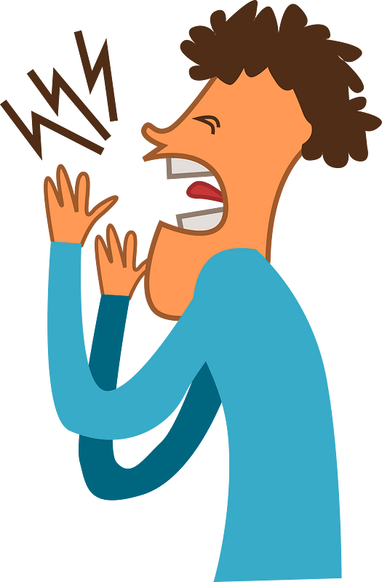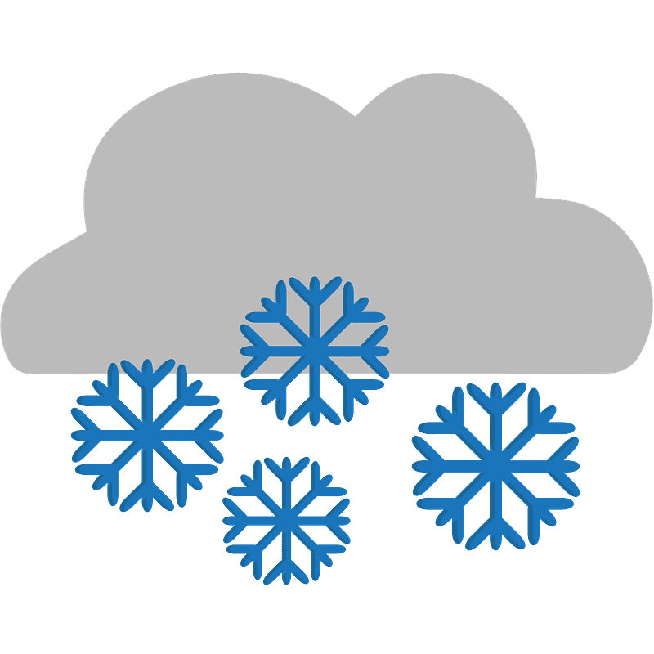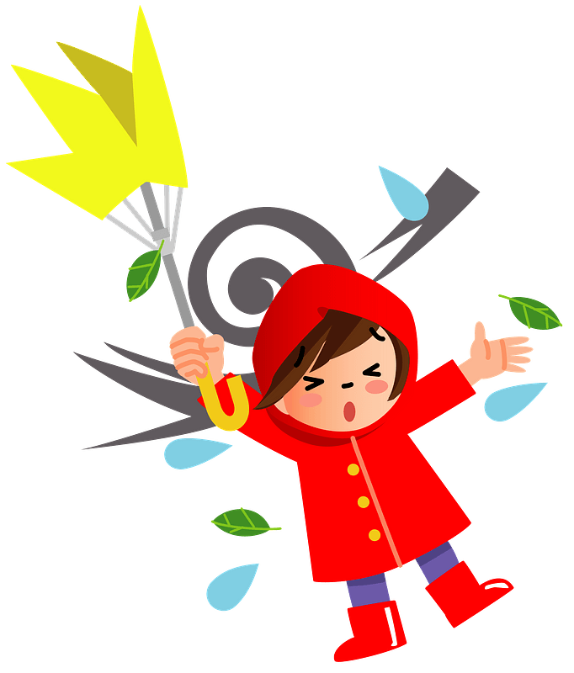

………………..

………………..

………………..

………………..

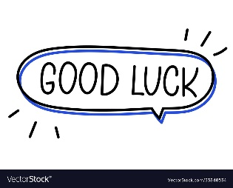



Your teacher



Kingdom of Saudi Arabia

Ministry of Education

………… Education Directorate

……………….. Intermediate School

**Super Goal 2** - **Test** unit 12 & 13

By **Rashed Alsulami** | **Telegram:** https://t.me/iRashed

Name :………………………………………………………………………… Class:…….……….

**Comprehension**

2 Marks

* **Read the text and answer the questions. Write T or F at the end of each question/statement.**

The best place to shop for a bargain is a yard sale. Many people in the U.S. have yard sales. They gather things from their home that they don’t use anymore and put them out in the front yard for other people to buy. You can buy almost anything at a yard sale, but there are usually clothes, appliances, toys, furniture, and DVDs. Usually these things are in good condition and the owner just doesn’t need them anymore. Items at a yard sale are usually very cheap, so you can get good bargains. Some people go to yard sales every week. They drive around neighborhoods every weekend looking for bargains. Sometimes they look for items that they can sell to someone for a higher price at their own yard sale!

1. You can buy almost anything at a yard sale. ( )
2. People sell things they don’t use anymore. ( )
3. Yard sale items are usually expensive. ( )
4. Yard sales are held in stores.( )

**Grammar**

* **Choose the best answer to fill in the blank in each question.**

5 Marks

1. Jeddah is__________________.

**a**. a beautiful city **b**. a city beautiful **c**. a beautiful **d.** beautiful a city

1. They _________ going to go by plane.

**a**. isn’t **b**. are  **c**. is **d.** am

1. _______ is he going to leave ?

**a**. What **b**. Which  **c**. When  **d.** Who

1. **Jane:** Will it be sunny tomorrow? **Amira:** No, ______________.____________________.

**a**. it won’t **b**. it will **c**. won’t it **d.** will it

1. If the hurricane hits Florida, it _________ a lot of damage.

**a**. may causing **b**. causes **c**. might cause  **d.** will causes

**اقلب الصفحة**



* **Write the correct adverb to fill in the blank.**

1.5 Marks

1. My grandmother is a good cook. She cooks ____________________.
2. Majid is a fast learner. He learns ______________.
3. They have a peaceful life in the village. The people in the village live ____________.

* **Use Information Questions ( How – Where – What ).**

1.5 Marks

1. _______________will you do in the summer? I’ll probably trave.
2. ______________ will you go? I’ll go to Jordan.
3. ______________will you go? Maybe I’ll drive.

**Vocabulary**

* **Choose the best answer to fill in the blank in each question.**

5 Marks

1. This quiet beach is __________.

**a**. noisy **b**. relaxing  **c**. adventurous **d.** expensive

1. I go to this place to relax because it is ___________.

**a**. noisy **b**. cultural  **c**. historical **d.** peaceful

1. This place is ________. It was built thousands of years ago.

**a**. adventurous **b**. historical  **c**. relaxing  **d.** noisy

1. It’s _______________ today. Hold on to your hat.

**a**. windy  **b**. sunny **c**. cloudy **d.** snows

1. It will be _______________ this afternoon. You should bring your umbrella.

**a**. windy **b**. cloudy **c**. rainy  **d.** sunny

* **Write the correct word under the picture.**

3 Marks

Partly cloudy – Desert – Rainforest

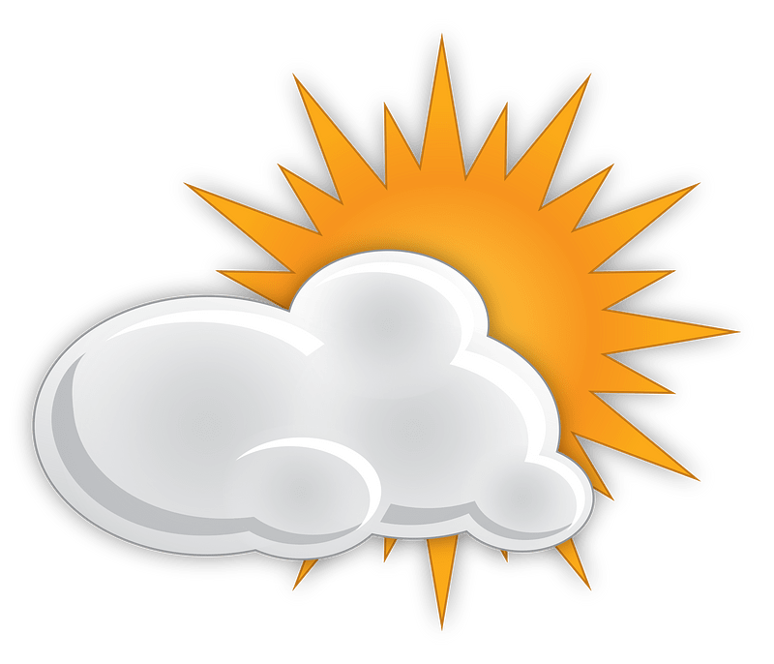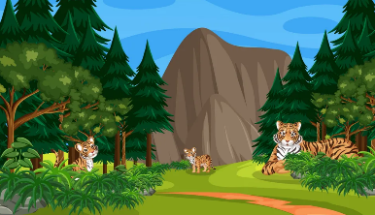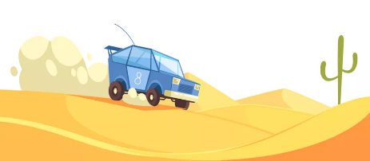

………………………………………….

………………………………………….

………………………………………….

**Orthography**

* **Choose the correct letter.**

2 Marks

* Are you going on va…..ation ? ( c – o – r )
* Spring is usually c….ol ( v – o – r )

**انتهت الأسئلة....**

**التوفيق والنجاح دوماً في طريقكم أبنائي.. تذكروا دائماً بأنني فخور بكم فأنتم مستقبل هذا الوطن الغالي إن شاء الله ونجاحكم هو نجاحي..**

**الأستاذ / راشد السلمي**