Kingdom of Saudi Arabia  Ministry of Education  Tabuk) )  Al Abnna 2 Secondary School  & Al-Qaliba Secondary School |    | Corrected by:  ………………….. |  | Medterm Exam  second term  1446  Second grade  Time:45 m  Mega Goal 3.1

Reviewed by:

…………………..

…………………..

10
 | …………………..  10 | Checked by:  …………………..
Name | ……………………………………………….... |  | Class |  | ……………

2
1.Reading

Read the following paragraph then answer the following questions:
Sheikh Sulaiman bin Abdul-Aziz Al-Rajhi, the world-renowned philanthropist and winner of the 2012 King Faisal International Prize for Service to Islam, has not always been a billionaire. Born in 1929, he spent his youth in Al-Qassim where he and his brother Saleh began their business, changing money for pilgrims, on their way to the cities of Makkah and Madinah. Their business expanded in the 1970s during the oil boom in Saudi Arabia. The Al-Rajhi brothers helped migrant workers from Indonesia, Pakistan and other places to send their earnings home. They were granted permission to establish a bank, the Al Rajhi Bank, which complied with religious tenets such as a ban on interest.

- Which prize did Sulaiman Al-Rajhi get in 2012?
- In London b. King Faisal International Prize for Service to Islam c. in 1929
- When was Suleiman Al Rajhi born?
- September b. King Faisal International Prize for Service to Islam c. in 1929
- Where was Suleiman Al-Rajhi born??
- in Al-Qassim b. King Faisal International Prize for Service to Islam c. in 1929
- What was the first business for Al-Rajhi brothers ?
- Changing money for pilgrims b. King Abdullah c. King Salman

4
2. Grammar

1
- I’m very hungry. Can you give me .............................. sandwich ?
- another | - others | - did | - do
- Ali and Salim are here, but where are the ....................................... ?
- another | - others | - did | - do
- I ....................................... play that match last week .
- another | - others | - did | - do
- I ....................................... eat this pizza, it’s delicious .
- another | - others | - did | - do
- He is …………………… now .
- study | - studies | - studied | - studying
- They are used to ................................. early .
- getting | - used to | - for | - since
- He ................................. be afraid of the dark .
- getting | - used to | - for | - since
- We have worked on this project ………………… three months .
- getting | - used to | - for | - since

4

3.Vocabulary
- Choose the correct answer:

- It's great to work with people who are .......................................
- work this out | - not my cup of tea | - on the same wavelength
- Basketball is ............................................., so I never watch it .
- work this out | - not my cup of tea | - on the same wavelength
- An animal that kills and eats other animals
- predator | - beehive | - ostrich
- fearsome means:
- priceless | - causing great fear | - no problem
- Health and education need ................................ from the government.
- cash | - get cold feet | - driving me crazy
- A rich person who gives a lot of money to help poor people.
- philanthropist | - pious | - poultry
- The charity I donate to helps to build schools in ................. areas.
- impoverished | - prominent | - philanthropist
- The opposite of word " formal " is:
- Poverty | - Informal | - Unreasonable
3

2

4. Writing
Complete the sentences about yourself:

4

I used to……………………………………………………………………….
I’m not used to ………………………………………………………………..
The students at my school are used to…………………………………………
I have ………………………………………………………………………….

Rewrite the following sentences using capitals :

4
my name is Mohamad. i am from jeddah . I have a test on sunday .
.....................................................................................................................................................
2


Kingdom of Saudi Arabia Grade: 3rd secondary
Ministry of Education Sheets: 1
………. High school Date : / /

Mid Term Exam for 3rd secondary stage

______
4
Student's Name:……………………………………………………………Class:…………………….
Reading…

Anthony jumped off the school bus and raced through the front door, leaving his jacket, shoes and backpack in a trail behind him. " Mom, Mom " he called. Guess what we studied in school today?
Anthony's mom had been cutting celery to go with some peanut butter for his afternoon snack. Smiling at his excitement, she stopped what she was doing and asked: What did you study? We learned all about Canada today. " Anthony answered “. That's where are you from, right? His mom nodded her head. Tell me what you learned. Well. " Anthony started as he sat down on a chair at the counter " We learned that Canada has almost 34 million people. We learned that there are two official languages: English and French " Oui! " Said his mother with a smile. We learned that lots of neat things come from Canada. like what? " Mom asked “. My teacher says that Canada produces tons of wheat and fish, like Salmon. He also said that a lot of movies and some T.V shows are filmed up in Canada. He says that many celebrities like actors and singers come from Canada too. His mom was smiling again as she put Anthony's snack in front of him. My teacher asked who we thought was the most important and influential person who came from Canada." Oh, and who would that be? " His mom asked, sitting down on the chair beside him." I told him it was you, Mom " Anthony said with big grin as he bit into the celery.
- What did Anthony learn in the school ?
………………………………………………………………….
- How many people live in Canada?
………………………………………………………………….
Put (True – False ):
1-We learned there are four official languages. ( )
2-There are many Canadian Celebrities. ( )
Choose:

1-Canada produces tons of fish like: { golden fish – Salmon – Tuna - Shark}
2-'she' in line 4 refers to: { Anthony – Canada – Mom - sister }
________________________________________________________________________________________
Grammar:

3
- Choose the correct answer:
- I know you want to go To Jeddah, but I have ( others – other – another) place.
- My teacher was agreed. ( other – others – another)teachers disagree.
3- I haven't finished my project( ever – so far – yet – once ) .
4 – Have you ( ever – so far – already – yet ) flown in a helicopter.
B) Do as shown between brackets:

1-They played football yesterday. (Rewrite each sentence adding the emphatic do, does or did )
………………………………………………
1-She used to live in Saudi Arabia. (Change to negative))
………………………………………………

Vocabulary:

3
- Match:
no problem. |  | pioneer | 1-
A polite way to say you don't like something. |  | Predators | 2-
Animals that live by hunting others. |  | Not may cup of tea | 3-
A person who starts or involved in a new  Method or activity. |  | No sweat | 4-
To overcome a weakness with a strength.

Fill in the spaces with suitable word
(- prominent - cash – impoverished )
- My professor is a …………………………………economist who is often quoted in magazines.
- The charity I donate to helps to build schools in .………………………………. areas.
Listening
Listen to the lecture about the history of money .Write the date by each form of money .Then number the forms of money in the order they were used.

5
____
Cowrie shells
___________

_____
Paper money

___________
___
Bartering

___________
____
Electronic money

___________

____
Inexpensive metal coins
___________
____
Coins made of valuable metal
___________

5
Speaking
Write your presentation topic

…………………………………………………………………………

10

Total Marks

Good Luck
English Teacher

3rd Grade ( U1&2 Exam )
Learner's Name/ ………………………………….. Learner's Class / ………………… ____________________________________________________________________________
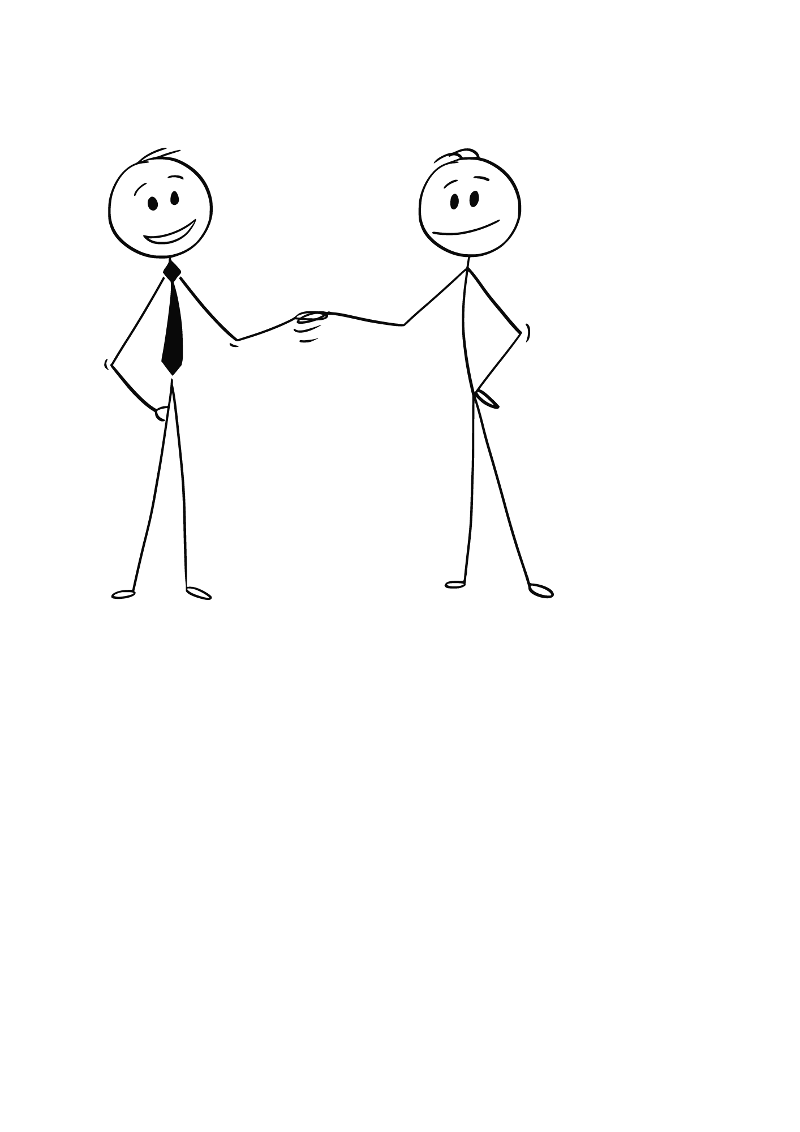 I. Composition *Write a short essay about you and your friend, explaining how you complement each other.
زززززززززززززززززززززززززززززززززززززززززززززززززززززززززززززززززززززززززززززززززززززززززززززززززززززززززززززززززززززززززززززززززززززززززززززززززززززززززززززززززززززززززززززززززززززززززززززززززززززززززززززززززززززززززززززززززززززززززززززززززززززززززززززززززززززززززززززززززززززز
............................................................................................................................................................................................................................................................................................................................................................................................................................................................................................................................................................................................................................................
II. Grammar 1) Do as shown between parentheses: a) he has been teaching English …………………………15 years.. (Use since or for) b) He works in a bank. …………………………………………………… . (Negate the sentence) c) We ( was)…………………….. going to watch a film tonight, but we were too tired. ( Correct the error ) d) This video is……………………………………………… interesting . (Complete with suitable intensifier) e) We enjoyed that movie./ ………………………………………………………………. ( Emphasize ) f ) He wants ( other – others – each other – another ) solutions. (Choose) g) Classify the following words:

Kingdom of Saudi Arabia

Ministry of Education

Tabuk) )
Al Abnna 2 Secondary School
& Al-Qaliba Secondary School

Archaeological | Technological | Gradable adj | Non gradable adj | Intensifier
…………………………………..……….…… | ……………………………………………………… | …………………………………………….. | ……………………………………………………….…… | ……………………………………………………….
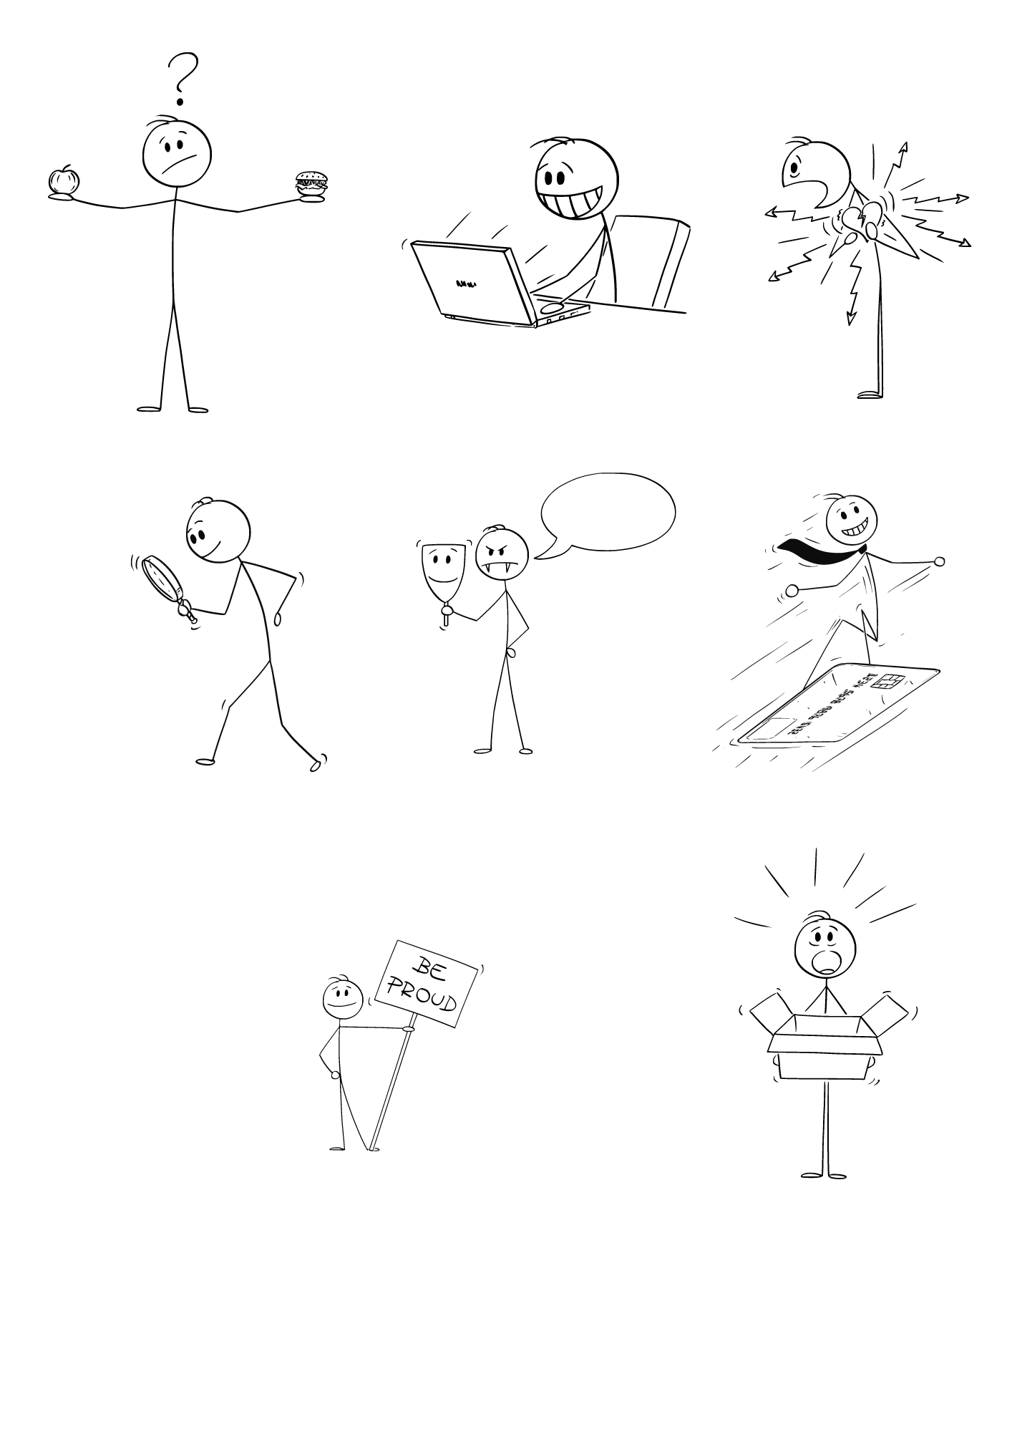 III. Comprehension What is a map?

Medterm Exam
second term
1446
Second grade
Time:45 m

Mega Goal 3.1

1.) Is a map flat or round? 2.) What are the four directions on a map called? …………………………………………………………………………………

IV. Vocabulary 1)Match the word with its definition: a. devoted ( ) argument b. legendary ( ) obstacle c. dispute ( ) dedicated d. hurdle ( ) supporter ( ) famous Best Wishes/

2
First monthly exam ….. Mega goal 3.1
A
Name:………………………………………………………..class:……………………………….
Read the passage and answer the questions below
Autumn is the season that occurs between summer and winter. It is one of the four temperate seasons. Some people call autumn, "fall," which refers to the leaves falling off the trees during this season. There are many changes that begin in this fascinating season. The weather gets colder and more windy. Days become shorter on this season . Leaves of trees turn from green to vibrant red, yellow and orange because they don't get enough sun light. Trees need sunlight to keep their leaves a lively green

1/ what do some people call autumn?
A/ spring B/ summer C/ fall D/ winter
2/ the weather gets …………….
A/ Colder B/hotter C/ rainy D/ dusty

Grammar

3/ I …………………….a new book right now
A) Read B) reads C) reading D) am reading
4/ They did …………………..here before.

- live B) is living C) lived d) lives
5/ would you like …………….cup of coffee
A) other B) others c) another d) the other
6/ she …………………look good in that dress
- do B) does C) did d) doing

7/ I work every day [change to negative]

- I not work every day B) I doesn't work every day
C/ I don't work every day D) I didn't work every day

8/ I phoned you last night [ use…..did ]
- I did phoned you last night b) I did phoning you last night c) I did phones you last night d) I did phone you last night

Vocabulary:
- a) reliable b) laboratory c) pioneers B) lent C) batteries

put these words in a suitable sentence
9/Suliman Olayan was a Saudi Arabian …………………...who contributed to the kingdom's development
10/ Imad and Hussein spent hours in their …………………….doing experiments .

match: match these words in column A with their meanings in column B
A | B
11 / legendary | A) causing great fear
12/ no sweat | B) airplane manufacture
13/ fearsome | C) no problem
14 / invaluable | D) valuable , priceless
 | E) famous

B /Match each word with a suitable picture
a) antiques b) jewelry c) stung d) robots e) beehive
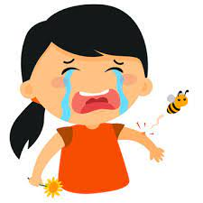

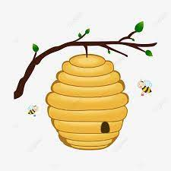

15 16 17 18

Optional question
What does " influential people " mean ?
……………………………………………………………………………………………………………………………………………………………………
…………………………………………………………………………………………………………………………………………………………………..

Good luck 😊
T. Areej AL-Msned

First monthly exam ….. Mega goal 3.1
B
Name:………………………………………………………..class:……………………………….
Read the passage and answer the questions below
Autumn is the season that occurs between summer and winter. It is one of the four temperate seasons. Some people call autumn, "fall," which refers to the leaves falling off the trees during this season. There are many changes that begin in this fascinating season. The weather gets colder and more windy. Days become shorter on this season . Leaves of trees turn from green to vibrant red, yellow and orange because they don't get enough sun light. Trees need sunlight to keep their leaves a lively green
Answer the question :
1/days become……………on this season
A/ longer B/ equal C/ shorter
2/ trees needs sunlight to keep their leaves a lively ………….
A/ green B/yellow C/white D/ red

Grammar

3/ they……………to London every year
A) travelled B) travels C) travelling D) travel
4/ I did ………………… a novel .

- writing B) write C) wrote d) writes
5/ I'm going to set the table with ………………kids
A) another B) others c) other d) the other
6/ he …………………speak English well
A) do B) does C) did d) doing

7/ I play tennis every week [change to negative]

- I not play tennis every week B) I doesn't play tennis every week
C/ I don't play tennis every week D) I didn't play tennis every week

8/ I enjoyed that party yesterday [ use….did ]
- I did enjoyed that party yesterday. b) I did enjoys that party yesterday c) I did enjoy that party yesterday d) I did enjoying that party yesterday

Vocabulary: put these words in a suitable sentence
- Chores b) legendary c) reliable
B) lent C) batteries

9/ Majed Abdallah is …………………even children today have heard his name
10/ When you buy a car , make sure it's a …………….brand.

match: match these words in column A with their meanings in column B
A | B
11 / invaluable | A) no problem
12/ on the same wavelength | B) airplane manufacture
13/ no sweat | C) thinking the same thing
14 / fearsome | D) causing great fear
 | E) extremely valuable, priceless

B /Match each word with a suitable picture
a) antiques b) jewelry c) zebra d) space e) clownfish

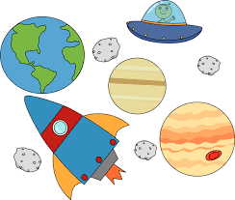
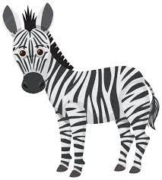
15 16 17 18

Optional question
What does " symbiosis" mean
……………………………………………………………………………………………………………………………………………………………………
…………………………………………………………………………………………………………………………………………………………………..

Good luck 😊
T. Areej AL-Msned

First monthly exam ….. Mega goal 3.1
A
Name:………………………………………………………..class:……………………………….
Read the passage and answer the questions below
Some people like travelling by sea. They don’t like travelling by plane or by car. They travel on big ships. While they are travelling, they can sit in the sun and they can enjoy looking at the clear sky and the blue water of the sea. The sun and the fresh air are very good for your health. On a big ship you can play games and meet many people from other countries. Travelling by sea is fantastic but it takes a longer time.

1/ the sun and the fresh air ………………..for health
A/ bad B/ very bad C/ good D/ dangerous
2/ ……………….like travelling by sea
A/ all people B/most people C/ some people

Grammar

3/ she …………………… on the phone now
A) talk B) talks C) talking D) is talking
4/ I did …………………..that party last night.

- enjoy B) is enjoying C) enjoyed d) enjoys
5/ He wants …………….books
A) other B) others c) another d) the other
6/ she …………………visit her grandparents
- do B) does C) did d) doing

7/ They eat sea food [change to negative]

- they not eat sea food B) they doesn't eat sea food
C/ they don't eat sea food D) they didn't eat sea food

8/ He worked hard last night [ use…..did ]
- he did worked hard last night b) he did working hard last night c) he did works hard last night d) he did work hard last night

Vocabulary:
a) reliable b) laboratory c) pioneers lent C) batteries

put these words in a suitable sentence
9/Suliman Olayan was a Saudi Arabian …………………...who contributed to the kingdom's development
10/ Imad and Hussein spent hours in their …………………….doing experiments .

match: match these words in column A with their meanings in column B
A | B
11 / legendary | A) causing great fear
12/ no sweat | B) airplane manufacture
13/ fearsome | C) no problem
14 / invaluable | D) valuable , priceless
 | E) famous

B /Match each word with a suitable picture
a) antiques b) jewelry c) stung d) robots e) beehive
15 16 17 18

Optional question
What does " partner " mean ?
……………………………………………………………………………………………………………………………………………………………………
…………………………………………………………………………………………………………………………………………………………………..

Good luck 😊
T. Areej AL-Msned

First monthly exam ….. Mega goal 3.1
B
Name:………………………………………………………..class:……………………………….
Read the passage and answer the questions below
Some people like travelling by sea. They don’t like travelling by plane or by car. They travel on big ships. While they are travelling, they can sit in the sun and they can enjoy looking at the clear sky and the blue water of the sea. The sun and the fresh air are very good for your health. On a big ship you can play games and meet many people from other countries. Travelling by sea is fantastic but it takes a longer time.

Answer the question :
1/travelling by sea takes …………………….time
A/ longer B/ equal C/ shorter
2/ we can meet many people from other countries ……………..
A/ in the sky B/in the sun C/on a big ship

Grammar

3/ He always……………early.
A) slept B) sleeps C) sleeping D) sleep
4/ I did ………………… her an hour ago .

- seeing B) see C) is seeing d) sees
5/ he needs ………………pen
A) another B) others c) other d) the other
6/ he …………………feel tired
A) do B) does C) did d) doing

7/ I wash my car every week [change to negative]

A)I not wash my car every week B) I doesn't wash my car every week
C/ I don't wash my car every week D) I didn't wash my car every week

8/ I enjoyed that party yesterday [ use….did ]
A)I did enjoyed that party yesterday. b) I did enjoys that party yesterday c) I did enjoy that party yesterday d) I did enjoying that party yesterday
Vocabulary: put these words in a suitable sentence
- Chores b) legendary c) reliable
B) lent C) batteries

9/ Majed Abdallah is …………………even children today have heard his name
10/ When you buy a car , make sure it's a …………….brand.

match: match these words in column A with their meanings in column B
A | B
11 / invaluable | A) no problem
12/ on the same wavelength | B) airplane manufacture
13/ no sweat | C) thinking the same thing
14 / fearsome | D) causing great fear
 | E) extremely valuable, priceless

B /Match each word with a suitable picture
a) antiques b) jewelry c) zebra d) space e) clownfish
15 16 17 18

Optional question
What does " philanthropist " mean
……………………………………………………………………………………………………………………………………………………………………
…………………………………………………………………………………………………………………………………………………………………..

Good luck 😊
T. Areej AL-Msned
A- Composition :
Write a paragraph about what progress and developments will have been made by 2030 in ( education ):

3
3
Electronically - computers - studying electronic - subject - digital - improved

……………………………………………………………………………………………………………………………………………………………………………………………………………………………………………………………………………………………………………………………………………………………………………………………………………………………………………………………………………………………………………………………………………………………………………………………………………………………………………………………………………………………………………………………………………………………………………………………………………………………………………………………………………………………………………………………………………………………………………………………………………………………………………………………………………………………………………………………………………………………………………………………………………………………………………………………………..
2-Comprehension:

2
Read the following passage carefully then answer the questions below:
Arabic coffee or (Gahwa) is a very important drink in Saudi Arabia and in the Arabian Gulf countries. Preparation, serving and drinking Arabic Coffee are derived from Bedouin hospitality. Usually, guests are served with Arabic Coffee and Dates. It is all about tradition, hospitality and ceremony. It's a sign of welcome and marks the beginning and the end of a guest's visit. It can be served anytime at home, at social gatherings or business meetings. The coffee is served and received with the right hand. The host serving the coffee fills the small cup only half full. As soon as the guest drinks it, the cup is refilled continually until the guest gently jiggles the cup indicating he has had enough ,it is customary to take 2 to 3 cups. Sugar and milk are never added but it is often served with dates.
A- Answer the following question :
Is Arabic Coffee an important drink in the Arabian Gulf countries ?-
…………………………………………………………………………………………………………………………….
B-Choose the correct answers:
1- Guests usually are served with Arabic Coffee and………………….
A) Dates B) Milk C) Sugar D) Salt
2-Arabic Coffee is served and received with the …………….……….
A) left hand B) right hand C) order D) system

3-Grammar:

3
A-Choose the correct answer:
1-My brother used to ( work – works – worked – working ) but he is retired now .
2-She is ( study – studies – studied – studying ) now .
3-I would like ( other – others – the other – another ) cup of coffee ,please!
4-She will have been ( learn – learns – learned – learning ) French for two years .
B-Correct the mistakes :
1--I ( does ) ……………………………feel tired .
2-She (be) …………………….born in Jeddah .
4-Vocabulary :

2
- Match the words with their meanings :
1-Predators ( ) A-Money.
2-Cash ( ) B-known ,respected and admired.
C-animals that live by hunting others.
B-Fill the blanks with suitable words :
( orbits – rock – solar system –meteor)
1-The sun is at the center of our ………………… …………………… .
2-Each planet ………………………………the sun on its own invisible path.

Make a (yes/no) question :
Amal cooked pasta yesterday .
…………………………………………………………………?
Bonus Question +1

Good Luck
Tr: Kholoud AlGhamdi

