

Top Goal1- الصف ............. ابتدائي
الاسم ثلاثي: |  | الفصل | / | الدرجة | / 20
اختبار تشخيصي – اختبار الفاقد

1. Choose

- What school subject is more difficult at school?
- I am surprised. | - I think math.
- How often do you visit your grandparents?
- I always visit them. | - I love my grandpa.

222
2. Choose OR

She is afraid . | Take out the trash. | She is playing a soccer.
 |  | 

3. Do as shown between brackets:

…………………………………………………………………. |  |  | 1- a terrible – It – game – is . ( rearrange )
granny | mommy | mom | ( choose the informal word ) 4- She is my mom .

were | was | is | 1 – We ____ happy .
watches | watch | watching | 2. He is ______ TV right now .
are | does | do | 3- How often ____ you see your cousin? .
4. Choose :
 |  |  |  |   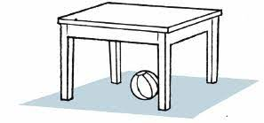
bus | drum | dishes | running | dad
poster | guitar | leaves | fishing | grandma
5. Choose :

  i  ca _ era | 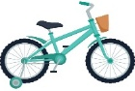  bi_ e |   mos_uito |   M_ _ se |   Grand__a
m | d | er | b | m
n | k | ar | q | p
6. fill in the missing letters :

TEACHER :

توزيع الدرجات

درجة كل فقرة | السؤال
درجة لكل فقرة | 1
درجة لكل فقرة | 2
درجة لكل فقرة | 3
درجة لكل فقرة | 4
درجة لكل فقرة | 5
درجة لكل فقرة | 6

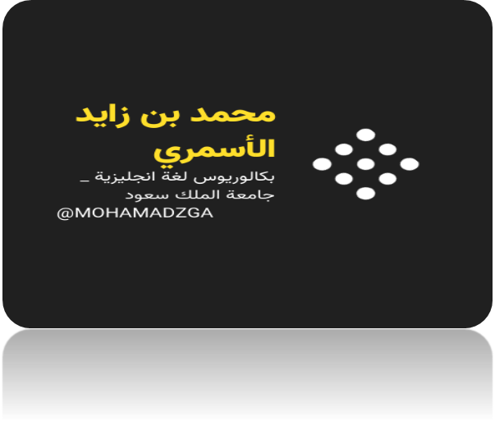


قناتي


MOHAMADZGA


M_zaid0

لا تنسوني من صالح دعائكم

