
Kingdom of Saudi Arabia  Ministry of Education  General Directorate of Education in Type Your GDE here. |  | Type Your School here. School  English Mega Goal 2.2 Midterm Exam  2nd Term 1446  Time: 45 minutes

Name: Class: Your Mark: /10

Tick where each match meets.
Vocabulary
 |  |  | dedicated | do me a favor | organic | leave | inadequate | for example
 | help me out
 | lame
 | take off
 | committed
 | for instance |  |  |  |  |  |  | 
Choose the correct option.
- to be grateful for
A. cooperate B. entail C. satisfy D. appreciate
- substances that cause sensitivity or reactions in some people
A. flair B. infection C. allergens D. captive
- Pollution is the of many environmental problems.
A. consumption B. pesticide C. conditioner D. source

Number the correct option in the box.
Grammar
- She asked that we be late.
- He didn’t get the job, ?
- I enjoy horror stories.
- If you put water in the freezer, it ice.
help had to becomes
not don’t did he
Could Would to help
reading to use need
Choose the correct option.
- I want you the report this afternoon.
A. finish B. to finish C. have finished D. finishing
- You stop at the ‘STOP’ sign.
A. must B. needs to C. needn’t D. don’t need to
- Does Planet Earth round the sun?
A. go B. goes C. went D. going

Read and choose the correct option.
Reading
There is a climate crisis. We need to stop using oil and gas. The European Space Agency (ESA) is testing giant solar farms in space. It wants to send energy wirelessly from space into people's homes. One solar-farm satellite could make the same amount of power as a power station. The ESA wants many of these farms in space.
The ESA project is called Solaris. The ESA wants "a clean and secure energy future". This means becoming more carbon-neutral. The ESA said we needed to cut the use of fossil fuels. Solar farms could help us to do this. One farm is around 1.7 km long. This is bigger than the International Space Station, which is 110 m long.
- Using oil and gas don’t affect the climate.
F
T
F
T
F
T
- ESA is trying to transfer energy from space to our houses wirelessly.
- One farm in Solaris project is around 110 km long.
Best of Luck!
MARWAN


المملكة العربية السعودية المادة: لغة إنجليزي
وزارة التعليم - إدارة التعليم بعسير الصف: ثالني ثانوي-مسارات
___________________ ١٤٤٦هـ الفصل الدراسي الثاني –الفترة الأولى
الاسم_____________________________________________________الصف_________________
Vocabulary
A) Fill in the space with the suitable word:
appreciate | jump ship | air traffic controller
infection | surgeon | a doll fashion designer

- Which jobs require a medical degree?_______________
- What is Lily Martinez’s job?___________________
- polite, showing consideration ____________________
- Which job requires that the person be willing to accept responsibility _____________
- leave a job suddenly, usually to go to a new job___________________
- disease or sickness received from someone or something_______________
B) Match:
- identical ___confined, kept under restraint or control
- captive ___ in a difficult situation
- keep it to yourself ___ not tell anyone
- in a bind ___ exactly the same.

Grammar
Do as shown between brackets:
- he / that / bring his résumé to the interview / he recommended. (rearrange)
____________________________________________________________

- I recommend that you talks about your skills. (correct)
__________________________________________________________
- I recommend you that put your educational background on it. (correct)
__________________________________________________________

- You are not going to resign from your job ________________ ?(write a tag question)

- They took over the company, ___________________ ? (write a tag question)

- He _____________ be patient with his customers. (complete)

1. satisfaction |  | A. to involve or require
2. respectful |  | B. money received or earned
3. entail |  | C. polite, showing consideration
4. income |  | D. feeling of contentment
5. analyze |  | E. confined, kept under restraint or control
6. determine |  | F. to study closely
7. captive |  | G. to decide or discover

1. in a bind |  | A. in a difficult situation
2. No kidding? |  | B. leave
3. cover |  | C. take someone’s place, often in a work situation
4. take off |  | D. Really?

Opposite | 1. identical |  | A. disorganized
Opposite | 2. methodical |  | B. different

- Choose identifying / survey/ infection / allergens / respectful / income
  - I try to be when working with other people.
  - Elephant pedicurists scrape the dirt that can cause
  - My work entails the individual chemicals found in nature.
  - The reveals some information about people's job satisfaction.
    - Choose

1. The manager insisted that he late.
A. work | B. works | C. worked | D. working
2. He is our English teacher, ?
A. he isn't? | B. he is? | C. is he | D. isn't he?
3. telling me where City Café is?
A. Would you mind | B. don't get | C. get didn't | D. won't get
4. It is recommended that we on time.
A. are | B. is | C. am | D. be
5. I want you to a new job.
A. found | B. finding | C. find | D. finds
6. They don't play, ?
A. don't they | B. do they | C. they do | D. aren't they
7. She a teacher, isn't she?
A. did | B. does | C. is | D. can


1. cooperate |  | A. exactly the same
2. allergens |  | B. disease or sickness received from someone or something
3. appreciate |  | C. state or condition
4. flair |  | D. to work together well
5. identical |  | E. a natural talent or ability
6. infection |  | F. substances that cause sensitivity or reactions in some people
7. status |  | G. to be grateful for

1. jump ship |  | A. leave a job suddenly, usually to go to a new job
2. help me out |  | B. do me a favor
3. take off |  | C. leave
4. keep it to yourself |  | D. not tell anyone

Opposite | 1. captive |  | A. Free
Opposite | 2. respectful |  | B. disrespectful

- Choose identifying / survey / allergens / respectful / income / cooperate
- I try to be when working with other people.
- Students in my class well with each other.
- My work entails the individual chemicals found in nature.
- The flavorists avoid using that cause reactions in some people.

- Choose

1. I'd like you shopping.
A. go to | B. to go | C. to going | D. going to
2. Ali that job, did he?
A. didn't get | B. did get | C. got | D. he did
3. You park here. There is a "No Parking" sign.
A. Must | B. mustn't | C. has to | D. need to
4. I suggested that she hard.
A. study | B. studies | C. studied | D. studying
5. It is important that Ali the meeting.
A. attending | B. attend | C. attends | D. attended
6. He listens carefully, ?
A. does he | B. is he | C. doesn't he | D. isn't he
7. You smoke in the hospital.
A. have to | B. must | C. need to | D. needn't

1. satisfaction |  | A. to involve or require
2. respectful |  | B. money received or earned
3. entail |  | C. polite, showing consideration
4. income |  | D. feeling of contentment
5. analyze |  | E. confined, kept under restraint or control
6. determine |  | F. to study closely
7. captive |  | G. to decide or discover

1. in a bind |  | A. in a difficult situation
2. No kidding? |  | B. leave
3. cover |  | C. take someone’s place, often in a work situation
4. take off |  | D. Really?

Opposite | 1. identical |  | A. disorganized
Opposite | 2. methodical |  | B. different

- Choose identifying / survey/ infection / allergens / respectful / income
  - I try to be when working with other people.
  - Elephant pedicurists scrape the dirt that can cause
  - My work entails the individual chemicals found in nature.
  - The reveals some information about people's job satisfaction.
    - Choose

1. The manager insisted that he late.
A. work | B. works | C. worked | D. working
2. He is our English teacher, ?
A. he isn't? | B. he is? | C. is he | D. isn't he?
3. telling me where City Café is?
A. Would you mind | B. don't get | C. get didn't | D. won't get
4. It is recommended that we on time.
A. are | B. is | C. am | D. be
5. I want you to a new job.
A. found | B. finding | C. find | D. finds
6. They don't play, ?
A. don't they | B. do they | C. they do | D. aren't they
7. She a teacher, isn't she?
A. did | B. does | C. is | D. can

1. cooperate |  | A. exactly the same
2. allergens |  | B. disease or sickness received from someone or something
3. appreciate |  | C. state or condition
4. flair |  | D. to work together well
5. identical |  | E. a natural talent or ability
6. infection |  | F. substances that cause sensitivity or reactions in some people
7. status |  | G. to be grateful for

1. jump ship |  | A. leave a job suddenly, usually to go to a new job
2. help me out |  | B. do me a favor
3. take off |  | C. leave
4. keep it to yourself |  | D. not tell anyone

Opposite | 1. captive |  | A. Free
Opposite | 2. respectful |  | B. disrespectful

- Choose identifying / survey / allergens / respectful / income / cooperate
- I try to be when working with other people.
- Students in my class well with each other.
- My work entails the individual chemicals found in nature.
- The flavorists avoid using that cause reactions in some people.

- Choose

1. I'd like you shopping.
A. go to | B. to go | C. to going | D. going to
2. Ali that job, did he?
A. didn't get | B. did get | C. got | D. he did
3. You park here. There is a "No Parking" sign.
A. Must | B. mustn't | C. has to | D. need to
4. I suggested that she hard.
A. study | B. studies | C. studied | D. studying
5. It is important that Ali the meeting.
A. attending | B. attend | C. attends | D. attended
6. He listens carefully, ?
A. does he | B. is he | C. doesn't he | D. isn't he
7. You smoke in the hospital.
A. have to | B. must | C. need to | D. needn't
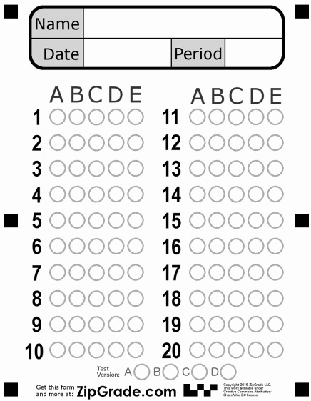
Choose the correct answer :
1- They enjoy……………………………………………………… to music.
- Listen B ) listens C ) listened D ) listening
2- All governments promise…………………………………………………pollution.
A ) to reduce B ) reducing C ) reduces D ) reduce
3- He……………………………………………………………football every day.
A ) play B ) playing C ) played D ) plays
4- They are………………………………………………a movie at the moment.
A ) watch B ) watched C ) watching D ) watches
5- If you heat water, it……………………………………………………….
A ) boil B ) boils C ) boiled D ) boiling
6- Pollution is the …………………………………..of many environment problems.
A ) source B ) organic C ) bold D ) air conditional
7- ………………………………………...food is produced entirely without chemicals.
A ) recycle B ) committed C ) organic D ) low
WORD | meaning
8 – harsh | ( A ) extremely large
9 – enormous | ( B ) severe - difficult
10 – bold | ( C ) strong and courageous
 | ( D ) depending on
 | ( E ) oil

Listening Exam
Listen to the task ; then answer the following questions:
** Choose the correct answer :
11- The name of the student is………………………………………………………..
A ) Sally B ) Lily C ) Lucy D ) Sara
12- The student's surname is ………………………………………….….
A ) More B ) Moor C ) Moore D ) Mor
13- She is…………………………………………………………………..years old.
A ) 13 B ) 14 C ) 15 D )16
** Put ( ) or ( ) :
- She is in the hospital . A ) B )
- The student get her school library card. A ) B )



English Language
2nd secondary Grade
period Exam
…………….\10
Kingdom of Saudi Arabia
Ministry of Education
…………… secondary school

Student's Name : class:
……\ 2 marks
1-Read the passage then answer the questions:
We cannot live without the sun’s heat or the air that we breathe, but these givers of life can also become dangerous killers. Moreover, they can behave even more dangerously when they are combined with another great natural force: water. The largest and most destructive results of this are hurricanes. These huge storms can hit land so powerfully that they destroy everything in their path. Information is therefore collected from space satellites.

1-Name the three things in nature that combine to produce hurricanes.
c- sun's heat ,air and trees | b- sun's heat ,air and mountains | a- sun's heat ,air and water
2- How hurricane forecasters get their information?
c- radio | b-News  Grammar | a- space satellites
A.choose the correct answer:
1- It is important that you ( brush _ brushes – brushing ) your teeth.
2- It was apart time job, ( isn't – wasn't – doesn't ) it ?
3-You ( must – had to – need to ) stop at " STOP " sing.
4- If you heat the water to 100 Cº , it ( boil – boils – boiling ).
B-Do as shown between brackets.
1-(correct)
a- We decide to gets good marks. ………
b- Would you mind tell me where the supermarket is?....................
2-( reorder)
a- could \ me \ you \ help \ ? ………………………………………………………………………



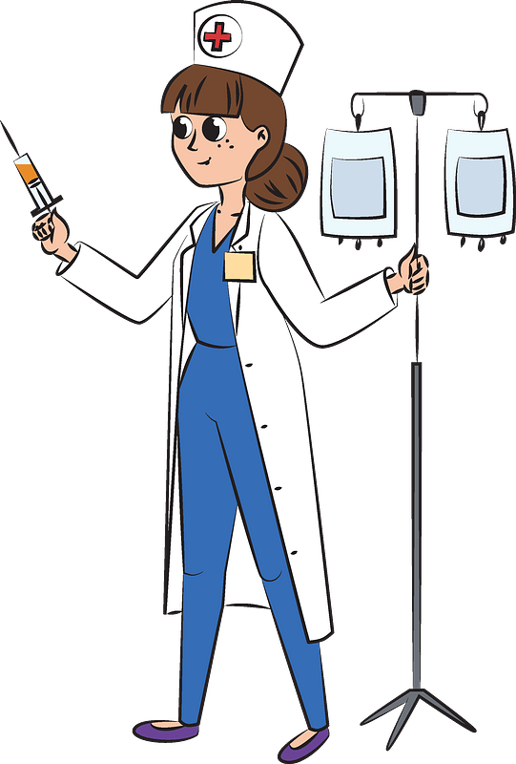
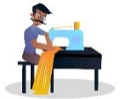

……\ 4 marks
……\ 4 marks
Vocabulary
Your teacher:

……………………….
……………………….
……………………….
……………………….
C-write the correct word under each picture. ( tailor – recycle- nurse – turbines )
B.Find the odd words.
1- wood glass plastic
2- fashion fabric window
2-
A-Complete the sentences with these words: (organic veterinarian pesticides)
1-………………. Food is produced entirely without chemicals.
2-………………………………is a doctor for animals.

English Language
Mega Goal 2.2
2nd Secondary Grade
Time: 45 minutes
Kingdom of Saudi Arabia
Ministry of Education
…………………………….. Education Directorate
…………………………………………………….. School



Midterm English Language Exam Form for the Year 1446 AH – 2nd Semester

Name: ………………………………………………………………………………….……… Class: ……………….

10

2

1. Guided Composition

Consider the following English proverb "Home is where the heart is." Then, derive your own quote
about home that embodies your feelings and vision in short.

2

2. Reading Comprehension

Read the following passage. Then, tick the correct option:

Out of concern for the environment and a desire for self-reliance, a growing number of people have made the bold decision to live off the grid. Living off the grid entails sacrifices, and is certainly not for everyone. But for the thousands of people who have made this bold choice, life off the grid is filled with rewards that can't be matched by the conveniences and luxuries of life on the grid. Among those, the avoidance of the environmental and financial costs that come with on-grid living.

1. The bold choice is to live … | on the grid | off the grid
2. Living off grid requires ... | selfishness | sacrifices
3. Living off the grid costs much less. | True | False
4. The demonstrative pronoun (those) on line (6) refers to … | people | rewards

1

Please turn the page over

3
3. Grammar
Do as required in the brackets:
1. Finish the project tonight. | Use one: subjunctive / 'd like … to/ want … to
…………………………………………………………………………………………………………………………………………………………………………………………………………….…………………..
2. Your uncle is a snow researcher, ………………………….? | Supply the missing tag question
3. The team …………..… if the players practice hard. | Choose the correct option
needn't win won will win have not won

3

4. Vocabulary

1. Replace the underlined words with the suitable synonym:

quit – outfits – are grateful for – pedicurists – extremely large
a). Good people appreciate each other. | ……………….…………………………………….
b). The house is enormous as if it is a palace! | ……………….…………………………………….

2. Supply the missing word from the given options:

consumption – profession – organic – go green – satisfaction

Incomplete Sentences
a). The food regarded to be ……………………..………. is produced entirely without chemicals.
b). Heating and cooling are represented half of the average of family's energy ……………………..………… .

3. Match the underlined expression from column (A) with its explanation from column (B):

A | B
1). Look! I've done it! It was a piece of cake. | a). very easy
1). Look! I've done it! It was a piece of cake. | b). very delicious
2). Hind is in a bind, and we have to give her our hands. | a). in a difficult situation
2). Hind is in a bind, and we have to give her our hands. | b). feel sleepy

Questions Over

With best wishes,
Nourah Abdul-Aziz
2
أسئلة الاختبار النصفي للفصل الدراسي الثاني للعام الدراسي 1446 هــ
ـــــــــــــــــــــــــــــــــــــــــــــــــــــــــــــــــــــــــــــــــــــــــــــــــــــــــــــــــــــــــــــــــــــــــــــــــــــــــــــــــــــــــــــــــــــــ
اسم الطالب : .......................................................................................................................... الفصل : .......................................

- Put the following job titles with the job descriptions:

(Zoologist – Surgeon - Social worker - Screen writer)

- _______________ This person is involved in the study and care of animals.

- _______________ This is someone who helps people in need, such as the poor or disabled.

3. _________________ This is a special kind of doctor that operates on sick or injured people.

- Choose the correct answer :

- I recommended that he …………………………… a specialist ( . a - see b- seeing -c was see)

- I’d like you to ………………………………… this medicine .( a - takes b- taken -c take )

- They don't play, ……………………………… (do they – don't they – they do – aren't they) ?

- You ……………………….. ………… (have to – must – need to – mustn't) smoke in the hospital.

- I don't …………………………… ( needn't – must – need to – mustn't) take my passport. ID card is ok .

- It is important that he ( works ) here today . ( Correct )

………………………………………………………………………………………

- She is a good teacher, …………………………………..? (Write the question tag)

- Match the words to their meanings :

- flair ( ) A- confined, kept under restraint or control .
2- captive ( ) B- exactly the same .
3- identical ( ) C- a natural talent or ability .
4- analyze ( ) D- to study closely

- What is Lily Martinez’s job ?

……………………………………………………………………………………………………………………………

