Name: ................................... Ms. Tahani
Class: 4th + 5th + 6th Elementary / ........
Revision Sheet _ Unit (3): Stories
- General Questions:
  - Match the questions with the correct answers:
- Did he play soccer at school? |  | It was good.
- What do you like to do for fun? |  | My mom is very late.
- How was your day at school yesterday? |  | I like to jump rope.
- What is your favourite story? |  | Yes, he did.
 |  | Cinderella
- Controlled Writing:
  - Rearrange the words to form sentences or questions:
    - waited – the bus – I – for
……………………………………………..
    - he – the movie? – like – Did
……………………………………………..
  - Complete the information about a story:
on the top of a mountain –
We climbed the mountain, but we were scared. –
an old man and two young friends –
The Kind Man –
Hello, children. Do you need some help?
Title:
…………………………………….

Setting:
…………………………………….

Characters:
………………………………………………………….
Dialogue: old man
………………………………………………………….
Dialogue: two friends
………………………………………………………….

- Reading Short Sentence:

  - Read the sentences then match them with the correct pictures:
 |  |  | 
a-_I call my friend.  b-_I carry the books. | a-_She looks sad.  b-_She looks happy. | a-_I fix the hose.  b-_I water the plants. | a-_He robbed the house.  b-_He clapped his hand.
- Grammar:
  - Choose the correct answer:
1-He (play – plays – played) soccer yesterday. | 4-She (didn’t call – didn’t called) her mom.
2-He didn’t (play – plays – played) soccer. | 5-(Does – Did) he send an e-mail last week?
3-He (laughs – laughed) at my joke last night. | 6-Did you (invite – invited) your friends?

  - Do as shown between brackets:
    - (Write the past form of the following verbs)
Base Form | Simple Past | Base Form | Simple Past
dream |  | play
stop |  | carry
plan |  | score

- Vocabulary:
  - Write the words under the correct pictures:
jump – worm – fix – drop – cry – clap

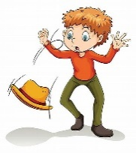 | 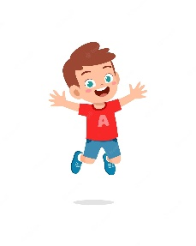 |  |  |  | 

- Orthography:
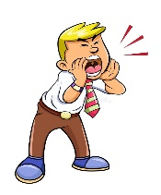
  - Fill in the missing letters:
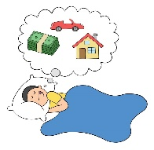 | 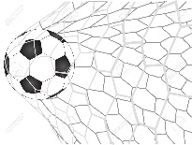 |  | 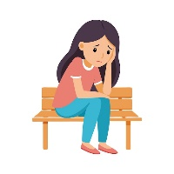 | 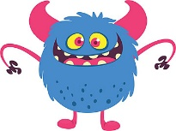 | 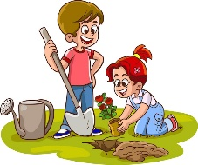 | 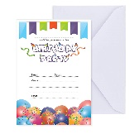
d__eam | sc__re | shou__ | a__one | mo__ster | pl__nt | inv__te

Name: ................................... Ms. Tahani
Class: 4th + 5th + 6th Elementary / ........
Revision Sheet _ Unit (4): After-School Fun
- General Questions:
  - Match the questions with the correct answers:
- Do you want to play hide and seek? |  | I go swimming.
- What activities do you do in your free time? |  | I usually do it on the weekend.
- Did you go shopping on Saturday? |  | Because I had to buy clothes.
- When do you do the activity? |  | No, I prefer to play board games.
- Why did you go to the shopping mall? |  | No, I didn’t.
- Controlled Writing:
  - Rearrange the words to form sentences or questions:
    - catch – I – ball – the
……………………………………………..
    - took photos – zoo – at the – She
……………………………………………..
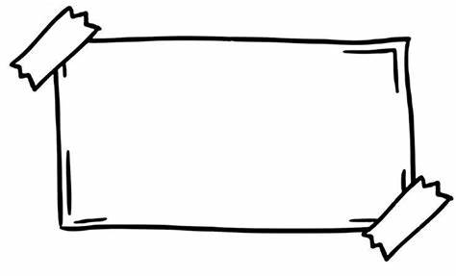
  - Complete the poster. Use the words in the box:
models – Enjoy – sports – fun – dress

AFTER-SCHOOL CLUB
Come to the after-school club. It’s ……………..!
- Meet lots of new people.
- ……………… lots of different activities.
- Learn new things.
Inside:
Make ……………….. and ……………….. up
Outside:
Go swimming and play …………………..

- Reading Short Sentence:
  - Read the sentences then match them with the correct pictures:
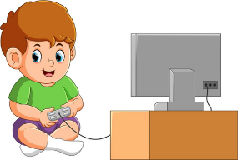 | 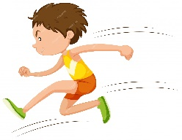 |  | 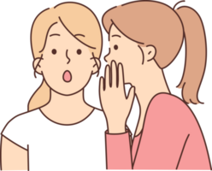
a-_I play video games.  b-_I play board games. | a-_He walks slowly.  b-_He runs quickly. | a-_She likes vlogging.  b-_She likes texting. | a-_She talks loudly.  b-_She talks quietly.
- Grammar:
  - Choose the correct answer:
1-He (go – goes – went) shopping yesterday. | 6-(Does – Did) he make a model last week?
2-He didn’t (go – goes – went) shopping. | 7-I can speak Arabic (and – but – so) English.
3-He (sleeps – slept) late last night. | 8-I am hungry, (and – but – so) I order a burger.
4-She (didn’t see – didn’t saw) a movie. | 9-I go to the hospital (because – and) I am sick.
5-Did you (take – took) photos in the park? | 10-I like soccer, (and – but) I don’t like tennis.

  - Do as shown between brackets:
    - (Write the past form of the following verbs)
Base Form | Simple Past | Base Form | Simple Past
go |  | see
take |  | sleep

- Vocabulary:
  - Write the words under the pictures:
present – seeds – vegetables – piano – dominoes – graduation

 |  |  |  | 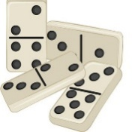 | 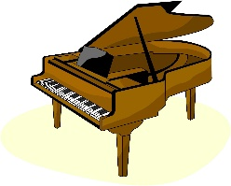

  - Match the opposites:
    - quickly a- inside
    - loudly b- quietly
    - outside c- happily
d- slowly

- Orthography:
  - Fill in the missing letters:
 | 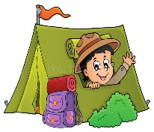 | 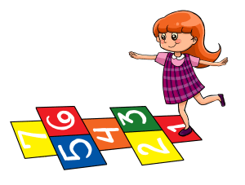 | 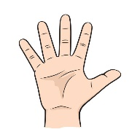 | 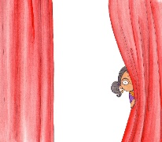 |  | 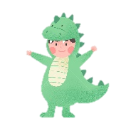
mu__ic | i__side | ho__scotch | fin__ers | h__de | te__ting | d__ess up

