Name: …………………………………… Ms. Tahani
Class: 1st Intermediate
Revision Sheet _ Unit ( 6 ) : Is There a view ?
- Vocabulary:
- Write the words under the pictures:
curtains – rug – sink – balcony – bathtub



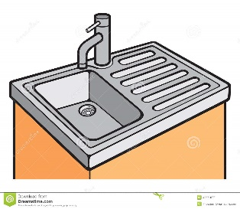
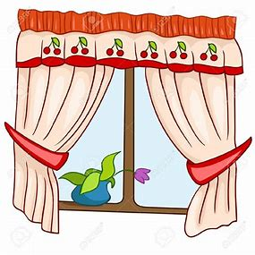

________________ __________________ __________________ __________________
- Classify the words:
shower – bed – sofa – stove

Living room | Bathroom | Bedroom | Kitchen

- Circle the odd word:
- House parts: garage – lamp – living room – yard
- Dining room: chair – table – toilet – vase
- Garden: washer – tree – flowers – grass
- Furniture: armchair – closet – laundry room – dryer

- Match the opposites:
- upstairs a- small
- big b- behind
- in front of c- cold
- hot d- unusual
. e- downstairs

- Fill in the blank with the correct words in the box:
view – apartment – mirror – crowded – comfortable

- These new shoes are not …………………… to wear.
- You can see a beautiful ………………. from our balcony.
- His …………………... is in a really good location.
- Abha was very ……………….. last summer.

- Grammar:
- Choose:
- There (am – is – are) a car in the garage.
- There (am – is – are) four chairs in the kitchen.
- I can walk, (and – but – or) I can’t fly.
- I want to go to the party (and – but – or) I am tired.
- You can buy the blue (and – but – or) the red dress.
- The rug is (in – on – under) the table.
- The poster is (in – on – under) the wall.
- The lamp is (in – on – under) the table.
- The board is (in front of – under – on) the students.

- Do as shown between brackets:
- There is a cat on the sofa. (Change into negative)
…………………………………………………..
- There are flowers in the yard. (Change into negative)
…………………………………………………..
- There is a ball under the bed. (Make a Yes/No question)
…………………………………………………..
- There are three apples in the refrigerator. (Make a Yes/No question)
……………………………………………………
- I like drawing, (or) I don’t like reading. (Correct the mistake)
……………………………………………………
- You can play football (but) tennis. (Correct the mistake)
……………………………………………………
- There is a sofa (or) an armchair in the living room. (Correct the mistake)
……………………………………………………

Name: …………………………………… Ms. Tahani
Class: 1st Intermediate
Revision Sheet _ Unit ( 7 ) : Where Do You Live?
- Vocabulary:
- Write the words under the pictures:
pharmacy – corner – swimming pool – bus stop – gym

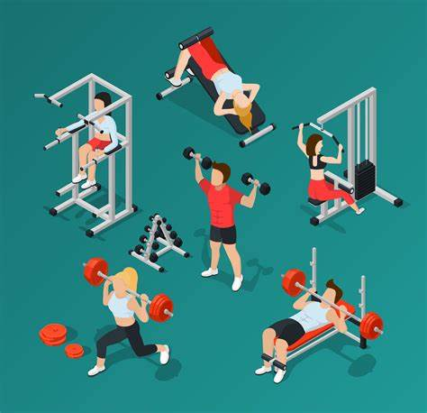
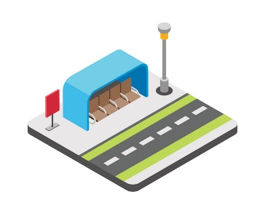
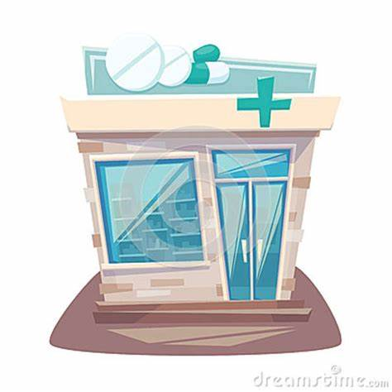


________________ __________________ __________________ __________________
- Classify the words:
bookstore – turn right – go straight – airport

Places in neighborhood | Give directions

- Circle the odd word:
- Places in neighborhood: post office – bank – mall – curtains
- Give directions: go up – sauna – turn left – go to the corner

- Match the opposites:
- left a- open
- closed b- famous
- different c- right
- up. d- same
e- down

- Fill in the blank with the correct words in the box:
floor – convenience store – trust – get off – station

- Give me a call when you ……………………. the bus.
- I looked for Layan and Lora at the bus ………………. .
- Mayar lives on the second …………………... .
- I am going to the ……………………... to buy some bread.

- Grammar:
- Choose:
- I live (in – on – at) Dubia.
- Huda lives (in – on – at) the fourth floor.
- Nada lives (in – on – at) Main Street.
- The bank is (next to – near – between) the pharmacy and the restaurant.
- The bus stop is (next to – on – between) the corner.
- Nora is (tall – taller – tallest).
- Jawaher is (tall – taller – tallest) than Dalia.
- Bushra is the (tall – taller – tallest) student in the class.
- Jeddah is (modern – more modern – most modern).
- Jeddah is (modern – more modern – most modern) than Abha.
- Riyadh is the (modern – more modern – most modern) city in KSA.
- Ali’s mark is (good – better – best) than Hassan’s.
- Dr Omar is the (good – better – best) doctor in the city.

- Do as shown between brackets:
- Planes are (fast) than cars. (Correct the mistake)
…………………………………………………..
- The ring is (expensive) than the necklace. (Correct the mistake)
…………………………………………………..
- Adel’s mark is (bad) than Ahmed’s. (Correct the mistake)
…………………………………………………..
- Cheetah is the (fast) animal in the world. (Correct the mistake)
…………………………………………………..
- A Ferrari is the (expensive) car. (Correct the mistake)
…………………………………………………..
- That restaurant has (bad) food in the town. (Correct the mistake)
…………………………………………………..
- Shmookh lives ……….. the tenth floor. (Use in or on)
…………………………………………………..
- Rawan lives ………. Dammam. (Use in or on)
…………………………………………………..
- Amani lives ……….. Sari Street. (Use in or on)
…………………………………………………..

Name: …………………………………… Ms. Tahani
Class: 1st Intermediate
Revision Sheet _ Unit ( 8 ) : What Are You Doing?
- Vocabulary:
- Write the words under the pictures:
deliver – magazine – hang out – drink – wear





________________ __________________ __________________ __________________
- Classify the words:
science fiction – watch – comedy – study

Kinds of film | Verbs

- Circle the odd word:
- Kinds of film: action – comedy – sandwich – documentary

- Match:
- What’s up? a- looking for information
- checking out b- teenagers
. c- What’s happening?

- Fill in the blank with the correct words in the box:
food court – busy – generation – actor – speak

- I will be …………… cleaning the house.
- He can …………….. three languages.
- They ate dinner at the mall’s ……………………..
- Nasser AlQasabi is a famous ……………….

- Match the word with its opposite:
- advantage a- comfortable
- safe b- dangerous
c- disadvantage

- Grammar:
- Choose:
- We (am – is – are) studying now.
- He (am – is – are) playing volleyball now.
- I (am – is – are) eating now.
- Sara is (read – reads – reading) a story now.
- The children are (sleep – sleeps – sleeping).
- I would (like – to like – like to) a salad.
- I would (like – to like – like to) go to the mall.
- I would like (watch – to watch – watching) a comedy.

- Do as shown between brackets:
- He is chatting with a friend. (Change into negative)
…………………………………………………..
- They are surfing the internet. (Make a Yes/No question)
…………………………………………………..
- Is she drinking coffee? (Answer the question)
Yes, ……………………………
No, …………………………….
- I would like to a burger and fries. (Correct the mistake)
……………………………………………………
- I would like have lunch at the food court. (Correct the mistake)
……………………………………………………

Name: …………………………………… Ms. Tahani
Class: 1st Intermediate
Revision Sheet _ Unit ( 9 ) : What Do You Do?
- Vocabulary:
- Write the words under the pictures:
newspaper – lawyer – waiter – carpenter – reporter

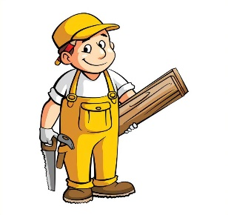



________________ __________________ __________________ __________________
- Classify the words:
clinic – mechanic – salesperson – school

Jobs | Place of work

- Circle the odd word:
- Jobs: chef – designer – gadget – teacher
- Place of work: hospital – restaurant – cameraman – store

- Match the opposites:
- agree a- bored
- interested b- difficult
. c- disagree

- Fill in the blank with the correct words in the box:
cook – drive – meet – sell – travel

- These stores ……………. clothes and shoes.
- I will ………….. you at 10 o’clock.
- Ali is not old enough to …………….. a car.
- It is expensive to ……………… by plane.

- Grammar:
- Choose:
- A: (What – Where – Why) do you do?
B: I am a flight attendant.
- A: (What – Where – Why) do you want to be a doctor?
B: Because I want to help sick people.
- I like Math (and – but – or) I like history.
- I like coffee (and – but – or) I don’t like tea.
- I am sick, (because – so – or) I will take a painkiller.
- I want to be an architect (because – so – or) I like to design houses.
- A: What (do – does – are) she do?
B: she (do – does – is) a nurse.
- A: What (do – does – is) they do?
B: They are football players.
- Yasser (work – works – working) in the bank.
- My uncle (drive – drives – driving) a bus.
- Ali and Omar (play – plays – playing) tennis.
- Mothers (cook – cooks – cooking) the dinner for their children.

- Do as shown between brackets:
- Yara usually (write) a letter to her friend. (Correct the mistake)
……………………………………………………
- Deema and Rand are teachers. They (works) at school. (Correct the mistake)
……………………………………………………
- I like drawing, (and) I don’t like reading. (Correct the mistake)
……………………………………………………
- I have to study (so) I have an exam tomorrow. (Correct the mistake)
……………………………………………………
- for / writes / a magazine / Fahad (Rearrange)
……………………………………………………
- A: …………………………………………………? (Complete)
B: I am a bus driver.
- A: ………………………………………………….? (Complete)
B: Sami is a reporter.

Name: …………………………………… Ms. Tahani
Class: 1st Intermediate
Revision Sheet _ Unit ( 10 ) : What’s School Like?
- Vocabulary:
- Write the words under the pictures:
experiment – archaeology – math – athletic – confused



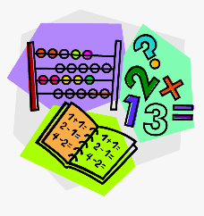

________________ __________________ __________________ __________________
- Classify the words:
math – tall – thin – history

School subjects | Adjectives to describe people’s look

- Circle the odd word:
- School subjects: geography – PE – team – science
- Adjectives: smart – fun – strict – basketball

- Match the opposites:
- easy a- intelligent
- boring b- interesting
- long c- difficult
d- short

- Fill in the blank with the correct words in the box:
glasses – active – excavate – fascinating – blond

- She has ……………………. hair and blue eyes.
- He is an ……………………. student.
- I see so much better with my new …………………...!
- History is not boring. It’s quite a ……………………... subject.

- Match:
- active a- difficult
- interesting b- athletic
- smart c- annoyed
- hard d- intelligent
e- not boring

- Grammar:
- Choose:
- He (speak – speaks – speaking) English.
- They (speak – speaks – speaking) English.
- He doesn’t (speak – speaks – speaking) English.
- They don’t (speak – speaks – speaking) English.
- Leen (doesn’t watches – doesn’t watch – don’t watch) TV every night.
- Leen and Reem (doesn’t watches – doesn’t watch – don’t watch) TV every night.
- (Do – Does – Is) Ali teach geography?
- (Do – Does – Are) they teach math?
- Do they (play – plays – playing) volleyball?
- Does she (play – plays – playing) volleyball?
- I am never (bored – boring – boreds) in science class.
- This book is (bored – boring – boreds).

- Do as shown between brackets:
- has / black / Sara / hair (Rearrange)
…………………………………………………..
- is / Tala / short (Rearrange)
…………………………………………………..
- Ghina (read) a story every Sunday. (Correct the mistake)
…………………………………………………...
- Fahad gets up early. (Change into negative)
……………………………………………………
- They brush their teeth. (Change into negative)
…………………………………………………….
- Dana drinks coffee every morning. (Make a Yes/No question)
……………………………………………………
- They pray in the mosque. (Make a Yes/No question)
…………………………………………………….
- Science is a difficult subject. (Use ‘really’)
……………………………………………………
- Rana is tall. (Use ‘very’)
……………………………………………………

Name: …………………………………… Ms. Tahani
Class: 1st Intermediate
Revision Sheet _ Unit ( 11 ) : What Time Do You Get Up?
- Vocabulary:
- Write the words under the pictures:
karate – wake up – take a shower – work out – brush your teeth






________________ __________________ __________________ __________________
- Classify the words:
never – lunch – breakfast – usually

Frequency adverbs | Meals

- Circle the odd word:
- Meals: breakfast – lunch – traffic – dinner
- Weekday: Monday – Friday – Tuesday – Thursday

- Match:
- Where are you off to? a- really great
- awesome b- absolutely not!
- No way! c- Where are you going?

- Fill in the blank with the correct words in the box:
get up – check – learn – go – breakfast

- I ……………… my mailbox every Tuesday.
- They …………….. early in the morning.
- I always have a boiled egg for ……………………..
- It is never too old to ……………….

- Match the word with its opposite:
- bad a- early
- same b- good
- late c- weekend
- weekday d- fun
e- different

- Grammar:
- Choose:
- Wafaa eats breakfast (after – before – then) she wakes up.
- You should do your homework (after – before – by) you play video game.
- I usually study (at – in – on) the afternoon.
- Sara goes to bed (at – in – on) 10 o’clock.
- The children never play football (at – in – on) weekdays.
- I sometimes meet my friends (at – in – on) Fridays.
- I go to school (to – on – by) car.
- He goes to school (to – on – by) foot.
- I (read – reads – am reading) a story now.
- I usually (read – reads – am reading) a story.
- Look! The children (play – plays – are playing) football.
- The children (play – plays – are playing) football every day.
- I (want – wants – am wanting) to be a doctor.

- Do as shown between brackets:
- sometimes / eats / pizza / Dana (Unscramble the sentence)
…………………………………………………..
- Thamer gets up early. (Use ‘always’)
…………………………………………………..
- I understanding the lesson well. (Correct the mistake)
…………………………………………………...

