Name: …………………………………… Ms. Tahani
Class: 2nd Intermediate
Revision Sheet _ Unit ( 6 ) : What Was It Like?
- Vocabulary:
- Write the words under the pictures:
astronaut – navigation – volcano – electricity – robot

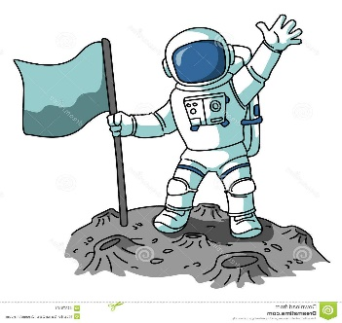
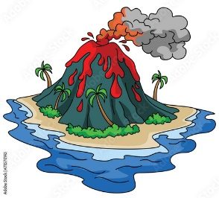



________________ __________________ __________________ __________________
- Classify the words:
space – calligraphy – dinosaurs – painting

Museum of Science & Technology | Museum of Natural History | Museum of contemporary Art | Islamic Heritage Museum

- Circle the odd word:
- Museum: art – technology– history – food
- Calligraphy: Kufic – table – Thuluth – cursive

- Match:
- Calligraphy a- very clever
- out of this world b- beautiful writing
- brilliant c- very tasty
- awful d- an expression used to say that something is very good
- delicious e- very sure
f- very bad

- Fill in the blank with the correct words in the box:
discovered – delicious – awesome – invite – binoculars

- We looked at the birds through …………………..
- Columbus ……………… America in1492.
- I will …………….. my cousin to stay with us for few weeks.
- The food was absolutely ………………….

- Grammar:
- Choose:
- The match (was – were – are) amazing.
- They (was – were – is) students.
- Hala (go – goes – went) to the beach yesterday.
- Remas (play – plays – played) tennis last week.
- Norah (do – does – did) not sleep late last night.
- Marwah didn’t (eat – eats – ate) pizza.
- Tahani didn’t (visit – visits – visited) her uncle last month.
- (Do – Does – Did) Reema meet her friend last weekend?

- Do as shown between brackets:
- Enas was absent yesterday. (Change into negative)
…………………………………………………..
- Hadeel and Rania were in the mall. (Change into negative)
…………………………………………………..
- Shoug was in Makkah. (Make a Yes/No question)
…………………………………………………..
- Shahad wore sunglasses. (Change into negative)
……………………………………………………
- Salhah watched TV. (Change into negative)
……………………………………………………
- Retaj swam in the pool. (Make a Yes/No question)
……………………………………………………
- Badreah visited her grandfather. (Make a Yes/No question)
……………………………………………………
- Aryam did not drove a car. (Correct the verb)
……………………………………………………
- Did Kholoud worked at school? (Correct the verb)
……………………………………………………
- The story is interesting. (Use ‘very’)
……………………………………………………
- (Rewrite the sentences with different intensifiers and adjectives):
- The dinosaur was very big.
……………………………………………………
- (Rewrite the sentences with strong adjectives):
- Rana is very clever.
……………………………………………………
- The cake is very tasty.
……………………………………………………
- (Write the past form of the following verbs):
Base form | Simple past | Base form | Simple past
swim |  | eat
go |  | drink
write |  | see

Name: …………………………………… Ms. Tahani
Class: 2nd Intermediate
Revision Sheet _ Unit ( 7 ) : What Happened?
- Vocabulary:
- Write the words under the pictures:
traffic light – intersection – sleepy – scared – angry

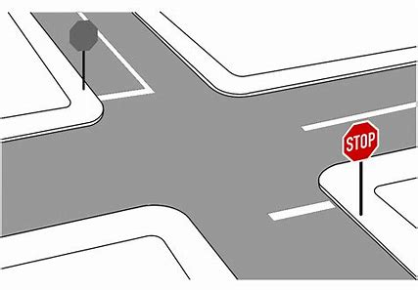
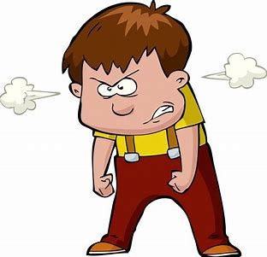
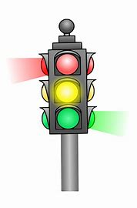
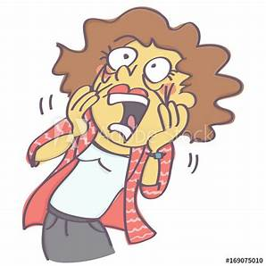

________________ __________________ __________________ __________________
- Classify the words:
nervous – Where – tired – How

Feeling | Five W’s

- Circle the odd word:
- Feeling : sad – happy – driver – worried

- Match:
- witness a- someone who saw an event
- insurance b- don’t get angry
- injury c- payment for costs of an accident
- don’t lose your cool d- where two roads cross
f- hurt from an accident

- Fill in the blank with the correct words in the box:
fortunately – busy – hurt – mess – accident

- Ali was injured badly in the …………………..
- I was late, but ……………….. the meeting hadn’t started.
- Lama cried because she had ………..…….. her knee.
- I’m sorry, but I’m ………………… right now.

- Match the opposites:
- outgoing a- sad
- stupid b- cheap
- happy c- smart
- expensive d- silly
e- shy

- Grammar:
- Choose:
- There (was – were – are) a book on the desk.
- There (was – were – is) two bikes in the garden.
- A: (Where – Why – What) are you worried?
B: Because I have a test tomorrow.
- A: Why are you absent yesterday?
B: (So – Ago – Because) I was sick.
- They saw Reema in her room 10 minutes (because – age – ago).
- Do you have (someone – nothing – anything) to eat in the fridge?
- I didn’t know about the meeting. (No one – Nothing – Anything) told me.
- A: What do you want to drink?
B: (Nothing – Someone – No one), I am not thirsty.
- Yesterday I saw (nothing – someone – anything) playing with a ball in the park.
- We stayed at home (so – because – neither) it was raining.
- Farah was ill, (so – because – neither) she had to stay in bed.
- A: I am a good student.
B: (So – Neither – Because) am I.
- A: I am not scared.
B: (So – Neither – Because) am I.
- A: I speak English.
B: (So – Neither – Because) do I.
- A: I don’t speak Chinese.
B: (So – Neither – Because) do I.
- A: I never speak French.
B: (So – Neither – Because) do I.

- Do as shown between brackets:
- There was a car in the garage. (Change into negative)
…………………………………………………..
- There were three books on the shelf. (Change into negative)
…………………………………………………..
- (Complete the sentences with so or because)
- I am going to make a cake, …………. I need some eggs and flour.
- She is going to stay at home …………….she has to study for an exam.
- (Show agreement with the statements. Use so or neither)
- I am happy today.
………………………………….
- I eat fruit and vegetables.
………………………………….
- I played football yesterday.
………………………………….
- I am not hungry.
…………………………………
- I don’t have a driver’s license.
…………………………………
- I didn’t sleep early.
…………………………………

Name: …………………………………… Ms. Tahani
Class: 2nd Intermediate
Revision Sheet _ Unit ( 8 ) : What’s Wrong?
- Vocabulary:
- Write the words under the pictures:
sore throat – vomit – stomachache – symptom – shoulder


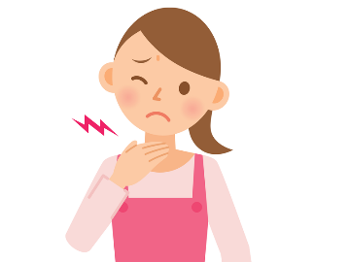
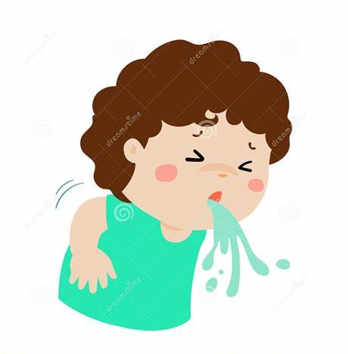
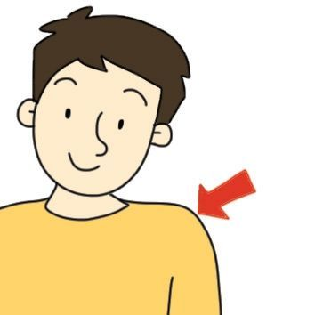

________________ __________________ __________________ __________________
- Classify the words:
chest – fever – neck – cold

Illnesses | Parts of the body

- Circle the odd word:
- illnesses: headache – earache – knee – diarrhea
- parts of the body: nose – medicine – arm – leg

- Match:
- I just did a- not a great amount
- Nothing much b- get angry
- ill c- I did that a short time ago
d- sick

- Fill in the blank with the correct words in the box:
dizzy – sneeze – prescription – toothache – rest

- Ali has a …………………. He should go to the dentist.
- I felt ……………… when I looked down from the top of the tower.
- When you have a cold, you …………………...a lot .
- The doctor gave me a ………..………….. for pain killers.

- Match the word with its opposite:
- bored a- sad
- strong b- fine
- happy c- weak
- sick d- thirsty
e- interested

- Grammar:
- Choose:
- You (should – shouldn’t – not should) eat so much.
- You (should – shouldn’t – not should) study hard.
- You should (sleep – slept – sleeping) early.
- What do you do (who – what – when) you have a cold?
- Omar is sick. (He – She – They) should see a doctor.
- Sami gave (he – him – his) a watch on his graduation.
- Amal has two sisters. (Her – Their – She) names are Lama and Hind.
- That jacket is (I – my – mine).
- You and (I – my – me) will go to the supermarket.
- The teacher gave Leen and (I – my – me) gifts.

- Do as shown between brackets:
- (Use should or shouldn’t)
- I have an earache. I …………….. go to the doctor.
- I ……………. be noisy in the library.
- He …………….. push his friends in the playground.
- She ……………. tidy her bedroom and keep it clean.

- Him and me are the same age. (Correct the mistake)
…………………………………………………..
- Can you come to the meeting with we? (Correct the mistake)
…………………………………………………..

- (Replace the underlined words with the correct pronouns or possessive adjectives)
- Eman is my friend. I sit next to Eman in the class.
………………………………………….
- I should take the medicine three times a day. The medicine tastes terrible!
………………………………………….
- That room is Abeer’s.
………………………………………….
- Mom’s job is difficult.
………………………………………….

- (Complete the table):

Subject pronouns | Object pronouns | Possessive adjectives | Possessive pronouns
I |  | My
She |  |  | hers
 | him | His
It |  | Its
 | them |  | theirs
You |  | Your
 | us |  | ours

Name: …………………………………… Ms. Tahani
Class: 2nd Intermediate
Revision Sheet _ Unit ( 9 ) : Let’s Go Out
- Vocabulary:
- Write the words under the pictures:
do the laundry – iron the clothes – go bowling – hang out – wash the dishes

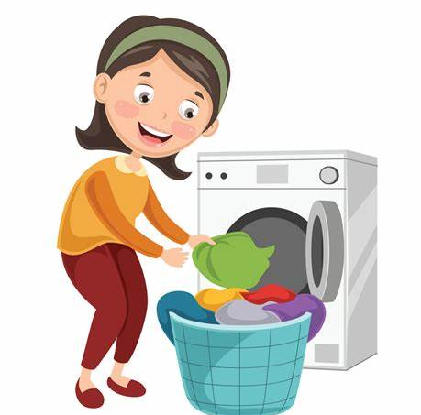
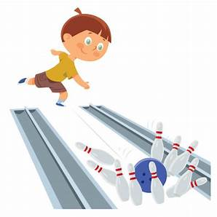
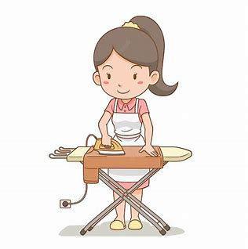


________________ __________________ __________________ __________________
- Classify the words:
babysit – shopping – dust – swimming

Activities | Chores

- Circle the odd word:
- Activities: clean the room – go out for dinner – go for a drive – go for a ride
- Chores: take out the garbage – mow the lawn – hang out – babysit

- Match:
- Come on a- compromise
- Let down b- disappoint someone
c- used to encourage someone to do something

- Fill in the blank with the correct words in the box:
obligation – suggest – complain – dust – garbage

- You should call customer service and ………………..
- Don’t forget to take out the ………………..
- There is a lot of …………… on this table.
- I ………..……. we go out to eat.

- Grammar:
- Choose:
- You should (eat – ate – eating) healthy food.
- Let’s (playing – played – play) football.
- Why don’t you (take – took – taking) a rest?
- Ali goes (swim – swam – swimming) three times a week.
- I can’t play now. I (has to – have to – had to) study for a test.
- Dana can’t come today. She (has to – have to – had to) clean her room.
- I didn’t go to the party yesterday because I (has to – have to – had to) look after my baby.
- You (must – don’t have to – mustn’t) talk during the test.
- You (must – don’t have to – mustn’t) listen to your parents.
- You (must – don’t have to – mustn’t) eat lunch at school , you can eat at home.

- Do as shown between brackets:
- (Use must or mustn’t)
- You …………….. cheat.
- You ……………. be on time.
- You …………….. go to bed early at night.
- You ……………. shout in the class.

- (Make a suggestion)
- I am bored. (go/ the beach)
………………………………………………...
- I am hungry. (eat/ pizza)
…………………………………………….

- I can’t go shopping now I had to do my homework. (Correct the mistake)
…………………………………………………..
- You must eat too much chocolate. It’s bad for your teeth. (Correct the mistake)
…………………………………………………..

- (Complete the sentences. Use “go + verb + -ing”)
- Farah …………………..………. (swim) every Friday.
- Tala and Lana ……………………………. (bowl) at the mall on the weekend.

Name: …………………………………… Ms. Tahani
Class: 2nd Intermediate
Revision Sheet _ Unit ( 10 ) : It’s a Bargain!
- Vocabulary:
- Write the words under the pictures:
necklace – socks – perfume – tie – escalator

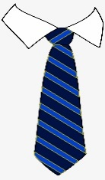
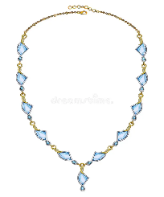
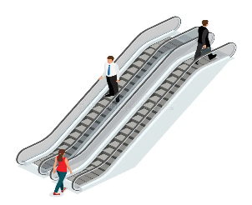
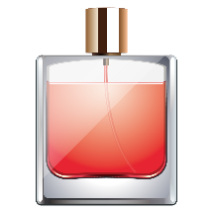

________________ __________________ __________________ __________________
- Classify the words:
hat – suit – earrings – bracelet – sunglasses – sweatshirts

Jewelery | Accessories | Outerwear

- Circle the odd word:
- Jewelery: ring – wallet – bracelet – necklace
- Accessories: scarf – belt – leather bag – windbreaker
- Outerwear: coat – dress – makeup – raincoat
- Home department store: furniture – pillowcase – eye shadow – appliances
- Woman’s department store: skirt – shoes – tie – dress
- Men’s department store: suit – shirt – boots – blouse

- Match:
- Haraj a- things in general
- Stuff b- a large market where people buy and sell both new and used items
c- a polite way to answer ‘no’

- Fill in the blank with the correct words in the box:
bargain – brand – umbrella – gold – sale

- The boots are on …………………...
- The store had a huge …………………….. on shoes.
- We use an ………………….. for protection from the rain.
- Could I see that …………….. necklace?

- Match the word with its opposite:
- men a- comfortable
- cheap b- expensive
c- women

- Grammar:
- Choose:
- A: (Who – Whose – Where) backpack is this?
B: It is (mine – my – me).
- It is (they – their – theirs) house.
- This house is (they – their – theirs).
- That is not (she – her – hers) book.
- A: Which coat do you like?
B: The green (one – ones – too).
- A: Which boots do you like?
B: The black (one – ones – too).
- Faten didn’t buy any sunglasses because they were (one – ones – too) expensive.

- Do as shown between brackets:
- This is mine ring. (Correct the mistake)
………………………………..
- That jacket is her. (Correct the mistake)
……………………………………
- (Complete the sentence with one or ones):
- I am eating some red apples and some green ………………
- I don’t like this hat. Please show me another ………………
- (Use Can , Could or May to ask for permission):
- Ask your teacher that you want to drink water.
………………………………………………………………
- Ask your mother that you want to go out with your friends.
………………………………………………………………

Name: …………………………………… Ms. Tahani
Class: 2nd Intermediate
Revision Sheet _ Unit ( 11 ) : There’s No Comparison
- Vocabulary:
- Write the words under the pictures:
diamond – shark – doorknob – oryx – falcon


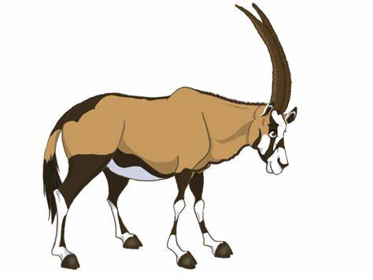
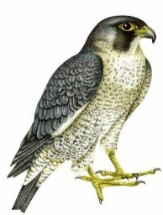
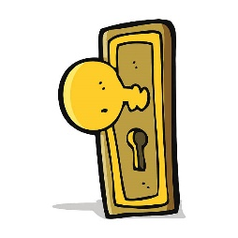

________________ __________________ __________________ __________________
- Classify the words:
pounds – cheetah – kilograms – shark

Animals | Measurement words

- Fill in the blank with the correct words in the box:
endangered – install – competition – recharge – weigh

- I want to …………………... anti-virus software.
- Pandas are one of the …………………….. species in the world.
- There will be a chess ………………….. next week.
- How much do you …………………?

- Choose the correct answer:
- Abha was ………… with tourists.
- luxurious b- crowded
- They have a ……….. house.
- luxurious b- crowded
- This lake is ………. for swimmers.
- dangerous b- smart
- My teeth are very ………. to cold food.
- precious b- sensitive
- His children are very ……… to him.
- precious b- worldwide

- Grammar:
- Choose:
- Hind is (tall – taller – tallest).
- Jaber is (tall – taller – tallest) than Hatem.
- Bushra is the (tall – taller – tallest) student in the class.
- Jeddah is (modern – more modern – most modern).
- Jeddah is (modern – more modern – most modern) than Abha.
- Riyadh is the (modern – more modern – most modern) city in KSA.
- Ali’s mark is (good – better – best) than Hassan’s.
- Dr Omar is the (good – better – best) doctor in the city.
- The meal was (so – such – so many) delicious that we ate too much.
- John is (so – such – so many) a naughty boy that nobody likes him.
- I have (so – so many – so much) watches that I can’t decide which one to wear.
- He put (so – so many – so much) salt that we couldn’t eat it.

- Do as shown between brackets:
- (Complete the sentences with so many or so much)
- He has ……………………. money that he could buy any house in the city.
- He has ……………………. books that he can hardly carry them.

- (Complete the sentence with so or such):
- It was ……………… expensive that we couldn’t afford it.
- There was ……………… bad weather that we had to stay home all day.

- (Combine the sentences with so…that or such…that)
- It was a beautiful day. We decided to go for a drive in the countryside.
………………………………………………………………….
- The music was loud. We called the police.
………………………………………………………………….

