Name: ……………………………………… Ms. Tahani
Class: 3rd Intermediate
Revision Sheet _ Unit ( 5 ) : Since When?
- Vocabulary:
- Write the words under the pictures:
brick – printer – stove – paper clips – credit cards

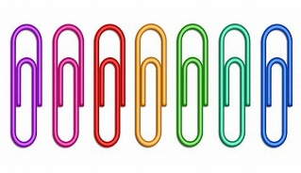
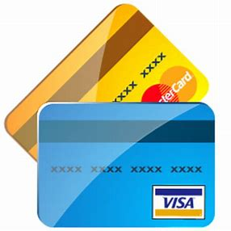
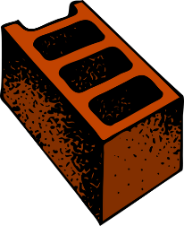
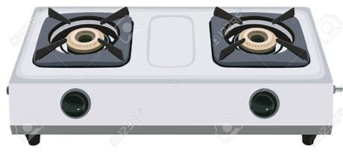

________________ __________________ ___________________ __________________
- Classify the words:
he – her – him – she – me – they – I – them

Subject pronouns |  | Object pronouns

- Circle the odd word:
- Inventions: camera – oven – television – people

- Match:
- long-time no see a- get married
- settle down b- congratulations!
- sequence c- I haven’t seen you for a long time
- interrupt d- stop in the middle
- accomplish e- action or events in a particular order
f- succeed in doing something

- Fill in the blank with the correct words in the box:
available – clumsy – invent – portable – conventional – successful

- Most food tastes better when it is cooked in a ………………….……oven.
- Free ticket is ………………...only to students.
- People can …………… things to make life easy.
- Tala had been ………………. at every job she had done.
- I always carry a ……………….computer with me.

- Match the word with its opposite:
- huge a- heavy
- slow b- cheap
- light c- widespread
- expensive d- small
e- fast
- Grammar:
- Choose:
- (Have – Has – Did) you ever travelled to London?
- (Have – Has – Did) you travel to London last year?
- Rama has (study – studies – studied) English for five years.
- Lana hasn’t received an email (for – since – ago) Monday.
- Joud hasn’t received an email (for – since – ago) three days.
- Rateel has lived in New York (for – since – ago) 2020.
- Leen has had his new mobile (for – since – ago) two months.
- Lara was in Paris two years (for – since – ago).
- Waad has worn glasses (for - since – ago) the age of seven.
- Layan has taught Chinese (for – since – ago) she was 22.
- How (long – many – much) have you played football?

- Do as shown between brackets:
- Lama (eat) lunch at the mall yesterday. (Correct the verb)
…………………………………………………..
- Seba (play) tennis since 2022. (Correct the verb)
…………………………………………………..
- Wala has learned French …….. April. (Use ‘since’ or ‘for’)
…………………………………………………..
- Abeer has been sick …….. two days. (Use ‘since’ or ‘for’)
…………………………………………………..
- Deema bakes a cake. (Change into passive)
…………………………………………………...
- Raseel baked a cake. (Change into passive)
……………………………………………………
- Fatimah has baked a cake. (Change into passive)
……………………………………………………
- A story is written by Ruba. (Change into active)
……………………………………………………
- A story was written by AlJazi. (Change into active)
……………………………………………………
- A story has been written by Hajar. (Change into active)
……………………………………………………

Name: ……………………………………… Ms. Tahani
Class: 3rd Intermediate
Revision Sheet _ Unit ( 6 ) : Do You Know Where It Is?
- Vocabulary:
- Write the words under the pictures:
bullet train – bridge – commuters – fountain - suburb



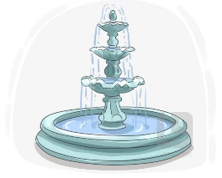
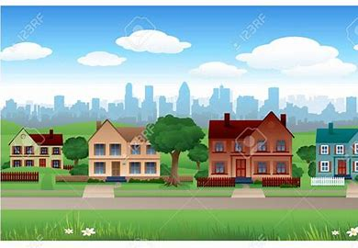

________________ __________________ ___________________ __________________
- Classify the words:
crime rate – taxis – kilometres

Vehicle | Measurement words | Features of town

- Circle the odd word:
- Vehicle: car – stadium – bus – taxi
- Features of town: green area – cost of housing – clean air – mile

- Match:
- run down a- holds
- consecutive b- an unbroken series
- leading c- in needed of fixing / not looked after
- combination d- popular
e- mixture

- Fill in the blank with the correct words in the box:
renovate – fare – survey – efficient – transportation

- There is public ………………………. available throughout the city.
- The ……………… questions were not very clear.
- The homeowners decided to ………………. their old kitchen.
- Ali is very ……………….. at his job.

- Match the word with its opposite:
- narrow a- high
- low b- cheap
- polluted c- wide
- cozy d- uncomfortable
e- clean

- Grammar:
- Choose:
- Fadi is (tall – taller – tallest) .
- Hatem is (tall – taller – tallest) than Samer.
- Rama is the (tall – taller – tallest) student in the class.
- The chair is (comfortable – more comfortable – most comfortable).
- The sofa is (comfortable – more comfortable – most comfortable) than the chair.
- The bed is the (comfortable – more comfortable – most comfortable) furniture.
- Leen’s marks are (good – better – best) than her friend.
- Dammam has the (bad – worse – worst) weather in Saudi Arabia.
- Your sister is as (smart – smarter – smartest) as you.
- Your mobile (is not as – is as not – not is as) new as mine.
- (A – An – The) sun rises in the east and sets in the west.
- The bird is flying in (the – a – an) sky.

- Do as shown between brackets:
- Where is the supermarket? (Make indirect question)
…………………………………………………..
- When does the shop open? (Make indirect question)
…………………………………………………..
- Wafa’s hair is long than Faten’s. (Correct the mistake)
…………………………………………………..
- Dana is in the Jeddah on vacation. (Correct the mistake)
…………………………………………………..

Name: ……………………………………… Ms. Tahani
Class: 3rd Intermediate
Revision Sheet _ Unit ( 7 ) : It’s a Good Deal, Isn’t it?
- Vocabulary:
- Write the words under the pictures:
broom – fan – teapot – hammer – saw


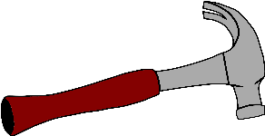



________________ __________________ ___________________ __________________
- Classify the words:
knife – screwdriver – vacuum cleaner – pliers – saucers – hose

Things used for cleaning | Things used for cooking | Things used for repairing

- Circle the odd word:
- Things used for cleaning: vacuum cleaner – hose – plates – broom
- Things used for cooking: spoon – fork – cup – teddy bear
- Things used for repairing: rocking chair – hammer – saw – pliers

- Match:
- coincidence a- three children born at the same time
- confuse b- what you get from your parents
- orphan c- a situation in which two things happen together by chance
- triplets d- think wrongly that a person is someone else
e- a child who has lost his parents

- Fill in the blank with the correct words in the box:
antique – guess – heredity – lawn mower – talkative

- I don’t know the answer, so I had to ……………………
- My friend is a ………………. person.
- We need a ………………………. to cut the grass.
- They have a lot of ………………. furniture in their house.

- Grammar:
- Choose:
- He is a teacher, (is he – isn’t he – is he not)?
- He eats pizza, (don’t he – doesn’t he – didn’t he)?
- They eat pizza, (don’t they – doesn’t they – didn’t they)?
- She ate a burger, (don’t she – doesn’t she – didn’t she)?
- They aren’t doctors, (aren’t they – are they – do they)?
- He doesn’t play football, (is he – does he – doesn’t he)?
- They’ve graduated, (did they – have they – haven’t they)?
- When I was young, I (was able to – were able to – be able to) run fast.
- When they were young, they (was able to – were able to – be able to) ride horses.
- He will (was able to – were able to – be able to) repair our car in three days.
- Let’s (go – went – going) to the park this afternoon.
- Why don’t we (ordering – orders – order) a pizza?

- Do as shown between brackets:
- watch / a movie (Make a suggestion)
…………………………………………………..
- Why don’t we have a garage sale?
………………………………………………….. (Accept the suggestion)
………………………………………………….. (Refuse the suggestion)
- (Complete the tag questions)
- Hind didn’t buy the cups, ……………………..?
- Dana is a nurse, ………………………..?
- She works in a bank, …………………….?
- Ali doesn’t have a car, ……………………….?
- They aren’t football players, …………………..?
- You travelled to Taif last weekend, ………………….?

- ……………………………………………………………. (Write a negative question)
Yes, she is going to meet you at 5 o’clock.
- (Complete the sentence using ‘be able to’)
- Hatem ……….. take part in this competition tomorrow.
………………………………………………………………………….
- Ali …………. skate better when he was 12.
………………………………………………………………………….
- They ……….. do difficult exercises when they were young.
………………………………………………………………………….

Name: ……………………………………… Ms. Tahani
Class: 3rd Intermediate
Revision Sheet _ Unit ( 8 ) : Drive Slowly!
- Vocabulary:
- Write the words under the pictures:
ignition – rearview mirror – windshield wipers – steering wheel – brake pedal
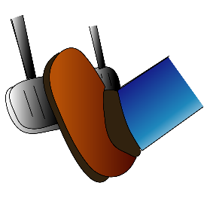

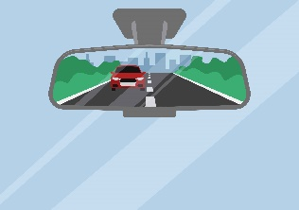


________________ __________________ ___________________ __________________
- Classify the words:
trunk – Stop – No Entry – hood

Traffic signs | Parts of the car

- Circle the odd word:
- Traffic signs: Speed Limit – Danger – gas tank – Pedestrian Crossing
- Parts of the car: bumper – slowly – signal light – dashboard

- Match:
- investigate a- something that is usually done
- custom b- study and research
- trend c- uncertainty about what happened
- conquered d- a direction of change, a tendency
e- took control of (a country, city etc.) through the use of force

- Fill in the blank with the correct words in the box:
seat belt – obey – license – horn – aggressive

- He was arrested for driving without a ……………………
- Make sure you fasten your …………………………....
- He is an ……………………. driver.
- We must ……………………. the road signs.

- Match the opposites:
- exterior a- wrong
- slowly b- interior
- right c- carefully
d- quickly

- Grammar:
- Choose:
- You (must – mustn’t – shouldn’t – should) honk your horn. It’s a hospital area.
- You (must – mustn’t – shouldn’t – should) listen to your teacher.
- You (must – mustn’t – shouldn’t – should) help your classmates.
- You (must – mustn’t – shouldn’t – should) come to school when you are ill.
- I did my homework (correct – correctly).
- My friend is a fast driver. He drives (fast – fastly).
- Mona is a good cook. She cooks (good – well).
- Dana is a hard worker. She works (hard – hardly).
- )Must – Should – Can) you go with me?

- Do as shown between brackets:
- (Rewrite the sentences using adverbs of manner)
- Rana is a quiet talker.
…………………………………………………..
- Omar is a reckless driver.
…………………………………………………..
- Nasser is a good player.
…………………………………………………..
- (Report the requests and commands)
- Nada: “Clean the room”.
………………………………………………………
- Reem: “Don’t open the window”.
……………………………………………………….
- Hanan: “Can you carry the bag?”
………………………………………………………..
- Can you help me?
…………………………………………………………… (Agree)
…………………………………………………………… (Refuse)

