
المملكة العربية السعودية |  |  |  |  |  | المادة |  | اللغة الانجليزية (شفوي)
وزارة التعليم |  |  |  |  |  | الصف |  | الأول متوسط
الادارة العامة للتعليم ب_______ |  |  |  |  |  | مقرر |  | Super Goal 1
مدرسة________المتوسطة |  |  |  |  |  | الزمن |  | نصـف ساعة
اختبار نهاية الفصل الدراسي الثاني – الدور الأول للعام الدراسي 1446 هــــ
الاستماع 5 |  | التحدث 5 |  | المجموع 10
الاسم ثلاثي |  |  |  | الفصل | أول / |  | رقم الكشف

Listen and circle the right answer:

- What are Frank and Jason doing?
They’re eating snack - breakfast - sandwiches .

- What do you usually do after dinner?
I usually read books - watch TV – do my homework .

- Where’s the English school?
It’s near – next to – across from the supermarket.

- The speaker favorite teacher
is the math - history – science teacher.

- The neighborhood is noisy – great - modern .

- His father is a designer - mechanic – lawyer .

- Jeffrey goes to school
by car – by bus – on foot .




Write or :

- The teacher doesn’t like his job. ( )
- There are two bedrooms downstair. ( )
- Carol and Frank are working in a bank. ( )

Audio : https://youtu.be/TQxD5IZAfts
Forms: https://forms.office.com/Pages/ShareFormPage.aspx?id=b4OQU5QpqkK9sELnf3f9C84PUFGeBGBFuY4-jPdGsvZUQ1NESVhHMDQxSlhJUTFYOVlWUlFFSE1MQiQlQCNjPTEu&sharetoken=QxXSyURY6oodUFJXUP0A

المملكة العربية السعودية |  |  |  |  |  | المادة: |  | اللغة الانجليزية (شفوي)
وزارة التعليم |  |  |  |  |  | الصف |  | الأول متوسط
الادارة العامة للتعليم ب_______ |  |  |  |  |  | مقرر |  | Super Goal 1
مدرسة________المتوسطة |  |  |  |  |  | الزمن: |  | نصـف ساعة
اختبار نهاية الفصل الدراسي الثاني – الدور الأول للعام الدراسي 1446 هـ
الاستماع 5 |  | التحدث 5 |  | المجموع 10
الاسم ثلاثي |  |  |  | الفصل | أول / |  | رقم الكشف

Listen and circle the right answer:

- What is Ryan doing?
He’s drinking a cup of tea - milk - coffee .

- What time does Amal usually get up?
She usually gets up at 3:15 - 5:30 – 4:30 .

- Do you like math? Yes, I do. It’s great.
I think it’s easy - boring – difficult .

- There’s a rug under - behind – in front of the sofa.

- Where do you live?
I live on Main - Park – 52nd Street.

- The kitchen is small - modern – beautiful .

- Is there a café near here?
It’s next to the bank - bookstore – supermarket .
Write or :

- The restaurant is closed on Saturdays. ( )
- Omar is fourteen years old. ( )
- Lee is from China. ( )

Audio : https://youtube.com/watch?v=Ay7i4pphjWU&si=EnSIkaIECMiOmarE
Forms: https://forms.office.com/Pages/ShareFormPage.aspx?id=b4OQU5QpqkK9sELnf3f9C84PUFGeBGBFuY4-jPdGsvZUQzNWSE9LODlBWFExTDZVUEpXRjdOWVo1UyQlQCNjPTEu&sharetoken=QxXSyURY6oodUFJXUP0A

Audio Script:

Super Goal 1 Listening | Resources
- What is Ryan doing?  He’s drinking a cup coffee. | Unit 8 - Page 65  Pair Work  Audio CD2 trick 15
- What time does Amal usually gets up?  She usually gets up at five thirty . | Unit 11- Page 89  Pair Work  Audio CD2 trick 33
- Do you like math?  Yes, I do. It’s great  I think it’s difficult | Unit 10 – Page 81  Pair Work  Audio CD2 trick 27
- There’s a rug in front of the sofa. | Unit 6 – Page 51  Listening  Audio CD2 trick 4
- Where do you live?  I live on Park. Street. | Unit 7 – Page 57  Pair Work  Audio CD2 trick 9
- Omar’s apartment is small. It has one bedroom and one bathroom. There’s a comfortable living room and there’s a modern kitchen. There isn’t a yard. But the apartment has a balcony with a beautiful view. | Unit 6 – Page 49  Listen and discuss  Audio CD2 trick 33
- Is there a café near here?  Yes, there is. Go straight. It’s on the corner on your right. It’s next to the bookstore. | Unit 7 – Page 59  Listening  Audio CD2 trick 10
- I like to cook. It’s very hot in the kitchen, but we’re very busy and I don’t notice it. I prepare meals for customers. The restaurant is excellent. I work all week, except Fridays. The restaurant is closed on Fridays. I work a lot, but I love my job. | Unit 9 – Page 75  Listening  Audio CD2 trick 22
- Omar Hamadan lives in Tabuk. He is sixteen years old  And he’s on the school football team. Omar is very good player, and he’s the team’s top strikers this season. | Unit 9– Page 77  Reading  Audio CD2 trick 25
- Who are your friends in school? Here’s a picture of my school friends the boy with glasses is Lee. He is an exchange student form China. He’s nice and very smart. | Unit 10 – Page 81  Listen and discuss  Audio CD2 trick26

Audio : https://youtube.com/watch?v=Ay7i4pphjWU&si=EnSIkaIECMiOmarE
Forms: https://forms.office.com/Pages/ShareFormPage.aspx?id=b4OQU5QpqkK9sELnf3f9C84PUFGeBGBFuY4-jPdGsvZUQzNWSE9LODlBWFExTDZVUEpXRjdOWVo1UyQlQCNjPTEu&sharetoken=QxXSyURY6oodUFJXUP0A
المملكة العربية السعودية |  |  |  |  |  | المادة: | اللغة الانجليزية (شفوي)
وزارة التعليم |  |  |  |  |  | الصف | الأول متوسط
الادارة العامة للتعليم ب_______ |  |  |  |  |  | التاريخ: | / /١٤٤٦هـ
مدرسة__________المتوسطة |  |  |  |  |  | الزمن: | نصـف ساعة
اختبار نهاية الفصل الدراسي الاول – الدور الأول للعام الدراسي 1446 هـ
الاستماع 5 |  | التحدث 5 |  | المجموع 10
الاسم ثلاثي |  |  |  | الفصل | أول/ | رقم الكشف

- Mustafa, this is my____ Mohammed! Nice to meet you |  | 
 | father
 | friend
 | classmate

- When’s your final test? |  | 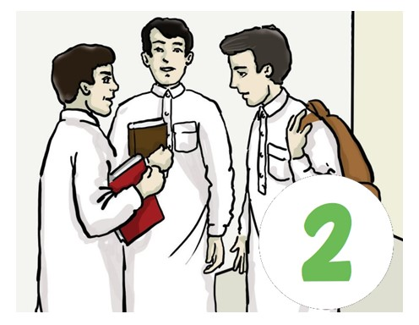
 | It’s on April 7th.
 | It’s on November 17th.
 | It’s on September 27th.

- What’s that? |  | 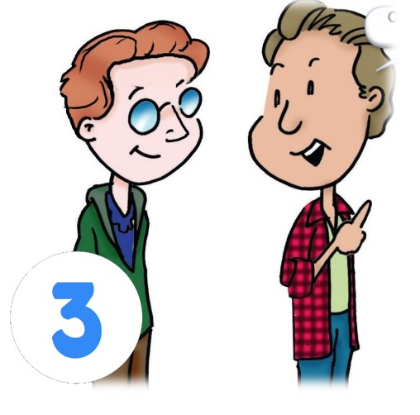
 | I don’t know.
 | I think it’s a radio.
 | I think it’s a bicycle.

- Where is Tom from? |  | 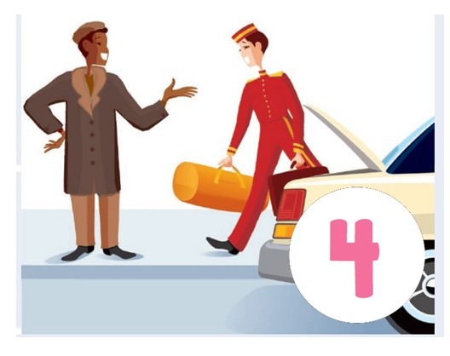
 | He’s from China.
 | He’s from Australia.
 | He’s from New York.

- Do you have any brothers and sisters? |  |   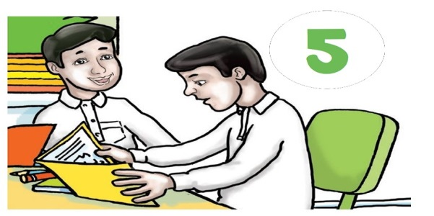
 | No, I’m an only child.
 | Yes, I have one brother.
 | I don’t have any brothers.

Audio: https://youtu.be/rGYNleheXfY
Forms: https://forms.office.com/Pages/ShareFormPage.aspx?id=b4OQU5QpqkK9sELnf3f9C84PUFGeBGBFuY4-jPdGsvZUQVM0SUdFT0xCU0pOUTRBVzdVTEtVREhVUi4u&sharetoken=T3dzOiuIUUc1LDGxHa1T

اسم الطالبة بالعربي: | الدرجة
الفصل: | الدرجة | 5

A. Listen to the recording and check the correct answer for each question:
What is the name of the girl? |  |  |  |  | 1
Lina | C | Sally | B | Sara | A
She comes from a ………family. |  |  |  |  | 2
 |  | small | B | big | A
She has …………brothers. |  |  |  |  | 3
3 | C | 7 | B | 5 | A
She has …………sisters. |  |  |  |  | 4
1 | C | 4 | B | 2 | A
Her mother is from a small family. ( ) |  |  |  |  | 5
 |  |  | B |  | A
Her father doesn’t have any brothers and sisters. ( ) |  |  |  |  | 6
 |  |  | B |  | A
The girl's mother's brothers and sisters are married. ( ) |  |  |  |  | 7
 |  |  | B |  | A
She has ………uncles. |  |  |  |  | 8
4 | C | 7 | B | 6 | A
She has ……… cousins. |  |  |  |  | 9
9 | C | 21 | B | 18 | A
She is talking about ………. |  |  |  |  | 10
Her friends | C | Her teachers | B | Her family | A

اسم الطالبة بالعربي: نــــــمــــوذج إجــــابـــــة | الدرجة | 5
الفصل: | الدرجة | 5

A. Listen to the recording and check the correct answer for each question: ½ for each
What is the name of the girl? |  |  |  |  | 1
Lina | C | Sally | B | Sara | A
She comes from a ………family. |  |  |  |  | 2
 |  | small | B | big | A
She has …………brothers. |  |  |  |  | 3
3 | C | 7 | B | 5 | A
She has …………sisters. |  |  |  |  | 4
1 | C | 4 | B | 2 | A
Her mother is from a small family. ( ) |  |  |  |  | 5
 |  |  | B |  | A
Her father doesn’t have any brothers and sisters. ( ) |  |  |  |  | 6
 |  |  | B |  | A
The girl's mother's brothers and sisters are married. ( ) |  |  |  |  | 7
 |  |  | B |  | A
She has ………uncles. |  |  |  |  | 8
4 | C | 7 | B | 6 | A
She has ……… cousins. |  |  |  |  | 9
9 | C | 21 | B | 18 | A
She is talking about ………. |  |  |  |  | 10
Her friends | C | Her teachers | B | Her family | A

Listening Transcription

My name is Sarah Brown. I’m from a big family. I have three brothers and two sisters. My mother is from a big family too. She has four brothers and three sisters. My father is from a small family. He doesn’t have any brothers and sisters. He’s an only child. All of my mother’s brothers and sisters are married. So I have seven uncles, and seven aunts. And I have twenty-one cousins. This is great. We have big family dinners, and we have lots of fun.

