
English 1.2/ English Language
1st Secondary grade
2nd Term Final Exam 1446
Time: 2 hours

Kingdom of Saudi Arabia
Ministry of Education
Hail Education Directorate
ALrawdah Secondary School

y

أول ثانوي – الدور الأول.
أختبار نهاية الفصل الدراسي الثاني 1446 هـ
Q1 | Q2 | Q3 | Q4 | Q5 | Total | Teacher's  Sign | Reviser's Sign | Adjusters Sign
 |  |  |  |  |  | Nora Enzy
6 | 6 | 6 | 6 | 6 | 30
اسم الطالبة
رقم الجلوس

أستعيني بالله ثم ابدأي الحل ، و تذكري أن تكتبي بالقلم الأزرق فقط بدون أستخدام مصحح الأخطاء ( الليكويد).
1.Writing
1.Free Composition:

6
Write about your self the following word bank:
Word bank: (name – city – age – family – interest )

…………………………………………………………………………………………………………………………………………………………………………………………………………………………….…………………………………………………………………

…………………………………………………………………………………………………………………………………………………………………………………………………………………………….…………………………………………………………………

…………………………………………………………………………………………………………………………………………………………………………………………………………………………….…………………………………………………………………

…………………………………………………………………………………………………………………………………………………………………………………………………………………………….…………………………………………………………………

…………………………………………………………………………………………………………………………………………………………………………………………………………………………….……………………………………………………………………

…………………………………………………………………………………………………………………………………………………………………………………………………………………………….…………………………………………………………………

6

2.Guided Composition:
Write about My wishes the following word bank:
Word bank: (granted – positive – changes – enough – hungry )

…………………………………………………………………………………………………………………………………………………………………………………………………………………………….…………………………………………………………………

…………………………………………………………………………………………………………………………………………………………………………………………………………………………….…………………………………………………………………

…………………………………………………………………………………………………………………………………………………………………………………………………………………………….……………………………………………………………………

…………………………………………………………………………………………………………………………………………………………………………………………………………………………….……………………………………………………………………

…………………………………………………………………………………………………………………………………………………………………………………………………………………………….……………………………………………………………………

…………………………………………………………………………………………………………………………………………………………………………………………………………………………….……………………………………………………………………

…………………………………………………………………………………………………………………………………………………………………………………………………………………………….……………………………………………………………………



3. Reading Comprehension

6
Read the passage Then Answer the question:

Maha and Sara go to a school in London. They are classmates. There are thirty students
in the class. Only ten of them are girls. Most students are hard-working and helpful.
Maha likes to sing songs. She likes Music lessons very much. Sara likes to read books.
She goes to the library every Friday. Miss Lora is their English teacher. She is also the class
teacher. Maha and Sara have English dictation every Monday afternoon.
Maha and Sara like to help Miss Lora. Maha turns on the fans and the lights every
morning. Sara closes the windows and turns off the fans after school.
A- Choose the correct answer:
1- Maha and Sara are ………………
a- teachers b- sisters c- friends
2- There are …….. students in the class.
a- 13 b- 30 c- 31
B- Check ( T ) or ( F ) :
1- She doesn’t go to the library every Friday. ( )
2- Maha and Sara like to help Miss Lora. ( )
C- Find from the passage:
1- A city: …………………….
2- She in line 3 refers to: ……………….

4. Grammar

6

A. Choose the correct answer

1-Sarah cut ________ while she was peeling potatoes.
- Herself | - Themselves | - Myself | - Were
2- I didn’t want to wake up late, ________ I used two alarm clocks.
- So | - Because | - more | - If
3-I’m a careful driver.
- So am I. | - So did I. | - Neither do I | - Neither am I
4- ________________ the traffic, I arrived on time.
- In spite of | - Although | b-Even though | - Even
B.Correct:
1- Is there some pollution?
…………………………………………………………………
2- If I find a million dollars, I would keep it
…………………………………………………………………

5.Vocabulary

6
- Write the words under the pictures:
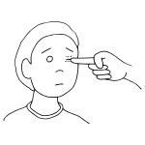
Burn/hand - poke/eye -cut /finger - break/nose
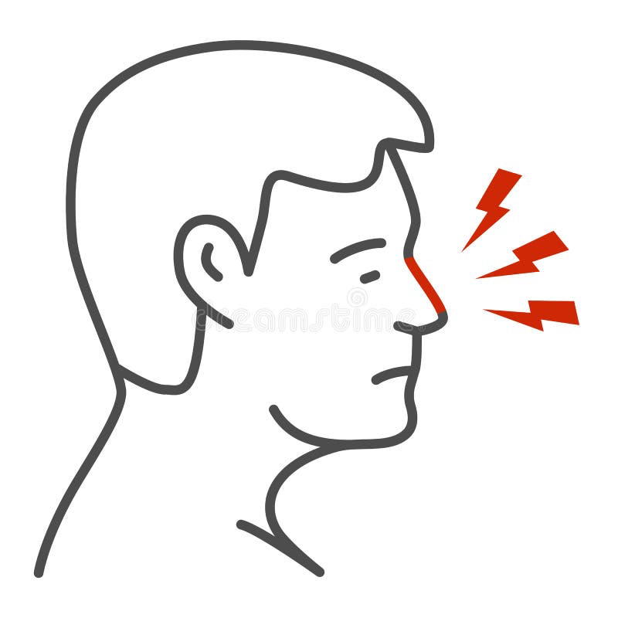
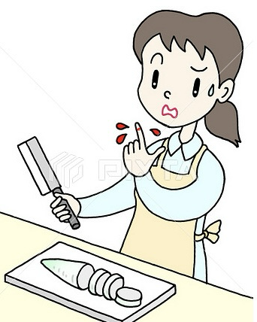
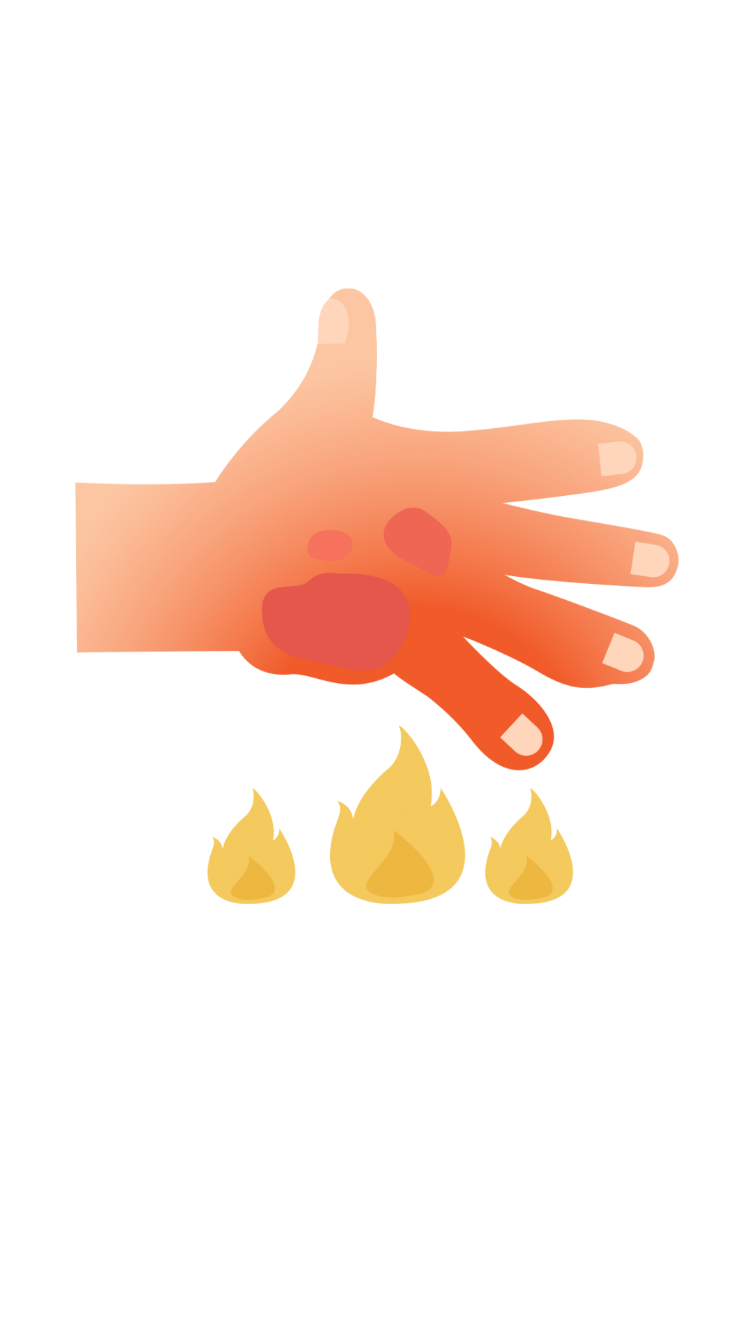


__________ ___________ ___________ ___________

- Choose the correct answer to fill in the blank in each question:
- to me . Means:
- be part of | b-in my opinion | - give up | - busy
- have a ball ……….. Means.
- I’m certain | - have a good time | - abroad | - Are you joking?

End of questions , good luck
T. Nora Enzy

English Language Final Exam |  | Kingdom of Saudi Arabia
The Second Trimester,1st Session, 1446 |  | Ministry of Education
The 1.2 Secondary Grade |  | General Directorate of Education in Makkah
Time: 2.30 hours |  | South Education Office
No. of pages: 3 |  | …Secondary School
مستعينة بالله أجيبي عن الأسئلة التالية:
I- Composition:
English 1.2/ English Language
1st Secondary grade
2nd Term Final Exam 1446
Time: 2 hours

A- Guided Composition:
Kingdom of Saudi Arabia
Ministry of Education
Hail Education Directorate
ALrawdah Secondary School

Write an email to advice Nasir that has problem in his new school
Guided words: great school- feeling down- sorry- accepted - new student- short conversation- participate- football team- get better
Dear Nasir
…………………………………………………………………………………………………………………………………………………………………………………………………………………………………………………………………………………………………………………………………………………………………………………………………………………………………………………………………………………………………………………………………………………………………………………………………………………………………………………………………………………………………………………………………………………………………………………………………………………………………………………………………………………………………………………………………………………………………………………………………………………………………………………………………………………………………………………………………………………………………………………………………………………………………………………………………………………………………………………………………………………………………………………………………………………………………………………………………………………………………………………………………………………………………………………………………………………………………………………………………………………………………………………………………………………………………………………………………………………………………………………………………………………………………………………………………………………………………………………………………………………………………………………………………………………………………………………………………………………………………………………………………………………………………………………………………………………………………………………………………………………………………………………………………………………………………………………………………………………………………………………………………………………………………………………………………………………………………………..………………………………………………………………………………………………………………………………………… hope to see you soon
…………….
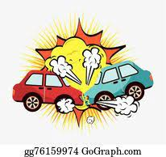
+++++++++++++++++++++++++++++++++++++++++++++++++++++++++++++++++++++++++++++++
B- Free Composition:
Write an essay about( accidents )
………………………………………………………………………………………………………………………………………………………………………………………………………………………………………………………………………………………………………………………………………………………………………………………………………………………………………………………………………………………………………………………………………………………………………………………………………………………………………………………………………………………………………………………………………………………………………………………………………………………………………………………………………………………………………………………………………………………………………………………………………………………………………………………………………………………………………………………………………………………………………………………………………………………………………………………………………………………………………………………………………………………………………………………………………………………………………………………………………………………………………………………………………………………………………………………………………………………………………………………………………………………………………………………………………………………………………………………………………………………………………………………………………………………………………………………………………………………………………………………………………………………………………………………………………………………………………………………………………………………………………………………………………………………………………………………………………………………………………………………………………………………………………………
اسم الطالبة
رقم الجلوس

6

II -Grammar:

6
A-Choose the correct answers:

1- He bought ( himself – herself-ourselves ) a new tablet.

2-​I went to the doctor ( because – so-no ) I was sick. -
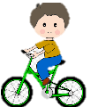
3-How (many - much -any) cell phones have you bought ?
4-When I was young, I _(used to- would-could) have a lot of energy. I was always outside playing
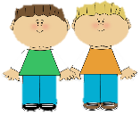
or riding my bike.
5-Ali and Ahmad were (boy-a boy-boys) who we saw them at the local school
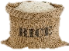
6- I bought ( some- any-not) rice.
B-Do as shown between brackets:
1-projector - no - There - is - in the class [Unscramble to make a sentence]
----------------------------------------------------------------------------------------------
2- You __________ eat while driving. [ Give advice]
3- You ought to ignore speed limits. [Make it negative]
-----------------------------------------------------------------------------------------------
III- Vocabulary:

6
A-Match between the words and their pictures:
1-

6

6
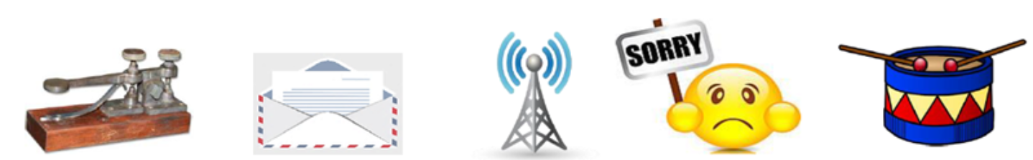
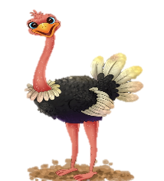
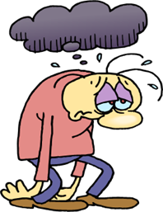

2- Match the words with the meanings:
1-challenge | ( ) being in good health
2- recover | ( ) a period in the history
3-stone age | ( ) get better
4- keep fit | ( ) "fight against
5-Of course
3- Circle the Odd words :
Burn/hand - poke/eye -cut /finger - break/nose

4-Give the antonyms for the words:
6

IV-Reading
1
Read the following passage and answer the questions below:

6


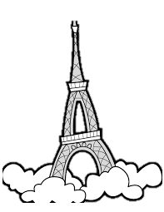

A-Answer these question:
1 – What is of the most famous building in the world.?
………………………………………………………………………………………………………………………………………………………………………………
2 - Was it the tallest building in the world?
………………………………………………………………………………………………………………………………………………………………………………
3- Where can you find smaller copies of Eiffel Tower?
……………………………………………………………………………………………………………………………………………………………………………

B- Write [ T ] for True or [ F ] for False :
- The tower got its name from its designer,.
- At present, it is without doubt one of the most recognizable memorial in Europe.
C- Choose the right answer :
1. The tower opened to the public on
a-5 May 1889 b-6 May 1889 c-7 May 1889
2. Eiffel Tower is a ,,,,,,,,,, high
a-324m b-325m c- 326m
D-Find the antonym :
a- bigger #..................................... b- shorter #......................



