
Kingdom of Saudi Arabia 4th, 5th & 6th Elementary Grade
Ministry of Education Time: An hour and a half
……… Elementary School Number of papers: 3 . Final Exam – Second Term – 1446 AH
- General Questions:
/ 6
- Choose the correct answer:
- What is your favorite story?
- I like to jump a rope b- Cinderella
- How was your day at school yesterday?
- It was great b- I played soccer
- Did you go shopping on Friday?
- Yes, I did b- Yes, she did
- What activities do you do in your free time?
- I usually do it on weekend b- I go swimming
- Could you ride a horse?
- Yes, I can b- No, I couldn’t
- What did you do on your vacation?
- I climbed the mountains b- It was boring

- Controlled Writing:
/ 5
- Fill in the missing words:
Earth – loudly – robbed – desert

  He talks (……………….) | 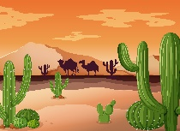  Very dry land, usually with sand.  (……………….) |   The planet we live on. (……………….) |   He (……………….) the house.

- Rearrange the words to form a sentence:
- forgot – her backpack – She – to take
……………………………………………………..

- Reading Short Sentence:
/ 4
- Read the sentences then choose the correct sentence for each picture:
 | 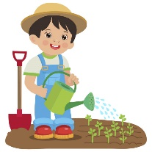 |  | 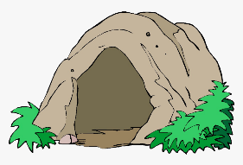
a-_I call my friend.  b-_I carry the books. | a-_I fix the hose.  b-_I water the plants. | a-_I play video games.  b-_I play board games. | a-_We visit a cave.  b-_We walk in the forest.

/ 5
- Grammar:
- Choose the correct answer:
- Did you (called – call) your friends?
- I like soccer, (and – but) I don’t like tennis.
- She (didn’t see – didn’t saw) a movie.
- He decided (to play – playing) soccer.
- I could (read – reading) when I was 2.

- Vocabulary:
/ 6
- Choose the correct answer:
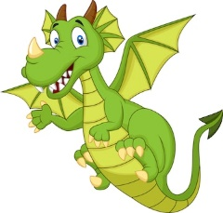 | 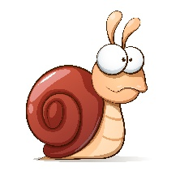 |  |  |  | 
- island  - dragon | - snail  - frog | - rope  - present | - homework  - graduation | - clap  - paint | - cry  - carry

- Orthography:
/ 4
- Choose the correct missing letters:
  mo__ster |  | 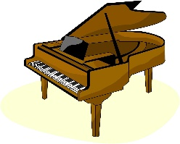  pi__no |  | 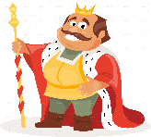  __ing |  | 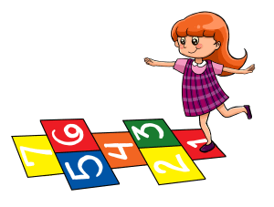  ho__scotch
m | n | a | e | j | k | p | q
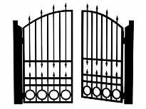  __ate |  |   te__ting |  | 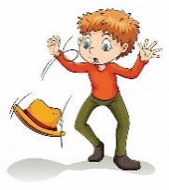  dr__p |  | 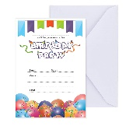  in__ite
g | r | x | k | o | u | f | v

BEST OF LUCK
Ms. Tahani Al-Ghamdi



اختبار نهاية الفصل الثاني ( الدور....)
للعام الدراسي 1446هـ
المادة /اللغة الانجليزية
الصف :رابع، خامس،سادس (.......)
زمن الإجابة / ساعة ونصف
التاريخ : 12/7/1443 هـ

المملكة العربية السعودية
وزارة التعليم
الإدارة العامة للتعليم بالمنطقة الشرقية
مكتب التعليم بالخبر
مدرسة ....................

30

الدرجة كتابة :

``
اسم الطالب ……………………………………………………………………….……………………………………………رقم الجلوس …………………………
Answer the general questions:

- What do you like to do for fun?

I like to climb ……………………
- Did you win?
No, we………………..
- Which activities do you do in your free time?
I like to play………………………….. games.
- Can you run quickly?
Yes, I …………………….
5- Which places in nature do you like visiting?
I like to visit ………………….
- Could you swim when you were six?
Yes, I…………………..

Reorder the words:

- the books! / drop / Don’t
………………………………………………………………………………………………………………………………....
- jumped / the rope. / She
………………………………………………………………………………………………………………………………….
- play / I want to / board games.
…………………………………………………………………………………………………………………………………..
- Did you / the car. / fix
………………………………………………………………………………………………………………………………….
- Happily. / playing / She is
…………………………………………………………………………………………………………………………………..
Match the questions to their answers:


1-What is your favorite story? Yes, I did. I like football.
2- Did you play football today? My favorite story is the city mouse.
3-Do you want to make a model? No, I couldn’t
4-Could you ride a horse? No, I want to play hide and seek.

أقلب الورقة
Choose the correct words:
- I ( score – scored) three goals yesterday.
- She didn’t ( drop – dropped ) the cup.
- Did he ( play – played ) video games last night.
- I want to go out, ( but – and ) it’s raining now.
- He’s walking ( quick – quickly ).

Circle the correct word:
fixed  e-mailed | 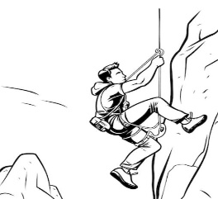  climbed  invited |   cave  Earth | 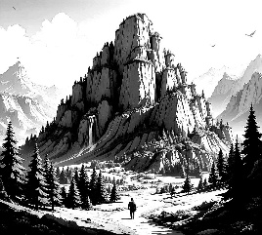  loudly  mountain | 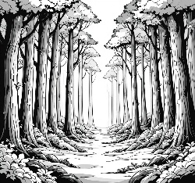  robbed  forest | 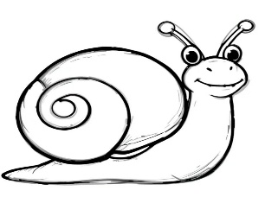  vlogging  snail
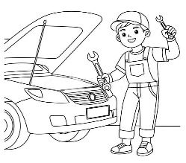

Circle the missing letter:
  Tex_ing  n  t | 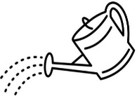  Wate_ed  s  r | 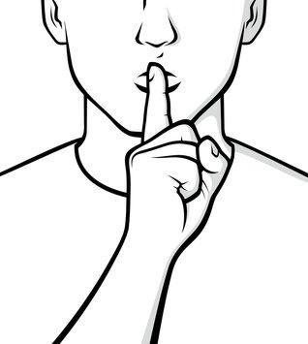  Qu_etly  i  g | 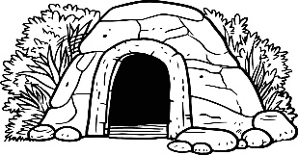  Ca_e  v  z

انتهت الأسئلة

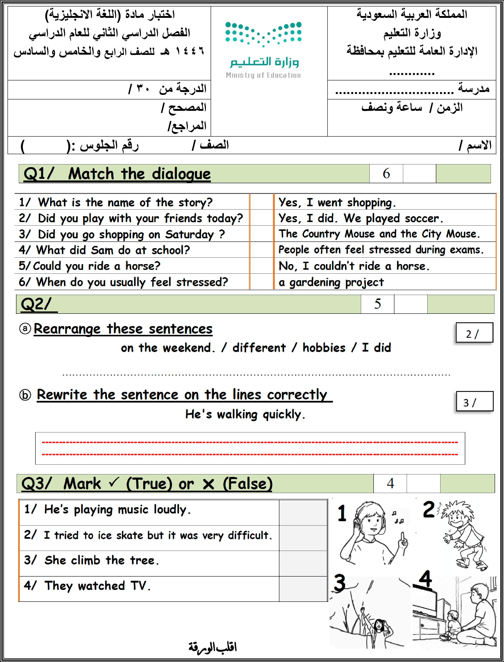

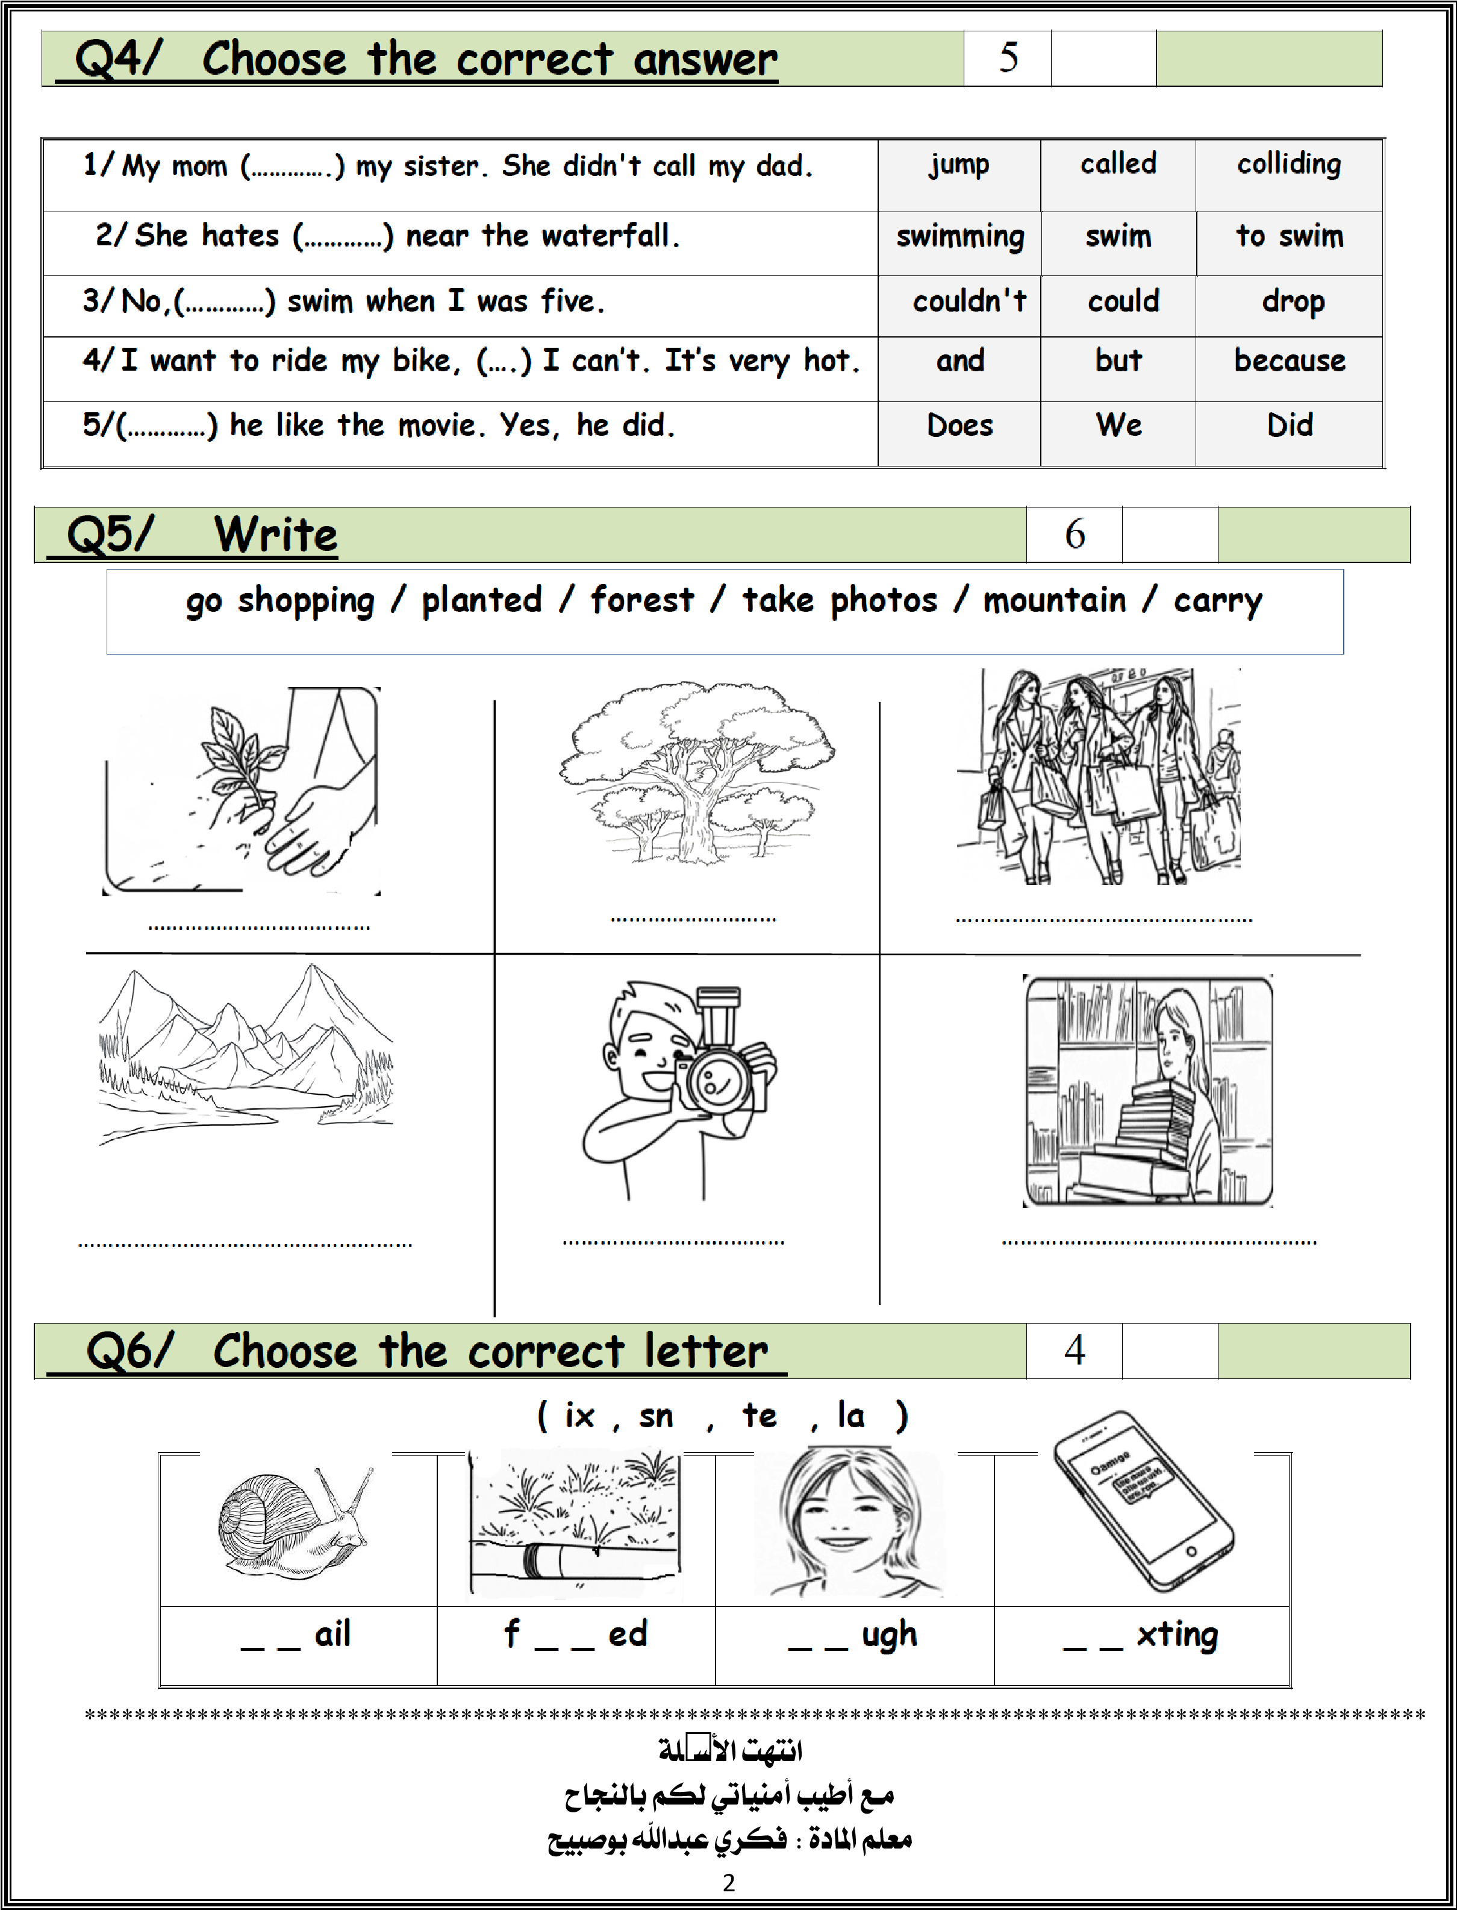

6
Q1:( A ) Match "A" with "B":
"A" |  | "B"
- What do you like to do for fun? |  |  | I like visiting the countryside.
  - What is this ? |  |  | This is the Earth.
- Which place do you like visiting? |  |  | I like to jump rope.

(B) Choose the correct answer :
1- Did she invite her friend at home ?
∎ Yes, I do . | ∎ No, I don't. | ∎ Yes, she did.
2- Could they climb the mountain?
∎ No, he does . | ∎ Yes, he doesn't. | ∎ Yes, they could.
3- What do you do after school ?
∎ She is my mom . | ∎ Here you are . | ∎ I dress up .

5
(2) A / Order the words to make a sentences with a good handwriting:
- climb – the tree – didn't – He .
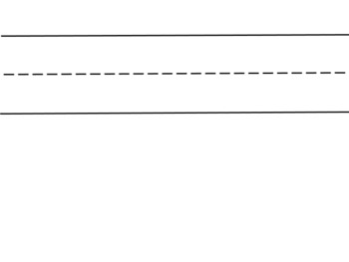

B\ Do as shown between brackets:
- The adverb of quick is ………………….. . ( USE ly )
- The past of go ( went – took ). (CHOOSE )
- I ………………… the flowers yesterday . ( COMPLETE)

Q 3) Put (✔️) or ( ✖️):

4 | 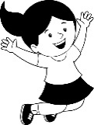  1- She is playing happily .
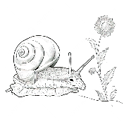
The snail is close to the plant . 2-
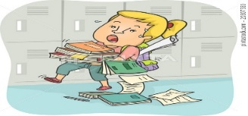
3- She didn't drop the books .

They took a photo . 4-

Q 4 ) Choose the correct word:.
5
1- Yesterday I ( dreamed _ dream _ dreams ) about monsters.
( Did _ Are _ Do ) he make a model last week ? . 2-
3- She can run, ( but _ what _ because ) she can't swim.
4- I want (to walk _ walks _ walked ) in the mountain.
5. The children didn't ( like _ likes _ liking ) the movie .

6
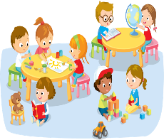
Q5 ) Number
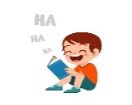
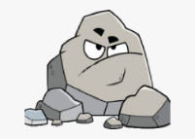
1.hard rock .
2. funny book .
3. inside activities.

Q 6 ) : Tick the correct word :
  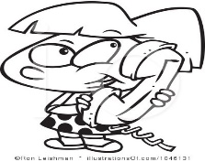 |  | 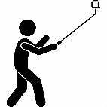 |  | 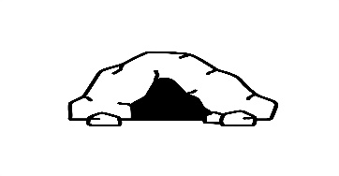 | 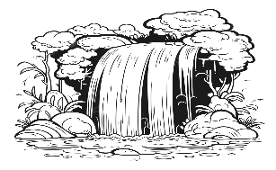
□ cry  □ call | □ invite  □ water | □swimming  □ vlogging | □ slowly  □ badly | □ tree  □ cave | □ desert  □ waterfall

4


Q 7)Choose the correct splling :
 | 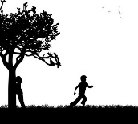 | 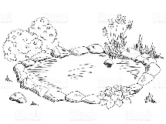 | 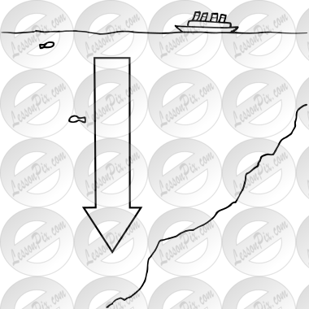
◊ stop  ◊ skop | ◊ hide  ◊ heid | ◊ laek  ◊ lake | ◊ daip  ◊ deep

