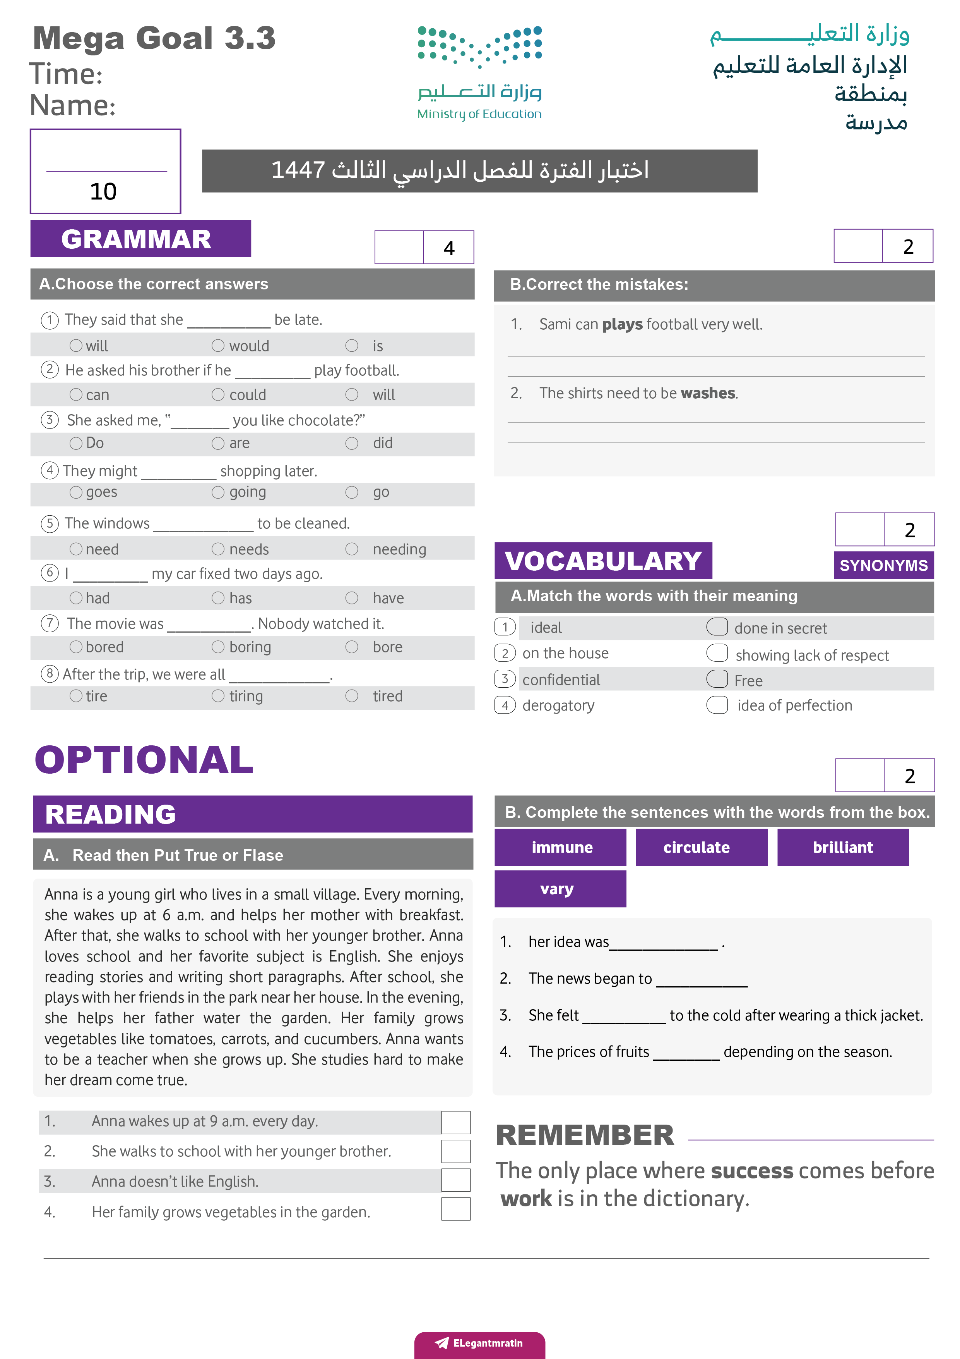
الزمن هنا
اسم المدرسة
اسم المدينة

الاسم ثلاثي: |  | الفصل | / | الدرجة
اختبار اللغة الانجليزية للصف الثالث الثانوي مسارات الفصل الدراسي الثالث لعام 1446هـ


2

Read then answer the following questions:
Mrs. Sara often blow too much money on clothes. She does not need new clothes,
but she loves buying them . Yesterday she saw a beautiful coat in a shop window .
She went in and put it on . It was just the right size, but the problem is that she maxed out her credit card.
Mrs. Sara did not have enough money ,but she took the coat home and showed it to her
husband . He liked it very much , but he did not like the price. His wife gave him a bill for
2000 RS.

- ( true or false )

1-Mrs. Sara left the coat in the shop ( )
2-Mrs. Sara does not need new clothes , but she loves buying them( )

B-Choose:

1-Her husband did not like..........
a-the color of the coat b –the price of the coat.
2-The coat was very.........
a-expensive b-very cheap

A-choose the correct form in brackets:
2

1-The computer ( need – needs – needed – needing ) to be fixed.
2-You had better ( brushing – brushes – brushed – brush ) your teeth.
3-The technician fixed his ( broken – break – breaking – broke ) phone.
4-They may ( go – went – gone – going ) to the party.
2

B-Do as shown between brackets:
1-Ali said” I`m hungry” ( repot the quoted speech)
………………………………………………………………………………………………………………
2-Don`t you like coffee I`m surprised ( complete using that )
…………………………………………………………………………………………………………..
A-Fill in the spaces with suitable word:
rumor – discover - elements
2

1-Iron,copper,oxygen and carbon are all examples of …………………………………
2-I heard a ……………….that you are moving away . Is it true?
2

B-Choose the correct word for each picture:
nail polish – hand – lipstick – gossip - throat

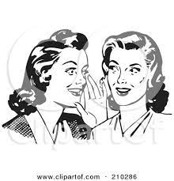 | 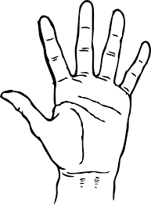 | 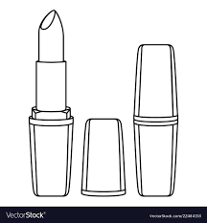 | 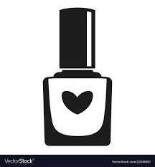




Kingdom of Saudi Arabia Period Exam
Ministry of Educations MG 3.3
English Language Department Date : ……………

المجموع : 10/ | الصف : | الاسم :

Choose the correct answer:

1_ The meaning of (ridicule) is

A _ exceptional B_ making fun of C_ leaving out

2_ The meaning of (malicious) is

A _deliberately harmful B _ permanently C _move around

3 _I………….. my house painted yesterday.

A _have B _has C _had

4 _ He is a good actor (the noun clauses after verb is

A _I'm sour that B _I think that C _I'm happy that

5 _They said that he …………..gossip

A _liked B _likes C _ liking

6 _ Nour said that he had ……………. Them leave.

A _ seen B _ see C _ saw

7 _ I think ……………. Support your brother.

A _ should B _ that you should C _ you that should

8 _ He asked me where I …………………going

A _ be B _ was C _ were

Underline the correct word for each picture:

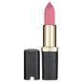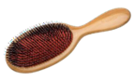

(backstabber – superior) (praise _ gossip ) (lipstick – blusher ) ( toothbrush – hairbrush )

BEST WISHES
Haya Alshahrani

