Choose:

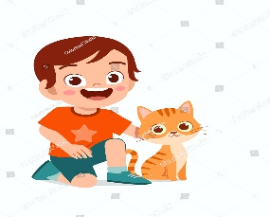
1 – Do you have a pet ?

A. Yes I do , I have a cat .

B. No, I don't .

Match:


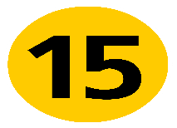



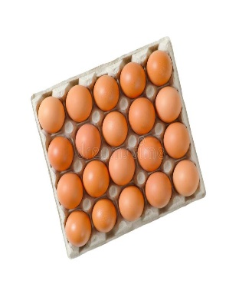
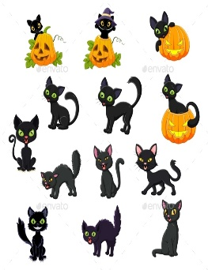

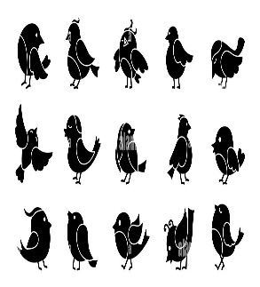

_____ _____ _____ _____
_______________________________________________________________________________________________________________________________________________________________________________________________________
Copy :

I am 7 years old.

……………………………………………………………………………..………………………………………………………………….……..……………………………………………………………………………..……………………………………………………………………..……………………………………………………………………………..……………………………………………………………..……..

Choose:

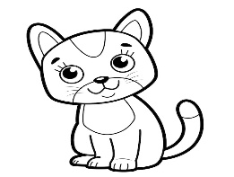 | 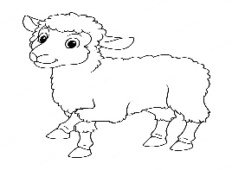 | 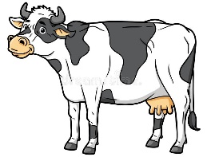 | 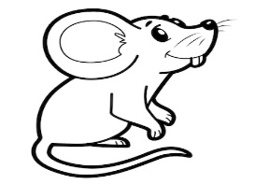 | 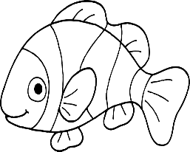
cat | sheep | bird | chicken | bird
duck | horse | cow | mouse | fish

Choose the correct letter:

  __mbrella | 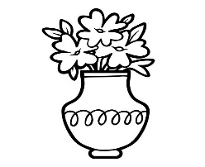  __ase | 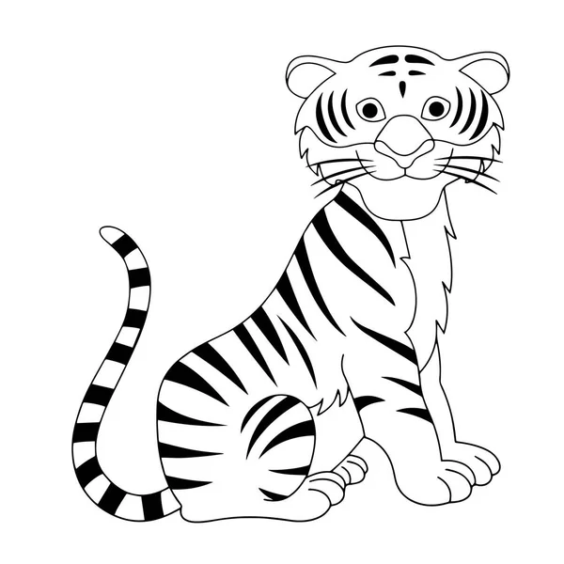  __iger | 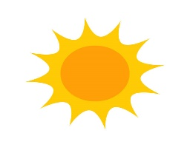  __un
u | v | d | c
v | f | t | s

________________________________________________________________________________________________________________________________________________________________
A
h
Match:
b
H

y
D

B
d

Y
a

_
__________________________________________________________________________________________________________________________________________________________________________________
Controlled writing

4
Good luck





M_zaid0
