

Worksheet – we can3

3rd grade Unit 10 A Healthy Life

Name ………………………………… Class ………………………………

__________________________________________________________________________________________

General Questions

1– What should you do to live a healthy life ?

A.I should go to bed early. B. I should skip breakfast.
2 – Did you get up early this morning?

A. Yes, we do . B. Yes, I did .


____________________________________________________________________________________________________

Reading short sentences

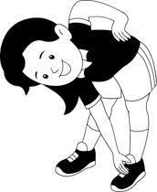
1. I should do my exercise.

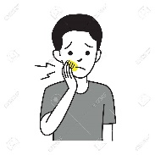
2. I have a headache.


___________________________________________________________________________________________

Controlled writing
______________________ |  |  | 1– sleep – should – early – I ( rearrange )
Goodbye | Goodnight | Good morning | 2-Greeting at night ____. ( choose )
earache | headache | toothache | 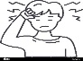  ( choose ) 3. I have a _____.
poor | wealthy | Healthy | 4. He is _____ .  He has a lot of money . ( choose )

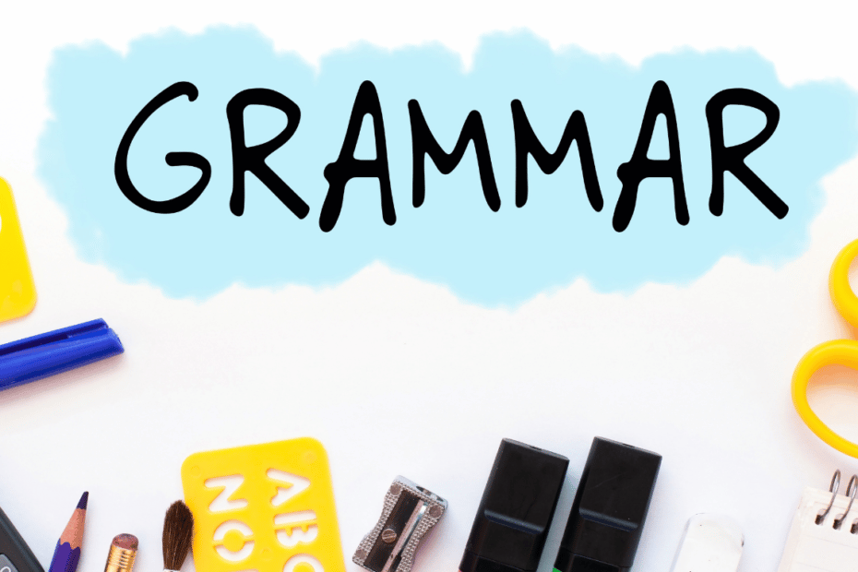
Grammar
brushing | brush | brushed | 1- I should ______ my teeth.
got up | get up | do | 2- Did you ____ early this morning ?
does | did | do | 3- Did you eat breakfast? yes, I ______.
drinks | drank | drink | 4- Did you drink milk ? Yes, I _____ milk .

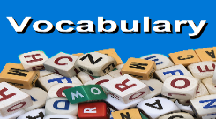
_____________________________________________________________________________________________________

Vocabulary

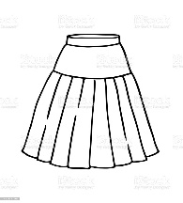 | 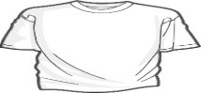 | 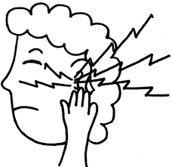 | 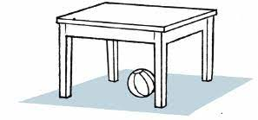
belt | T-shirt | stomachache | Headache
skirt | scarf | earache | toothache


_____________________________________________________________________________________________________
Orthography (spelling)

Choose the correct letter:

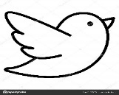  b_ _ d | 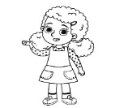  g_ _l | 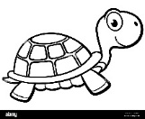  t_ _tle | 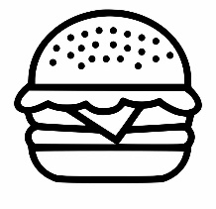  b_ _ ger
ur | ir | ur | ar
ir | ur | er | ur

Controlled writing

4

Good luck T.

3th Grade Unit 10 A Healthy Life
Name……………………………………………………. Class………...
I can answer questions about A Healthy life . . .

Answer the following questions: -
1- What are the things you should do to live a healthy life?
get up early in the morning.
I should ………………………………………….
2-What are the things you shouldn’t do to live a healthy life?
stay up late at night.
I shouldn’t …………………………………………

3-Did you get up early this morning?
Yes, I did.
…………………………………………………
I can choose the correct aches .
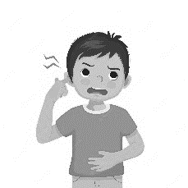
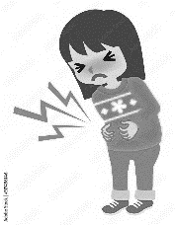

Match: -
3
4
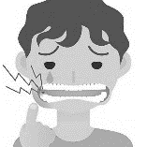
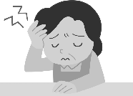
1-Headache 2-Toothache
3-Stomachache 4-Earche
2
1
I can write the correct form of the verb

Write the missing verb form: -
Regular Verbs
Present | Past
play  talk | ……………….  played
……………………  brush | talked
………………………. | brushed  watched
watch | …………………….
Irregular Verbs
Present | Past  Got up
Get up  eat | ……………….
……………………  do | ate
………………………. | did  drank
drink | …………………….
I can tell & do healthy things
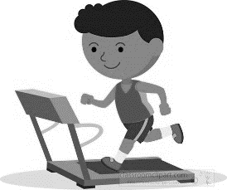
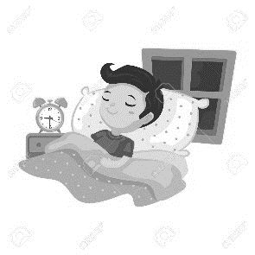
Choose: -
3
1-Do some exercise.
1
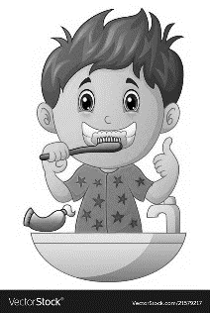
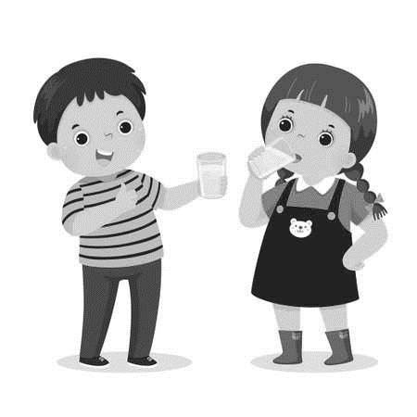
2-Brush your teeth.
3-Go to bed early.
2
4
4-Drink lots of water.
I can fill in missing letters

Fill in: -
ur / ir

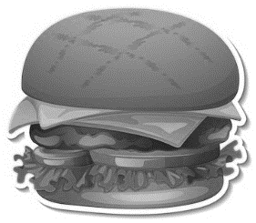
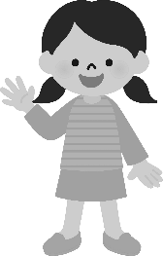
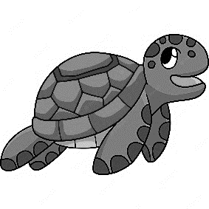
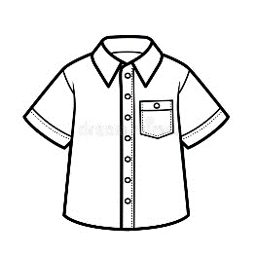

ir
ur
ur
ir
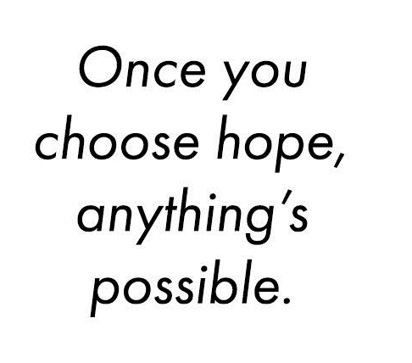
1-T__ __ tle 2-Sh__ __t 3-G__ __l 4-B__ __ ger

