Name: …………………………………… Ms. Tahani
Class: 1st Intermediate
Revision Sheet _ Unit ( 12 ) : What Can You Do There?
- Vocabulary:
- Write the words under the pictures:
draw – fish – rollerblade – dive – climb

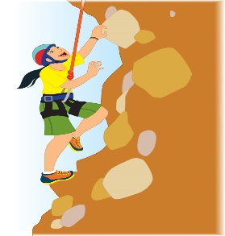
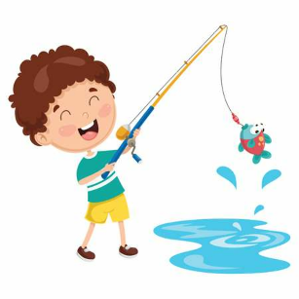
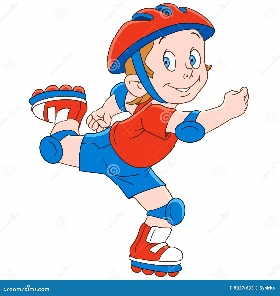
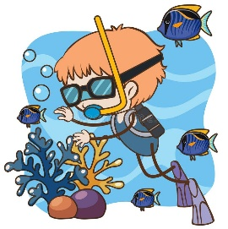

________________ __________________ __________________ __________________
- Classify the words:
golf – bookstore – hotel – swimming

Places in a town | Sport

- Circle the odd word:
- Places in a town: bus station – mall – snorkel – museum
- Verbs-Sports: sail – restaurant – hike – ice skate

- Match:
- When’s good for you? a- You’re saying something I think is strange.
- Are you crazy? b- Are you sick?
c- What time is good for you?

- Fill in the blank with the correct words in the box:
resort – fly – museum – match – beach

- Today’s football …………….. is France versus Brazil.
- I will …………. to London tomorrow.
- We collected shells on the …………….
- We stay the whole summer at a beach ……………..

- Choose the correct answer:
- You can go shopping and meet friends. This place is a (hotel – mall – bank).
- You can open an account. This place is (airport – bus station – bank).
- You can buy books. This place is a (bookstore – mosque – supermarket).

- Grammar:
- Choose:
- I can (speak – speaks – speaking) English.
- A: Can you swim?
B: Yes, (I can’t – can I – I can).
- A: Can you swim?
B: No, (I can’t – can I – I can).
- Where is my book? I (can – no can – can’t) find it.
- The children (can – no can – can’t) tie their shoelaces yet.
- Ali is a skilled swimmer. He (can – no can – can’t) swim very well.
- They like (read – reads – to read) novels.
- He likes (ride – rides – to ride) a bike.
- I (don’t like – doesn’t like – no like) to play basketball.
- She (don’t like – doesn’t like – doesn’t likes) to cook.
- Do you enjoy (go – to go – going) to football matches?
- Do you want (stay – to stay – staying) at home tonight?
- I can’t stand (wear – to wear – wearing) glasses.
- I feel like (drink – to drink – drinking) cappuccino. Anyone else?
- I would like (go – to go – going) to the beach.

- Do as shown between brackets:
- Dana can cook. (Change into negative)
…………………………………………………..
- Turki can drive a car. (Make a Yes/No question)
…………………………………………………..
- I want (buy) some stickers. (Correct the verb)
…………………………………………………..
- He can’t stand (wait) in line. (Correct the verb)
…………………………………………………..
- Faten likes to talk on the phone. (Change into negative)
…………………………………………………..

Name: …………………………………… Ms. Tahani
Class: 1st Intermediate
Revision Sheet _ Unit ( 13 ) : What Are You Going To Wear There?
- Vocabulary:
- Write the words under the pictures:
sneakers – waterfall – sunglasses – graduation – suit
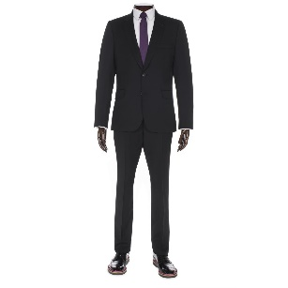
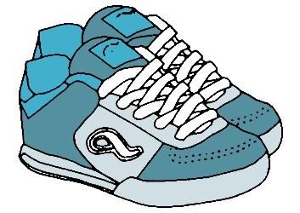

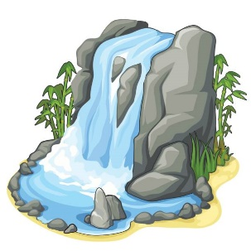

_______ _________ __________________ __________________ __________________
- Classify the words:
beige – skirt – pants – gray

Clothes | Colors

- Circle the odd word:
- Clothes: blouse – jacket – brown – coat
- Women’s clothes: skirt – thobe – dress – abaya
- Men’s clothes: shomagh – suit – thobe – dress
- Warm clothes: coat – scarf – shorts – gloves
- Light clothes: T-shirt – raincoat – hat – jeans
- Colors: yellow – purple – sweater – orange

- Match:
- ‘put on’ means: a- dark blue
- The opposite of ‘casual clothes’: b- wear
- The opposite of ‘light blue’: c- wedding
d- formal clothes

- Fill in the blank with the correct words in the box:
uniform – tie – socks – weather – sandals

- My brother never wears shoes without …………….. .
- A businessman usually wears a suit and a …………. .
- In the summer, Ali wears shorts and …………….
- The color of my school …………….. was dark green.

- Grammar:
- Choose:
- I am going (buy – buys – to buy) a new dress.
- She (am – is – are) going to meet her friends.
- They are (going play – going playing – going to play) football tomorrow.
- He (visits – is going to visit – visiting) his uncle next week.
- She is wearing a (red new shoes – new red shoes – shoes red new).
- I (wear – wearing – am wearing) a black skirt now.

- Do as shown between brackets:
- Sara is going to bake a cake. (Change into negative)
…………………………………………………..
- Talal is going to buy a car. (Make a Yes/No question)
…………………………………………………..
- I (wear) a pink dress tomorrow. (Correct the verb)
…………………………………………………..
- is / to fly / Lama / to Dubai / going / next month (Unscramble the sentence)
…………………………………………………..
- new / tie / Ali / a / has / nice / silk (Unscramble the sentence)
…………………………………………………..

Name: …………………………………… Ms. Tahani
Class: 1st Intermediate
Revision Sheet _ Unit ( 14 ) : Let’s Celebrate
- Vocabulary:
- Write the words under the pictures:
fireworks – gift – parade – flag – donate



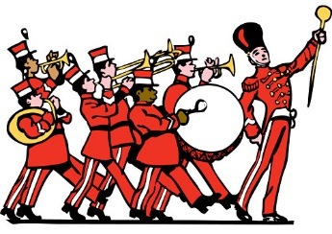

________________ __________________ __________________ __________________
- Classify the words:
National Day – me – invitation – us – fun – Eid Al-Fitr

Words related to celebrations | Holidays | Object pronouns

- Circle the odd word:
- Holidays: Independence Day – Liberation Day – Eid Al-Adha – decorate
- Words related to celebrations: flag – gift – kitchen – card
- Object pronouns: her – snack – them – you

- Match:
- donate a- by a large number of people
- widely b- sacrifice
- generosity c- give away in order to help
d- the spirit of giving or sharing freely

- Fill in the blank with the correct words in the box:
decorate – fireworks – invite – share – donate

- I want to ……………… my cousins for Eid.
- We will ……………… our old clothes to charity.
- You can watch the ………………… in the sky at night.
- People ……………….. their homes with bright lights.

- Grammar:
- Choose:
- You give (I – me – my) a pen.
- My dad bought (they – their – them) a car.
- I will ask (her – she – hers) to help me.
- Our mom makes a cake for (we – our – us).
- She needs (drink – to drink – drinks) water.
- He wants (buy – buys – to buy) a smartphone.
- They like (study – studies – to study) in the morning.
- Let’s (play – playing – to play) basketball.
- We (must – mustn’t – should) eat in the class.
- You (must – mustn’t – shouldn’t) study, if you want to pass the exam.
- She has a headache. She (mustn’t – should – shouldn’t) take some painkillers.
- He is fat. He (should – shouldn’t – must) eat junk food.

- Do as shown between brackets:
- (Write the object pronoun that can take the place of the underlined noun)
- We invite Rana and Hind to the party. (…………….)
- I will ask Nasser to help me. (…………….)
- Mom loves you and me. (……………)

- (Complete the sentences using must or mustn’t)
- We ……………… drive too fast.
- We ……………… listen to the teacher.

- (Complete the sentences using should or shouldn’t)
- You …………….. brush your teeth.
- You …………….. play with fire.

- I want (decorate) the house. (Correct the verb)
…………………………………………………..

Name: …………………………………… Ms. Tahani
Class: 1st Intermediate
Revision Sheet _ Unit ( 15 ) : Then and Now
- Vocabulary:
- Write the words under the pictures:
balcony – skyscraper – vendor – businessman - pedestrian

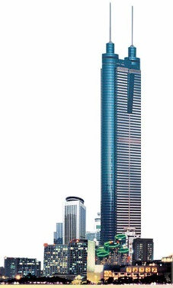

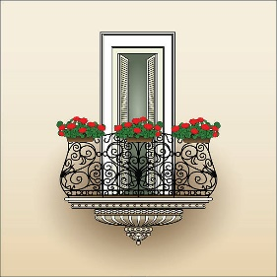

________________ __________________ __________________ __________________
- Classify the words:
narrow – mud bricks – house – wooden – mosque – tall

Building | Material | Size

- Match:
- How are things? a- You’re joking!
- You’re kidding! b- How old are you?
c- How are you?

- Fill in the blank with the correct words in the box:
boss – tournament – protect – attractive – crowded

- Omar was the best boxer in the ………………….
- Last summer, Abha was very …….………….
- Mr. Ali is our …………...…….
- We need to ……………… Earth because it is our home.

- Match the word with its opposite:
- interesting a- new
- comfortable b- boring
- old c- narrow
d- uncomfortable

- Grammar:
- Choose:
- I (were – was – not was) born in Dammam.
- She (wasn’t – not was – were) at school last Monday.
- The children (was – not were – were) hot and thirsty after the match.
- He (were – was – was no) on holiday in Hawaii.
- There (was – no was – were) a party in my uncle’s house last night.
- There (was – no was – were) some cars in the city last Monday.
- (She – Her – Hers) drinks some coffee.
- You gave (I – me – my) a pen.
- They have a car. This is (they – them – their) car.

- Do as shown between brackets:
- My mother was a nurse ten years ago. (Change into negative)
…………………………………………………..
- They were hungry and thirsty after work. (Make a Yes/No question)
…………………………………………………..
- Sara wasn’t at the hospital last weekend. (Change into affirmative)
…………………………………………………..
- There was a tree in the park. (Change to the plural form)
…………………………………………………..
- There were five dolls in your room. (Change to the singular form)
…………………………………………………..

Name: …………………………………… Ms. Tahani
Class: 1st Intermediate
Revision Sheet _ Unit ( 16 ) : What Did You Do Last Week?
- Vocabulary:
- Write the words under the pictures:
accident – race – console – rice – volleyball

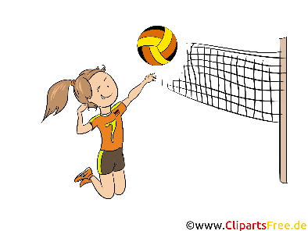
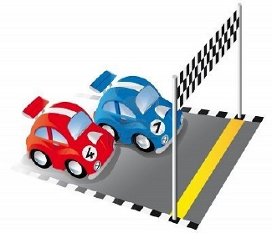
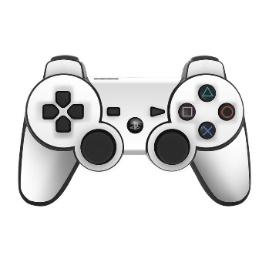
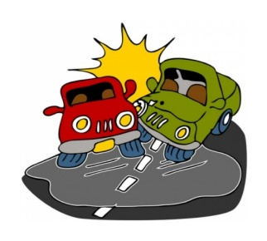

________________ __________________ __________________ __________________

- Circle the odd word:
- Sequence words: first – then – sugar – finally

- Match:
- looking for a- console
- equipment for video games b- smartphone
- a high-tech phone c- searching
d- assignment

- Fill in the blank with the correct words in the box:
melt – spicy – topping – stay – expensive

- Try not to eat too much …………….. food.
- Do you want to go out or ……………. home?
- If you warm ice, it will ……………. into water.
- The diamond ring is the most …..…………….. .

- Grammar:
- Choose:
- I (go – goes – went) to the mall yesterday.
- She (read – reads – reading) a story last night.
- They didn’t (drink – drinks – drank) hot chocolate.
- He usually (eat – eats – ate) pizza.
- He (eat – eats – ate) pizza last Monday.
- She (phone – phones – phoned) her aunt every Friday.
- She (phone – phones – phoned) her aunt last Friday.
- (Do – Does – Did) he sleep early yesterday?
- (Do – Does – Did) he always sleep early?
- (Do – Does – Did) they always sleep early?

- Do as shown between brackets:
- Sara watched TV last night. (Change into negative)
…………………………………………………..
- Talal drove his father’s car. (Make a Yes/No question)
…………………………………………………..
- I (see) my cousins last week. (Correct the verb)
…………………………………………………..
- Rana didn’t clean her room yesterday. (Change into affirmative)
…………………………………………………..
- Lama writes her homework. (Change to the past)
…………………………………………………..
- Ali swam in the pool. (Change to the present)
…………………………………………………..
- (Write the simple past tense of the verbs)
- go: …………….
- clean: …………...
- drink: ……………
- eat: ………………
- drive: …………….
- write: …………….
- play: ……………...

