Name: ……………………………………… Ms. Tahani
Class: 3rd Intermediate
Revision Sheet _ Unit ( 9 ) : All Kinds of People
- Vocabulary:
- Write the words under the pictures:
thief – pedal cab – flyers – spill – athletic
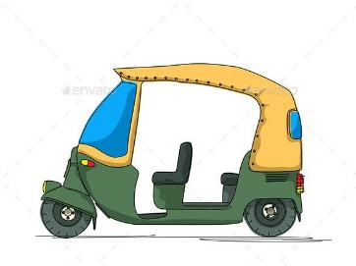




________________ __________________ ___________________ __________________
- Classify the words:
polite – rude – honest – pessimistic

Good manners | Bad manners

- Circle the odd word:
- generous – selfish – kind – clever
- absentminded – talkative – patient – liar

- Match:
- poverty a- lack of jobs
- to establish b- being poor
- loan c- to make less
- unemployment d- to create
e- money you borrow

- Fill in the blank with the correct words in the box:
persuasive – serious – on duty – hail – steal

- Shall we ………………… a taxi?
- A ………………….. person is someone who gets other to do what he/she wants or to think a certain way.
- There were two security guards …………………. outside the building.
- I caught him trying to …………………….. my bike.

- Match the opposites:
- optimistic a- lazy
- polite b- friendly
- hardworking c- unreliable
- reliable d- pessimistic
e- rude

- Grammar:
- Choose:
- An oven is a machine (who – which – when – where) is used for cooking food.
- A clown is a person (who – which – when – where) makes children laugh.
- A fashionable person is someone (that – which – when – where) dresses well.
- That isn’t the laptop (who – that – when – where) is on sale.
- My brother was wating TV while he (eat – eats – ate – was eating) dinner.
- Ahmed was walking in the park when he (see – sees – saw – was seeing) Hameed.
- Hind (study – studies – studied – was studying) for the math test when the phone rang.
- Dad (drink – drinks – drank – was drinking) coffee while he was reading the newspaper.
- May I (ask – asks – asked – asking) you a question?
- I would like (book – books – to book – booking) a room.

- Do as shown between brackets:
- They (surf) when it started to rain. (Correct the verb)
…………………………………………………..
- Mom was cutting some vegetables (while) she cut her finger. (Correct the mistake)
………………………………………………………
- Could I speak to the manager?
…………………………………………………. (Agree)
…………………………………………………. (Refuse)

Name: ……………………………………… Ms. Tahani
Class: 3rd Intermediate
Revision Sheet _ Unit ( 10 ) : Who Used My Toothpaste?
- Vocabulary:
- Write the words under the pictures:
nail polish – toothpaste – hairbrush – hair dryer – dishwashing liquid
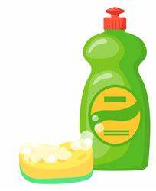

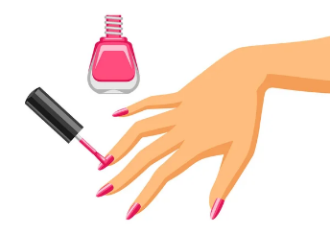
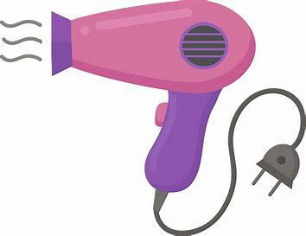

________________ __________________ ___________________ __________________
- Classify the words:
clean up after meals – don’t take out the garbage – say ‘please’ and ‘thank you’ – chewing with mouth opens

Good manner | Bad manner

- Circle the odd word:
- ‘irritate’ means: drive you crazy – get under your skin – piece of cake – annoy

- Match:
- let down a- let someone have
- find out b- learn
- give back c- phone
- give up d- express yourself freely
e- return

- Fill in the blank with the correct words in the box:
borrow – turn down – clean up – nephew – feed

- A …………………….. is a son of one’s brother or sister.
- The baby can’t …………………….. itself yet.
- Would you ……………………..your radio a little?
- Help me …………………….. the house.

- Grammar:
- Choose:
- Have you done the dishes (already – just – yet – since)?
- I have (just – yet – since – for) washed the clothes.
- I haven’t washed the clothes (just – yet – since – for).
- Faris has (since – for – yet – already) come home.
- I can’t stand (wait – waits – to wait – waiting) in line.
- He enjoys (read – reads – reading – to read) novels.
- I can’t stop (drank – drinking – drinks – drink) tea and coffee.
- Dana couldn’t sleep last night. She (can’t – is – must – didn’t) be tired.
- Rana’s just joking. She (can’t – is – must – did) be serious.
- The meal was (so – such – so many – so much) delicious that we ate too much.
- John is (so – such – so many – so much) a naughty boy that nobody likes him.
- I have (so – so many – so much – such) watches that I can’t decide which one to wear.
- He put (so – so many – so much – such) salt that we couldn’t eat it.

- Do as shown between brackets:
- (Complete the sentences with so many or so much)
- He has ……………………. money that he could buy any house in the city.
- He has ……………………. books that he can hardly carry them.

- (Complete the sentence with so or such):
- It was ……………… expensive that we couldn’t afford it.
- There was ……………… bad weather that we had to stay home all day.

- (Combine the sentences with so…that or such…that)
- It was a beautiful day. We decided to go for a drive after school.
………………………………………………………………….
- The music was loud. We called the police.
………………………………………………………………….
- (Rewrite each sentence with a two-word verb in two ways)
- Turn off the TV.
…………………………………
…………………………………
- Take out the garbage.
…………………………………
…………………………………
- Amal has done the grocery shopping. (Use already)
………………………………………………….
- Sara has put her jacket in the closet. (Use yet)
………………………………………………….
- done/the dishes/hasn’t/Jana/yet (Unscramble the sentences)
………………………………………………….
- I hate (be) in a dirty room, so I do the chores. (Correct the verb)
…………………………………………………

Name: ……………………………………… Ms. Tahani
Class: 3rd Intermediate
Revision Sheet _ Unit ( 11 ) : Making Choices
- Vocabulary:
- Write the words under the pictures:
farmer – airshow – resort – graduation – pollution
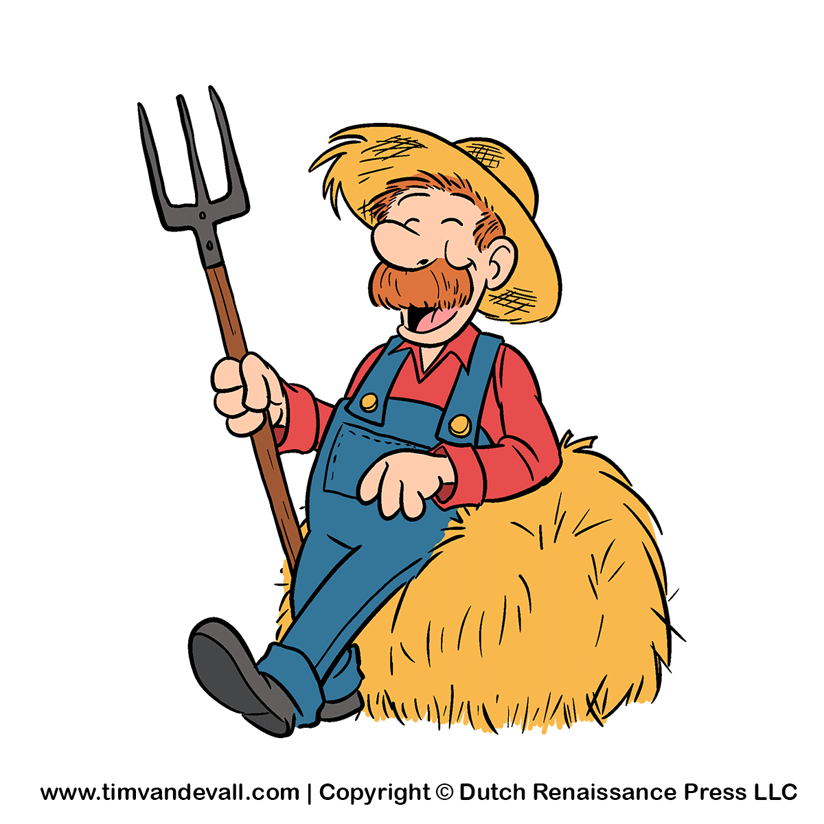
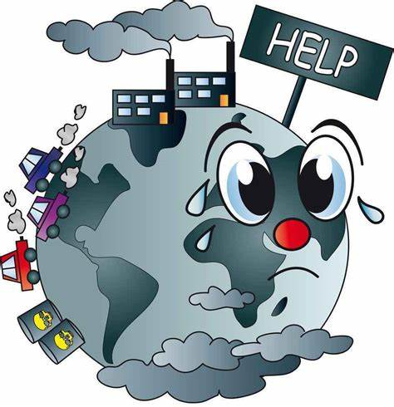

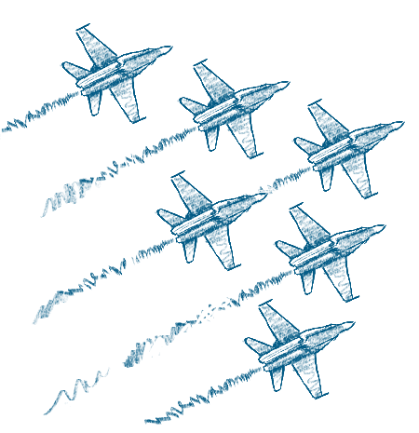

________________ __________________ ___________________ __________________

- Match:
- up in the air a- advantage
- make up your mind b- decide
- a ticket c- undecided
- benefit d- a fine
- scenic e- to prepare for a test
f- with beautiful views

- Fill in the blank with the correct words in the box:
scenic – pass – involve – choice – care

- Did you …………… your final exam?
- She had to make a …………….. between the two dresses.
- I’ll take …………… of my parents when they get old.
- Our hotel had a ……………. beauty of the countryside.

- Grammar:
- Choose:
- If you come home late, your mother (is being – will be – would be) angry.
- If he (cheat – cheats – cheating) on exams, he won’t learn anything.
- If you heat ice, it (melt – melts – will melt).
- I’d rather (eat – eats – eating) carrots for lunch.
- If I won a million dollars, I (put – will put – would put) the money in a bank.
- If you (have – has – had) a better job, we would be able to buy a new car.
- If she (bought – buys – buy) some new clothes, she would look much nicer.
- I wish I (live – lives – lived) in a big house in the city.

- Do as shown between brackets:
- (Correct the verb)
- If you mix red and blue, you (would get) purple.
…………………………………………………
- If he spoke more clearly, people (understand) him.
………………………………………………….
- If it (not rain), we will go for a walk.
………………………………………………

Name: ……………………………………… Ms. Tahani
Class: 3rd Intermediate
Revision Sheet _ Unit ( 12 ) : Culture Shock
- Vocabulary:
- Write the words under the pictures:
chopsticks – porter – lawyer – mud – pocket

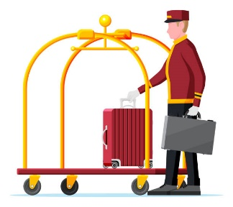
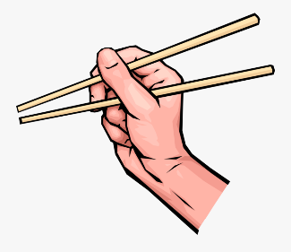



________________ __________________ ___________________ __________________

- Match:
- flexible a- person who has arrived recently
- frustrating b- an expression of surprise and disbelief
- homesick c- annoying because you can’t do something you want
- newcomer d- something new and interesting
- no kidding! e- able to change in different situation
f- missing home and family

- Fill in the blank with the correct words in the box:
host – tip – remove – punctual – expect

- She is always ……………………, but her friend is always late.
- He gave the porter a ……………… .
- She was a generous ………………… .
- Please help me to …………………….. the table to the corner.

- Choose the correct answer:
- ‘Being in a new place and not being comfortable’ means:
- Fish out of water b- Culture shock
- ‘The period of adjustment when someone moves to a new country’ is the definition of:
- Fish out of water b- Culture shock
- A …………… is a person who greets or welcomes a guest.
- guest b- host
- The opposite of ‘polite’ is:
- inpolite b- impolite

- Grammar:
- Choose:
- I forgot (take – takes – took – to take) my vitamins today.
- It is important (be – being – to be – was) patient.
- She decided (study – studies – studied – to study) abroad.
- Make sure (turn – turned – turning – to turn) off the light before you leave.
- It is polite for businessman (shake – to shake – shaking – shakes) hands.
- (Travel – Travels – Travelling – Travelled) is a good way to learn about other cultures.
- I am not used to (eats – to eat – eating – ate) with chopsticks.
- It isn’t easy to get used to (live – lives – lived – living) in a new cultural environment.
- She used to (drinking – drinks – drink – drank) coffee in the morning, but now she drinks tea.
- By the time we arrived at the station, the bus (leave – left – had left – leaving).
- Before we sold our car, we (own – owned – has owned – had owned) it for 12 years.
- After the guests had left, I (go – went – going – had gone) to bed.
- Until they found a new job, they (be – being – was – had been) unemployed for years.

- Do as shown between brackets:
- After she (move) out, I found her notes. (Correct the verb)
………………………………………………….
- By the time we (come), she had finished the project. (Correct the verb)
………………………………………………….
- (Complete the sentences using a gerund or an infinitive)
- The airline refused (pay) for our hotel.
………………………………………………
- (Eat) candy is bad for your teeth.
………………………………………………
- I promise not (lie) again.
………………………………………………
- I enjoy (read) novels.
………………………………………………

