Name: …………………………………… Ms. Tahani
Class: 2nd Intermediate
Revision Sheet _ Unit ( 12 ) : It’s Going to Be Fun!
- Vocabulary:
- Write the words under the pictures:
mosquito – coral reef – oasis – jungle – theme park

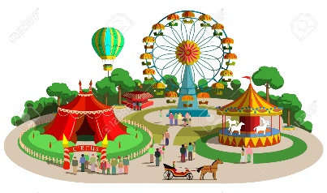
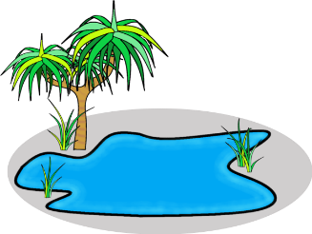
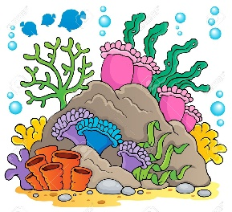
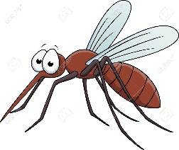

________________ ____________________ __________________ __________________

- Circle the odd word:
- Information Questions: Why – Did – When – Which
- Vacation kinds: relaxing – adventurous – luxurious – passport
- Vacation plans: climb a mountain – go to a museum – exciting – see amazing scenery

- Match:
- actually a- not visited by many tourists
- off the beaten track b- cheap
- inexpensive c- thrilling
d- used to introduce an opposing idea

- Fill in the blank with the correct words in the box:
scuba diving – safari – explore – allergic – coastal

- Columbus discovered America but he didn’t ……………… the new continent.
- My hobbies are skiing and ……………….……..
- Jeddah is a ……………….. city.
- I am ……………. to dairy products.

- Choose the correct answer:
- The restaurant serves international ………….
- tomb b- cuisine
- She likes to wear …………. clothes.
- peaceful b- exotic
- He wants to ……….. his name on his desk.
- carve b- ancient

- Grammar:
- Choose:
- Yasser is going to (eat – ate – eating) pizza.
- Lama (am – is – are) going to visit her friend tomorrow.
- Waleed is (go playing – going play – going to play) football.
- (How – Who – Where) do you get to school?
- (How – Who – When) is your best friend?
- (When – Who – Which) is your English exam?
- (How – Which – Where) colour do you prefer? Red or blue?
- Amal is (a student smart – a smart – a smart student).
- I did my homework (correct – correctly).
- My friend is a fast driver. He drives (fast – fastly).
- Mona is a good cook. She cooks (good – well).
- Dana is a hard worker. She works (hard – hardly).

- Do as shown between brackets:
- (Rewrite the sentences using adverbs of manner)
- Rana is a quiet talker.
…………………………………………………..
- Omar is a careful driver.
…………………………………………………..
- Nasser is a good player.
…………………………………………………..
- Imad is going to sail next Saturday. (Change into negative)
…………………………………………………..
- She is going to stay at home. (Make a Yes/No question)
…………………………………………………..

Name: …………………………………… Ms. Tahani
Class: 2nd Intermediate
Revision Sheet _ Unit ( 13 ) : What’s the Weather Like?
- Vocabulary:
- Write the words under the pictures:
hurricane – cherry blossom – gulf – cloudy – barometer

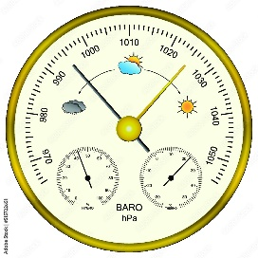
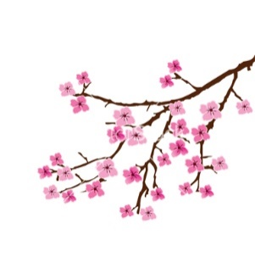
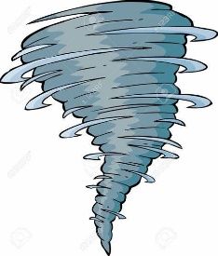


________________ ____________________ __________________ _________________

- Classify the words:
spring – dry – fall – windy

Seasons | Weather words

- Circle the odd word:
- Seasons: summer – winter – snow – fall
- Weather words: cold – cool – sunny – spring

- Match:
- I hear a- a way to introduce news
- It depends b- a prediction of future weather on the radio or television
- Weather forecast c- degrees Celsius
d- a way to say you are not certain

- Fill in the blank with the correct words in the box:
leaves – rain – warm – breathtaking – vary

- Temperatures …………… from city to city, even in the same state.
- It’s going to ………………. today. You need your umbrella.
- The view from my bedroom window was absolutely …………………...
- The color of …………….. is green in summer.

- Grammar:
- Choose:
- I will (meet – meets – meeting) you at seven.
- A: (What – Where – How) will you do in the summer?
B: I’ll probably travel.
- A: (What – Where – How) will you go?
B: I’ll go to Japan.
- A: (What – Where – How) will you go?
B: Maybe I’ll drive.
- If you put the water in the freezer, it (become – becomes – becoming) ice.
- If you study hard, you (passes – passing – will pass) your exam.
- If it (rain – rains – will rain), they won’t play tennis.
- If I go to university, I (studies – studied – may study) engineering.

- Do as shown between brackets:
- Amal will go shopping next week. (Change into negative)
…………………………………………………..
- Sara will stay home on Saturday. (Make a Yes/No question)
…………………………………………………..
- If you (will mix) blue and red, you get purple. (Correct the verb)
…………………………………………………..

Name: …………………………………… Ms. Tahani
Class: 2nd Intermediate
Revision Sheet _ Unit ( 14 ) : Could You Do Me a Favor?
- Vocabulary:
- Write the words under the pictures:
napkin – borrow – family gathering – graduation - lower
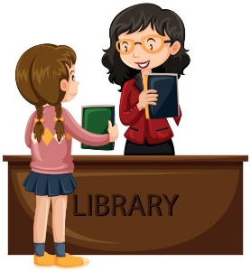
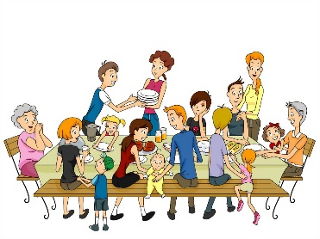
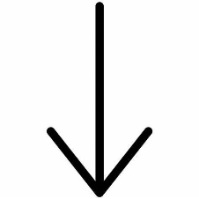
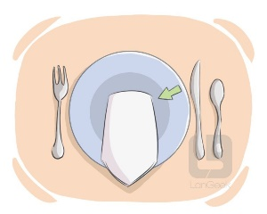

________________ ____________________ __________________ _________________

- Match:
- Will you do me a favor? a- borrow
- I have no idea b- I agree
- The opposite of ‘lend’ c- I don’t know
d- Will you help me with something?

- Fill in the blank with the correct words in the box:
lend – lower – snack – ticket – favor

- I had a huge lunch, so I’ll only need a …………….. for dinner.
- Could you ……………. Your voice?
- Will you ……………. me your camera?
- Will you do me a ………………..?

- Choose the correct answer:
- When people offer help:
- an offer b- a request
- When people ask for help:
- an offer b- a request
- Would you get me some more coffee?
- an offer b- a request
- Let me carry that for you.
- an offer b- a request

- Grammar:
- Choose:
- Would you (pass – passes – passing) me the salt?
- I want Omar (take – takes – to take) out the garbage.
- The mother wants her children (put – to put – putting) the toys away.
- Mr. Ali wants me (fill – fills – to fill) in this form.
- Ask him (to bring – bringing – brings) some snacks.
- Tell the children (lower – to lower – lowering) their voices.

- Do as shown between brackets:
- (Write requests for the situations)
- The bag is really heavy. I can’t carry it.
…………………………………………………..
- I’m thirsty. I want something to drink.
…………………………………………………..

- (Make offers for the situations)
- Someone is carrying a heavy bag.
…………………………………………………..
- Some people want someone to take their photo.
…………………………………………………..

- (Unscramble the words to make sentences)
- to the mall / your brother / ask / to drive you
…………………………………………………..
- her room / tell / to clean / your sister
…………………………………………………..
- dad / to help his brother / wants Fahad / with his homework
…………………………………………………..

- (Match each sentence with its function)
1. I’ll try harder next time. a. offer
2. I won’t let you use my bike. b. refusal
3. I’ll have a chicken burger. c. threat
4. I’ll talk to you later. d. promise
5. Will you explain it again? e. request
6. I’ll show you how to do it. f. instant decision
7. Stop that or I’ll tell the teacher. g. farewell
8. He won’t be home now. h. deduction

Name: …………………………………… Ms. Tahani
Class: 2nd Intermediate
Revision Sheet _ Unit ( 15 ) : Today’s News
- Vocabulary:
- Write the words under the pictures:
scream – parrot – snake – wound – lightning
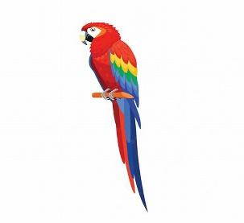
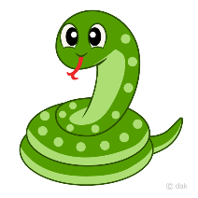
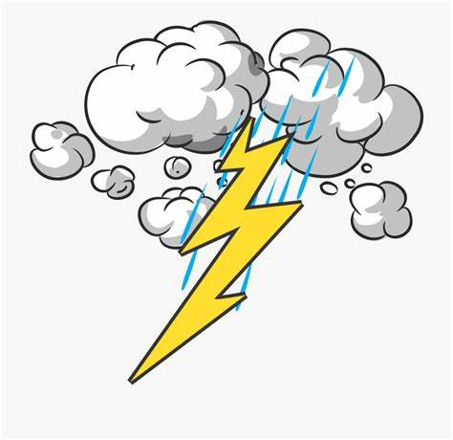
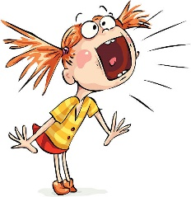

________________ ____________________ __________________ _________________

- Match:
- keep my cool a- piece of equipment
- be fired b- didn’t get stressed
- device c- lose one’s job
- wound d- shout loudly
- shriek e- dominate
f- injury

- Fill in the blank with the correct words in the box:
headphones – attack – burn – stuck – fired

- He didn’t work hard. Thus he was ………………
- She got ………………. in an elevator.
- He was sitting on a bench and listening to a music through his …………………...
- Children have to stay out of the sun because their skins …………… easily.

- Match the word with its opposites:
- empty a- weak
- improper b- full
- strong c- fast
d- proper

- Grammar:
- Choose:
- She was (listen – listens – listening) to my iPod, so she didn’t hear the fire alarm.
- You were (study – studied – studying) chemistry all day yesterday.
- When the phone rang, she (writes – were writing – was writing) a letter.
- When we got home from the party, the children (sleep – slept – were sleeping).
- I could (run – ran – running) fast when I was young.
- I wasn’t able to (seeing – saw – see) in the dark.

- Do as shown between brackets:
- She was cooking. (Change into negative)
…………………………………………………..
- They were playing golf. (Make a Yes/No question)
…………………………………………………..
- When the telephone rang, I (take) a shower. (Correct the verb)
…………………………………………………..
- I agree with you. (Use ‘absolutely’)
…………………………………………………..
- Nada couldn’t speak when she was one year and a half. (Use ‘be able to’)
…………………………………………………..
- I was able to ride a bike until I was 20. (Use ‘could’)
…………………………………………………..

Name: …………………………………… Ms. Tahani
Class: 2nd Intermediate
Revision Sheet _ Unit ( 16 ) : Have You Ever …?
- Vocabulary:
- Write the words under the pictures:
cage – rope – dive – knock – hang gliding
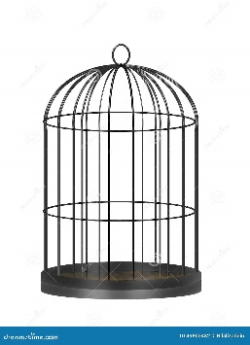
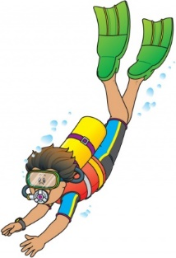
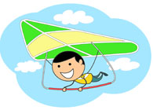
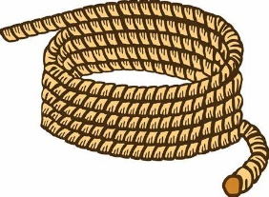

________________ ____________________ __________________ _________________

- Classify the words:
zebra – durian – cliff hanging

Sport | Animal | Food

- Circle the odd word:
- fish – shark – lobster – camel
- football – baseball – hang gliding – basketball
- bungee jumping – swimming – water skiing – surfing
- driving a car – cliff hanging – riding a bike – riding a motorcycle

- Match:
- You’re out of your mind! a- very frightened
- To be honest b- ships of the desert
- Scared to death c- You’re crazy!
d- to tell the truth

- Fill in the blank with the correct words in the box:
camel – weird – throw – up close – frightening

- I can’t …………… the ball up and catch it again.
- The child was ………………….. by the snake.
- This game has ………………….. rules.
- Some types of …………….. have two humps and others have one.

- Grammar:
- Choose:
- He (has – have – am – are) already played computer games.
- They haven’t (eat – ate – eating – eaten) the lunch yet.
- We (has – have – am – is) finished our math lesson.
- The students usually (write – are writing – wrote – have written) a test every month.
- The students (write – are writing – wrote – have written) a test at the moment.
- The students (write – are writing – wrote – have written) a test last week.
- The students (write – are writing – wrote – have written) a test so far.

- Do as shown between brackets:
- Amal has seen a shark. (Change into negative)
…………………………………………………..
- They have climbed a mountain. (Make a Yes/No question)
…………………………………………………..
- Eman (eat) a whole pizza yesterday. (Correct the verb)
…………………………………………………..
- Talal (not repair) his bike yet. (Correct the verb)
…………………………………………………..
- (Complete the chart. Use the correct forms of the verbs.)
Present | Simple Past | Past Participle
buy
 | drank
 |  | eaten
 | met
speak

