Name: ................................... Ms. Tahani
Class: 4th + 5th + 6th Elementary / ........
Revision Sheet _ Unit (6): House Accidents
- General Questions:
  - Match the questions with the correct answers:
- What’s the matter? |  | She has a headache.
- What does Reema have? |  | He should go to the hospital.
- Where should Ali go? |  | No, I am not.
- Do you need a doctor? |  | I had a stomachache.
- Are you all right? |  | Yes, I do.

- Controlled Writing:
  - Rearrange the words to form sentences:
    - should – the medicine – take – Omar
……………………………………………..
    - you eat – Wash – before – your hands
……………………………………………..
  - Read and write. Use the words in the box:
x-ray – stomach – upstairs – dentist

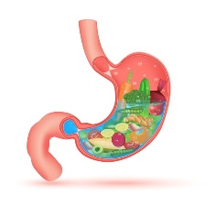  The part of your body where food goes.  ………………. | 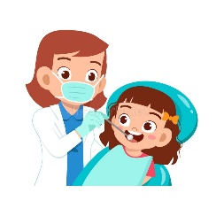  Amal has a toothache, she should go to the ……………… | 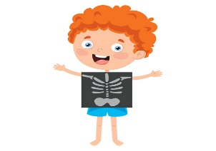  Fahad is having an ……………… | 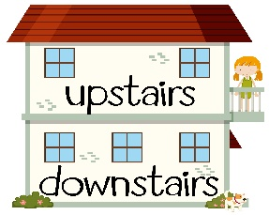  The top part of a building.  ………………..
- Reading Short Sentence:
  - Read the sentences then match them with the correct pictures:
 | 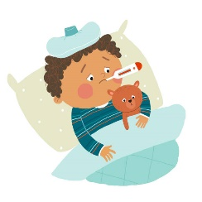 | 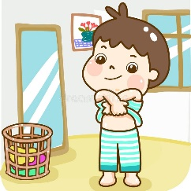 | 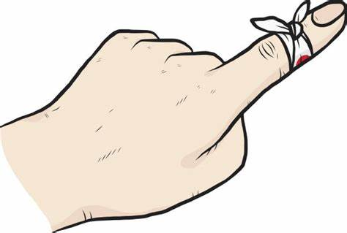
a-_He has an earache.  b-_He has a cough. | a-_I am ill.  b-_I am all right. | a-_I put on my clothes.  b-_I take off my clothes. | a-_I had a fall and my leg hurts.  b-_I have a cut on my finger.
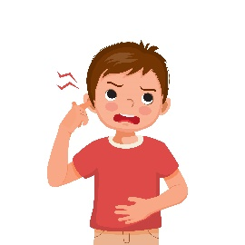

- Grammar:
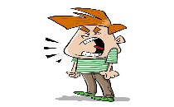
  - Choose the correct answer:
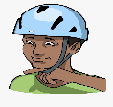
I want to ride my bike. You …………. wear a helmet.
must | mustn’t
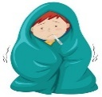
He has a cold. He …………
play outside.
should | shouldn’t
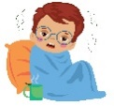
I’m feeling sick. You ……….
go to school.
don’t have to | have to
You …………… shout in the
hospital.
must | mustn’t
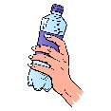
You ……….. drink a lot of
water. It’s good for your body.
should | 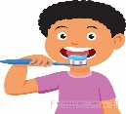  shouldn’t
You ………. brush your
teeth.
don’t have to | have to

  - Use the following words to complete the sentences:
someone everything nothing anything
    - Is there …………. to eat? I’m very hungry.
    - I bought ………….. we need to make a cake.
    - I think there is …………… at the door.
    - I have …………… to do. I have finished everything.
- Vocabulary:
  - Write the words under the pictures:
band aid – medicine – mask – cough – toys – cables
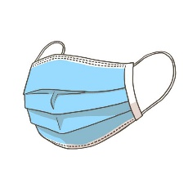

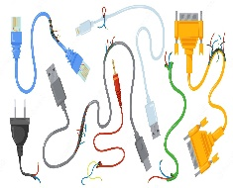 |  | 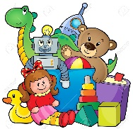 | 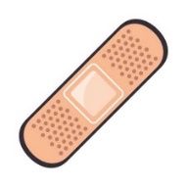 | 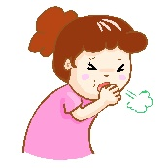
  - Write the opposite:
downstairs ≠ | put on ≠ | clean ≠ | all right ≠

- Orthography:
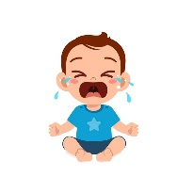
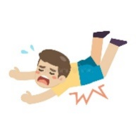
  - Fill in the missing letters:
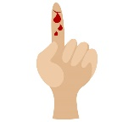 |  |  | 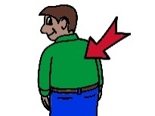 | 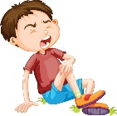 | 
c__t | f__ll | c__y | b__ck | hu__t | __ut on
  - Match the halves:
up | band | head | stomach | any | down | X
stairs | aid | one | ache | stairs | -ray | ache

Name: ................................... Ms. Tahani
Class: 4th + 5th + 6th Elementary / ........
Revision Sheet _ Unit (7): Wildlife
- General Questions:
  - Match the questions with the correct answers:
- What’s your favorite animal? |  | I work at the zoo.
- How is the tortoise moving? |  | I am a vet.
- Where do you work? |  | I love rabbits.
- What do you do? |  | It is moving slowly.

- Controlled Writing:
  - Rearrange the words to form sentences:
    - is – fast – The lion – moving
……………………………………………..
    - quiet – Cats – animals – are
……………………………………………..
  - Read and write. Use the words in the box:
frightened – cage – jungle – kangaroo

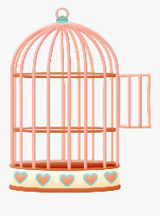  In zoos, some birds often live in this.  ………………. | 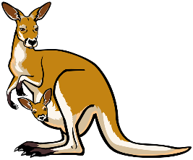  This animal jumps and has big legs.  ……………… | 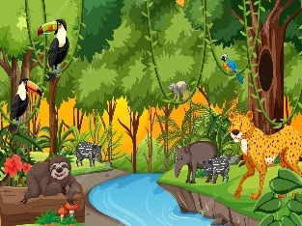  A place where wild animals lives.  ……………… | 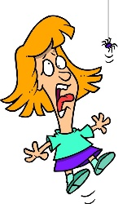  when you feel nervous and in danger.  ………………..
- Reading Short Sentence:
  - Read the sentences then match them with the correct pictures:
 | 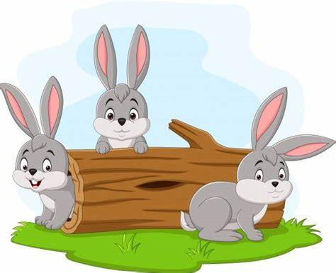 |  | 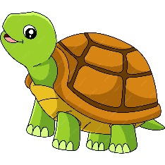
a-_They’re at the zoo.  b-_They’re at the animal shelter. | a-_I like parrots.  b-_I like rabbits. | a-_He is a vet.  b-_He is a zookeeper. | a-_It moves slowly.  b-_It runs fast.
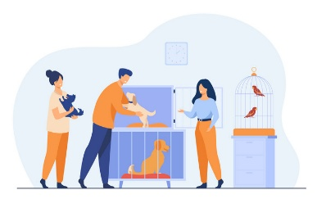

- Grammar:
  - Choose the correct answer:
- The mouse is (fast – faster – fastest) than the frog.
- The cheetah is the (fast – faster – fastest) animal in the world.
- Horses are (friendly – more friendly – most friendly) than cats.
- Kittens are the (friendly – more friendly – most friendly) animals in the world.

  - Use the following words to complete the sentences:
which whose where who when
    - Jungle is the place …………. tigers live.
    - This is the book ………….. I read.
    - It was October …………… I visited Jeddah.
    - The girl …………… dress is pink is my sister.
    - The girl …………… wears pink is my sister.
- Vocabulary:
  - Write the words under the pictures:
owl – giraffe – tortoise – polar bear – lion – friendly
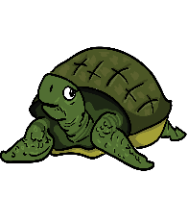
 |  | 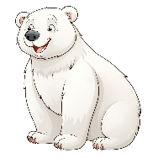 |  | 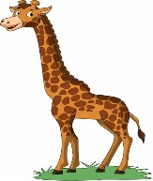 | 
  - Write the opposite:
slowly ≠ | dangerous ≠

  - Complete the chart:
Verb | Adjective | Noun
care |  | care
interest |  | interest
endanger | dangerous
help |  | help
- Orthography:
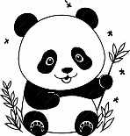 | 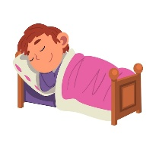 |  |  | 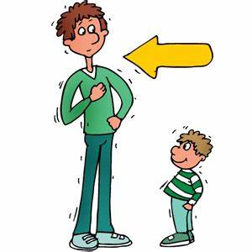 | 
pan__a | as__eep | s__art | bra__e | t__ll | dan__er

  - Fill in the missing letters:

Name: ................................... Ms. Tahani
Class: 4th + 5th + 6th Elementary / ........
Revision Sheet _ Unit (8): Weather
- General Questions:
  - Match the questions with the correct answers:
- What is the weather like today? |  | I like winter.
- What was the weather like yesterday? |  | I am going to visit my cousin.
- Is it going to be windy tomorrow? |  | It was windy.
- Was it sunny on Sunday? |  | Yes, it was.
- What are you going to do? |  | It is very hot.
- What’s your favorite season? |  | No, it isn’t.

- Controlled Writing:
  - Rearrange the words to form sentences:
    - very strong – is – The wind – today
……………………………………………..
    - going to – skateboarding – I’m – go
……………………………………………..
  - Look at the pictures and write the climate. Use the words in the box:
cold – wet – hot
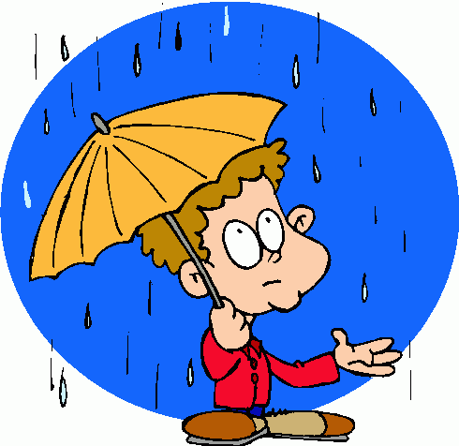  He is in the ……………. climate. | 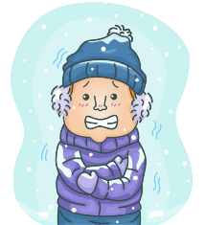  He is in the ……………. climate. | 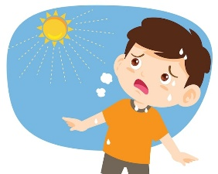  He is in the ……………. climate.

- Reading Short Sentence:
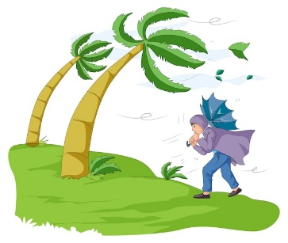 | 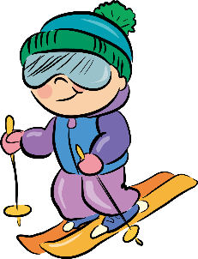 | 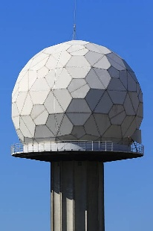 | 
a-_It’s going to be windy.  b-It’s going to be cloudy. | a-I’m going to go cycling.  b-I’m going to go skiing. | a- They go to the weather dome.  b- They go to the movies. | a-_It is summer.  b-_It is winter.
  - Read the sentences then match them with the correct pictures
- Grammar:
  - Choose the correct answer:
- They are going to (go – went – going) swimming next week.
- It (am – is – are) going to be sunny tomorrow.
- What (am – is – was) the weather like today?
- What (am – is – was) the weather like yesterday?

  - Do as shown between brackets:
--Is it going to be windy? (Answer the question)


…………………………………… ………………………………..

- Vocabulary:
  - Write the words under the pictures:
melting – flashlight – logo – umbrella – temperature – sunglasses

 | 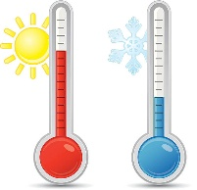 |  |  | 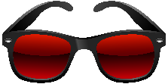 | 

  - Complete the chart:
Nouns | sun |  |  | wind | rain
Adjectives |  | cloudy | snowy

- Orthography:
 |  | 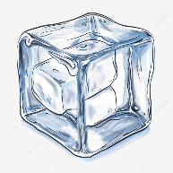 |  |  | 
s__n | rain__ow | i__e | rai__ | sea__ons | s__ow
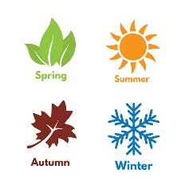
  - Fill in the missing letters:

