
Kingdom of Saudi Arabia Name: ……………………………
Ministry of education Class: 2nd Intermediate Grade
10 /
…….. Intermediate School First Exam - 1447 First Term
- Grammar:
- Choose:
- I (am – is – are) a smart student.
- This is the boy (who – which – when) had an accident
- Messi (play – plays – is playing) football now.
- The actors are ready to perform (over – in front of – under) the camera.

- Do as shown between brackets:
- Rasha bakes a cake. (Change into negative)
…………………………………………………………
- I (seeing) a bird in the tree. (Correct the verb)
…………………………………………………………

- Vocabulary:
- Write the words under the pictures:
salary – cameraman – key card – hotel – run away


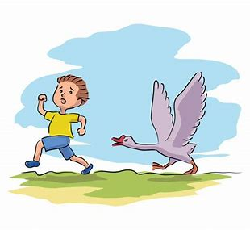


_____________ _______________ ________________ ______________

- Fill in the blank with the correct words in the box:
feed – festival – engineer

1- Fahad wants to be an ……………… in the future.
2- The baby is too young to …………………. itself.

- Match:
- All by myself a- an expression used when you give something to someone
- Here you are b-see you later
. c- with no one else’s help

- Orthography:
- Fill in the missing letters:
- I will call the hotel and make a reser__ation.
- She like to wear e__otic clothes.
- Have you ever watched this fi__m?
- The scr__pt is well-written.

Good Luck
Ms. Tahani Al-Ghamdi

Kingdom of Saudi Arabia
Ministry of Education
………… Education Directorate............
…………..……………….. Intermediate School

Total
المجموع | تحريري | شفهي
20 | 10 | 10

First Period Exam
Second Intermediate Grade

Name ………………………………… Class ………………………………
__________________________________________________________________________________________
/ 2
Comprehension

Read the following then answer the questions:

My family and I always go to the beach in the summer. We eat sandwiches and ice cream. We will drink orange juice. My brother likes to swim. My sister likes to likes to play with dad. We all have a good time .
A- Put (√ ) for true or ( ᵡ ) for false :

( ) | 1. We go to the beach in winter .
( ) | 2. My brother likes to play football.

B- Choose the right answer:

ice cream | apple | bread | meat | 1-Thy eat sandwiches and______.
brother | friend | dad | mom | 2-my sister likes to play with _____.
_________________________________________________________________
/ 2.5
Grammar

Choose the right answer:

1- We ___________ here for the festival.
A. is B. am C. are D. do
2 - ______ are you doing? Fine, thanks
A. Where B. How C. When D. which
3 - I am ______ a book now?
A. reading B. reads C. read D. write
4 - He is _______ in a hospital now.
A. work B. working C. works D. worked
5 - The waiter _______is serving the customers is friendly.
A. which B. who C. when D. how

/ 2
Vocabulary

A- Choose the best answer to fill in the blank:
1. _________ are good places for meeting people.
D. Playground | C. Room | B. Schools | A. Hotels
.2. Good night. ___________ tomorrow
D. Good afternoon | C. See you | B. Good bye | A. Good morning
3- Are you here for the conference? No, I’m here on ________ with my family.
D. playing | C. study | B. vacation | A. hotel
4- Half of the people in Saudi Arabia are under the _____ of 25.
D. strong | C. tall | B. age | A. old
B- Put the right word under its picture:
/ 2.5
 | 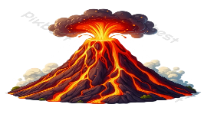 |  |  | 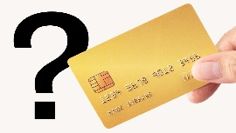

Credit card - engineer - cameraman - reception desk - volcano

_______________________________________________________________________________
/ 1
Orthography

Choose the correct letter:
k | h | d | 1. I’d like to intro_uce you to Joe.
b | m | t | 2. The soup s_ells good .

Good luck T.


Kingdom of Saudi Arabia
Ministry of Education
………………… School
English Language
Intermediate Grade 2nd
1st period Exam
……….\20
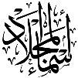

Student's Name : class:

……\ 5 marks
1-Read the following passage and answer the questions below:
Ali wanted to try a new sport. One day, he joined a karate class in his town. At first, he was afraid because karate looked difficult. The teacher gave him a white uniform and white belt. Ali started to learn how to kick, block, and punch. With practice, he became stronger and more confident. His teacher told him that karate is not just about fighting, but also about respect and self-control. After many months, Ali worked hard and earned a yellow belt. Karate helped Ali become healthy, brave, and focused.
c- tennis | b- basketball | a- Karate | 1- What sport did Ali join?
c- Books and pens | b- Short and cap | a-uniform and belt | 2- The teacher gave him…………………
c-sad | b-afraid | a-hungry | 3-How did Ali feel at first in the karate class?
c-Yellow | b-Blue | a-Green | 4- Which belt did Ali earn ?
c-brave | b-tired | a-lazy | 5- Karate helped Ali become…….
A.Choose the correct answer.
……\ 5 marks
2-Choose the correct answer.

c-am | b-is | a-are | 1- Riyadh………..in Saudi Arabia.
c- sleeps | b- sleeping | a- sleep | 2- Are you …………..?
c-What | b-How | a-Where | 3-………….old are you?
c- making | b- makes | a- make | 4- Sara is …………. a cake.
c-opened | b-open | a-opens | 5-……….the book please.
c-are | b-is | a-am | 6- Aisha and Fadwa ………. at the mall.
c- smelling | b- smells | a- smell | 7- The pizza ………….. good.
c- am | b- are | a-is | 8- Who …………….your teacher?
c- eat | b- eats | a- eating | 9- Don't ………… junk food.
c-like | b-likes | a-liking | 10- I ……………..martial arts films.

3-Do as shown between brackets.
……\ 2 marks
a-( make a Yes or No question)
They are working now.
……………………………………………………………………………..…..?
b-( Reorder)
are\ Where \from \you\?..............................................................................

……\ 4 marks
4- write the correct word under each picture ( karate - volcano - elevator - credit card )
)

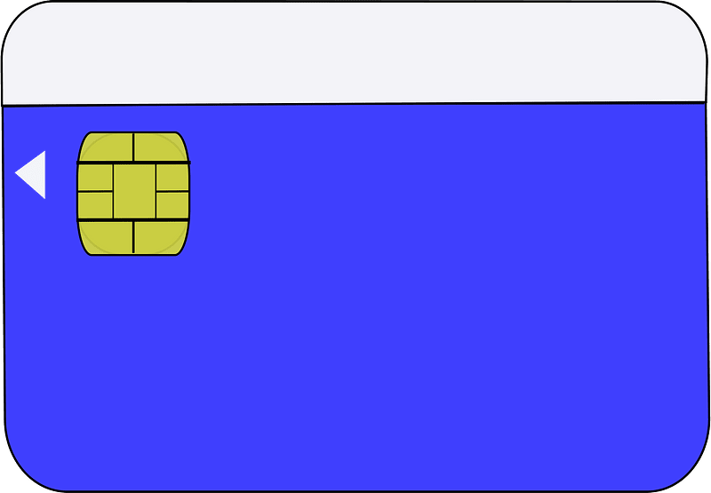
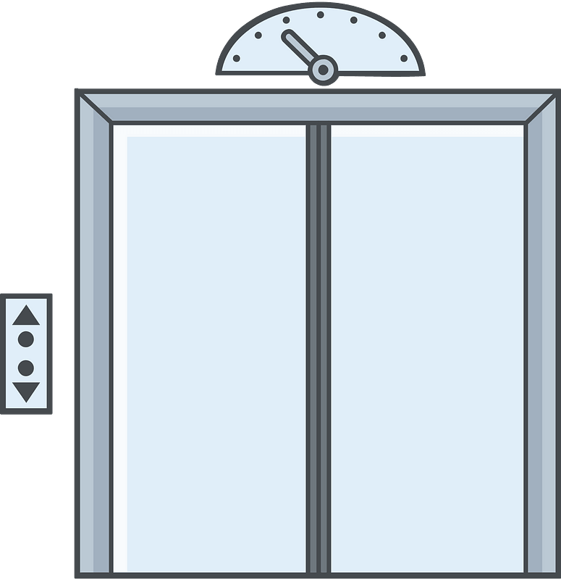
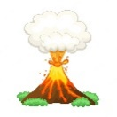
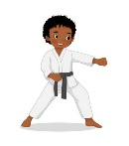

………………………
………………………
………………………
………………………

……\ 2 marks
5- Choose the correct answer.
1-(script -soup - sofa ) is the words of a movie, play, or speech
2- I'd like to make a table (business – reservation – mall ) for two people for nine o'clock.

6.Choose the missing letter.
1- I had just returned from the Cannes Film Fe….tival. ( q - s - w )
2- …ideos is becoming popular tool for e-learning. ( V- H – T)
3- The camera o…erator is holding the camera.( n – j – p )
4- During his summer ……acation, he visited Dubai. ( d - a - v )

……\ 2 marks

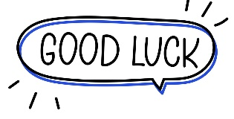

Your teacher:


Kingdom of Saudi Arabia
Ministry of Education
………… Education Directorate............
…………..……………….. Intermediate School

20
Total

Midterm Test units 1 & 2
Second Intermediate Grade

Name ………………………………… Class ………………………………
__________________________________________________________________________________________
/ 4
Comprehension

Read the following then answer the questions:

Last weekend, I went to a new shopping mall that opened last month. The shopping mall is so huge and has five gates. Inside the mall, there are many stores and a place for people to pray. Also, the mall has a food area with more than 5 different restaurants.
A- Put (√ ) for true or ( ᵡ ) for false :

( ) | 1. The shopping mall opened last week.
( ) | 2. The mall has five gates.

B- Choose the right answer:

beautiful | crowded | huge | small | 1-The mall is so ______.
sleep | pray | play | study | 2-Inside the mall there is a place for people to _____.
_________________________________________________________________
/ 5
Grammar

Choose the right answer:

1- We ___________ here for the festival.
A. is B. am C. are D. do
2 - ______ are you doing? Fine, thanks.
A. Where B. How C. When D. which
3 - What are you ______ now?
A. doing B. do C. does D. did
4 - I _______ martial arts films.
A. am liking B. likes C. like D. liking

5 - The apple is _______the boxes .
A. under B. on C. in D. between

/ 4
Vocabulary

A- Choose the best answer to fill in the blank:
1. _________ are good places for meeting people.
D. Playground | C. Room | B. Schools | A. Hotels
.2. Good night. ___________ tomorrow
D. Good afternoon | C. See you | B. Good bye | A. Good morning
3- Are you here for the conference? No, I’m here on ________ with my family.
D. playing | C. study | B. vacation | A. hotel
4- He is _____ ______ in the library.
D. eating a sandwich | C. watching a film | B. reading a book | A. playing a game
B- Put the right word under its picture:
 | 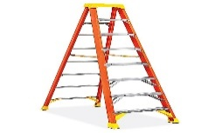 | 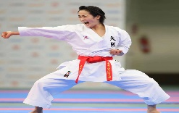 | 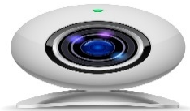 | 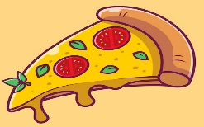
pizza , ladder , webcam , credit card , karate
/ 5

_______________________________________________________________________________
/ 2
Orthography

Choose the correct letter:
k | h | d | 1. I’d like to intro_uce you to Joe.
b | m | t | 2. The soup s_ells good .

Good luck T.

Kingdom of Saudi Arabia
Ministry of Education
………… Education Directorate............
…………..……………….. Intermediate School

20
Total

Midterm Test units 1 & 2
Second Intermediate Grade – Model Answer

Name ………………………………… Class ………………………………
__________________________________________________________________________________________
/ 4
Comprehension

Read the following then answer the questions:

Last weekend, I went to a new shopping mall that opened last month. The shopping mall is so huge and has five gates. Inside the mall, there are many stores and a place for people to pray. Also, the mall has a food area with more than 5 different restaurants.
A- Put (√ ) for true or ( ᵡ ) for false :

( ᵡ ) | 1. The shopping mall opened last week.
( √ ) | 2. The mall has five gates.

B- Choose the right answer:

beautiful | crowded | huge | small | 1-The mall is so ______.
sleep | pray | play | study | 2-Inside the mall there is a place for people to _____.
_________________________________________________________________
/ 5
Grammar

Choose the right answer:

1- We ___________ here for the festival.
A. is B. am C. are D. do
2 - ______ are you doing? Fine, thanks.
A. Where B. How C. When D. which
3 - What are you ______ now?
A. doing B. do C. does D. did
4 - I _______ martial arts films.
A. am liking B. likes C. like D. liking

5 - The apple is _______the boxes .
A. under B. on C. in D. between

/ 4
Vocabulary

A- Choose the best answer to fill in the blank:
1. _________ are good places for meeting people.
D. Playground | C. Room | B. Schools | A. Hotels
.2. Good night. ___________ tomorrow
D. Good afternoon | C. See you | B. Good bye | A. Good morning
3- Are you here for the conference? No, I’m here on ________ with my family.
D. playing | C. study | B. vacation | A. hotel
4- He is _____ ______ in the library.
D. eating a sandwich | C. watching a film | B. reading a book | A. playing a game
B- Put the right word under its picture:
 | 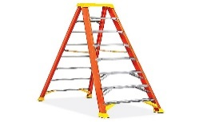 |  | 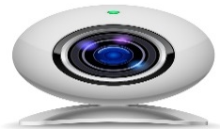
credit card | ladder | karate | webcam | pizza
pizza , ladder , webcam , credit card , karate
/ 5

_______________________________________________________________________________
/ 2
Orthography

Choose the correct letter:
k | h | d | 1. I’d like to intro_uce you to Joe.
b | m | t | 2. The soup s_ells good .

Good luck T.

Name :…………………………………………………………………… Class:…….……….
Super Goal 2 - Test unit 1 & 2

Reading
2 Marks
- Read the text and answer the questions. Write T or F at the end of each question/statement.
I like to go to the sports center. I go there every weekend. At the sports center, you can do many things. For example, you can play golf or tennis. There is a pool, so you can also swim or relax by the pool. There is a beach next to the sports center. You can swim, water-ski, or windsurf in the ocean. You can also sail on windy days. There aren’t any fish near the beach, so you can’t snorkel. When I go to the sports center, I like to play volleyball on the beach. I also like to jog on the beach. I can’t swim well, so I don’t like to water-ski or windsurf.
- At the sports center, you can do many things. ( )
- You can swim in the pool or in the ocean. ( )
- People can windsurf in the pool. ( )
- You can sail on windy days in the ocean. ( )
Grammar
5 Marks
- Choose the best answer to fill in the blank in each question.
- Who _____ that girl?
a. am b. is c. are d. i
- John: _____ your friend? - Adnan: He is in the restaurant.
a. How’s b. What’s c. When’s d. Where’s
- It _____ a beautiful day today.
a. is b. are c. not d. am
- _____ in that new TV film?
a. He acting b. He is acting c. Is acting d. Is he acting
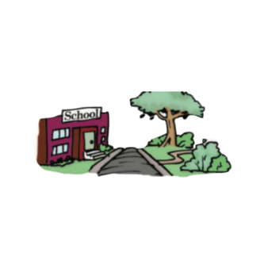
- What is he eating ? - he's ________ an apple .
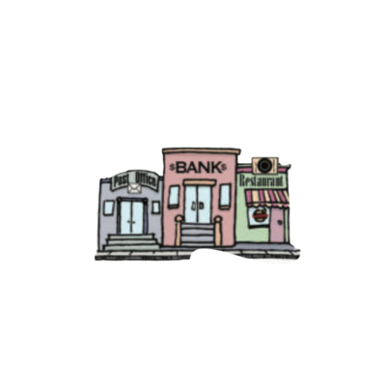
a. eat b. is eat c. eating d. ate
1.5 Marks
- Use ( across from – next to – between )
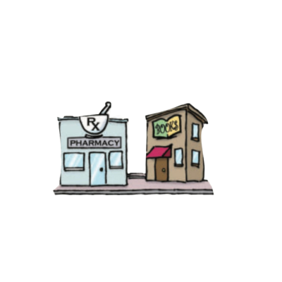
- The park is ____________________ the school .
- The bank is ______________ the post office and the restaurant .
- The pharmacy is ______________ the bookstore .

- Write the imperative sentence.
1.5 Marks
- Will you clean up this mess? ________________________________________
- Why aren’t you eating your vegetables? _______________________________
- You can’t take photographs. _________________________________________

Vocabulary
- Choose the best answer to fill in the blank in each question.
5 Marks
- Thank you !
a. You’re welcome. b. He’s from Muscat. c. That’s all right. d. Hi
- What is your country ?
a. Fine thank you b. I'm 13 years old c. Nice to meet you d. I'm from Saudi Arabia
- Many young people traveling around the world are ________ .
a. old people b. backpackers c. teachers d. business men
- What is Ali doing ? - He’s _______ soup .
a. making b. breaking c. writing d. talking
- ________ sometimes use webcams in the classroom.
a. Students b. Teachers c. Farmers d. business men

- Write the correct word under the picture.
3 Marks
coffee shop – Webcam – Turn Right





…………………………………………….

…………………………………………….
…………………………………………….

- Choose the correct letter.
2 Marks
- See you tomorr…..w. ( o – y – r )
- I don't he….r anything. ( t – a – r )


English Language
Intermediate Grade 2nd
1st period Exam
Kingdom of Saudi Arabia
Ministry of Education
………………… School
Student's Name : class:

5
5
1-Read the following e-mail then answer the questions below:
Dear Salem,
I would like to tell you about my last winter vacation. I travelled to Morocco with my family. Morocco is a wonderful country in North Africa. It is famous for its high mountains. My family booked a hotel in a small village in Al-Atlas Mountains. We stayed there for a week. The views were wonderful. We watched the snow falling. After that, we went skiing in the mountains. On the next day, we went to the market to buy some presents for our friends. We bought some colorful wool rugs. The people were so friendly there. I advise you to visit Morocco soon.
Yours sincerely,
Rashid

1- The best title for this email is:
c- The weather in Jordan | b- The weather in Oman | a- The weather in Morocco
2- I travelled to Morocco with my …………………..
c-cousins | b- family | a-friends
3- Morocco is a wonderful country in ………….
c- North Africa | b- South Africa | a- East Africa
4- We stayed in Morocco for ………….
c- a year | b- a month | a- a week
5- The meaning of the word "friendly" in the last line is:
c- sad | b-hungry | a- welcoming

2-Choose the correct answer
5
5
1- I ( isn't – aren't – am n't ) doctor.
2- Sara is ( make – makes – making ) a cake.
3- Who ( is – are – am ) your teacher?
4-(open – opening – opened ) the book please.
5- Aisha and Fadwa ( is -are – am ) at the mall.
6-( How – what – where ) old are you?
7- The pizza ( smell – smells - smelling ) good.
8- Riyadh(is – are – am )in Saudi Arabia
9- I (liking – likes - like )martial arts films.
10- Don't ( eat – eats – eating ) junk food.
3. Do as shown between brackets.
5
5
A-( Correct )
1- when is your name? …………………….……
2-I wanting a new cell phone. …………………
B-(Give a short answer)
a- is he a doctor ?
No,………………………………………………………...…..
C-(make a Yes or No question)
1-They are working now.
………………………………………………………………....…..?
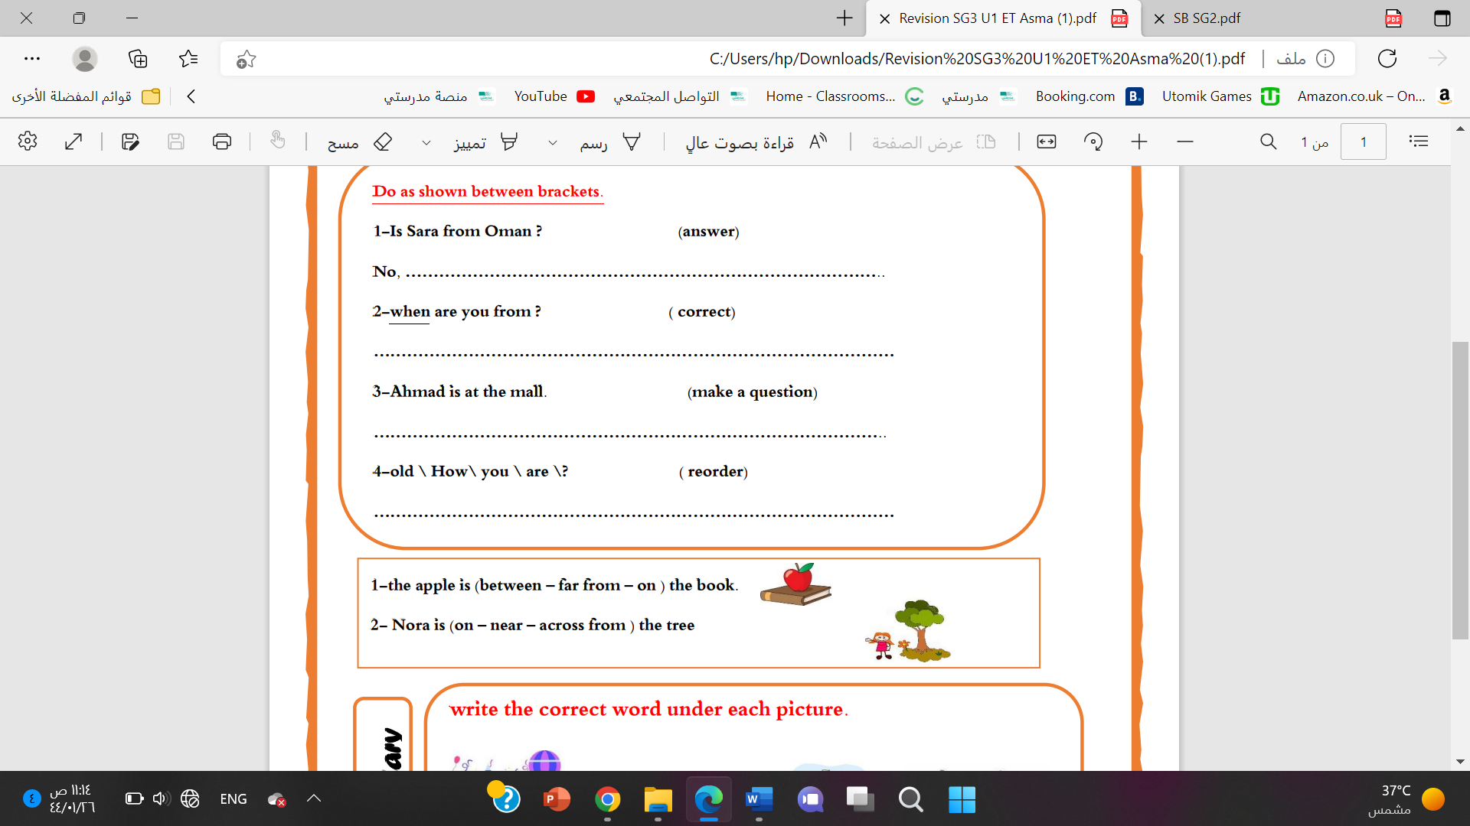
a-Mahmoud isn’t in the kitchen.
…………………………………………………..………….………?

D-(Choose)
a- Nora is (on – near – across from ) the tree

b-The thieves are getting (in front of – away ) in a fast car.

4-choose the missing letter
1-During his summer ……acation, he visited Dubai. ( v - a - d )
5

2-I had just returned from the Cannes Film Fe….tival. ( q - s - w )

5- write the correct word under each picture.
Webcam elevator volcano castle


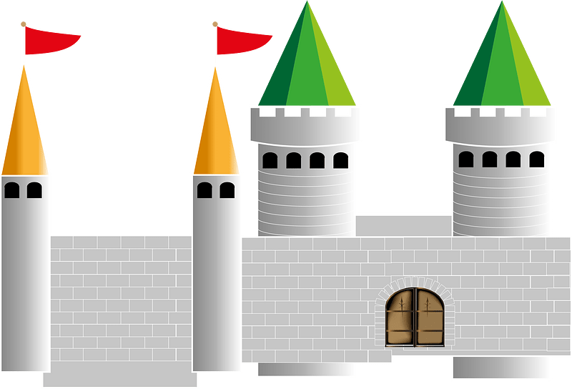

……………….
……………….
……………….
……………….

Best of luck
Your teacher:

Your teacher:

20

English Language
Midterm Exam
\3\1445
King of Saudi Arabia
Ministry of Education
2nd Intermediate Grade

Class\ |  | Student's name

Section A: Read and answer the following questions:_
4
This is Salwa. She lives in a house. It is a big house. There are 4 bedrooms upstairs. There is a living room downstairs. They have a garage, they keep the car inside it. They have a beautiful garden. The garden has flowers and trees. Her family is nice. She has 2 sisters and I brother. His name is Ali. Her mother works in the kitchen and her father works in the garden.
A) Choose the right answer
1-The living room is [ downstairs - behind – upstairs ]
2-The garden has [ beds - cars – flowers ]
B) Put ( √ ) or ( x )
1-Salwa's father works in the garden. [ ]
[ ] 2-They keep the car in the garage.
5
------------------------------------------------------------------------------------------
Section B: _ "Grammar"

1) …………………. the book please.
a) open b) opening c) opened d) opens

2) Sara is …………… a cake now
a) make b) makes c) making d) makes

3) A: ……………..is Ali from? B: He is from Jordon.
a) What B) How c) When d) Where

4) She is English teacher . ( make yes- no question )
………………………………………………………………………………………..

5) He is playing football . ( make negative )
………………………………………………………………………..
8
-------------------------------------------------------------------------------------
Section C: Vocabulary" Write the correct word under each picture:
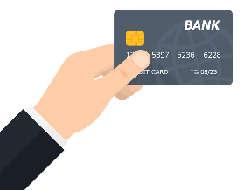 | 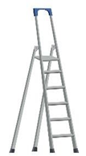 | 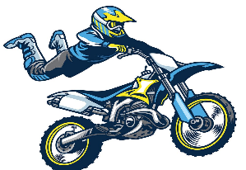 | 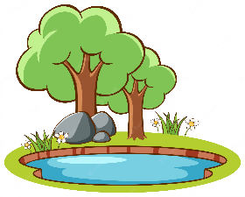
 | 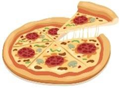 |  | 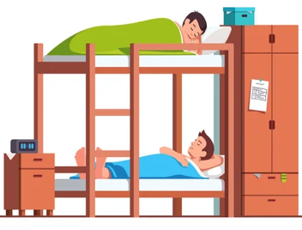
1-gostel 2- turn right 3- pizza 4- cameraman
5-pond 6-stantman 7-ladder 8-credit car 9- Webcam

3
-------------------------------------------------------------------------------------------------
Section D: Match the conversations.
1. Are you here for vacation? |  | a. S-a-a-d
2. Where is your house? |  | b. yes, I am .
3. How do you spell your name? |  | c. It is between the bank and the park.

Good luck
Kingdom of Saudi Arabia Name: ……………………………
Ministry of education Class: 2nd Intermediate Grade
20 /
…….. Intermediate School Mid-Term Exam First Term
- Comprehension:
Read the passage to answer the questions below:
My name is Chris. I like to read. I like stories about stars and planets the best. The book I am reading now is about the sun. The book has many pictures. It has a picture of the sun on the cover. You know what; I am so excited because we will study the sun in science class next week.

- Choose the correct answer:
- This text is about ………………
- Chris’s family b- Chris’s hobby c- Chris’s house
- Chris likes ……………….in his free time.
- playing football b- painting c- reading books
- Check ( T ) or ( F ) :
- Chris likes stories about animals. ( )
- Chirs is interested in science classes. ( )

- Find from the passage:
- A word related to space: ………………….
- A school subject: …………………...

- Grammar:
- Choose:
- I (am – is – are) a smart student.
- (When – How – Why) are you?
- Messi (play – plays – is playing) football now.
- The actors are ready to perform (over – in front of – under) the camera.

- Do as shown between brackets:
- Stand up. (Change into negative)
…………………………………………………………
- I (seeing) a bird in the tree. (Correct the verb)
…………………………………………………………

- Vocabulary:
- Write the words under the pictures:
studio – cameraman – key card – hotel – run away
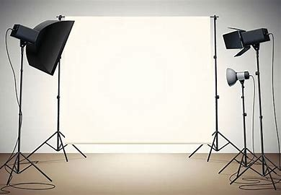

_____________ _______________ ________________ ______________
- Match:
- All by myself a- an expression used when you give something to someone
- Here you are b-see you later
. c- with no one else’s help

- Orthography:
- Fill in the missing letters:
- I will call the hotel and make a reser__ation.
- Let me intr__duce myself.
- Have you ever watched this fi__m?
- The scr__pt is well-written.

Good Luck
Ms. Tahani Al-Ghamdi

