1
1– What school subject is more difficult at school?
I. CHOOSE
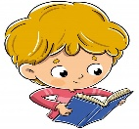
A. I think math. B. I am surprised.
2– What are you doing?

A. I am reading. B. I am eating .
المملكة العربية السعودية |  |  | اسم الطالب/ ......................................
وزارة التعليم
إدارة التعليم بمنطقة |  |  | المادة : انجليزي
مدرسة : |  |  | الزمن :
 |  |  | الصف : فصل ( )
شفهي | تحريري |  |  | المجموع
10 / | 10 / |  |  | 20 /
Top goal1 اختبار الفترة الأولى للفصل الأول - للعام الدراسي 1447– لغة انجليزية –– للصف الرابع
اسم الطالب / هـ الفصل /

2. CHOOSE OR
1.5

She is playing a soccer.
She is afraid.
Take out the trash




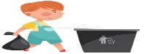

3. DO AS SHOWN BETWEEN BRACKETS
1.5

1– It - a terrible – game – is . ( rearrange ) ………………………………………………………………
mommy | granny | daddy | ( choose the informal word ) 2- She is my mom
4. CHOOSE
1

are | do | does | 1- How often ____ you see your cousin?
watches | watch | watching | 2- He is ______ TV right now .

3
4. CHOOSE
dad - drum - trash can

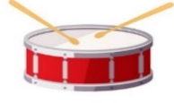 | 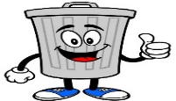 | 


2

Choose the correct letter: ( k - p - m - n ) )

 |  |  | 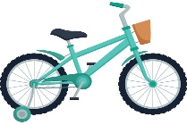
grand_a | kitte_ | Ca_era | Bi_e

___________________________________________________________________________________________________________________________________________________________________________________________________________________________________
Controlled writing

4

Good luck T.



First Period Exam – Top Goal1

مدرسة :
الاسم | الفصل | شفهي | تحريري | المجموع
 | / | 10 / | 10 / | 20 /
Choose the correct answer:
/ 1
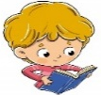
1– What school subject is more difficult at school?

A. I think math. B. I am surprised.
1– What are you doing?

A. I am reading. B. I am eating .
____________________________________________________________________________________________________
/ 1.5
Choose or :
She is afraid. | Take out the trash | She is playing a soccer.
 | 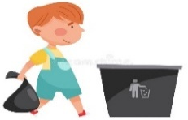 | 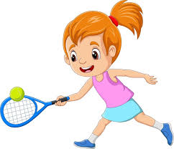
___________________________________________________________________________________________
/ 1.5
1- a terrible – It – game – is ( Rearrange) ………………………………………………………………………………………
grandparents | parents | uncle | 2 - My mom and dad are my ______. (choose )
Do as shown between brackets :
Choose the correct word:
/ 1.5
are | do | does | 1- How often ____ you see your cousin?
were | was | is | 2- We ____ happy .
watches | watch | watching | 3- He is ______ TV right now .

Choose the correct word:
/ 3

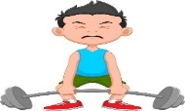 | 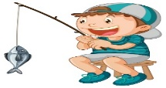 | 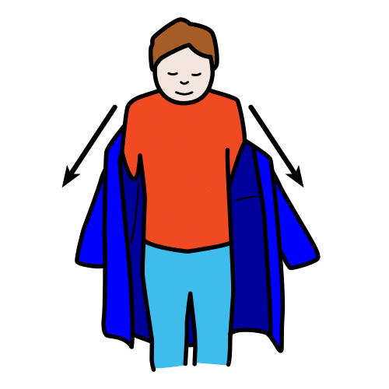 | 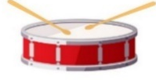 | 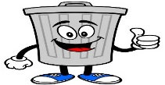 |   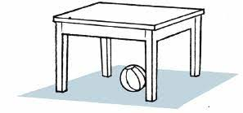
Strong | Cycling | Get dressed | Drum | Trash can | Bus
weak | Fishing | Get undressed | Guitar | Leaves | Poster
Choose the correct letter to fill in the blank:
/ 1.5
 |  | 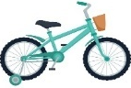
Ca_era | grand_a | Bi_e
n | p | f
m | m | k

Good luck T.
Controlled writing

4

Kingdom of Saudi Arabia 4th Elementary Grade
Ministry of Education First Term

10
………… Elementary School . . First Exam - 1447 AH
Name: ………………………………………………………….………………. Class : …………..
- General Questions:
- Choose the correct answer:
1- Which food do you think smells terrible?
a- My little brother |  |  |  |  | b- I think fish
2- What school subject is more difficult?
a- Math |  |  |  |  | b- I go to school by bus
3- How many brothers do you have?
a- spiders |  |  |  |  | b- I have 3 brothers
- Controlled Writing:
- Fill in the missing words:
weak – grandpa – parents

1- Your mom and dad are your …………………..
2- Sara is not strong. She is ……………….
- Reading short sentence:
- Read the sentences then match them with the correct pictures:
 |  |  | 
a-_They are different.  b-_They are same. | a-_He is shy.  b-_He is naughty. | a-_I never read book  b-_I always read book | a-_I often go cycling  b-_I often go fishing

- Grammar:
- Choose the correct answer:
- He ……… absent in the class yesterday.
- was |  |  | - were |  |  |  |  | - are
- It is my pen. It is …………
- yours |  |  | - mine |  |  |  |  | - hers
- Huda is ………… than Rana.
- tall |  |  | - taller |  |  |  |  | - tallest
- Vocabulary:
- Choose the correct answer:
 |  |  |  |  |  |  |  |  | 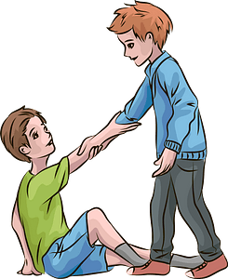
- brilliant  - exciting |  | - pizza  - fish |  |  |  | - afraid  - surprised |  |  | - dangerous  - helpful
- Orthography:
- Choose the correct missing letters:
  d__ums |  |   k__tten |  |  |  | 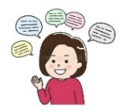  chatt__ |  |  | 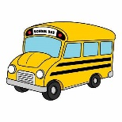  b__s
e | r | i |  | m |  | o | y |  | e | u

BEST OF LUCK
Ms. Tahani Al-Ghamdi

الاسم/............................................................... الصف (.......... /......
Match:صل الأسئلة مع إجاباتها
- Is this your car? It was theirs.
2- Whose car was this? I rarely go shopping.
3- How often do you go shopping? Yes, it’s mine.

Circle the correct answer:ضع دائرة على الإجابة الصحيحة بين الأقواس
1-___ ( Do – Does ) you play tennis?
2-This book is ___ ( her – hers )

  balloons  camera | 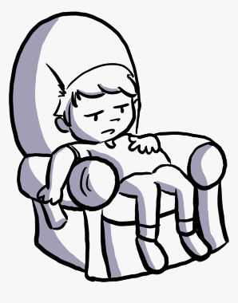  Afraid  lazy | 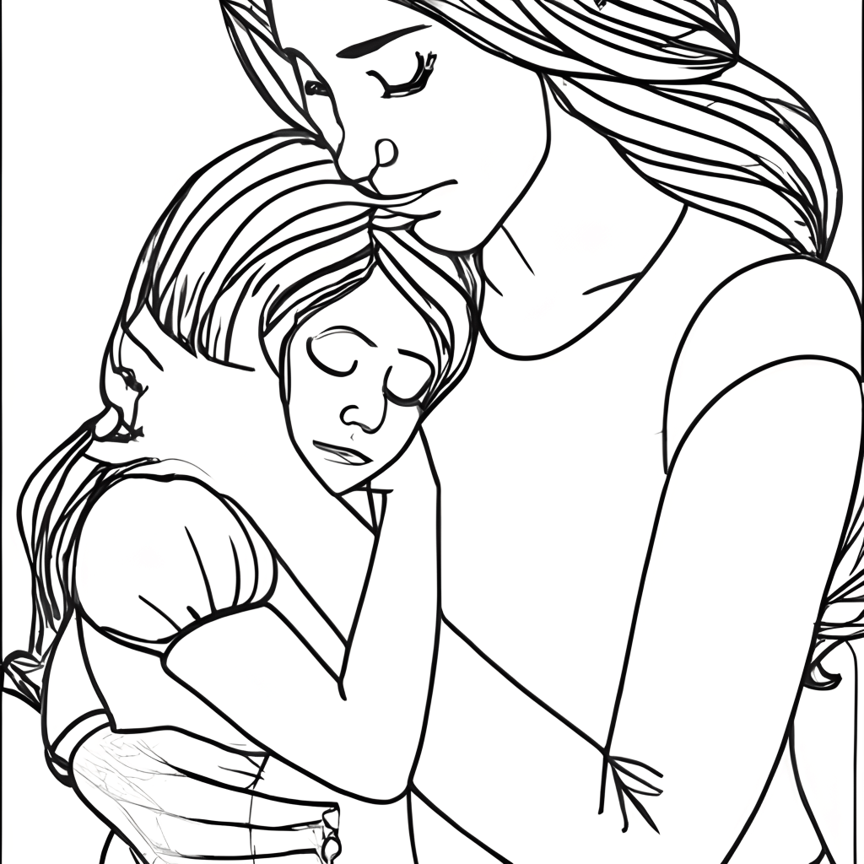  dad  mom | strong  grandma | 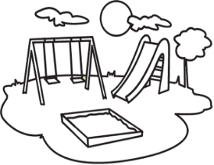  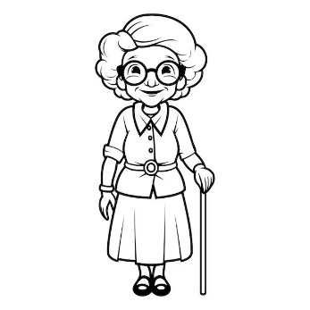  playground  bus
Choose:ضع دائرة على الإجابة الصحيحة

Mid Term Exam
Name : Class : ◊ 4th ◊ 5th ◊ 6th

Q1) Match "A" with "B":
"A" |  | "B"
- ? What are you afraid of ? |  |  | It was mine.
- Who is the tallest in the class? |  |  | Ali is the tallest.
- Whose dress was that ? |  |  | I am afraid of snakes.

Q2) Order the words to make a sentence:
1. makes – My mom – always – dinner.
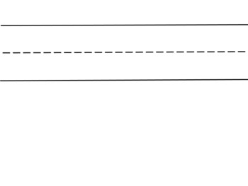

Q 3) Put (✔️) or ( ✖️):

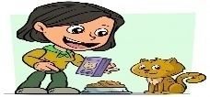
1- My aunt always feeds the cat. She is kind .

They are my grandparents . 2-

Q 4 ) Choose the correct word:.
1. She ( was _ were _ weren't ) sick.
Amal is ( short _ shorter _ shortest ) than Maha . 2.
3. How often ( do _ does _ doing ) you visit your grandparents?
4- . It’s her kitten.It’s (theirs _ she _ hers ).


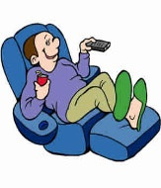
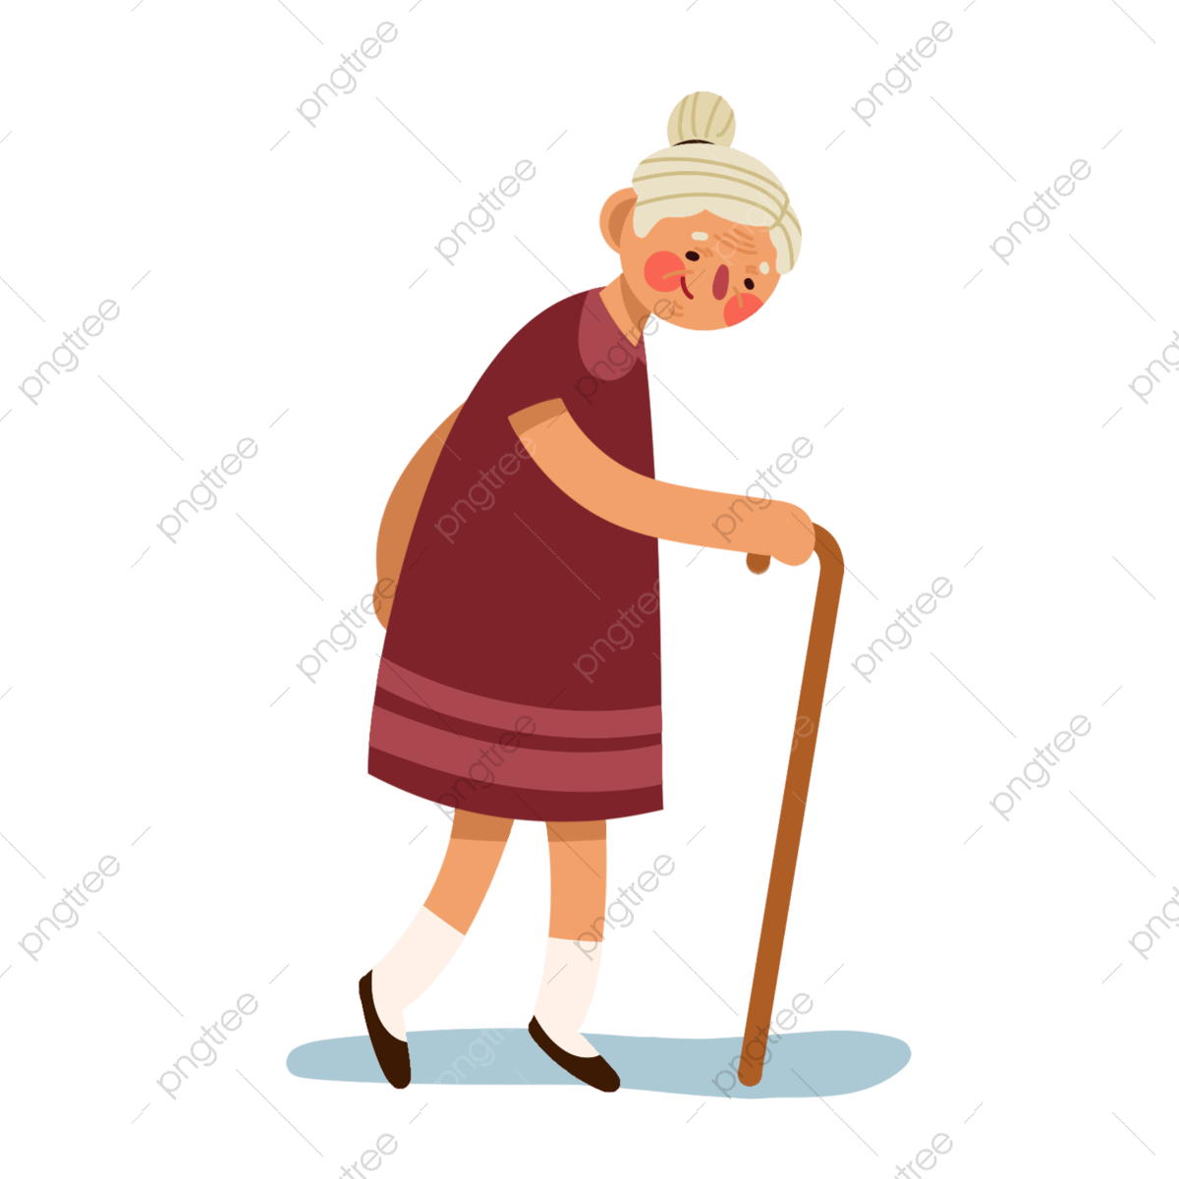
Q5 ) Number :
1. She is a weak grandma.
2. My brother is naughty.
3. He is a lazy boy.
*********************************************************************************
Q6) Choose the correct answer :
- Mom and dad are my……. |   2-
  - Parents  - Cousins |   - always  - never

Q 7 ) : Tick the correct word :
 |  |  |  |  | 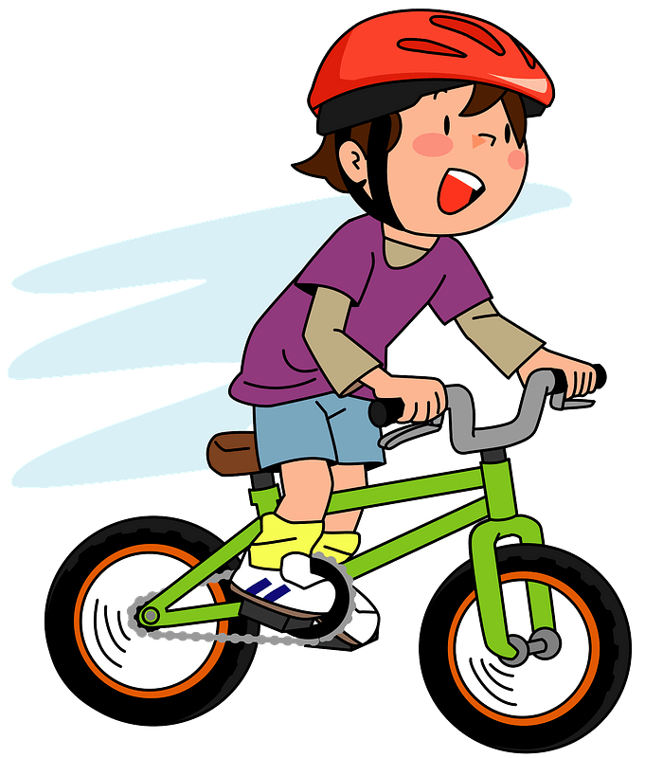
□ chatty  □ sleepy | □ drums  □ guitar | □ granny  □ daddy | □ tired  □ exciting | □ one  □ first | □ reading  □ cycling

Q 8) Write the missing letters :

sh
m
m
sh
ph
y
 |  | 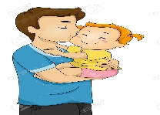 | 
ca - era | - - oto | dadd - | - - y

Midterm Exam– Top Goal1

مدرسة:

الاسم ثلاثي: |  | الفصل | / | الدرجة | 20 /
__________________________________________________________________________________________
Choose the correct answer:
1– What school subject is more difficult at school?

A. I think math. B. I am surprised.
2 – What is your favorite place to visit?

A. Diriyah is my favorite place . B. I usually visit my uncle .

____________________________________________________________________________________________________
Choose or :
She is afraid. | He is fishing in a boat. | She is playing a soccer.
 | 

___________________________________________________________________________________________
1- a terrible – It – game – is ( Rearrange) ………………………………………………………………………………………
grandparents | parents | uncle | 2 - My mom and dad are my ______. (choose )
Do as shown between brackets :
Choose the correct word:
are | do | does | 1- How often ____ you see your cousin?
were | was | is | 2- We ____ happy .
mine | your | my | 3- Whose dress was it? It was _____ .

Choose the correct word:

 |  | 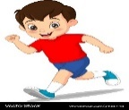 | 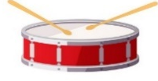 | 
Strong | Cycling | Running | Drum | Stop | Bus
weak | Fishing | Reading | Guitar | Dangerous | Poster
Choose the correct letter to fill in the blank:
 |  |  | 
Cele_ration | Ca_era | grand_a | kitte_
b | n | p | n
d | m | m | b

Good luck T.
Controlled writing

4


Midterm Exam– Top Goal1

مدرسة:

الاسم ثلاثي: |  | الفصل | / | الدرجة | 20 /
__________________________________________________________________________________________
Choose the correct answer:
1– What school subject is more difficult at school?

A. I think math. B. I am surprised.
2 – What is your favorite place to visit?

A. Diriyah is my favorite place . B. I usually visit my uncle .

____________________________________________________________________________________________________
Choose or :
She is afraid. | He is fishing in a boat. | She is playing a soccer.

___________________________________________________________________________________________
1- a terrible – It – game – is ( Rearrange) It is a terrible game .
grandparents | parents | uncle | 2 - My mom and dad are my ______. (choose )
Do as shown between brackets :
Choose the correct word:
are | do | does | 1- How often ____ you see your cousin?
were | was | is | 2- We ____ happy .
mine | your | my | 3- Whose dress was it? It was _____ .

Choose the correct word:

Strong | Cycling | running | Drum | Stop | Bus
weak | Fishing | reading | Guitar | Dangerous | Poster
Choose the correct letter to fill in the blank:
Cele_ration | Ca_era | grand_a | kitte_
b | n | p | n
d | m | m | b

Good luck T.
Controlled writing

4

Name:
VOCABULARY
- Look, read, and circle the correct option. / 5 points
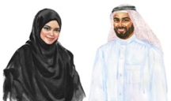 1 These are my parents / uncles. Omar is my dad and Amal is my mom.
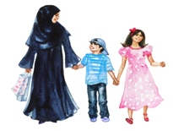 2 This is my mom’s sister. She is Uncle / Aunt Badria.
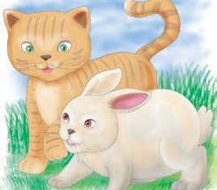 3 I have two pets – a kitten, and a cousin / rabbit.
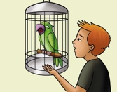 4 This is Rocky. He’s my brother’s parrot / kitten.
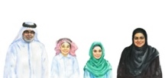 5 Saud and Asma love their grandchildren. Their grandson / son Faiz is very tall.

- Read and complete with the words in the box. / 5 points
chatty helpful lazy strong tired
- My friend Yousef always helps me. He is .
- My dad didn’t sleep well. He’s very today.
- Layla talks a lot. She is .
- Abdullah is picking up those heavy boxes! He is very .
- Our cat Luna sleeps all day. She is very !

GRAMMAR
- Read and circle the correct option. / 5 points
- How often do / does you walk in the park?
- I sometimes / usually see Uncle Hashim after school. He lives with us.
- I love my friend Sahar! I always / rarely give her beautiful presents.
- I never / usually have lunch with my dad. He eats at the office, but I eat at home.
- My grandpa and I love fish. He never / sometimes cooks it on weekends when I visit him.

- Read and complete with a possessive pronoun. / 5 points

- This is my rabbit. It’s .
- That is her bike. It’s .
- These are our books. They’re .
- This is your dress. It’s .
- These are his pens. They’re .

VOCABULARY AND GRAMMAR
- Read and complete with the words in the box. / 10 points
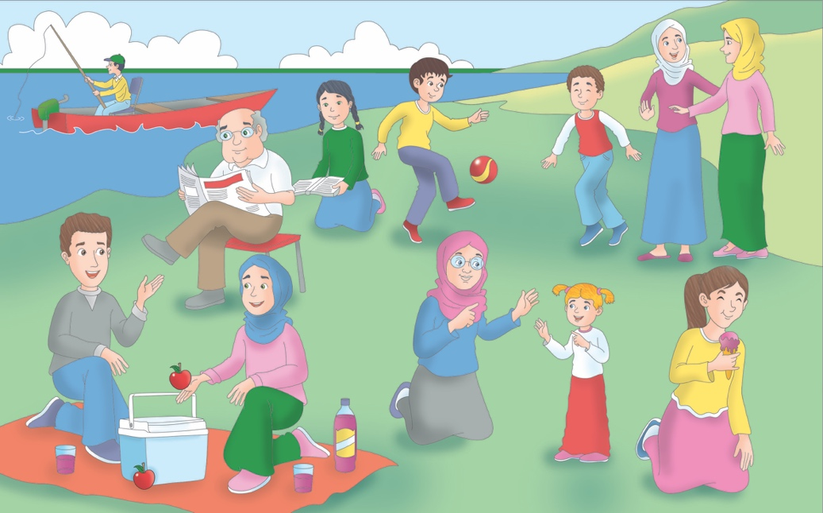
always aunt cousins granddaughter kind family ours parents shy chatty
My favorite photo is of my family in the park. We often take photos in the park, but this photo is special. You can see my (1) _____________ . They’re having a picnic. My two (2) ___________ are in the photo with their soccer ball. Well, I think it’s theirs; they always play with it in the park. I like them a lot. They’re (3) ____________ and helpful! How often do we go to the park? In the summer, we (4) _____________ go to the park! We sometimes think the park is (5) ____________ , and the soccer balls are, too! My (6) _____________ and uncle are in the photo, too. My Aunty Ashley is very (7) _____________ , and she’s talking to a woman. My Uncle Jeff is sitting in a little boat fishing, but it’s not his. I think it’s a friend’s boat. My sister is sitting behind my grandpa. She’s reading a book. She’s not very chatty and a bit (8) _______________ . My granny is with my little sister, her youngest (9) ________________ . You can see me in the photo. I’m eating ice cream. All my (10) __________ is in the photo, and I love it!
TOTAL / 30 points
Name:
VOCABULARY
- Read and complete with the words in the box. / 5 points
book catch get leaves trash
- I dressed and then I eat breakfast.
- I the bus to school at 8 o’clock.
- On the bus, I read my comic .
- In the afternoon, I collect in the garden.
- Before I go to bed, I take out the .

- Look and complete. / 5 points
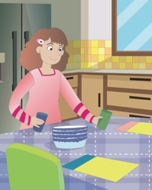 1 the table 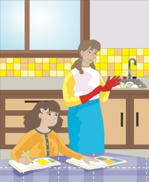 2 the dishes
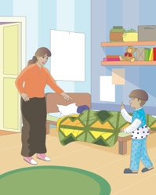 3 the bed 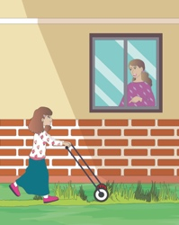 4 the grass 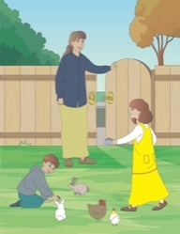 5 the animals

GRAMMAR
- Read and circle the correct option. / 5 points

- My grandma makes / is making chocolate cake on weekends.
- Ahmed reads / is reading a book now.
- What time do you do / are you doing your homework every day?
- My mom isn’t working / doesn’t work in the afternoon.
- They aren’t getting dressed / don’t get dressed now.

- Reorder the words to make questions. / 5 points

- Can / table / the / clear / you / ?

- trash / Can / I / you / for / take / the / out / ?

- homework / help / me / Can / with / you / my / ?

- car / I / wash / help / you / Can / the / ?

- sweep / you and / Can / the / your sister / floor / ?

VOCABULARY AND GRAMMAR

- Read and complete the dialogue with the words in the box. / 10 points
can doing feed grass make makes reading visit wash watching
Aisha: What do you do on weekends?
Nouf: I (1) my grandparents. I help them (2) their car and
(3) their bed. Do you help your grandparents?
Aisha: Yes. I (4) their animals and cut the (5) in their garden.
Nouf: What is your grandma (6) now?
Aisha: Now she is (7) a book.
Nouf: My grandparents are (8) TV now.
Aisha: My grandma (9) cookies for me on Saturdays.
Nouf: That’s nice—(10) I visit your grandparents with you?
Aisha: Yes, Nouf, of course!

TOTAL / 30 points

