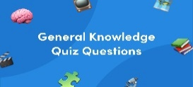
General Questions

1 – How old are you ?
A . I am 11 years old . B . I am fine .
2 – What is your name ?
A . I am 13 . B. My name is Ali .


________________________________________________________________________________________________________________________________________________________________________________________________

Reading short sentences
1. I have a bicycle .

This is a computer. .2

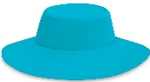

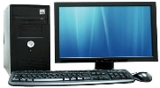


_______________________________________________________________________________________________________________________________________________________________________________________________________

Controlled writing
................................................................................................ |  |  | 1– to- nice – you – meet. ( rearrange )
where | whose | who | 2- ____ skirt is this? It's mine. ( Choose )

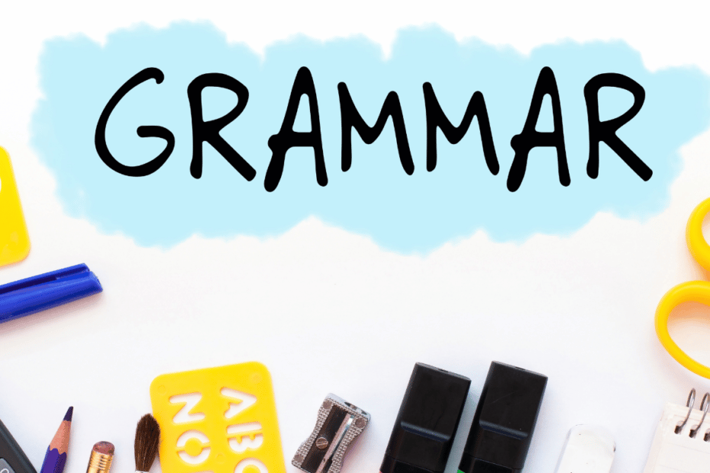
Grammar
your | my | his | 1 – I am a teacher , _____ name is Nora .
my | his | her | 2- She is a doctor , ___ name is Fatimah .
have | has | is | 3. I _____ a box

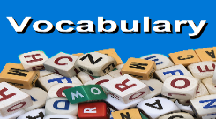
____________________________________________________________________________________________________________________________________________________________________________________________________

Vocabulary

Sandals - T-shirts – cap - computer

 | 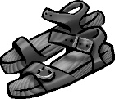 | 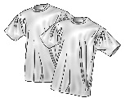 | 
……………………… | ……………………… | ……………………… | ………………………


________________________________________________________________________________________________________________________________________________________________________________________________________

Orthography (spelling)
 | 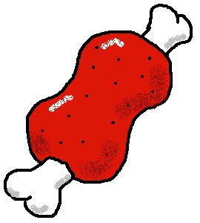 | 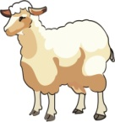 | 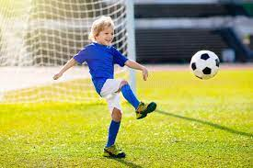
r_ _n | m_ _t | sh_ _ p | pl_ _

Choose the correct letter: ( ai - ea - ie - ee - ay )

Controlled writing

4

Good luck T.



لا تنسوني من صالح دعائكم





M_zaid0

Name ………………………………… Class ………………………………

_______________________________________________________________________________________________________________________

General Questions

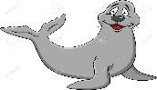
1 – What is that?
A . It's a seahorse. B . It's a seal.
2 – What do you think about sharks?
A. I like dolphins. B. I think they are scary
3 – Which of the following is a sea animal ?
A . seahorse . B. horse .

________________________________________________________________________________________________________________________________________________________________________________________________

Reading short sentences
1. The whale is small.

2. The dolphin is cute.


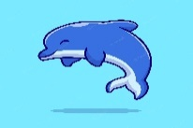

Controlled writing

______________________ |  |  | 1– think - I – whales – big - are. ( rearrange )
slow | scary | fast | 2. Seahorse is ___________ . ( choose)

biggest | big | bigger | 1 – The whale is ______ .
cutest | cuter | cute | 2- The baby seal is the _______.
_______________________________________________________________________________________________________________________________________________________________________________________________
Grammar
Vocabulary

seal - seahorse – crab -starfish

 | 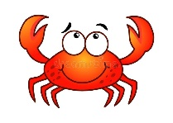 | 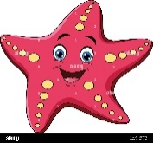 | 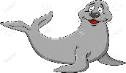
---------- | ---------- | --------- | ---------

Orthography (spelling)
Choose the correct letter: ( ou - ow - oa )

 | 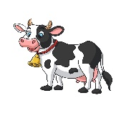 | 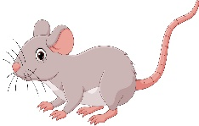 | 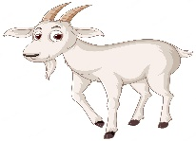 | 
h_ _se | c_ _ | m_ _se | g _ _ t | wind_ _

Controlled writing

4

------------------------------------------------------------------------------------------------------------------------------------------------------------

Good luck T.

لا تنسوني من صالح دعائكم


M_zaid0

Name ………………………………… Class ………………………………

_______________________________________________________________________________________________________________________

General Questions

1 – What sport do you like?
A . I like painting. B . I like football.
2 – What sport or activity do you want to try?
A. I like football. B. I want to try sky diving.
3 – which is taller a giraffe or a goat?
A . Giraffe . B. Goat.

________________________________________________________________________________________________________________________________________________________________________________________________

Reading short sentences

1. I do painting.

2.Falcons can see very far.

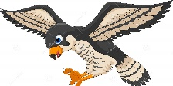

Controlled writing

______________________ | 1– horse - I – riding – like. ( rearrange )
____________ | 2. t – s – n – i – e – n . ( rearrange)

you | she | he | 1 – Do ___ play football ?
does | play | do | 2- I ____ golf .
as | more | most | 3. football is ___ exciting than jogging.
Grammar

___________________________________________________________________________________________________________________________________________________________________________________________________
Vocabulary

Scuba diving – computer games – pottery - hang gliding

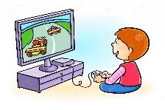 | 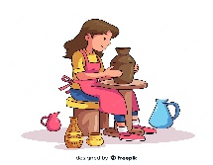 | 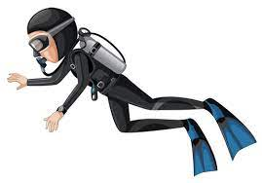 | 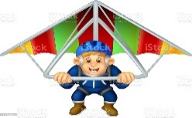
-------- | ---------- | --------- | ---------

Orthography (spelling)
Controlled writing
Choose the correct letter: ( oi - oy - ear - air - ere )

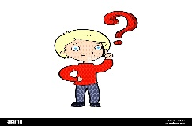 | 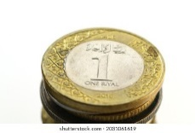 | 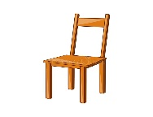 | 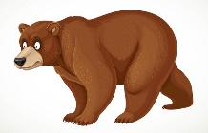 | 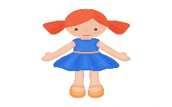
Wh _ _ _? | c_ _n | Ch_ _ _ | b_ _ _r | t_ _

4

Good luck T.

لا تنسوني من صالح دعائكم


M_zaid0



Worksheet – we can3

3rd grade Unit 5 Yesterday and Today

Name ………………………………… Class ………………………………
__________________________________________________________________________________________

General Questions

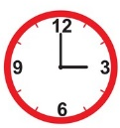
1 – What time is it ?
A . It is six o'clock. B . It is three o'clock.
2 –What is the time? 10:30
A . It is ten o'clock. B. It is ten thirty.

____________________________________________________________________________________________________

Reading short sentences

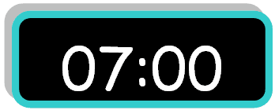
1. It is seven o'clock.

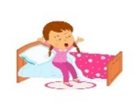
2. I eat my lunch.

___________________________________________________________________________________________

Controlled writing
______________________ |  |  | 1– brush - I – teeth – my. ( rearrange )
two | four | five |   2. It is ____o'clock. ( complete )

Grammar
got | get | go | 1 – I usually ____ up at 5:00 .
go | came | come | 2-ysterday, I ____ home at 1:00 .

_____________________________________________________________________________________________________

Vocabulary
clock – get up – brush – take a bath

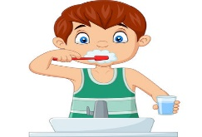 | 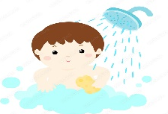 |  | 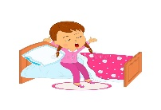
---------- | ---------- | --------- | ---------

_____________________________________________________________________________________________________
Orthography (spelling)
Choose the correct letter: ( nk - ng - ck - )

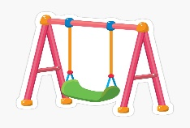 |  | 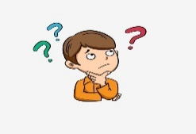 |  | 
swi_ _ | i_ _ | thi_ _ | ri_ _ | dri_ _

Controlled writing

4

Good luck T.

Worksheet – we can3

3rd grade Unit 6 Jobs

Name ………………………………… Class ………………………………
__________________________________________________________________________________________

General Questions

1 – What does your dad do ?
A . I am playing. B . He is a doctor.
2 – What does the firefighter do?
A. He puts out fires . B. He flies plane .
3 – What does your mom do?
A . She is sleeping . B. She is a nurse .

____________________________________________________________________________________________________

Reading short sentences


1.He is a pilot.


2. She works in a school.

___________________________________________________________________________________________

Controlled writing
______________________ | 1– she - a – teacher – is. ( rearrange )
____________ |   2.One _______. ( complete )

Grammar
where | what | who | 1- ____ does she do ? She is a nurse .
under | in | on | 2. He works ___ a hospital .
brushes | brushs | brush | 3- She ______ her teeth .
_____________________________________________________________________________________________________

Vocabulary
Three hundred – doctor – firefighter – baker

 |  | 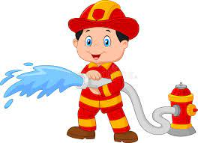 | 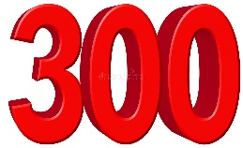
---------- | ---------- | --------- | ---------

_____________________________________________________________________________________________________
Orthography (spelling)
hoose the correct letter: ( kn - gh )

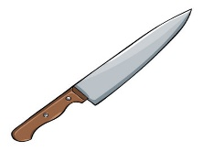 | 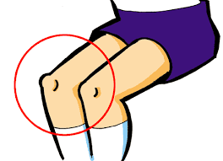 |  | 
_ _ ife | _ _ ee | li_ _t | r_ _t

Good luck T.

