


Worksheet – Top Goal 2

5th 6th grade Unit Welcome

Name ………………………………… Class ………………………………

__________________________________________________________________________________________

General Questions

1– Which month has the national day in Saudi Arabia?

A. In September 23rd . B. On Saturday .
2 – Which month is your birthday in?

A. My birthday is in February. B. My dad .
3 – Who is the tallest student in your class?

A. Yes, I do . B. I think Nawal the tallest .


____________________________________________________________________________________________________

Reading short sentences

A tired child. | On hundred twenty two. | It is a mountain.
 |  | 


___________________________________________________________________________________________

Controlled writing
1- April – march – February – January (Rearrange ) ……………………………………………………………………………

bigger | biggest | big | 2 - This is the __________ classroom. ( choose )
boy | calendar | ball | ( choose ) He checked the ______ on the wall. 3 -


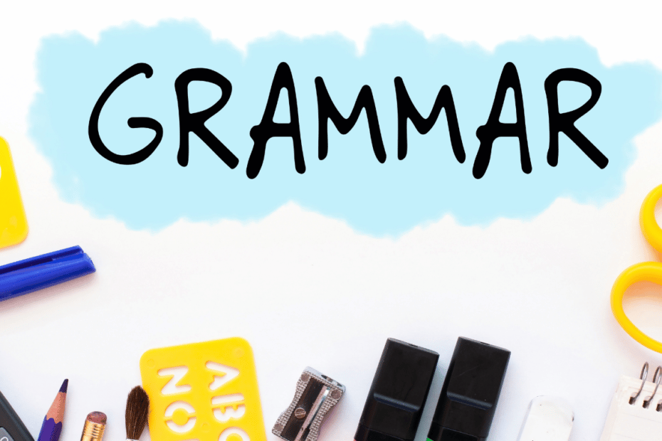
How many | How long | 1- _________ students are in your class ?
How many | How long | 2- _________ is the lunch break ?
Grammar

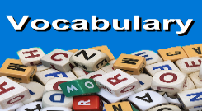
_____________________________________________________________________________________________________

Vocabulary

 |  | 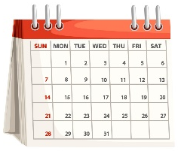 |  |     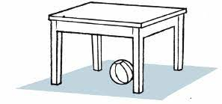
Rainbow | Hundred | Book | Bird | Lion
Snow | Thousand | Calendar | Snail | Horse

_____________________________________________________________________________________________________
Orthography (spelling)

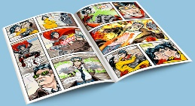 |  | 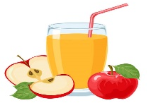
Co_ic book | Wa_e up | Apple jui_e
n | k | c
m | d | s

Controlled writing

4

Good luck T.



Worksheet – Top Goal 2

5th 6th grade Unit Personal Interests

Name ………………………………… Class ………………………………
__________________________________________________________________________________________

General Questions

1– What is your favorite interest?

A. My favorite interest is playing video games. B. Yes, I like it .
2 – What activities can you do in your neighborhood?

A. I am very happy . B. Meeting and chatting with friends.

____________________________________________________________________________________________________

Reading short sentences

Frightening Fridays. | I do exercise . | I have a very tidy room.
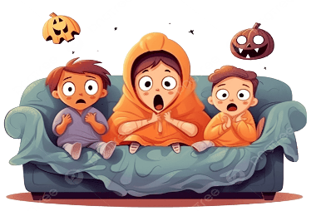 | 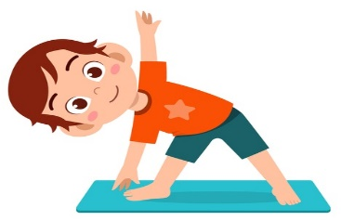 | 

___________________________________________________________________________________________
Controlled writing

1- (Rewrite the words using un) lucky - clean - happy ……………………………………………………………………………

head | hand | bag | 2 - shaking her _________ and smiling. ( choose )
smallest | usual | enormous | ( choose ) Another word for ( very big ). 3 -

painted | paints | 1- She _______ an amazing landscap yesterday.
do | did | 2- What day ____ you go last week?
cook | love | 3- The action verb is :
Grammar

_____________________________________________________________________________________________________

Vocabulary

 | 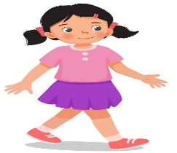 |  | 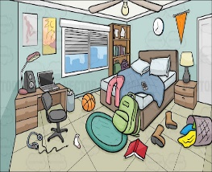 |   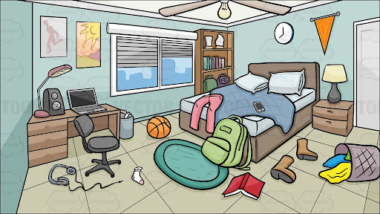
horrible | talk | dance | tidy | Lion
tidy | walk | eat | untidy | Horse
_____________________________________________________________________________________________________
Orthography (spelling)

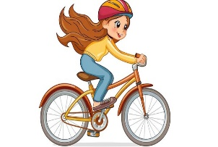 |  | 
ri_e a bike | ori_ami | no_ebook
n | g | t
d | k | s

Controlled writing

4

Good luck T.

Worksheet – Top Goal 2

5th 6th grade Unit House Designs

Name ………………………………… Class ………………………………
__________________________________________________________________________________________

General Questions

1– Name two parts of a house :

A. gate and basement. B. Yes, I like my house .
2 – what plans you have for the weekend ?

A. I'll visit my friend after class. B. No , thanks .
3 – Who designs houses?

A. A pilot. B. An architect .

____________________________________________________________________________________________________

Reading short sentences

I’ll dance down here! | The key under the mat. | The chicken is in the oven.
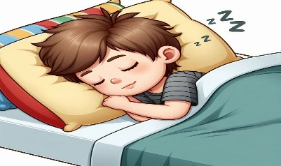 | 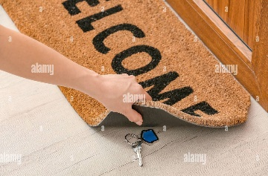 | 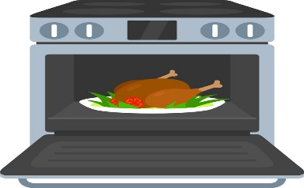

___________________________________________________________________________________________
Controlled writing

1- (Write V for verb or N for noun ) You can call me. _____ . TV screens in my house. ____

street | building | school | 2 - Jeddah Tower may become the tallest  _______ in the world!. ( choose )

going to | will | 1- “I ______ call her now".
sleep | slept | 2- Will I _____ in this room?
are | is | 3- She ___ going to come to my house.
Grammar

_____________________________________________________________________________________________________

Vocabulary

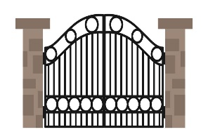 |  |  |  | 
Gate | entrance | Wi-fi | astronauts | corner
Date | screen | Layout | pets | cushion
_____________________________________________________________________________________________________
Orthography (spelling)

 | 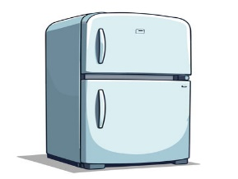 | 
Si_g | F_idge | Shel__
n | l | t
d | r | f

Controlled writing

4

Good luck T.

Worksheet – Top Goal 2

5th 6th grade Unit Job Paths

Name ………………………………… Class ………………………………
__________________________________________________________________________________________

General Questions

1– What are you going to be when you grow up ?

A. I am going to be an engineer. B. I am going to the market .
2 – Who works at an airport ?

A. Teachers and students . B. pilots and flight attendants .
3 – What do you call someone who takes professional photos?
A. The driver . B. The photographer.

____________________________________________________________________________________________________

Reading short sentences

He works in a factory . | That is an engineer . | That is an airport.
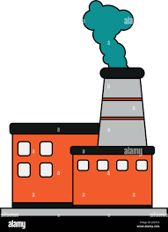 |  | 

___________________________________________________________________________________________
Controlled writing

1- going to /We /be /managers/ are /. / ( Rearrange ) ……………………………………………………………………………

mechanic | tourist | teacher | 2 - A person who is taking a tour is a .(choose)
journalist | pilot | driver | Someone who reports the news ( choose ) 3 -

going to | may | 1- I am ________ to be an artist.
Isn't he | Is he | 2- He is going to work here, ________?
might | may | 3- We use _______ when the future plan is unlikely to happen
Grammar

_____________________________________________________________________________________________________

Vocabulary

 |  |  |  | 
singer | engineer | pilot | mechanic | stage
driver | artist | doctor | waiter | airport
_____________________________________________________________________________________________________
Orthography (spelling)

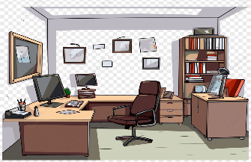 |  | 
Offi_e | Galle_y | Fashio_ designer
c | v | t
d | r | n

Controlled writing

4

Good luck T.

Worksheet – Top Goal 2

5th 6th grade Unit Glorious Food

Name ………………………………… Class ………………………………
__________________________________________________________________________________________

General Questions

1– What is your favorite dish?

A. My favorite dish is pizza . B. I am cooking pasta.
2 – How can you improve your eating habits?

A. I should sleep early. B. By eating enough fruit.
3 – What kind of food is pasta?
A. Starches. B. Proteins.

____________________________________________________________________________________________________

Reading short sentences

Wash your hands. | My favorite food is pasta. | She bakes a cake.
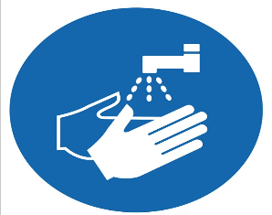 | 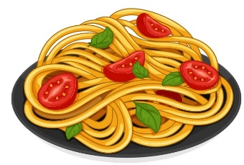 | 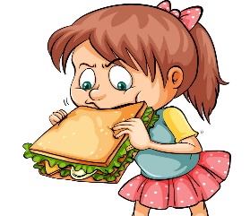

___________________________________________________________________________________________
Controlled writing

1- water/ lots /of/ Drink /. / ( Rearrange ) ………………………………………………………………………………………………..

Coffee | Water | Chips | 2 - _________ is good for your body . (choose)
should | Shouldn't | can't | You ________ eat enough vegetables . ( choose ) 3 -

turn | turned | 1- You should ________ the oven on .
using | use | 2- If I don't have sugar, I _____ honey.
Grammar

_____________________________________________________________________________________________________

Vocabulary

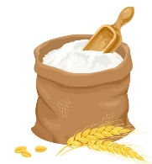 | 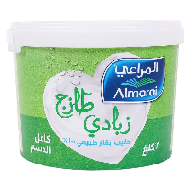 | 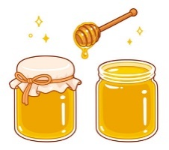 | 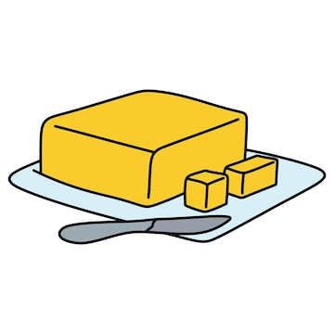 | 
flour | fruit | sugar | butter | smell
cake | yogurt | honey | water | taste
_____________________________________________________________________________________________________
Orthography (spelling)

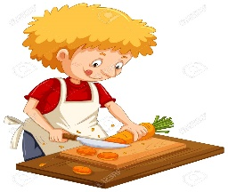 |  | 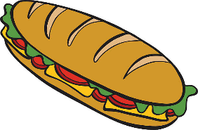
c_t | pou_ | san_wich
a | t | d
u | r | b

Controlled writing

4

Good luck T.

