


Worksheet – Top Goal1

4^{th'} grade Unit Welcome

Name ………………………………… Class ………………………………

__________________________________________________________________________________________

General Questions

1– What school subject is more difficult at school?

A. I think math. B. I am surprised.
2 – Who is naughty in your family?

A. My friend. B. My little brother.
3 – Who is the tallest student in your class?

A. My teacher. B. It's my sister.


____________________________________________________________________________________________________

Reading short sentences

She is afraid. | They are playing a game. | A shark in the water
 | 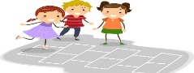 | 


___________________________________________________________________________________________

Controlled writing
........................................................... |  |  | 1- a terrible – It – game – is ( Rearrange )
naughty | delicious | happy | 2 - The food was __________. ( choose )
terrible | dangerous | brilliant | ( choose ) The taste of cheese is _________. 3 -


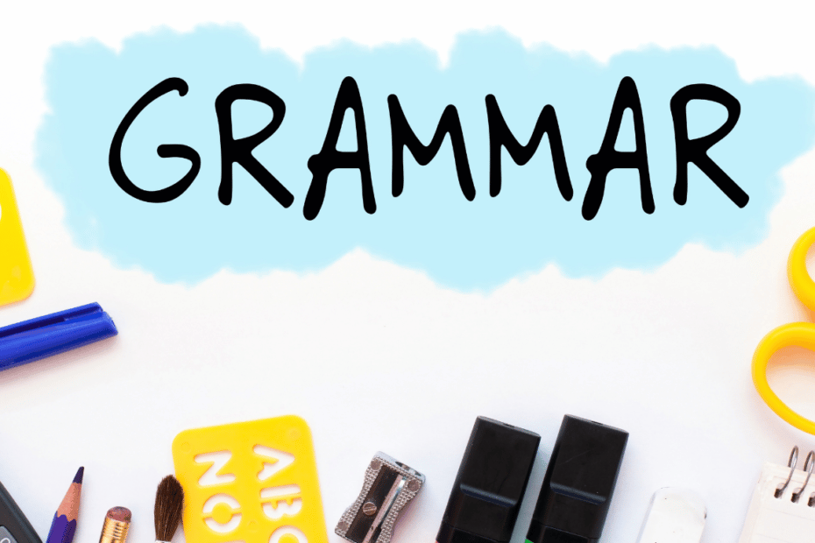
were | was | is | 1- We ____ happy .
are | was | were | 2- It _____ the best day of school .
Grammar

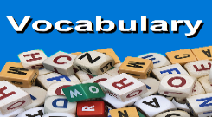
_____________________________________________________________________________________________________

Vocabulary

 |  |  | 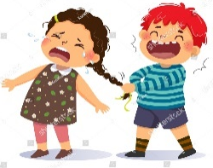 | 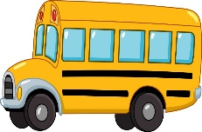  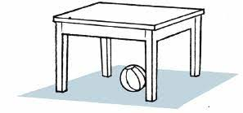
Surprised | Stop | Drum | Exciting | Bus
Brilliant | Dangerous | Guitar | Naughty | Poster

_____________________________________________________________________________________________________
Orthography (spelling)

 |  | 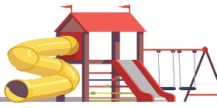
Ca_era | Cele_ration | Play_round
n | b | g
m | d | s

Controlled writing

4

Good luck T.



Worksheet – Top Goal1

4^{th'} grade Unit Family Events

Name ………………………………… Class ………………………………
__________________________________________________________________________________________

General Questions

1– How often do you visit your grandparents?

A. I always visit them. B. I love my grandpa.
2 – Is this your bag?

A. Yes, I have. B. Yes, it is mine.
3 – What is your favorite place to visit?

A. Diriyah is my favorite place . B. I usually visit my uncle .

____________________________________________________________________________________________________

Reading short sentences

I always walk in the park. | He is fishing in a boat. | She is playing a soccer.
  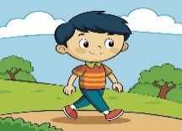 | 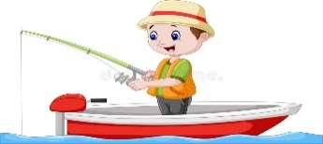 | 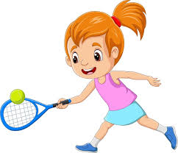

___________________________________________________________________________________________

Controlled writing
1- often / does / How / your /dad/cook/? ( Rearrange) ………………………………………………………………………………………
grandparents | parents | uncle | 2 - My mom and dad are my ______. (choose )
sometimes | usually | always | ( choose ) 3- They ___ (100%) have dinner together.
mommy | granny | daddy | ( choose the informal word ) 4- She is my mom

are | do | does | 1- How often ____ you see your cousin?
they | you | she | 2- How often does ____ have a cold?
mine | your | my | 3- Whose dress was it? It was _____ .
Grammar

_____________________________________________________________________________________________________

Vocabulary

 | 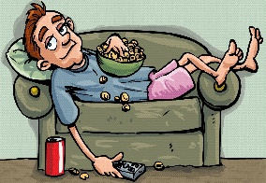 | 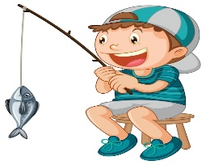 | 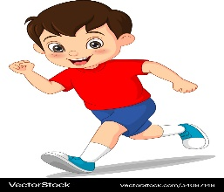 | 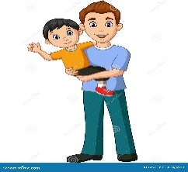
Strong | helpful | Cycling | Running | Dad
weak | Lazy | Fishing | Reading | Grandma
_____________________________________________________________________________________________________
Orthography (spelling)

 |  | 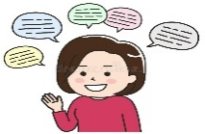
grand_a | kitte_ | ch_tty
p | b | a
m | n | e

Controlled writing

4

Good luck T.

Worksheet – Top Goal1

4^{th'} grade Unit Chores

Name ………………………………… Class ………………………………
__________________________________________________________________________________________

General Questions


1– What are you doing?

A. I am reading. B. I am eating .
2 – How often do you sweep the floor?

A. Yes, I am . B. I usually sweep the floor.
3 – What time do you go to sleep?

A. I wake up at 7:00. B. I go to sleep at 10:30 p.m.
4 – What chores do you help your family with?
A. I make the bed . B. Yes, I can .
____________________________________________________________________________________________________

Reading short sentences

I wash the dishes. | Sweep the floor. | Take out the trash
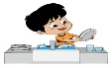 |  | 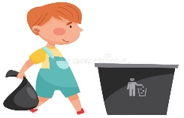

___________________________________________________________________________________________

Controlled writing
1- wash / Can / you / help /me/my/car/? ( Rearrange) ………………………………………………………………………………………
comic book | grass | pen | 2 - I am reading a _______________. (choose )
plane | bus | bike | ( choose ) 3- They take the ___ to school every day.
table | flower | trash | ( choose) 4- They water the ____ in the yard .



order | Request | Offer | 1- Can you help me set the table?
watches | watch | watching | 2- He is ______ TV right now .
go | goes | Is going | 3- She _____ to school by bus every day.
Can't | request | offer | 4 – We use Can I …? to express a / an….. .
Grammar

_____________________________________________________________________________________________________

Vocabulary

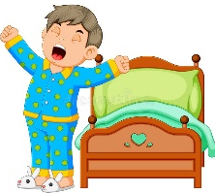 |  | 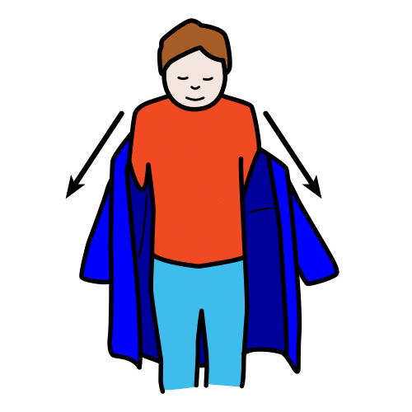 | 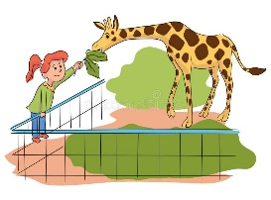 | 
Wake up | Trash can | Get dressed | Water | Leaves
Get up | Leaves | Get undressed | Feed | Dishes
_____________________________________________________________________________________________________
Orthography (spelling)

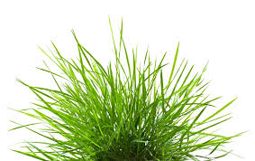 | 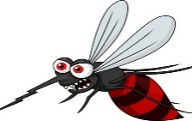 | 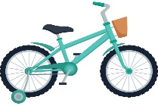
g_ass | mos_uito | Bi_e
r | b | f
t | q | k

Controlled writing

4

Good luck T.

Worksheet – Top Goal1

4^{th'} grade Unit Stories

Name ………………………………… Class ………………………………
__________________________________________________________________________________________

General Questions

1– What kind of stories do you like?

A. I like stories about animals. B. I like English.
2 – How do you know if friend is happy?

A. Smile on his face. B. He is crying.
3 – Did the boy climb the tree ?

A. Yes, he did . B. No, I didn't.

____________________________________________________________________________________________________

Reading short sentences

They are in the classroom. | He is reading a book . | He is a writer.
 |  | 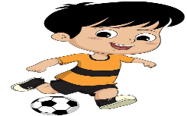

___________________________________________________________________________________________

Controlled writing
............................................................ |  |  | 1- played / Carta / a soccer / yesterday. (Rearrange)
jumped | clapped | dropped | 2 - She________ her pencil. ( choose )
stopped | dreamed | planted | ( choose ) My brother _________ some flowers. 3 -
plant | want | dreamed | He _______ a lot at night ( choose ) 4-

Yes, I am | No. I did | Yes, he did | 1- Did he like the movie?
scoring | scored | scores | 2- She _____ a goal yesterday.
shout | shouting | shouted | 3- He didn't _______.
Grammar

_____________________________________________________________________________________________________

Vocabulary

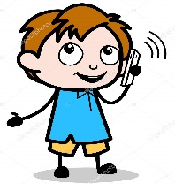 |  | 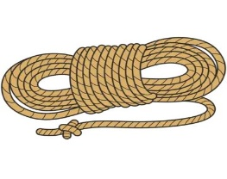 |  | 
fix | hose | rope | watered | shout
call | plant | leave | robbed | jump
_____________________________________________________________________________________________________
Orthography (spelling)

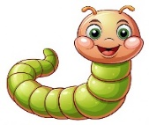 |  | 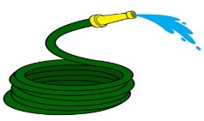
_rom | ter_mon | h_se
n | k | o
w | s | y

Controlled writing

4

Good luck T.

Worksheet – Top Goal1

4^{th'} grade Unit After-School Fun

Name ………………………………… Class ………………………………
__________________________________________________________________________________________

General Questions

1– Do you want to go shopping?

A. I like shopping. B. Yes, I do .
2 – What after-school activity do you do ?

A. I play computer games. B. No, I am not .
3 – What did your grandparents play when they were children?

A. They played hide and seek. B. They played PlayStation 5 .

____________________________________________________________________________________________________

Reading short sentences

He likes to take a photo. | They go shopping | He planted flowers.
 |  | 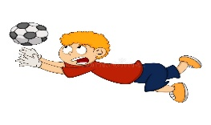

___________________________________________________________________________________________

Controlled writing
........................................................... |  |  | 1- played / I / video games / yesterday/. ( Rearrange)
quietly | quickly | loudly | 2 – He is walking ________. ( choose )

Did | Does | Do | 1- ____ you play a soccer yesterday?
going | went | go | 2- I didn't _____ shopping.
Yes, I do. | Yes, I did. | Yes, I am. | 3- Did you take photos of your family?
so | and | but | 4- I go swimming _____ play tennis.
Grammar

_____________________________________________________________________________________________________

Vocabulary

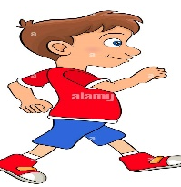 | 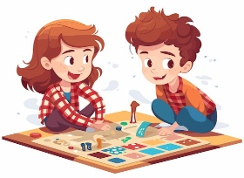 | 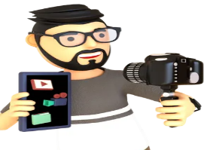 |  | 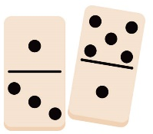
walking | Catch a ball | vlogging | cooking | Dominos
sleeping | Board game | running | reading | Piano
_____________________________________________________________________________________________________
Orthography (spelling)

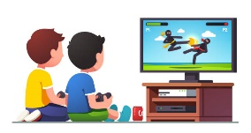 | 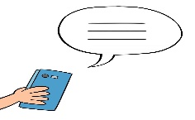 | 
Vi_eo games | ting_te | _appily
n | c | h
d | x | f

Controlled writing

4

Good luck T.

