Name: ................................... Ms. Tahani
Class: 2nd Elementary / ........
Revision Sheet _ Introduction + Unit ( 1 ): Feelings
- General Questions:
  - Match the questions with the correct answers:
- Good morning. |  | I’m great, thanks.
- How are you? |  | I’m hungry.
- It’s nice to meet you. |  | Good morning.
4. What’s the matter? |  | It’s nice to meet you, too.

- Controlled Writing:
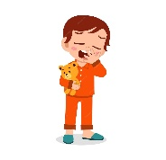
  - Rearrange the words to form sentences:
    - am – sleepy – I

  - Write the following ordinal numbers in words:
fifth – second – fourth – third – first

1st 2nd
3rd 4th 5th
- Reading Short Sentence:
  - Read the sentences then match them with the correct pictures:
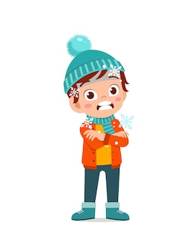 | 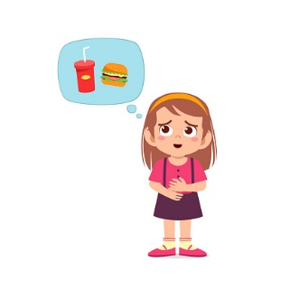  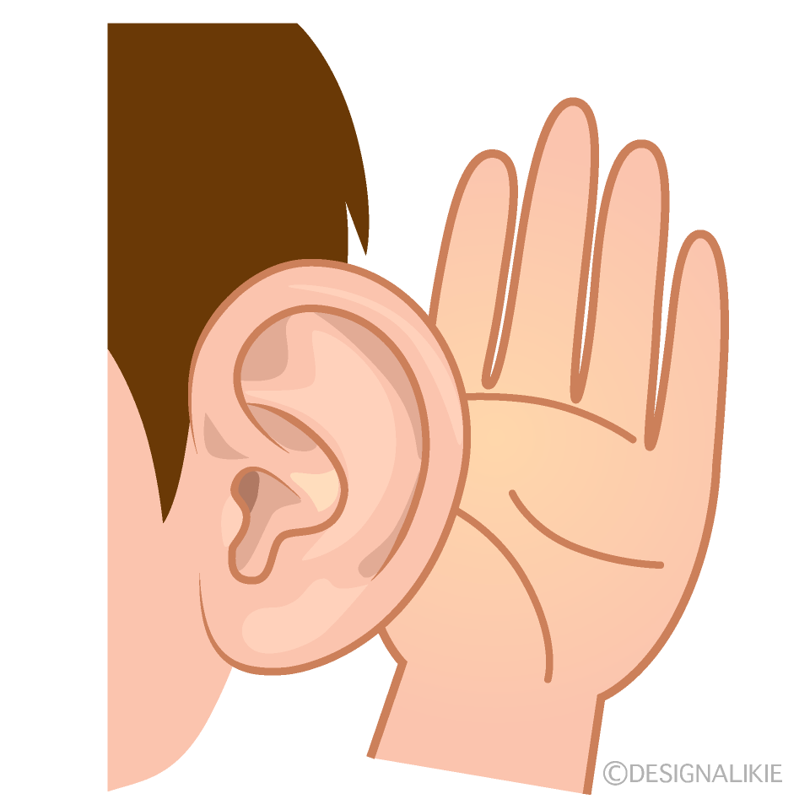 |  |  | 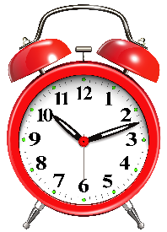
a. I am hot.  b. I am cold. | a. Clap your hands.  b. Listen to me. | a. I am hungry.  b. I am thirsty. | a. Watch me.  b. Make pairs. | a. It is a clock.  b. It is a cap.
- Grammar:
  - Choose the correct answer:
    - I ( am – is – are ) fine, thank you.
    - He ( am – is – are ) cold.
    - She ( am – is – are ) scared.
    - You ( am – is – are ) happy.
    - A: ( What – How ) are you?
B: I am great!
    - A: ( What – How ) is the matter?
B: I am thirsty.

- Vocabulary:
  - Write the words under the correct pictures:
clap – tenth – cap – lock – thirsty -scared – seventh – hot

 | 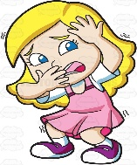 |  | 
 |  | 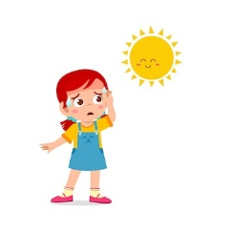 | 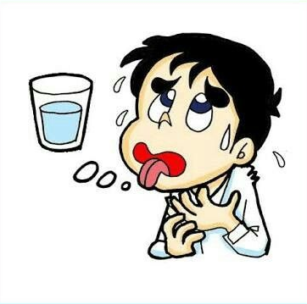
 | 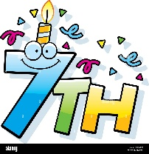

- Orthography:
A- Fill in the missing letters: B- Choose the correct missing letters:

a__e - i__e
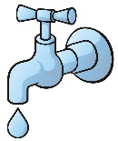  t__p |  |   p__n
  a | i | a | i
__nk |  | 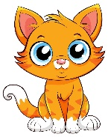  c__t
a | i | a | i

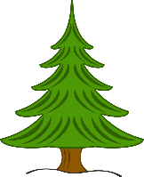


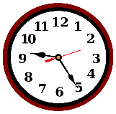
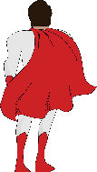
p__n__ t__p__

c__p__ t__m__
Name: ................................... Ms. Tahani
Class: 2nd Elementary / ........
Revision Sheet _ Unit ( 2 ): Things We Wear
- General Questions:
  - Match the questions with the correct answers:
- Whose hat is that? |  | Thank you.
- Who is wearing green today? |  | It’s mine. Thank you.
- I like your cap. |  | Good morning.
 |  | I am!

- Controlled Writing:

  - Rearrange the words to form sentences:
    - like – your – I – hat

  - Write the color:
yellow – blue – pink – green

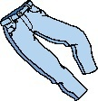
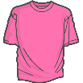
- I am wearing jeans and a jacket.
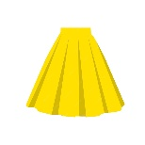
- I am wearing a T-shirt.
- I am wearing a skirt.
- Reading Short Sentence:
  - Read the sentences then match them with the correct pictures:
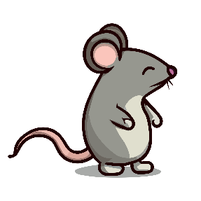 | 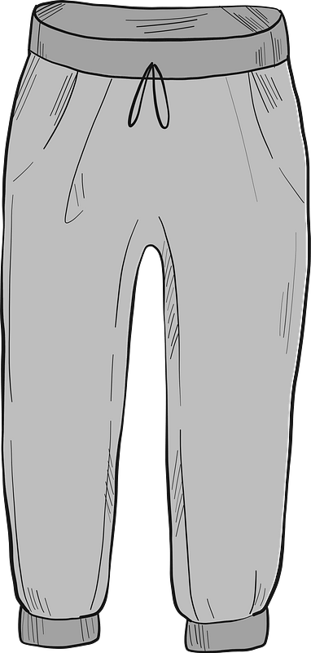 |  | 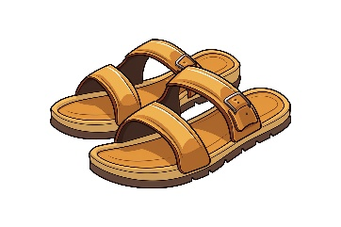
a. It is a mouse.  b. It is a squirrel. | a. I like your T-shirt.  b. I like your pants. | a. It is purple.  b. It is red. | a. They are shoes.  b.They are sandals.
- Grammar:
  - Choose the correct answer:
    - ( Whose – Who ) bag is this?
    - ( Whose – Who ) is wearing green today?
    - It is ( my – mine ) hat.
    - It is ( my – mine ) .

- Vocabulary:
  - Write the words under the correct pictures:
grass – sunglasses – blouse – sweater – shoes – squirrel – skirt – jeans

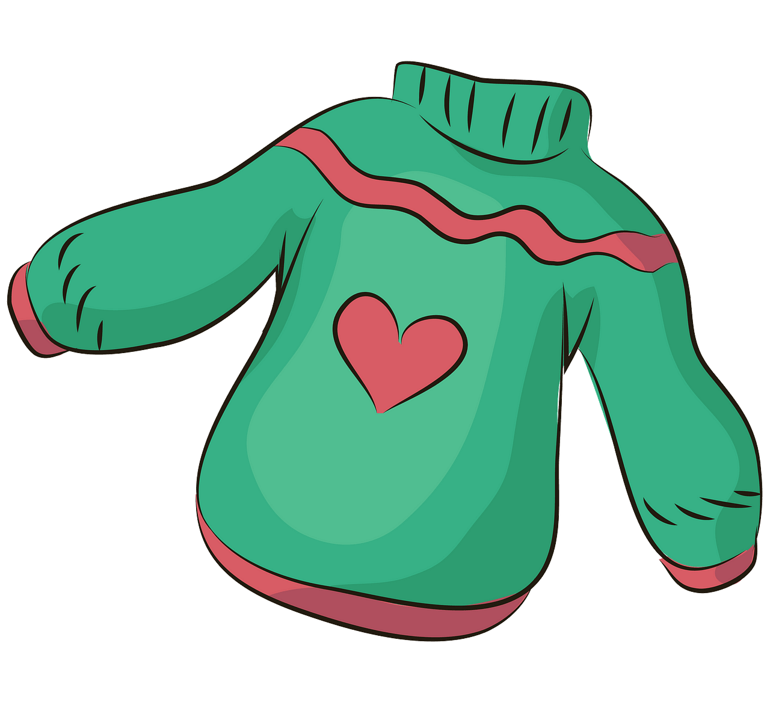 | 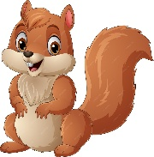 | 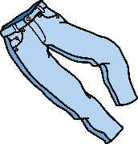
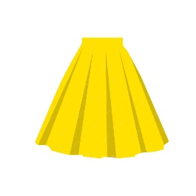
 |  | 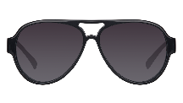 | 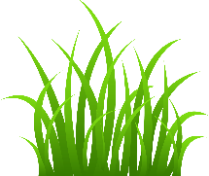
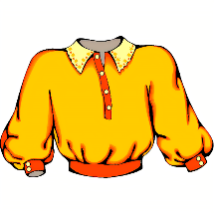

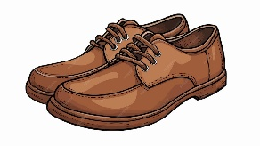

- Orthography:
A- Fill in the missing letters: B- Choose the correct missing letters:

pl - bl
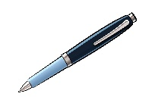  __en |  | __anda
b | p | b | p
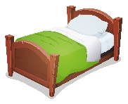  __ed |  |   __anana
b | p | b | p





__ __ate __ __ue



__ __ack __ __ane
Name: ................................... Ms. Tahani
Class: 2nd Elementary / ........
Revision Sheet _ Unit ( 3 ): Things We Do
- General Questions:
  - Match the questions with the correct answers:
- What are you doing? |  | He’s watching TV.
- What is he doing? |  | Bye.
- Can I speak to Ali? |  | I’m doing my homework.
4. Good-bye. |  | Speaking.
- Controlled Writing:
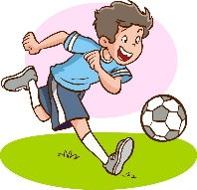
  - Rearrange the words to form sentences:
    - football – am – I – playing

  - Look at the pictures and write:
karate – computer games – homework

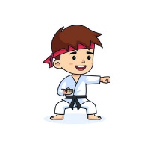
- I am playing

- I am doing
- I am doing
- Reading Short Sentence:
 |  |  |   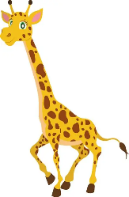
a. I’m doing nothing.  b. I’m doing karate. | a. I’m watching TV.  b. I’m playing football. | a. I’m speaking.  b. I’m eating snacks. | a. It’s tall.  b. It’s short. | a. It’s small.  b. It’s fat.
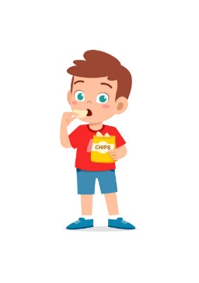
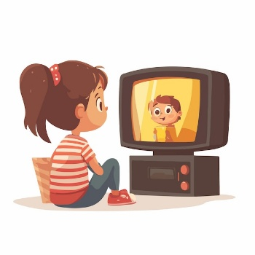
  - Read the sentences then match them with the correct pictures:

- Grammar:
  - Choose the correct answer:
    - I (am – is – are) doing my homework.
    - He (am – is – are) eating snacks.
    - She (am – is - are) watching TV.
    - I am (playing – doing) football.
    - He is (playing – doing) karate.

- Vocabulary:
  - Write the words under the correct pictures:
TV – snacks – football – speaking – karate – computer games
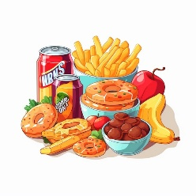
 |  |  |  |  | 

- Orthography:
A- Fill in the missing letters: B- Choose the correct missing letters:

tr - dr
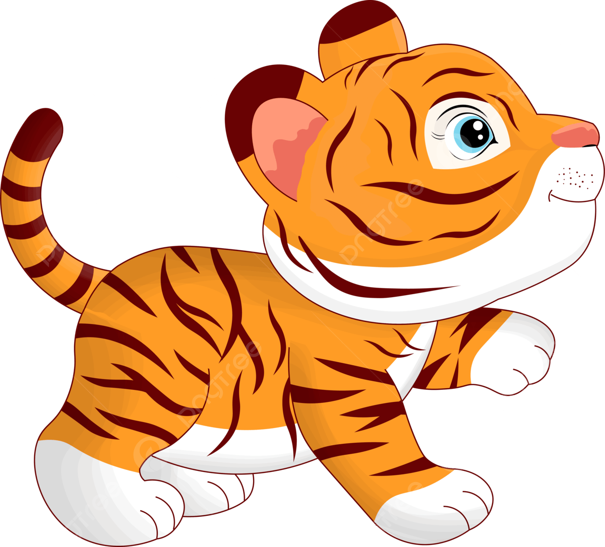  __iger |  | 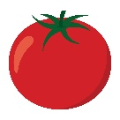  __omato
t | d | t | d
  __uck |  |   __oll
t | d | t | d

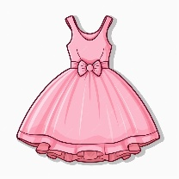
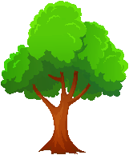

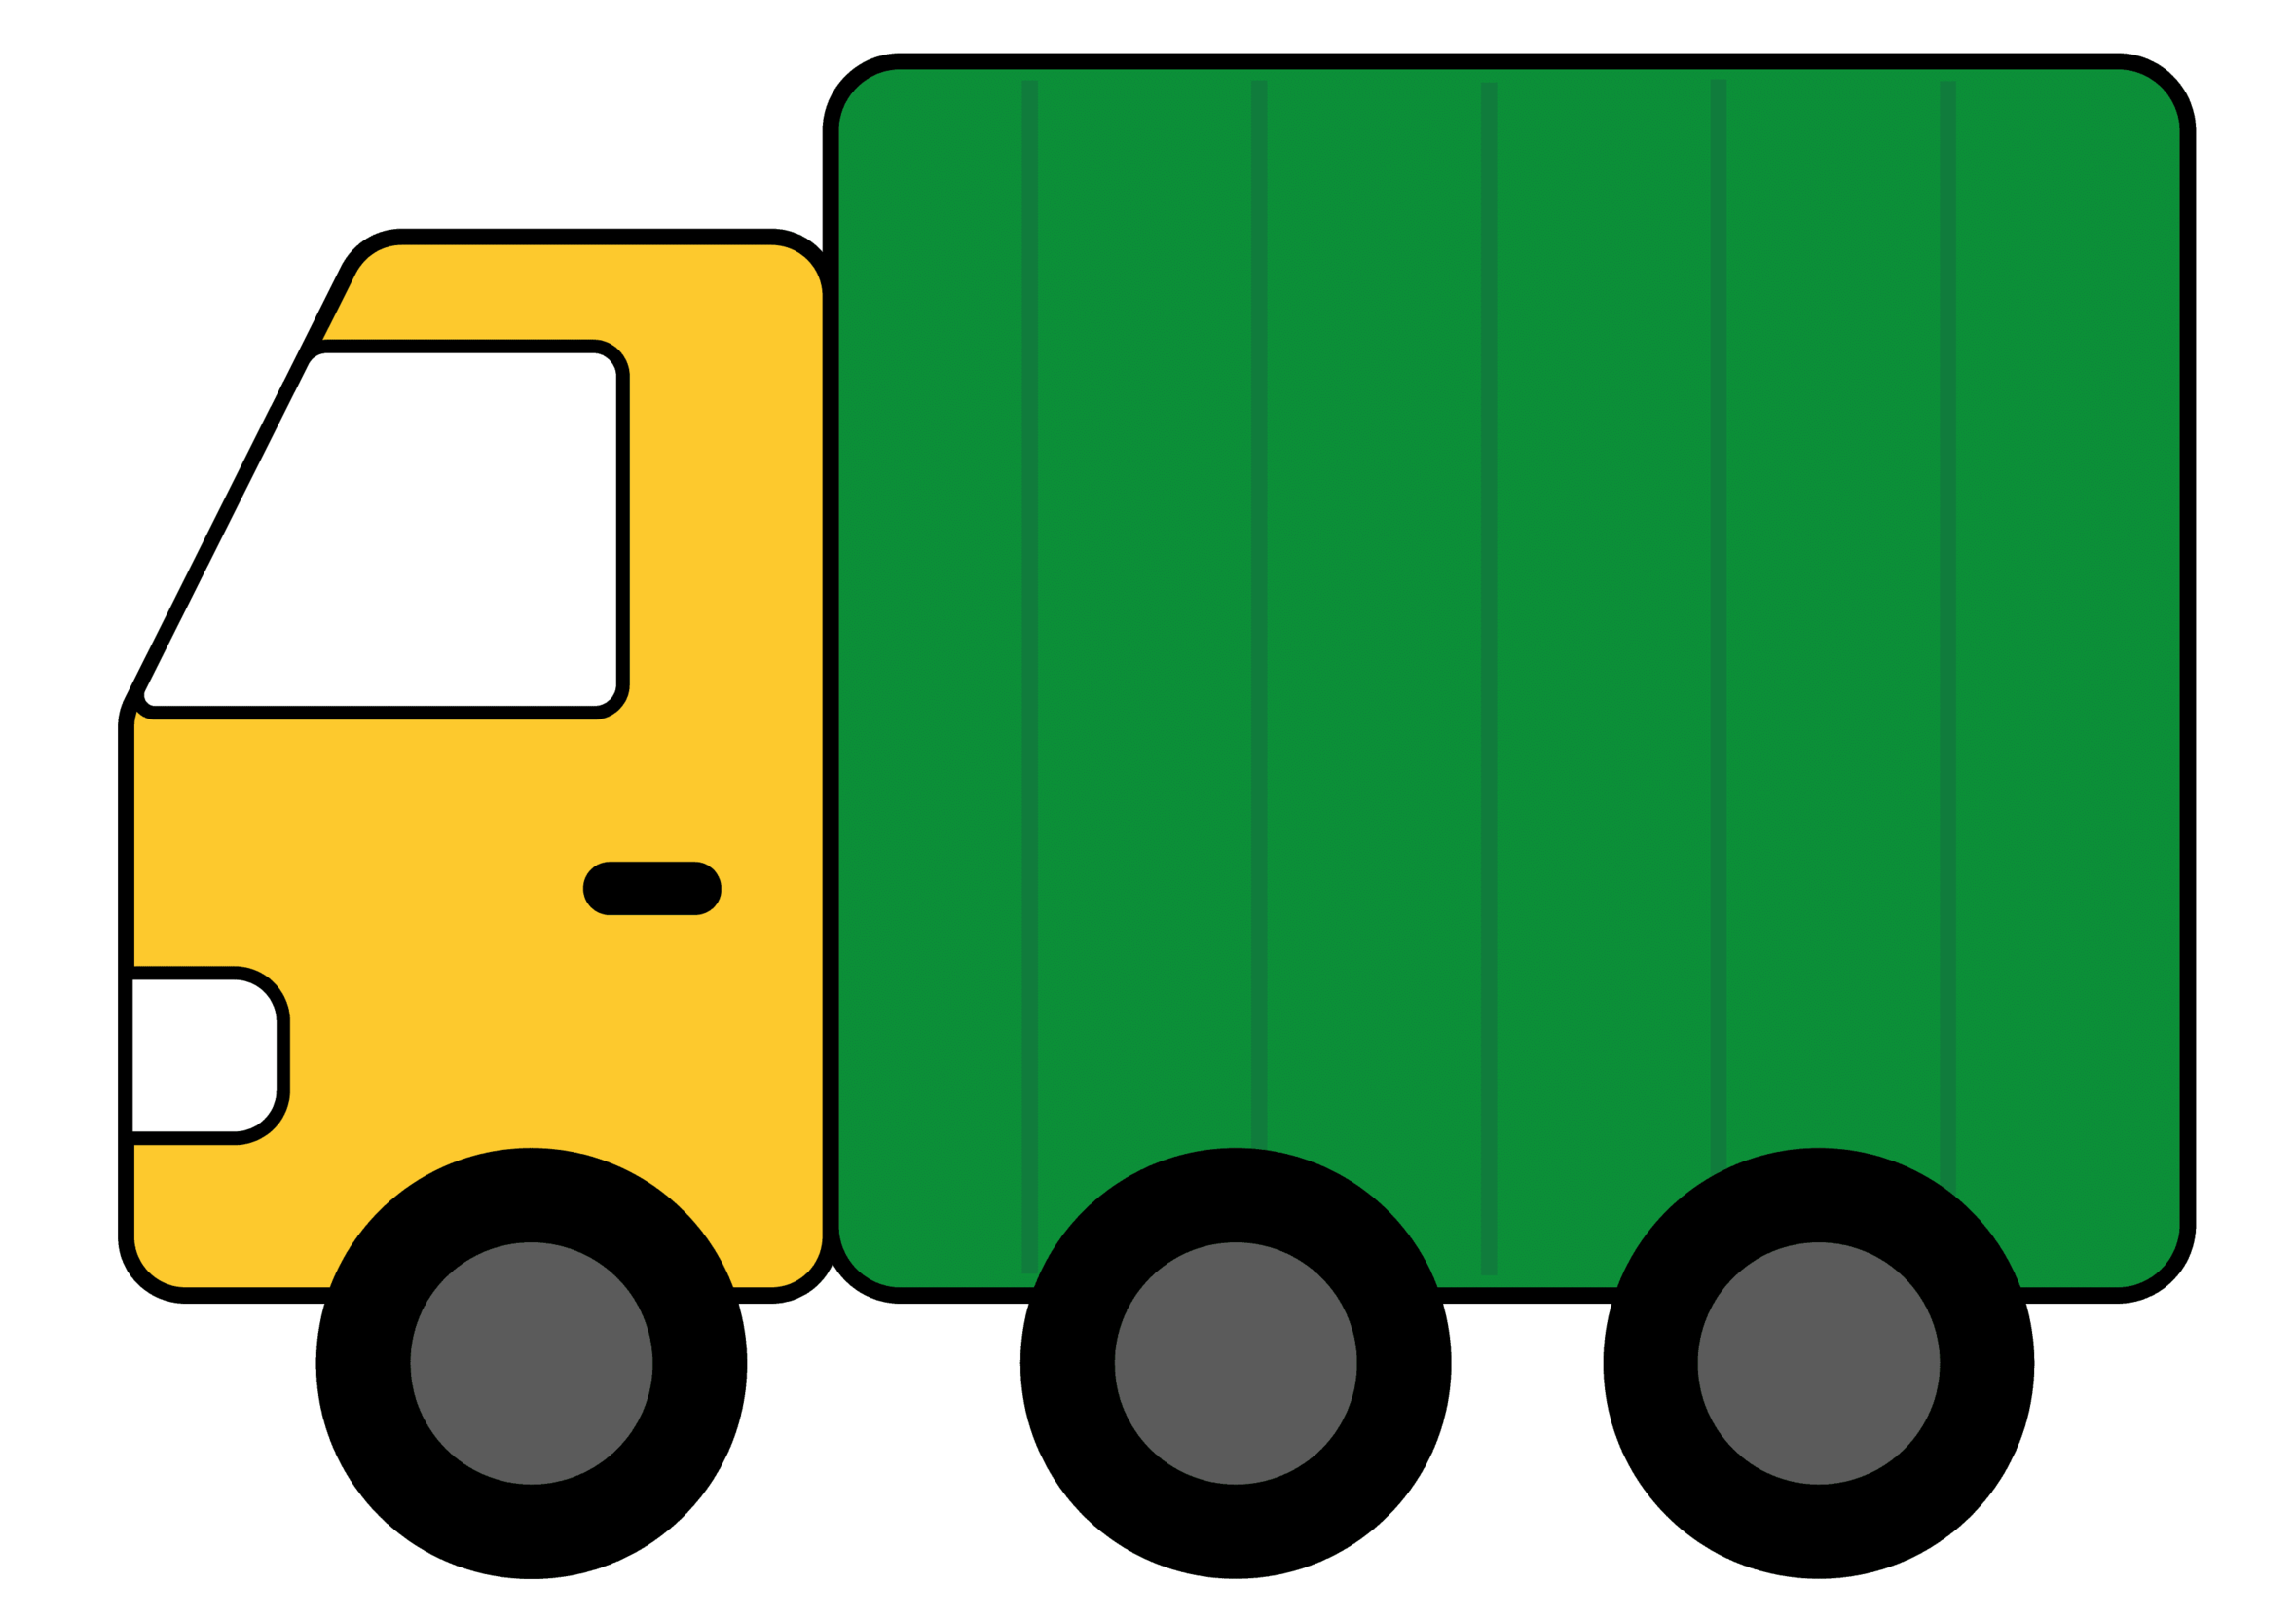
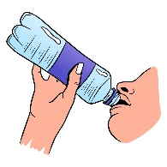
__ __ee __ __ess

__ __ink __ __uck
 |  |  | 
ring | wink | elephant | phonics
rink | wing | photo | phone
C- Choose the correct word for each picture:
Name: ................................... Ms. Tahani
Class: 2nd Elementary / ........
Revision Sheet _ Unit ( 4 ): Beautiful Nature
- General Questions:
  - Match the questions with the correct answers:
- How many seasons are in the year? |  | The flowers are out in spring.
- In which month are the flowers out? |  | December, January & February.
- What are the winter months? |  | There are four seasons.

- Controlled Writing:

  - Rearrange the words to form sentences:
    - a – bag – It’s – plastic

  - Write the months of the year in the correct order:
August – November – June – March

January | February |  | April | May
July |  | September | October |  | December
  - Write the opposites:
    - short ≠ 3- beautiful ≠
    - small ≠ 4- strong ≠

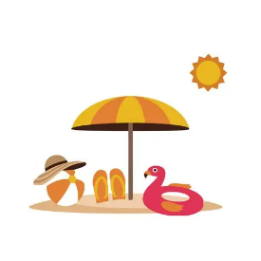 | 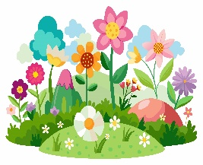 |  | 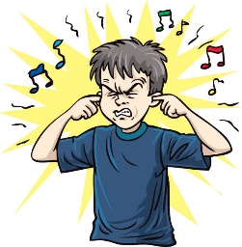 | 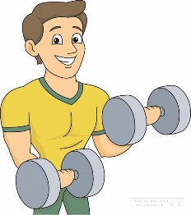
a. It’s winter.  b. It’s summer. | a. It’s spring.  b. It’s fall. | a. I love the mountains.  b. I love the rolling hills. | a. It’s quiet.  b. It’s noisy. | a. It’s weak.  b. It’s strong.
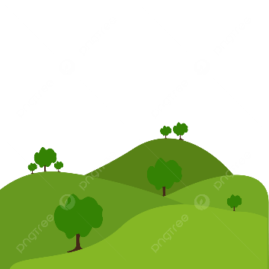
- Reading Short Sentence:
  - Read the sentences then match them with the correct pictures:
- Grammar:
  - Choose the correct answer:
1- It (am – is – are) big and gray.
2- It is (a – an) elephant.
3- It is (a – an) mouse.
- Vocabulary:
  - Write the words under the correct pictures:
sky – monster – flower – smile – star – campfire

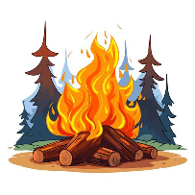
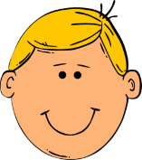 |  |  |  |  | 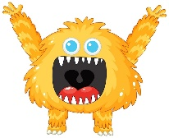

- Orthography:
A- Fill in the missing letters: B- Choose the correct missing letters:

gr – cr – gl – cl
  __ake |  | 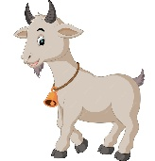  __oat
c | g | c | g
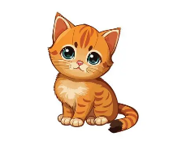  __at |  | 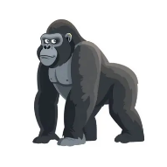  __orilla
c | g | c | g

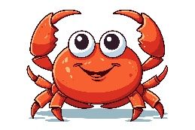


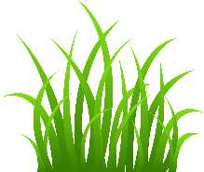
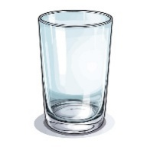
__ __ass __ __ab

__ __ass __ __ass
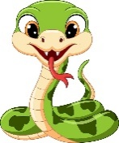  __ __ake | 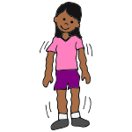  __ __ake |  |   mountains |  |  | cats |  |  | 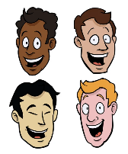  faces
sn | sn |  | /s/ | /z/ | /iz/ | /s/ | /z/ | /iz/ | /s/ | /z/ | /iz/
sh | sh
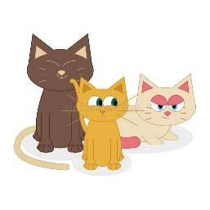
C- Choose the correct answer for each picture:
Name: ................................... Ms. Tahani
Class: 2nd Elementary / ........
Revision Sheet _ Unit ( 5 ): Friends, Actions, Things
- General Questions:
  - Match the questions with the correct answers:
- Where is he? |  | No, he isn’t.
- What color is it? |  | He’s at home.
- Is he watching TV? |  | It’s yellow.
- Do you have apples? |  | Maybe it’s Noura’s.
- Whose hat is that? |  | Yes, I do.

- Controlled Writing:
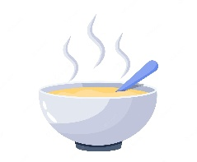
  - Rearrange the words to form sentences:
    - soup – hot – is – My

  - Write about food. Use these words:
Sour – salty – sweet – cold

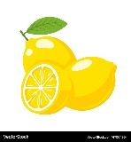

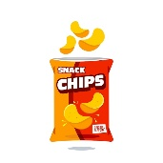
Lemons are . Ice-cream is .
chips are . Cherries are .

  - Answer the following questions with Yes or No:

1- Is he running?


2- Is it sour?

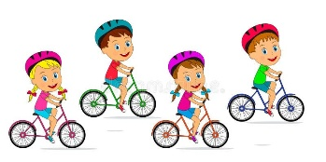 |  | 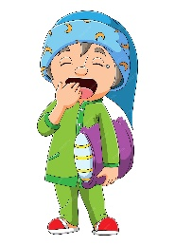 | 
a. They’re jumping.  b. They’re cycling. | a. It’s playtime.  b. It’s bath time. | a. Good afternoon!  b. Good night! | a. Good morning!  b. Good evening! | a. He’s walking.  b. He’s talking.
- Reading Short Sentence:
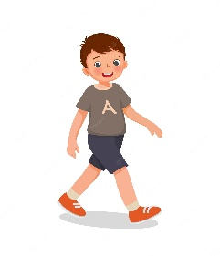
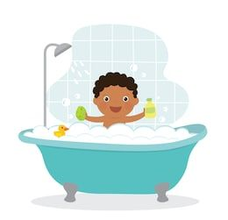
  - Read the sentences then match them with the correct pictures:

- Grammar:
  - Choose the correct answer:
1- (Is he – He is) running? 6- We (am – is – are) standing.
2- I have books (and – but) pens. 7- He (am – is – are) reading.
3- I have books (and – but) I don’t have pens. 8- They (am – is – are) writing.
4- Do you have apples? No, I (do – don’t). 9- (Whose – Who) skirt is this?
5-.Do you have apples? Yes, I (do – don’t). 10- It’s (Noura’s – Nouras’)

- Vocabulary:
  - Write the words under the correct pictures:
jump – orange juice – stand – tasty – carrot – sandwich
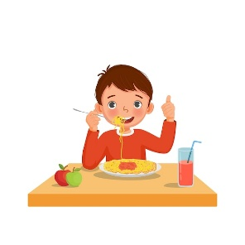
 | 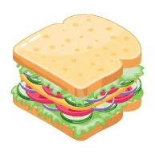 | 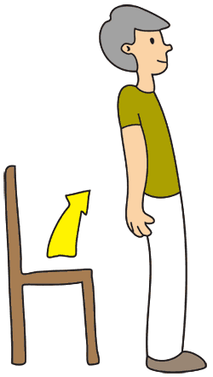 | 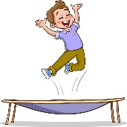 |  | 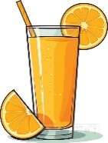
- Orthography:
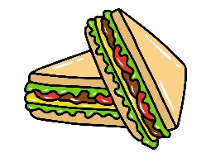  sandwiches |  |  | 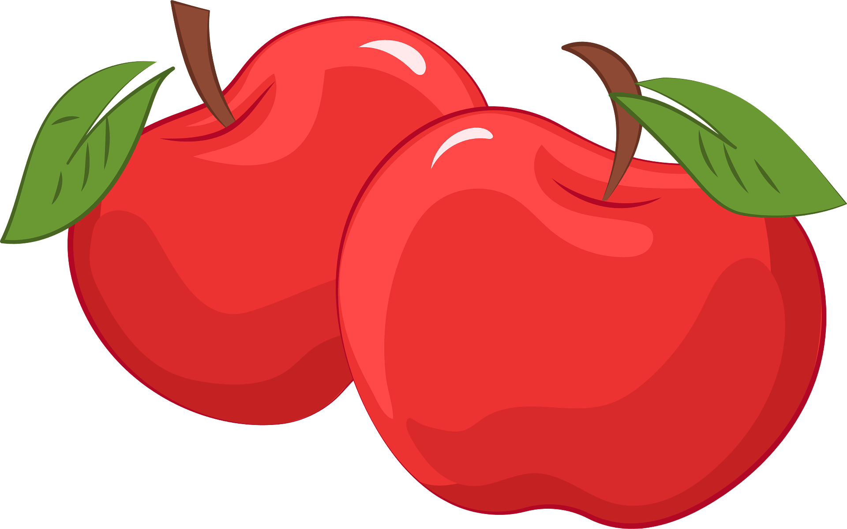  apples |  |  | 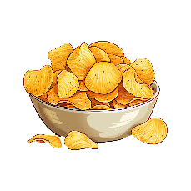  chips
/s/ | /z/ | /iz/ | /s/ | /z/ | /iz/ | /s/ | /z/ | /iz/
  - Choose the correct answer for

