
Kingdom of Saudi Arabia 5th &6th Elementary Grade
Ministry of Education

10
………… Elementary School . .اتااا اختبار تشخيصي
Name: ………………………………………………………….………………. Class : …………..
Choose the correct answer:
- ……….…… apples do you have?
- How much |  |  | - How many |  |  |  | - How long
- “I………. call her now”
- will |  |  | - going to |  |  |  | - am
- Who designs houses?
- Teachers |  |  | - Architects |  |  |  | - Doctors
- My hair is………. I need to brush it.
a- messy |  |  | b- unkind |  |  |  | c- friendly
Vocabulary:
- Choose the correct answer:
 |  |  |  |  |  |  |  | 
- engineer  - pilot |  | - screen  - wifi |  |  | - cookies  - onion |  |  | - taste  - smell
Orthography:
- Choose the correct missing letters:
___ate |  | Mi___ |  |  | 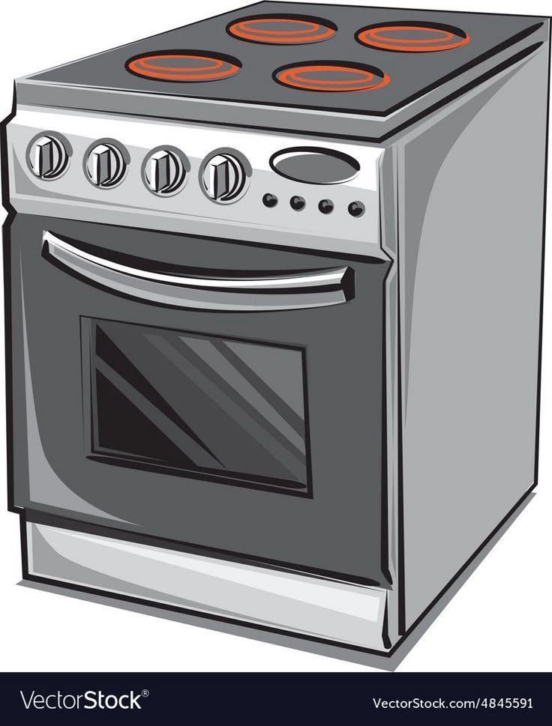  O___en |  |  |   Ama__ing
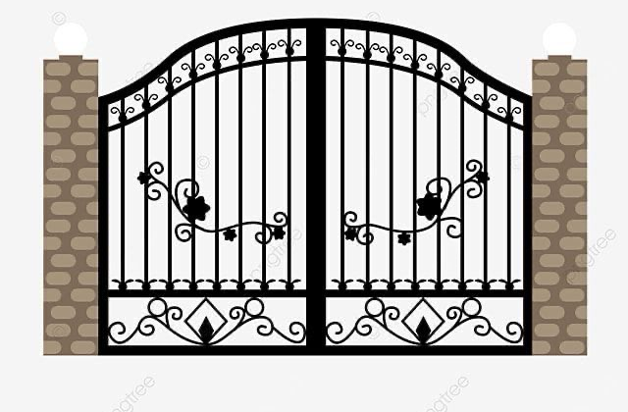  g | f | o |  | x | v | s |  | z | r
