

Worksheet – we can3

3^{rd '}grade Unit 1 Fun on the Weekend

Name ………………………………… Class ………………………………

__________________________________________________________________________________________

General Questions

1 – What did you do over the weekend?
A . I am 10 years. B . I cleaned my room .
2 – How much flour do we need?
A. It is 10 SAR . B. We need 2 cups .
3 – can I help you ?
A . Yes, please . B. No, I am not.


____________________________________________________________________________________________________

Reading short sentences

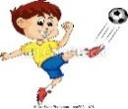
1. He kicked a ball .

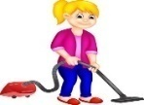
2. She watched TV.


___________________________________________________________________________________________

Controlled writing
______________________ |  |  | 1– breakfast – cooked – she . ( rearrange )
Ice cream | soup | cheese | 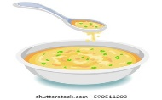  2. I'd like _______please . ( choose )

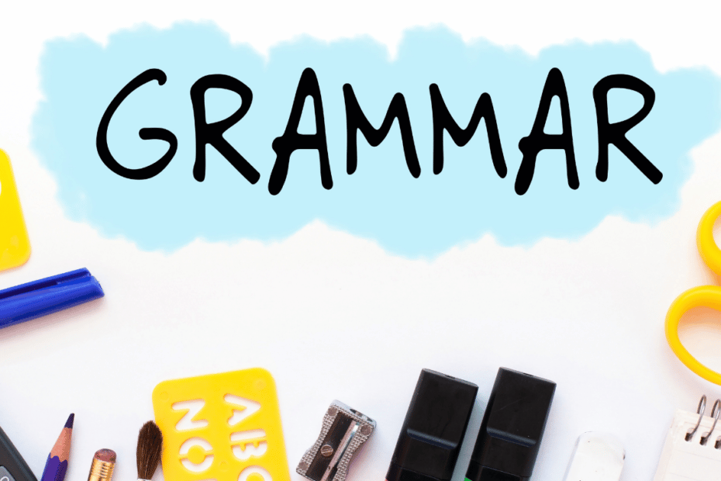
Grammar
some | many | much | 1 – How____ oil do you need ?
some | many | much | 2- How____ tomatoes do you need ?
many | some | any | 3. We have ____ flour .
many | some | any | 4- We don't have ____ oil.

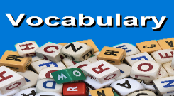
_____________________________________________________________________________________________________

Vocabulary

Trampoline – clean – French fries – cheese

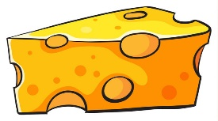 |  | 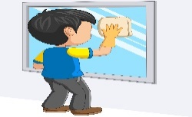 | 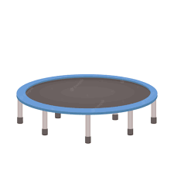
---------- | ---------- | --------- | ---------


_____________________________________________________________________________________________________
Orthography (spelling)
Choose the correct letter: ( nd - nt )

 | 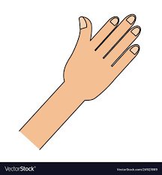 |  |  | 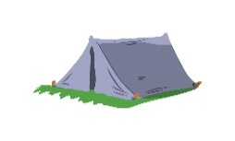
Pai _ _ | Ha _ _ | Pla _ _ | 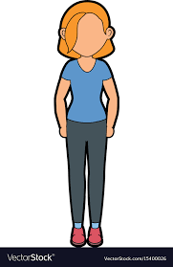  Sta _ _ | Te _ _

Controlled writing

4

Good luck T.

Worksheet – we can3

3rd Unit 2 Life's Ups and Downs

Name ………………………………… Class ………………………………
__________________________________________________________________________________________

General Questions

1– What happened to you last week?
A. I broke my leg. B. I am playing football.
2 – I won a table tennis game 21 to 3 .
A. Sorry about that . B. Congratulations.

____________________________________________________________________________________________________

Reading short sentences


1. I caught a cold.

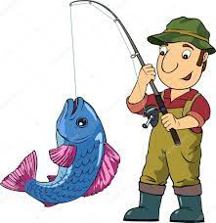
2. I caught a big fish .

_____________________________________________________________________________________
Controlled writing
______________________ |  |  | 1– sick – was – I . ( rearrange )
grocer's | park | bank | 4– I went to the ____ to buy some milk. ( choose )

Grammar

wining | won | win | 1- The PAST TENSE of win is ______ .
saw | lost | loses | 2- The PAST TENSE of lose is ______ .
us | he | I | 3- Our father drove ______ there

_____________________________________________________________________________________________________

Vocabulary
carrots – chicken – meat - oil

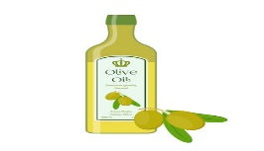 | 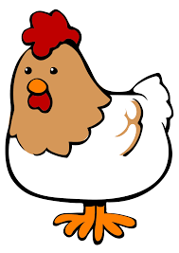 |  | 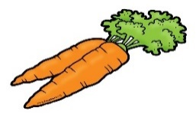
---------- | ---------- | --------- | ---------

_____________________________________________________________________________________________________
Orthography (spelling)

Choose the correct letter: ( gh - ph - f )

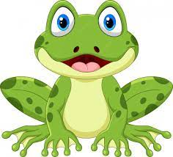 |  |  | 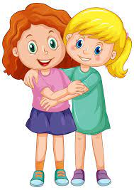 | 
_ rog | ele _ _ant | lau _ _ | _ riends | _ _one

Controlled writing

4
Controlled writing

4

Good luck T.


Worksheet – we can 3

3 ^{rd.} grade Unit 3 MY School is Cool

Name ………………………………… Class ………………………………

__________________________________________________________________________________________

General Questions

1– How many students are there in your school?

A. About 500 . B. Yes, I am.
2 – What time does your school start?

A. Yes, we do . B. It starts at 6:30.

____________________________________________________________________________________________________
Reading short sentences

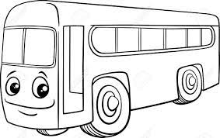
1. Our school has a school bus .


2. This year I like math .

___________________________________________________________________________________________
Controlled writing

______________________________ |  | 1– in – live – I - Riyadh . ( rearrange )
Shout | Speak | 2- ----------- English in class . ( choose )


Grammar

went | go | 1- Last week we ______ to Abha .
were | was | 2- Last year I ____ in the 2nd grade .
_____________________________________________________________________________________________________
Vocabulary

Match :

Don't shout - flag - PE - Language - Art - Math - School

 |  | 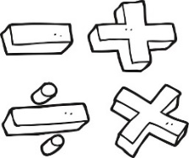 | 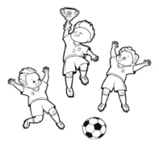 | 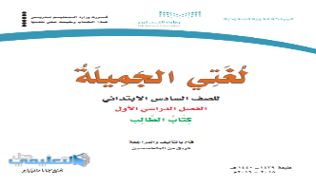 |  | 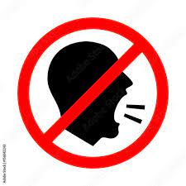

_____________________________________________________________________________________________________
Orthography (spelling)


Choose :
  _ _ y | 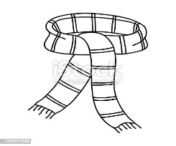  _ _arf |   _ _uare | 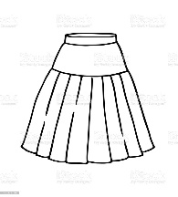  _ _ irt | 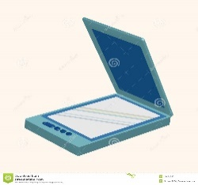  _ _an
sk | sk | sq | sk | sq
sc | sc | sk | sc | sc

Controlled writing

4

Good luck T.

Worksheet – we can3

3rd grade Unit 4 A Healthy Life

Name ………………………………… Class ………………………………
__________________________________________________________________________________________

General Questions

1– What should you do to live a healthy life ?

A.I should go to bed early. B. I should skip breakfast.
2 – Did you get up early this morning?

A. Yes, we do . B. Yes, I did .

____________________________________________________________________________________________________

Reading short sentences

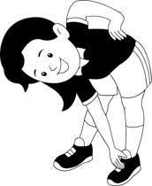
1. I should do my exercise.

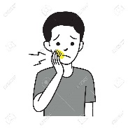
2. I have a headache.

___________________________________________________________________________________________

Controlled writing
______________________ |  |  | 1– sleep – should – early – I ( rearrange )
Goodbye | Goodnight | Good morning | 2-Greeting at night ____. ( choose )
earache | headache | toothache | 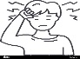  ( choose ) 3. I have a _____.
poor | wealthy | Healthy | 4. He is _____ .  He has a lot of money . ( choose )

Grammar
brushing | brush | brushed | 1- I should ______ my teeth.
got up | get up | do | 2- Did you ____ early this morning ?
does | did | do | 3- Did you eat breakfast? yes, I ______.
drinks | drank | drink | 4- Did you drink milk ? Yes, I _____ milk .

_____________________________________________________________________________________________________

Vocabulary

 | 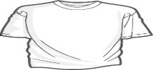 | 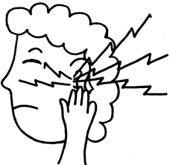 | 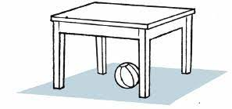
belt | T-shirt | stomachache | Headache
skirt | scarf | earache | toothache

_____________________________________________________________________________________________________
Orthography (spelling)

Choose the correct letter:

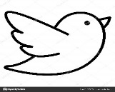  b_ _ d | 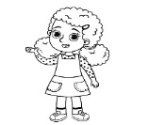  g_ _l | 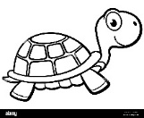  t_ _tle | 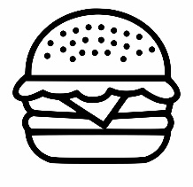  b_ _ ger
ur | ir | ur | ar
ir | ur | er | ur

Controlled writing

4

Good luck T.

Worksheet – we can3

3rd grade Unit 5 Hanging Out in Town

Name ………………………………… Class ………………………………
__________________________________________________________________________________________

General Questions

1– Excuse me. Where is the bank?

A. Go straight and you'll find it . B. Thank you .
2 – How long does it take ?

A. It's behind you . B. It's about 5 minutes .

____________________________________________________________________________________________________
Reading short sentences

There were two floors. | No parking. | Do not litter. | Switch off all cell phones.
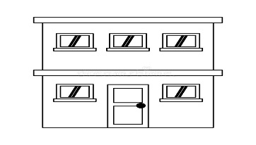 | 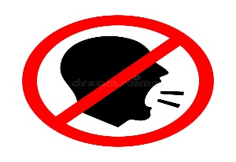 | 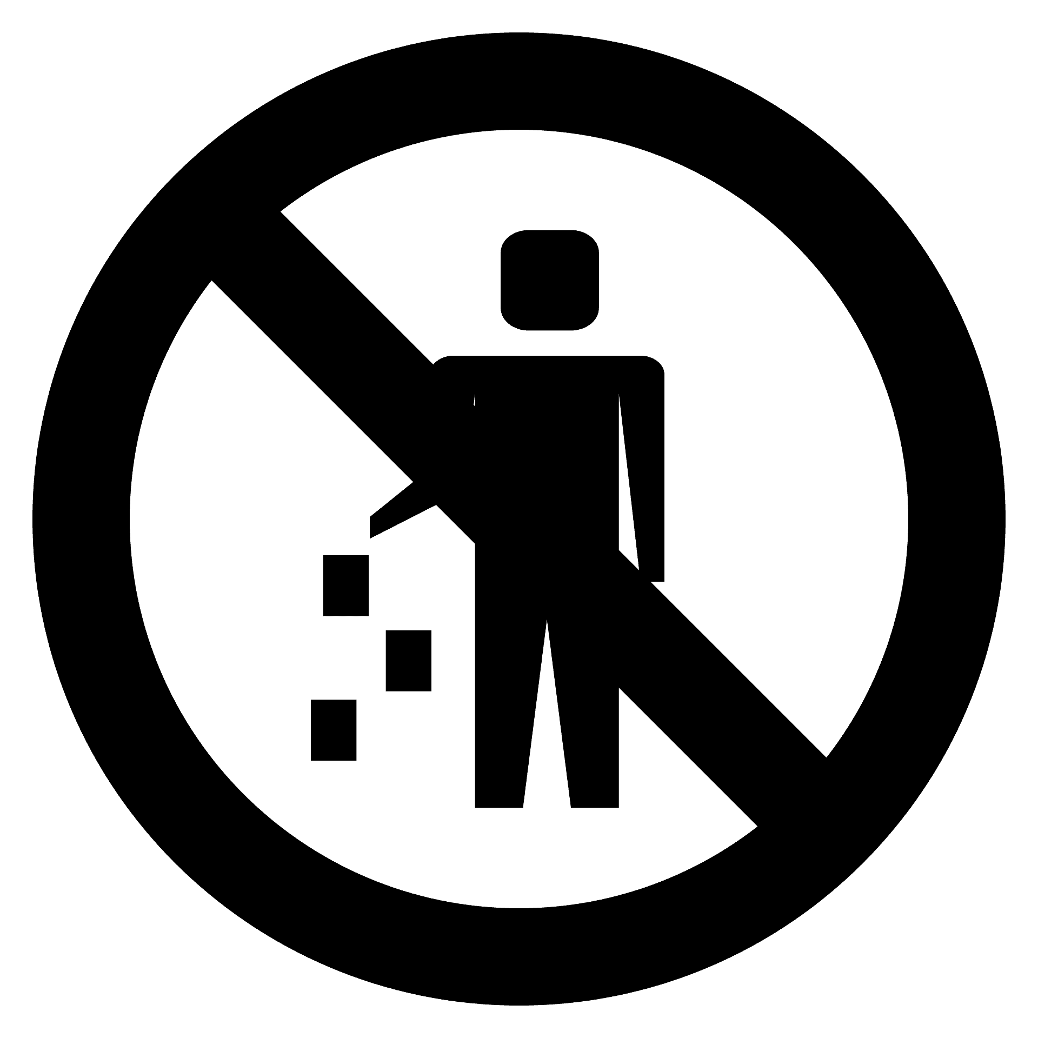 | 
___________________________________________________________________________________________

Controlled writing
bakery | supermarket | school | 1– A Store has many kinds of food. ( choose )
.............................................. |  |  |   2- Go straight and turn ____. ( complete)
DVD store | bookstore | bakery | 3- You want some books. Go to _____. ( choose )
flower | butcher | Coffee | 4-You can find flowers in the _____shop. ( choose )

Grammar
are | am | is | 1- We ____ going to the supermarket.
went | going | go | 2- She is _____ to the bakery .
going | go | going to | 3- We are _______ the bookstore .

_____________________________________________________________________________________________________
Vocabulary

 | 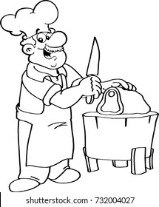 | 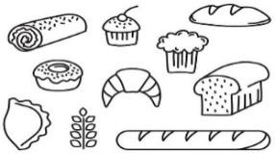 | 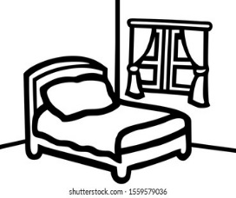 | 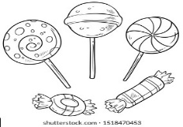
newspaper | Coffee shop | flower shop | Living room | candy
bread | Butcher shop | bakery | bedroom | books
_____________________________________________________________________________________________________
Orthography (spelling)

Choose the correct letter:

  mosq_ _ |   c_t _ | 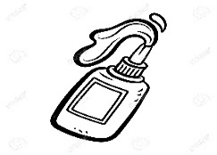  gl_ _ | 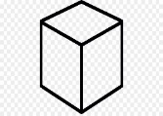  c_ b_
eu | i-u | ue | u-e
ue | u-e | er | u-i

Controlled writing

4

Good luck T.

Worksheet – we can3

3rd grade Unit 6 My Dream Vacation

Name ………………………………… Class ………………………………
__________________________________________________________________________________________

General Questions

1– Where are you going ?

A. I am going to Dammam. B. I am going sailing .
2 – How long does it take to get there?

A. It's a big city . B. It takes about 2 hours .
3 – What would you like to drink ?

A. I'd like some rice. B. I'd like some juice .

____________________________________________________________________________________________________
Reading short sentences

I am going sailing. | He is going to shop . | He is going to swim . | I'd like some juice.
 | 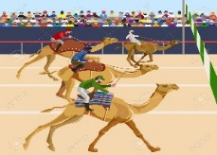 | 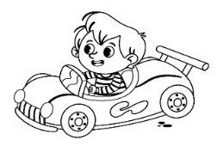 | 
___________________________________________________________________________________________
Controlled writing

So  cute | Very  hungry | very  sleepy | 1– Why did you eat all the soup?  Because I was ………………………… . ( choose)
Very thirsty | Very sleepy | So  cute | 2– Why did you sleep in my bed?  Because I was ………………………… ( choose )
races | work | climb | 3- I am going to watch camel ______ in Riyadh.  ( choose )

Grammar
are | am | is | 1- We ____ going to watch TV.
shopped | shopping | shop | 2- She is going to ____ in Dubai .
eating | to eat | eat | 3- We are going _______ rice .

_____________________________________________________________________________________________________
Vocabulary
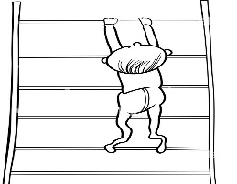 | 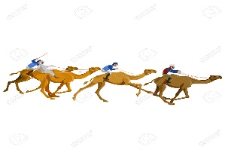 |  | 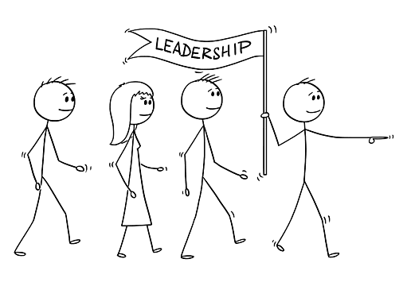 | 
eat | Camel race | Saudi flag | teacher | globe
climb | sailing | Saudi vision | leader | bed

_____________________________________________________________________________________________________
Orthography (spelling)

Choose the correct letter:

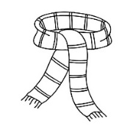  _ _arf | 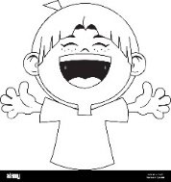  _ _ _gh | 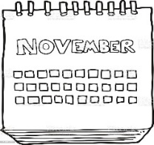  fe_ _ _ ary | 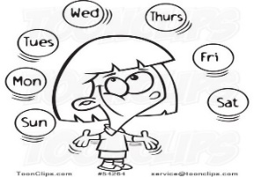  wed_ _ _day
sq | L a u | b r u | n o s
sc | L o o | b u r | n e s

Controlled writing

4

Good luck T.

