Name: ................................... Ms. Tahani
Class: 3rd Elementary / ........
Revision Sheet _ Unit ( 1 ): Fun on the Weekend
- General Questions:
  - Match the questions with the correct answers:
- What did you do over the weekend? |  | That’s okay!
- How much flour do we need? |  | Yes, please.
- Why don’t we make a pizza? |  | I cooked a big breakfast.
- What would you like? |  | We don’t have any oil.
- Can I help you? |  | I’d like spaghetti with meat sauce.
- He kicked a ball for three hours. |  | 2cups of flour
- Controlled Writing:
  - Rearrange the words to form sentences:
    - computer – I – games – played
……………………………………………..
    - tomatoes – have – some – We
……………………………………………..
  - Read and write the comments:
--I stayed at home.
………………………………………
--I watched a film about sharks.
……………………………………

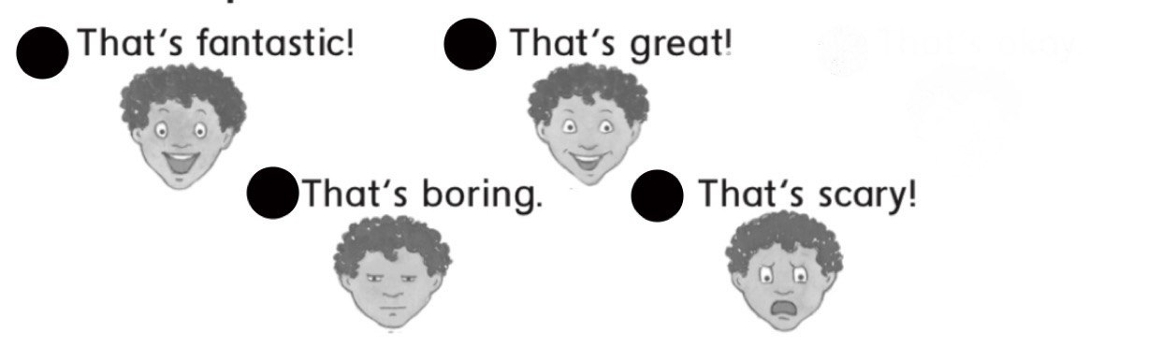

--I cleaned my room.
………………………………………
--I practiced on the trampoline.
……………………………………

- Reading Short Sentence:
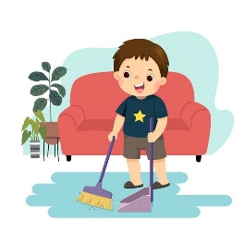
  - Read the sentences then choose the correct sentence for each picture:
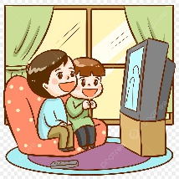 |  | 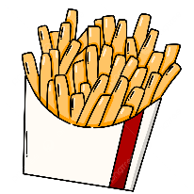 | 
a. They kicked a ball.  b. They watched a film. | a. He cleaned the house.  b. He cooked breakfast. | a. I’d like French fries.  b. I’d like green salad. | a. I buy sandals.  b. I buy a suit.

- Grammar:
  - Choose the correct answer:
1-How (many – much) tomatoes do we need? | 5-We don’t have (some – any) oil.
2-How (many – much) flour do we need? | 6-We have (some – any) sugar.
3-How (many – much) milk do you drink? | 7-There is (some – any) orange juice.
4-How (many – much) eggs do we need? | 8-There isn’t (some – any) oil in the bottle.

- Vocabulary:
  - Write the words under the correct pictures:
sandwich – boots – peppers – mushrooms – trampoline – kick – magazine


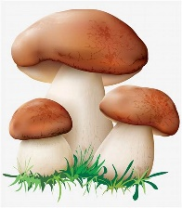
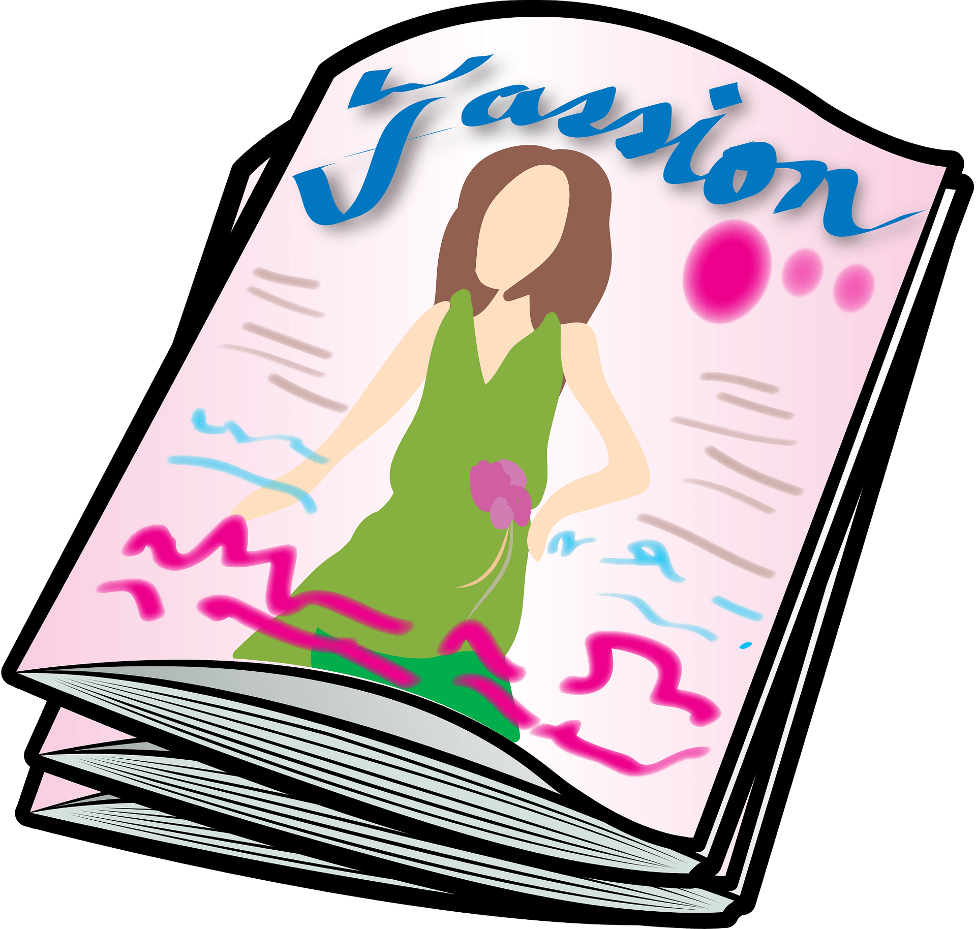

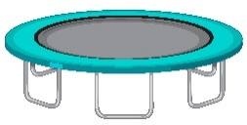
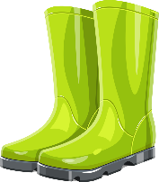
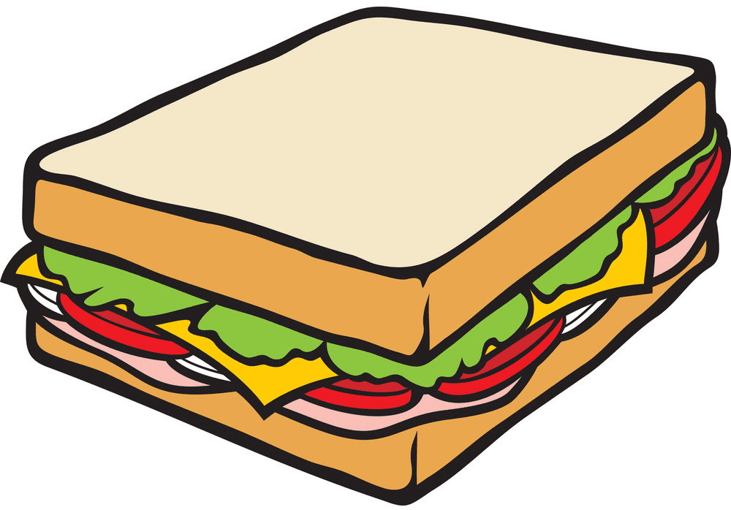

…………… …………… …………… ……...…… …………… …………… ……………
- Orthography:
  - Fill in the missing letters:
nd – nt


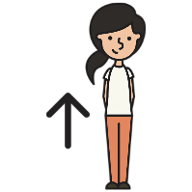


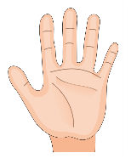
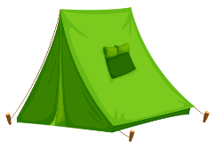

sa__ __ te__ __ ha__ __ pla__ __ sta__ __ pai__ __

Name: ................................... Ms. Tahani
Class: 3rd Elementary / ........
Revision Sheet _ Unit ( 2 ): Life’s Ups and Downs
- General Questions:
  - Match the questions with the correct answers:
- What good things happened to you last year? |  | We went to an adventure park.
- What bad things happened to you last year? |  | They cooked pasta.
- We were stuck in an elevator. |  | I broke my leg.
- What did they cook? |  | Don’t laugh!
- Where did you go with your family? |  | I saw a rainbow.
 |  | How scary!

- Controlled Writing:
  - Rearrange the words to form sentences:
    - a – made – I – rocket
……………………………………………..
    - some – had – We – milk
……………………………………………..

  - Read and write your comments:
Congratulations! – Sorry about that. – How scary!

    - We lost a basketball game 20 to 8.
………………………………………………
    - I won a table tennis game.
………………………………………………
    - We were stuck in a train.
………………………………………………

- Reading Short Sentence:
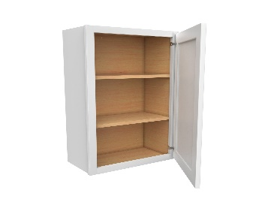
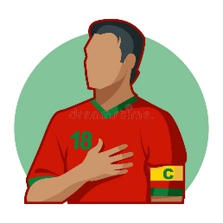

  - Read the sentences then choose the correct sentence for each picture:
 |  |  | 
a. He had an operation.  b. He had a cake. | a. He made a tree house.  b. He was team captain. | a. The cupboard was bare.  b. The cupboard was full. | a. I won a match.  b. I lost a match.

- Grammar:
  - Choose the correct answer:
1-He (have – had) some chicken. | 4-(We – Us) went on rides with our parents.
2-He didn’t (have – had) any meat. | 5- Dad got (I – me) an ice cream.
3-He (catch – caught) a big fish yesterday. | 6-I (was – am) sick last weekend.

  - Do as shown between brackets:
    - (Write the past form of the following verbs)
Base Form | Simple Past | Base Form | Simple Past
win |  | make
lose |  | see
am, is |  | are

- Vocabulary:
  - Write the words under the correct pictures:
rainbow – elevator – grocer – rides – glasses – sick – tree house
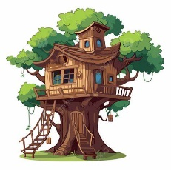


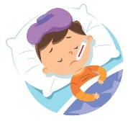

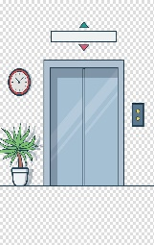
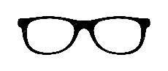

…………… …………… …………… ……...…… …………… …………… ……………

- Orthography:
  - Fill in the missing letters:
f – ph – gh

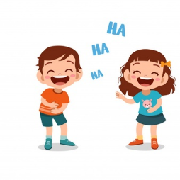


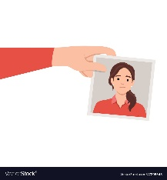

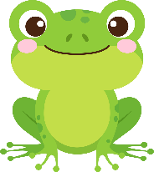

__ rog __ __one lau__ __ __ __oto ele__ __ant __ riends

Name: ................................... Ms. Tahani
Class: 3rd Elementary / ........
Revision Sheet _ Unit (3): My School is Cool!
- General Questions:
  - Match the questions with the correct answers:
- What’s the name of your school? |  | This year I like history.
- How many students are there in your school? |  | It starts at 7:00
- Do you have school lunch at your school? |  | Yes, it does. It has a big yellow bus.
- Does your school have a school bus? |  | 3rd Elementary School
- What time does your school start? |  | About 400 students
- Which subject do you like most this year? |  | Yes, we do
- Which grade are you in this year? |  | I live in Al-Lith
- Which city do you live in? |  | This year I am in the 3rd grade.

- Controlled Writing:
  - Rearrange the words to form sentences:
    - a school – We – uniform – have
……………………………………………..
    - to – Listen – teacher – the
……………………………………………..

  - Read and write. Use the words in the box:
teacher – library – uniforms – art


  It’s a room. There are many books. You go there to read or study.  ………………. | It’s a subject. Sometimes you draw. Sometimes you use colored pens or crayons.  ……………… | This is a person. He works in a school. He teaches students.  ……………… | 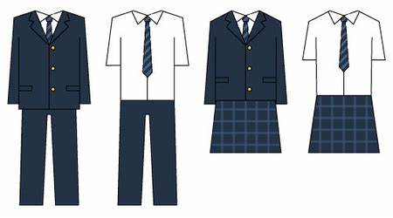  It’s a type of clothing. You wear it to school. Parts of it are: jackets, trousers or skirts.  ………………..

- Reading Short Sentence:
  - Read the sentences then match them with the correct pictures:
 | 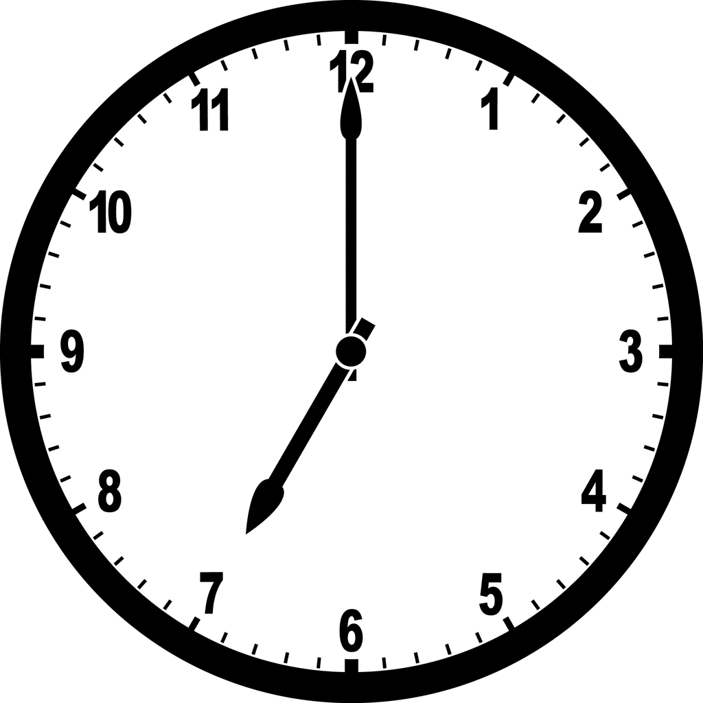 |  | 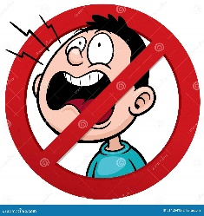
a-_He likes science.  b-_He likes PE. | a-_The school ends at 12  b-_The school starts at 7 | a-_I had a little cat.  b-_I had a little lamb. | a-_Don’t shout  b-_Listen to your teacher
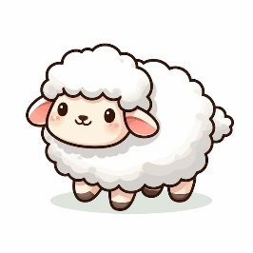
- Grammar:
  - Choose the correct answer:
      - This year I (am – was) in the 3rd grade.
      - Last year I (am – was) in the 2nd grade.
      - This year Ali (likes – liked) social studies.
      - Last year Sara (likes – liked) Arabic.

  - Do as shown between brackets:
    - (Write the past form of the following verbs)
Base Form | Simple Past | Base Form | Simple Past
has |  | are
make |  | go
is |  | like
- Vocabulary:
  - Write the words under the correct pictures:
math – stand up – projector – bus – listen – PE


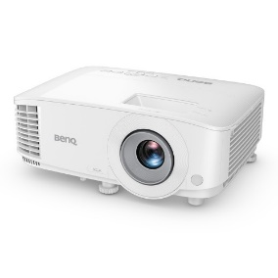

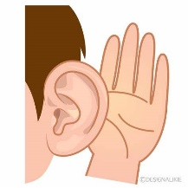

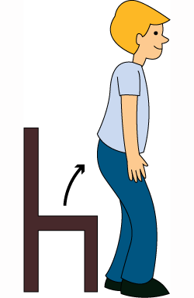

……………… ……………… ……………… ……...……… ……………… ………………
- Orthography:
  - Fill in the missing letters:
sc – sq – sk

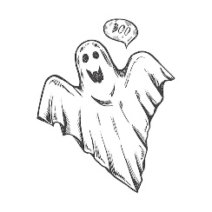
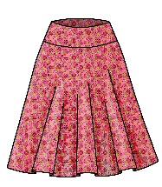


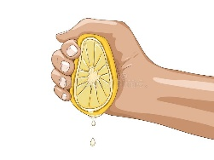
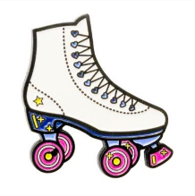

__ __arf __ __ate __ __ueeze __ __irt __ __uare __ __ary

Name: ................................... Ms. Tahani
Class: 3rd Elementary / ........
Revision Sheet _ Unit (4): A Healthy Life
- General Questions:
  - Match the questions with the correct answers:
- What should you do to live a healthy life? |  | I have a stomachache.
- Did you get up early this morning? |  | Yes, please.
- What’s the matter? |  | No, I didn’t.
- Do you clean your ear? |  | Well, I try. But sometimes I forgot.
- Can I help you? |  | It is 60 Riyals.
- How much is this skirt? |  | I should do some exercise.
- Controlled Writing:
  - Rearrange the words to form sentences:
    - a – I – sweater – want
……………………………………………..
    - early – go to – I – bed
……………………………………………..
  - Read and write. Use the words in the box:
soda – doctor– wealthy - cardigan

  You shouldn’t drink too much of it. It tastes sweet, like candy. It usually has bubbles in it.  ………………. | 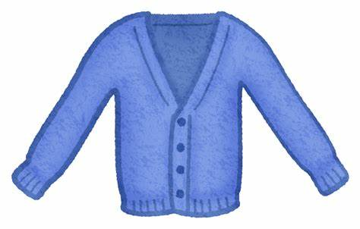  It’s warm. It’s made from wool. It has buttons at the front.  ……………… |   It’s a person. This person has a lot of money. Maybe he or she lives in a big house.  A ……………… person |   It’s a person. This person works in the hospital. This person wears a white coat.  ………………..
- Reading Short Sentence:
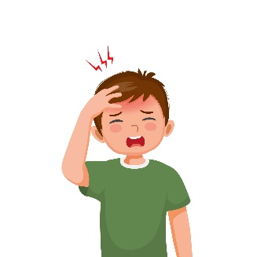
  - Read the sentences then match them with the correct pictures:
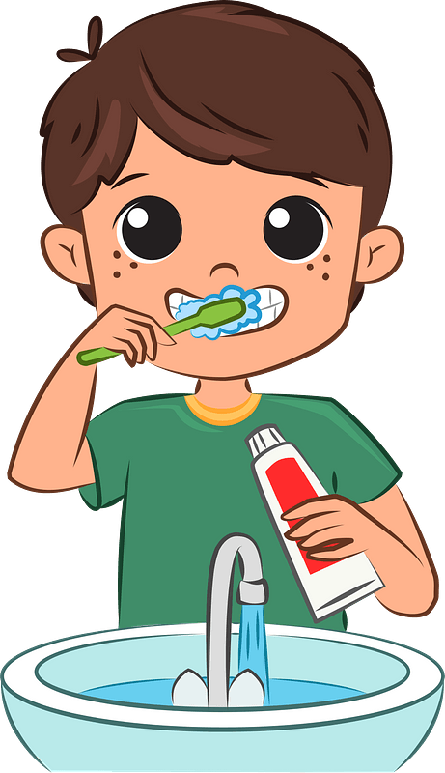 | 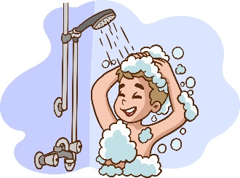 |  | 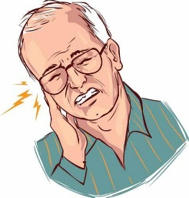
a-_I eat breakfast.  b-_I brush my teeth. | a-_I take a bath or shower.  b-_I play outside. | a-_I have a headache.  b-_I have a toothache. | a-_I have a stmoachache.  b-_I have an earache.
- Grammar:
  - Choose the correct answer:
      - Did you (get up – got up) early this morning?
      - I didn’t (drink – drank) milk this morning.
      - I (eat – ate) breakfast this morning.
      - You (should – shouldn’t) go to bed early.
      - You (should – shouldn’t) stay up late.
      - You (should – shouldn’t) skip breakfast.
      - You (should – shouldn’t) eat three meals a day.

  - Do as shown between brackets:
    - (Write the past form of the following verbs)
Base Form | Simple Past | Base Form | Simple Past
play |  | eat
talk |  | go
watch |  | drink
- Vocabulary:
  - Write the words under the correct pictures:
jacket – belt – sleepy – trousers – sweater – grumpy

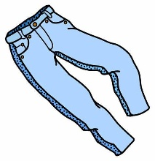
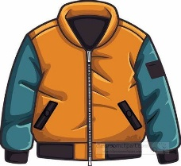

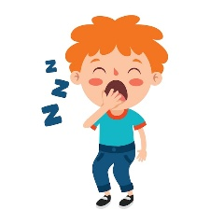
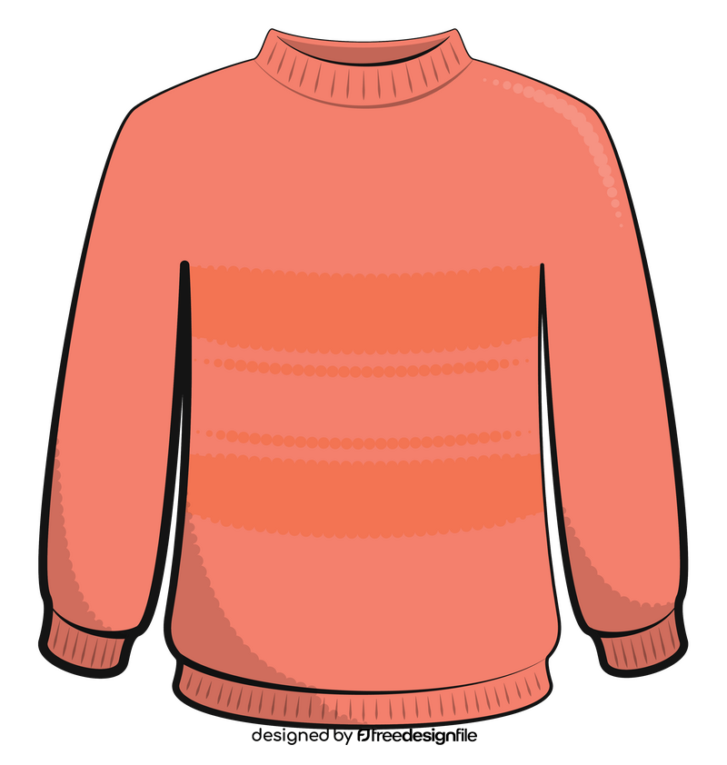
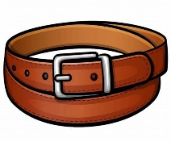

……………… ……………… ……………… ……...……… ……………… ………………
  - Circle the odd word:
      - Meals: breakfast – lunch – green – dinner
      - Illnesses: headache – book – earache – toothache
      - Clothes: skirt – trousers – sweater – horse

- Orthography:
  - Fill in the missing letters:
ir – ur

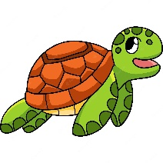
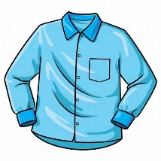





sh__ __t g__ __l t__ __tle b__ __ger b__ __d p__ __ple

Name: ................................... Ms. Tahani
Class: 3rd Elementary / ........
Revision Sheet _ Unit (5): Hanging Out in Town
- General Questions:
  - Match the questions with the correct answers:
- Where’s the post office? |  | It’s only a few minutes.
- Is it far from here? |  | I want some books.
- Where are you going? |  | I’m going to the candy store.
- What do you want? |  | Go straight and you’ll find it on your left.
- Controlled Writing:
  - Rearrange the words to form sentences:
    - some – I – cakes – want
……………………………………………..
    - opposite – It’s – bus stop – the
……………………………………………..

  - Read and write. Use the words in the box:
bakery – school – heart – convenience store

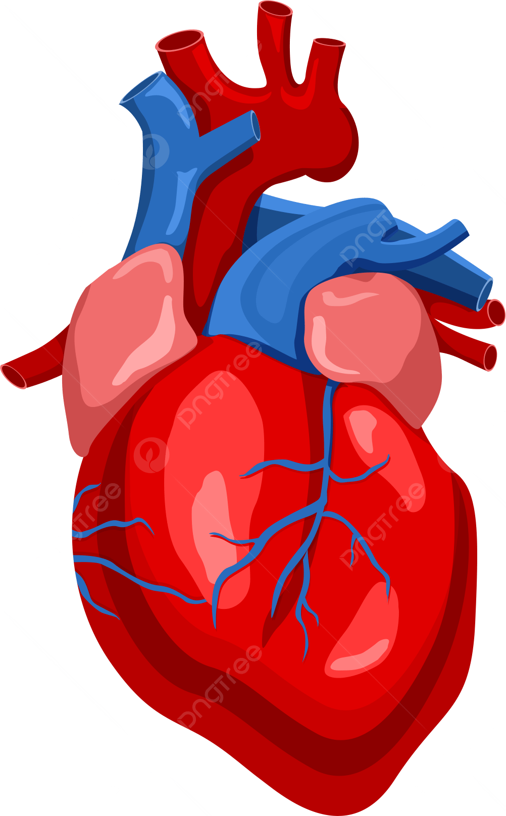  Everyone has one. We can’t live without it. It moves blood around your body.  ………………. |   It’s a store. It usually smells very good. You can get fresh bread there.  ……………… | 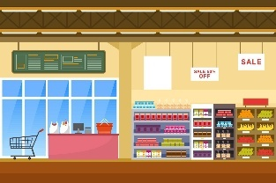  It’s a store. It’s usually very big. There are many kinds of food in the store.  ……………… | 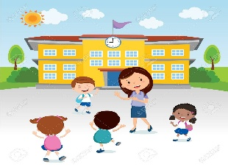  There are usually a lot of children there. The children are usually 1st to 6th graders. There are teachers there, too.  ………………..

- Reading Short Sentence:
  - Read the sentences then match them with the correct pictures:
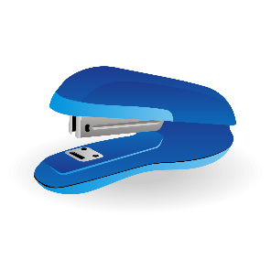 | 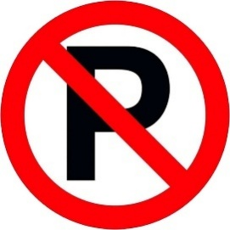 | 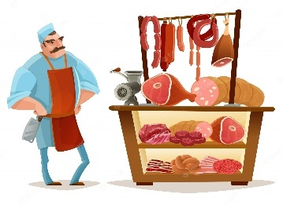 | 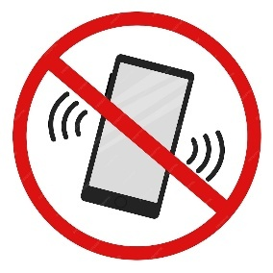
a-_I want a stapler.  b-_I want some candy. | a-_No Eating or Drinking.  b-_No parking. | a-_It’s a butcher shop.  b-_It’s a coffee shop. | a-_Switch off all cell phones.  b-_Switch on all cell phones.
  - Read and fill in the missing words.
Bookstore
Stationery store
Flower store
Candy store

- - …………………………… sells staplers and staples.
- - …………………………… sells candy.
- - …………………………… sells books.
- - …………………………… sells flowers.

- Grammar:
  - Choose the correct answer:
      - You (am – is – are) going to the coffee shop.
      - I (am – is – are) going to the bakery.
      - He (am – is – are) going to the supermarket.
      - There (is – are – were) a book on the desk.
      - There (is – was – are) books on the desk.
      - There (was – are – were) a chair in the bedroom.
      - There (is – was – were) two chairs in the bedroom.

- Vocabulary:
  - Write the words under the correct pictures:
flowers – skateboard – bread – staples – meat - newspaper


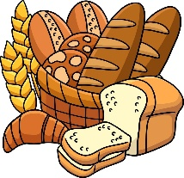
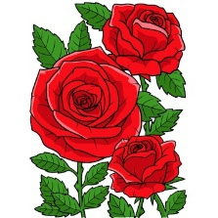
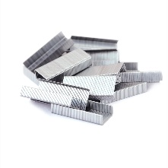
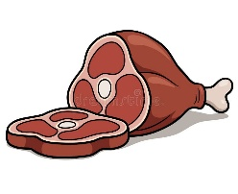
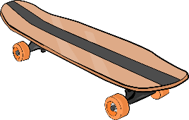

……………… ……………… ……………… ……...……… ……………… ………………
  - Circle the odd word:
      - Colors: brown – white – green – bedroom
      - Rooms: living room – bedroom – red – dining room
      - Stores: stationary store – silver – supermarket – bookstore

- Orthography:
  - Fill in the missing letters:

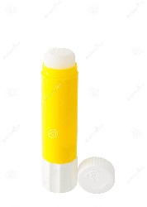
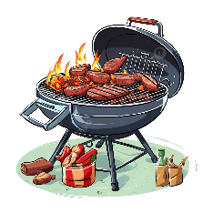




c__ b __ barbec__ __ gl__ __ mosq__ __ tiss__ __ c__ t __
Name: ................................... Ms. Tahani
Class: 3rd Elementary / ........
Revision Sheet _ Unit (6): My Dream Vacation
- General Questions:
  - Match the questions with the correct answers:
- Where are you going? |  | I am going sightseeing.
- How long does it take to get there? |  | I’m going to Abha.
- What are you going to do there? |  | I’d like some green tea, please.
- What would you like to eat? |  | It takes about two hours.
- What are you going to drink after dinner? |  | I’d like beef and rice, please.
- Controlled Writing:
  - Rearrange the words to form sentences:
    - in Riyadh – You’re going – camel races – to watch
……………………………………………..
    - some – like – I’d – water
……………………………………………..

  - Read and write. Use the words in the box:
very sleepy – very hungry – very thirsty – so cute
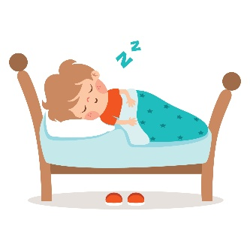
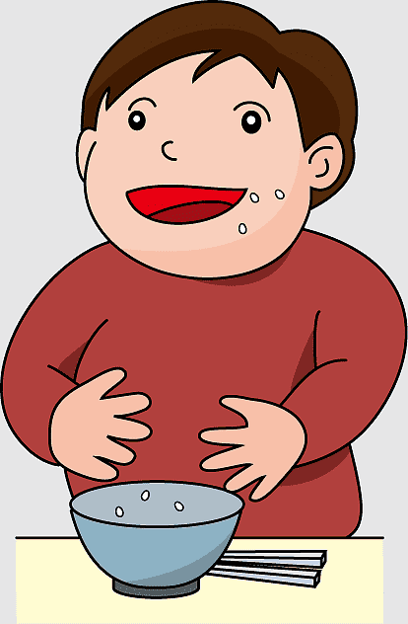  Why did you eat all the soup?  Because I was  ………………….…. | 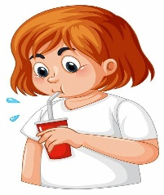  Why did you drink all the juice?  Because I was  ………………….…. |   Why did you take my panda?  Because It’s  ………………….…. | Why did you sleep in my bed?  Because I was  ………………….….

- Reading Short Sentence:
  - Read the sentences then match them with the correct pictures:
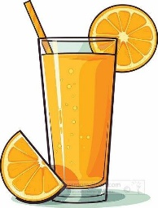 | 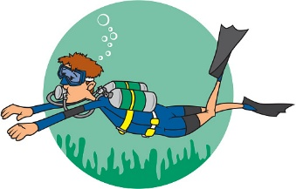 | 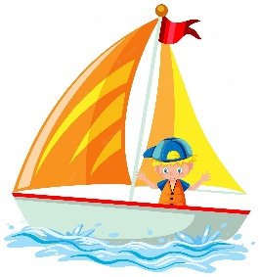 | 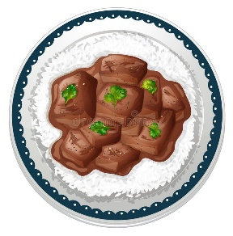
a-_I’d like apple juice.  b-_I’d like orange juice. | a-_I’m going skiing.  b-_I’m going diving. | a-_I’m going to shop.  b-_I’m going to sail. | a-_I’d like beef and rice.  b-_I’d like fish and rice.
- Grammar:
  - Choose the correct answer:
      - You’re going (eat – to eat – eating) traditional dishes.
      - I’m going to (shop – to shop – shopping) for new clothes.
      - He’s (going visit – goes to visit – going to visit) a famous museum.

- Vocabulary:
  - Write the words under the correct pictures:
noodles – tea – camel race – globe – leader – rock climbing

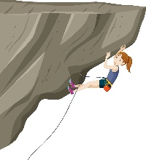

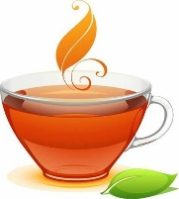
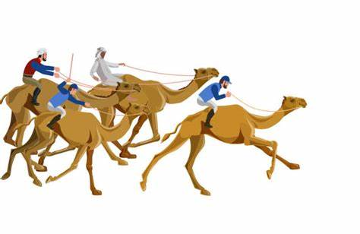



……………… ……………… ……………… ……...……… ……………… ………………
  - Circle the odd word:
      - Days: Sunday – June – Tuesday – Friday
      - Months: September – November – Wednesday – March
      - Pronouns: They – He – She – May

- Orthography:
  - Fill in the missing words:
            - Months of the year:
January |  | March |  | May
July |  | September |  | November
            - Days of the week:
 | Monday |  | Wednesday
 | Friday

