
Kingdom of Saudi Arabia 5th & 6th Elementary Grade

10
Ministry of Education Second Term
…… Elementary School Second Exam - 1447 AH
Name: ………………………………………………………….………………. Class : …………..
- General Questions:
  - Match the questions with the correct answers:
A | B
1. What items do you need for fishing? |  | We should wear the right equipment.
2. What do you know about being safe outdoors? |  | Go climbing in the mountains.
 |  | I need fishing rod for fishing.
  - Choose the correct answer:
1- Did you have fun on your trip?
a- Yes, I was. | b- Yes, I did.
2- Which activities can make you tired, scared, or bored?
a- playing video games. | b- hiking in the forest.

- Reading Short Sentences:
  - Read the sentences then match them with the correct pictures:
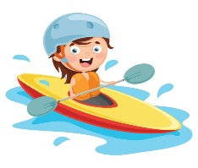 | 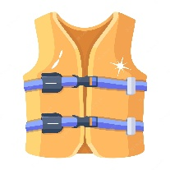 | 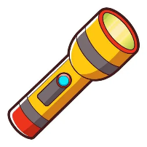 | 
a-_I go surfing on the waves.  b-_I go canoeing on the lake. | a- It is a life jacket.  b- It is a raft. | a- It is a flashlight.  b- It is a surfboard. | a-_That is a cliff.  b-_That is a forest.

- Grammar:
  - Choose the correct answer:
    - She (learn – learned – learning) how to climb yesterday.
    - They didn’t (see – saw – seeing) the snake.
    - We were canoeing (when – while) it started raining.
    - We ate hot dogs while we (sit – sits – were sitting) around the campfire.

- Vocabulary:
  - Write the words under the correct pictures:
horseback riding – thirsty – river – climbing

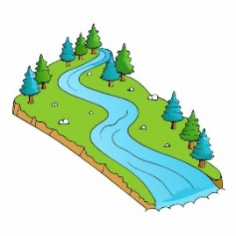 | 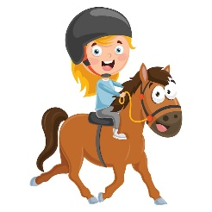 | 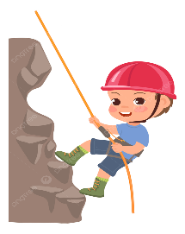 | 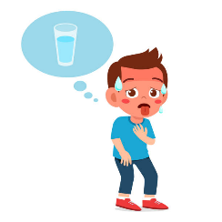

- Orthography:
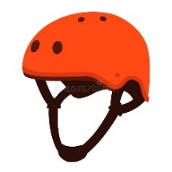  h__lmet |  | 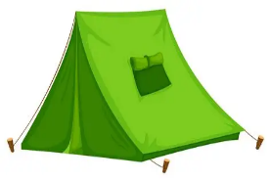  ten__ |  | 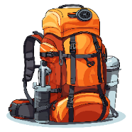  back__ack |  | 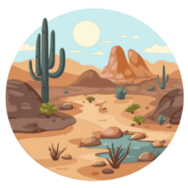  de__ert
i | E | t | b | b | p | z | s
  - Choose the correct missing letters:

BEST OF LUCK
Ms. Tahani Al-Ghamdi

1
1– Do you prefer activities you do outdoors or at home?

A. I like activities. B. I like outdoor activities.
I. CHOOSE
2– What is your favorite way to travel ?
A. By plane . B. I sometimes go to the beach.
المملكة العربية السعودية |  | اسم الطالب/هـ ......................................
وزارة التعليم |  | اسم الطالب/هـ ......................................
إدارة التعليم بمنطقة |  | المادة : انجليزي
مدرسة : |  | الزمن :
مدرسة : |  | الصف : فصل ( )
شفهي | تحريري | المجموع
10 / | 10 / | 20 /
اختبار الفترة الثانيه – الفصل الثاني 1447هـ - الصف الخامس والسادس ابتدائي
اسم الطالب / هـ الفصل /

2. CHOOSE OR
1.5

She put on her helmet.
He has a fun trip.
Put everything in a suitcase



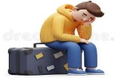
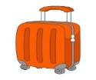

3. CHOOSE TO COMPLETE THE FOLLOWING:
1.5

Do as shown between brackets :

1- yesterday / raining / It / was (Rearrange)
………………………………………………………………………………………
2- __________ To go up in the sky. ( choose )
A. Take off. B. go out

1
was reading | read | 1- Mary ______________ in her tent when I saw her .
have travelled | has travelled | 2- I ______ with my friends.
4. CHOOSE

3
5. Write the correct word:

Taxi - Passport - Sleeping bag - Subway - backpack - Railroad

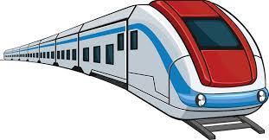 | 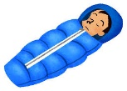 | 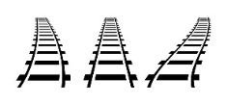 |  | 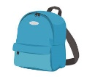 | 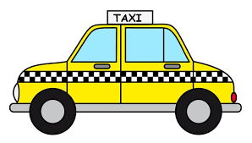  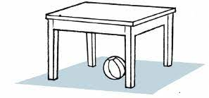

6. CHOOSE THE CORRECT LETTERS:
2

Choose the correct letter:

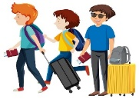 | 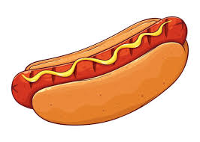 |  | 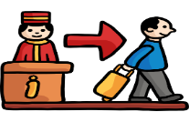
Passen_ er | Hot _og | Statio_ | Check _ut
f | d | n | o
g | b | m | a

___________________________________________________________________________________________________________________________________________________________________________________________________________________________________
Controlled writing

4

Good luck T.


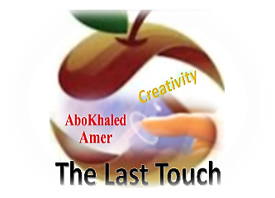
المملكة العربية السعودية
وزارة التعليم
الادارة العامة للتعليم بمنطقة ----------------
مدرسة ------------------ الابتدائية
ABOKHALEDAMER
0557325813
Second Term- Second Session Test
Name: ------------------------------------------------------ Grade: 5th & 6th
General Questions: Choose the correct answer:
1. What's your favorite way to travel? A. I travel by plane. B. I watch TV.
2. Do you like to travel by subway? A. Yes, I did. B. Yes, I do.
Reading short sentences : Choose ( / )
1.This road is slow. 2. They are checking in. 3. It is a plane.
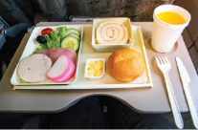

Controlled Writing
1. yet. / passengers / haven’t / Many / in / checked (Rearrange)
------------------------------------------------------------------
Read and fill in with the correct word: ( hotel – camping – farm )
1. We saw many animals in my grandfather's -------------------
2. We check in and out at the -----------------.

Grammar: Choose the correct answer:
1. We have (yet – just – no) arrived at the hotel. Let’s check in!
2. I haven’t found my suitcase (just – already – yet).
3. My family and I (hasn't – haven't – am not) traveled by plane.
4. The travel company has (lose – loses – lost) our suitcases.
Vocabulary
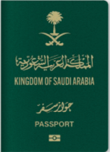
Match the words: 1. passport – 2. taxi – 3. suitcase – 4. tour – 5. traffic

------------------ ---------------- -------------------- ------------------ ----------------
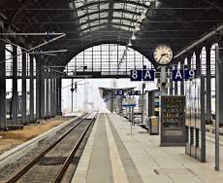

Orthography (Spelling)
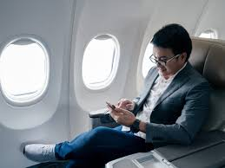
Choose the correct missing letter:

passe__ger t__ain plat__orm
( n – m ) ( s – r ) ( s – f )

(2) Top Goal - YouTube End of Questions https://t.me/abokhaledamer

