
Kingdom of Saudi Arabia Third Elementary Grade
Ministry of Education Second Term

10
……. Elementary School . . . Second Exam - 1447 AH
Name: ………………………………………………………….………………. Class: …………..
- General Questions:
- Match the questions with the correct answers:
1- What’s the matter? |  |  |  |  |  |  |  |  |  | No, I didn’t.
2- Did you get up early this morning? |  |  |  |  |  |  |  |  |  | It starts at 7:00.
3- Which city do you live in? |  |  |  |  |  |  |  |  |  | I have a stomachache.
4- What time does your school start? |  |  |  |  |  |  |  |  |  | I live in Al-Lith.
- Controlled Writing:
- Write the past form of the following verb:
Base Form |  |  |  |  |  |  | Simple Past
play
- Reading short sentence:
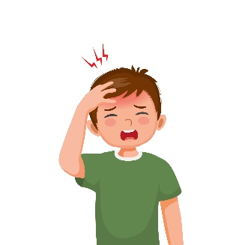
- Read the sentences then choose the correct sentence for each picture:
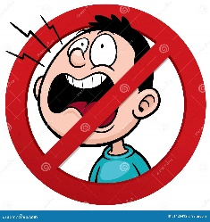 |  |  | 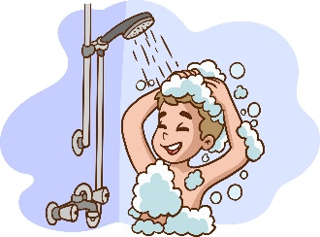
a-_Don’t shout  b-_Do your homework | a. I have a toothache.  b. I have a headache. | a-_He likes science.  b-_He likes PE. | a. I brush my teeth.  b. I take a bath or shower.

- Grammar:
- Choose the correct answer:
- Last year I ………….. in the 2nd grade.
- am |  |  |  |  | - is |  |  |  |  |  |  | - was
- I didn’t ………… milk this morning.
- drank |  |  |  |  | - drink |  |  |  |  |  |  | - drinks
- Vocabulary:
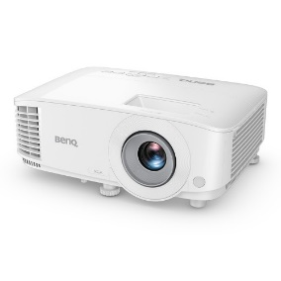
- Choose the correct answer:
 |  |  | 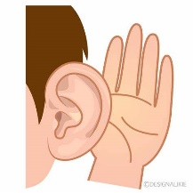 |  |  |  |  | 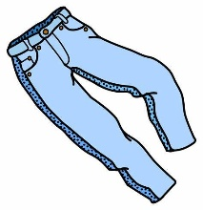 |  |  |  |  |  | 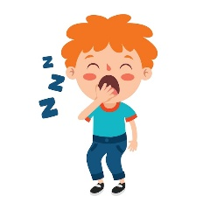
- projector  - computer |  |  | - listen  - speak |  |  |  |  | - trousers  - belt |  |  |  |  |  | - grumpy  - sleepy
- Orthography:
- Choose the correct missing letters:
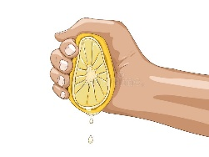  __ __ ueeze |  | 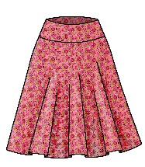  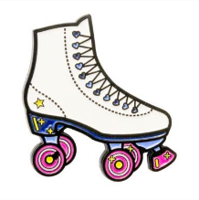  __ __ irt |  |  |  | 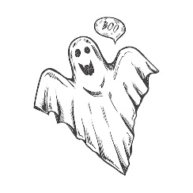  __ __ ary |  |  |  |  |   b __ __ ger |  |  |  |   b __ __ d
sk | sq | sc |  | sk |  | sc |  |  | sq |  | ir |  | ur |  | ir | ur

BEST OF LUCK
Ms. Tahani Al-Ghamdi

1
I. CHOOSE
المملكة العربية السعودية |  |  | اسم الطالب/ه ......................................
وزارة التعليم
إدارة التعليم بمنطقة |  |  | المادة : انجليزي
مدرسة : |  |  | الزمن :
 |  |  | الصف : فصل ( )
شفهي | تحريري |  |  | المجموع
10 / | 10 / |  |  | 20 /
اختبار الفترة الثانيه للفصل الثاني - للعام الدراسي 1447– لغة انجليزية –– للصف الثالث ابتدائي
اسم الطالب / هـ الفصل /

1 – How many students are there in your school?

A . About 500 . B . Yes, I am .
2 – What should you do to live a healthy life ?
A. I should go to bed early. . B. I should skip breakfast.

2. CHOOSE OR
1.5

1. This year I like math .

Our school has a bus ..2
3. I should do some exercise.

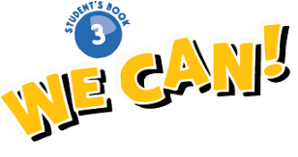
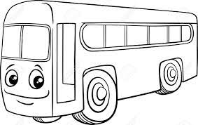

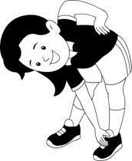

3. DO AS SHOWN BETWEEN BRACKETS
1.5

___________________________ |  | 1- in – live – I - Riyadh . ( rearrange )
Good night | Good morning | 2– Greeting usually say it at night . ( choose )

4. CHOOSE
1
4. CHOOSE
went | go | 1 – Last week we ______ to Abha
play | played | 2- The PAST TENSE of ( play) is

________________________________________________________________________________________________________________________________________________________________________________________________________________________________

T-shirt - flag - Don’t shout

3
5. CHOOSE
     | 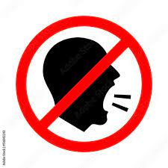 | 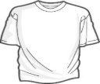

\

6. CHOOSE THE RIGHT LETTERS:
2

Choose the correct letter:

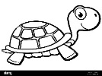  t_ _tle | 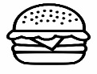  b_ _ger |   _ _ y | 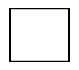  _ _an
er | ur | sc | sq
ur | ar | sk | sc

Controlled writing

4

______________________________________________________________________________________

Good luck

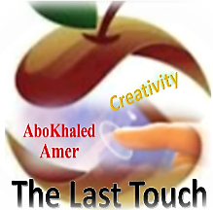

المملكة العربية السعودية
وزارة التعليم
الادارة العامة للتعليم بمنطقة ----------------
مدرسة ------------------ الابتدائية
ABOKHALEDAMER
0557325813
Second Term- Second Session Test
Name: ------------------------------------------------------ Grade: 3rd
1) General Questions: A) Match:
1. What should you do to live a healthy life? ----- a. I shouldn't eat fast food.
2. Bad thing I shouldn't do. ----- b. Yes, I ate breakfast.
3. Did you eat breakfast? ----- c. I should exercise.
2) Controlled Writing: A) Rearrange:
Did – drink – you – this – water – morning?
..........................................................................................................======led Writing
3) Grammar: A) Choose:
1. You ____________ ( shouldn't – should – was ) stay up late.
2. The past of ( drink ) is _________ . ( drank – drinking – drinks )
3. The past of ( go ) is _________ . ( going – went – goes )
4) Reading Short Sentences: A) Circle the correct ✓ or x:
1. I should do my exercise. ✓ x
2. I have a headache. ✓ x
5) Vocabulary: A) Circle the odd word:
1. ( white – black – candies – blue )
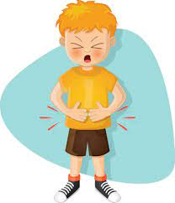
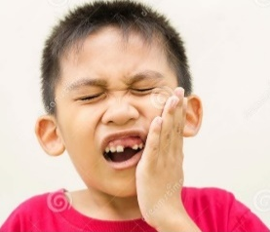

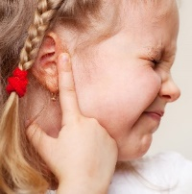
B) Read and write: 1. headache 2. toothache 3. stomachache 4. earache

------------------------ ------------------- --------------------- ----------------
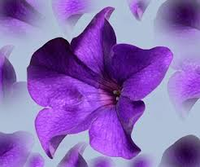
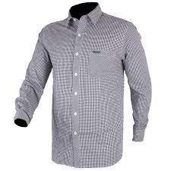
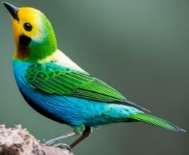

6) Orthography: A) Fill in the missing letter: ( ir – ur )

Q6. Orthography
g__ __l b__ __d sh__ __t p__ __ple
(2) Top Goal - YouTube End of Questions https://t.me/abokhaledamer

