
المملكة العربية السعودية الصف: الثالث الابتدائي
وزارة التعليم الفترة الدراسية: الثانية
المدرسة الابتدائية …………… العام الدراسي 1447 هـ
الزمن: ساعتان
الاختبار النهائي لمادة اللغة الإنجليزية – الصف الثالث الابتدائي – الفترة الدراسية الثانية (الدور الأول) لعام 1447 هـ
عزيزتي الطالبة:
- استعيني بالله ثم اجيبي عن الأسئلة
- فضلا تأكدي من كتابة اسمك الرباعي ورقم الجلوس
- الإجابة باللون الأزرق فقط

اسم الطالبة رباعيا
رقم الجلوس: |  | الصف: الثالث الابتدائي | المادة: اللغة الإنجليزية
اليوم: | التاريخ: / 1 / 1448 هـ

المدققة وتوقيعها | المراجعة وتوقيعها | المصححة وتوقيعها | الدرجة كتابة | الدرجة رقما | السؤال
 |  |  | فقط |  | General  Questions
 |  |  | فقط |  | Guided  Composition
 |  |  | فقط |  | Reading  Short Sentence
 |  |  | فقط |  | Grammar
 |  |  | فقط |  | Vocabulary
 |  |  | فقط |  | Orthography
 |  |  | فقط | 40 | المجموع


Kingdom of Saudi Arabia 3rd Elementary Grade
Ministry of Education Time: Two Hours
………. Elementary School Number of papers: 3 . Final Exam – Second Term – 1447 AH
- General Questions:
/ 7
  - Match the questions with the correct answers:
A |  | B
1. What did you do over the weekend? |  | I live in Jeddah.
2. Which city do you live in? |  | Yes, please.
3. How long does it take to get there? |  | I cooked a big breakfast.
4. Can I help you? |  | It takes about two hours.
  - Choose the correct answer:
1. What good things happened to you last year?
a- I broke my leg. | b- I saw a rainbow.
2. What’s the matter?
a- I have a stomachache. | b- It is 60 Riyals.
3. Where are you going?
a- I’m going to the candy store. | b- I’m a doctor.
/ 7
- Guided Composition:
  - Complete the paragraph about your school. Use the words from the box.
Hi! Let me introduce my school.
The ……………. of my school is the 3rd Elementary School. There are about 400 ……………. in my school. I go to school by the school ……………. . All the students wear the same ……………. . Our school ……………. at 6:45. Our teachers are ……………. and helpful. We ……………. English, math, science, and Arabic. I love my school and my friends.

study starts name uniform kind studentsbus



- Reading Short Sentences:
/ 7
  - Read the sentences then match them with the correct pictures:
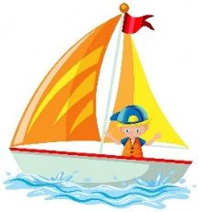 | 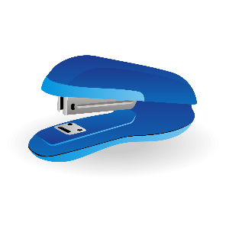 |  | 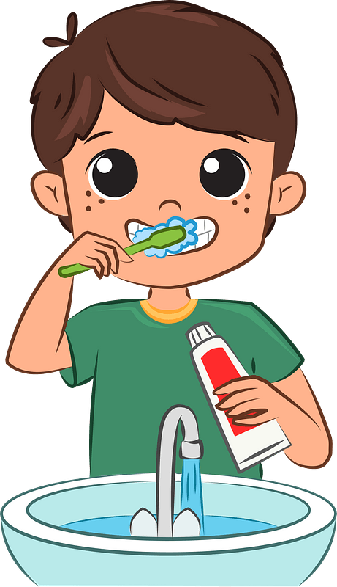 | 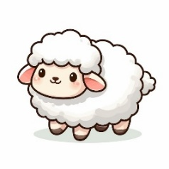
a-_I’m going to shop.  b-_I’m going to sail. | a-_I want a stapler.  b-_I want a pen. | a. I won a match.  b. I lost a match. | a-_I eat breakfast.  b-_I brush my teeth. | a-_I had a little cat.  b-_I had a little lamb.

  - Look at the email then choose the correct option.
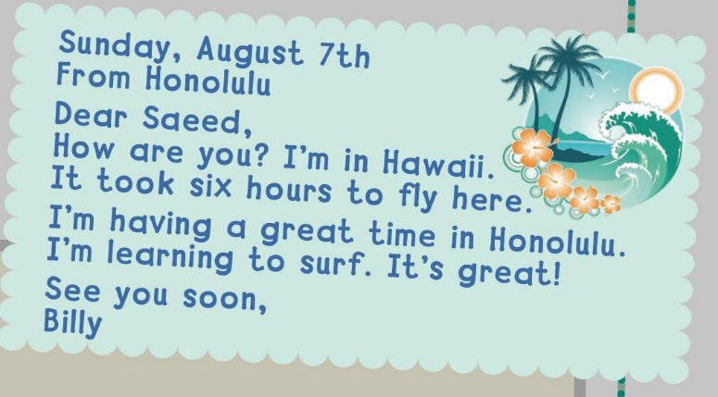
    - Where is Billy now?

      - in London.
      - in Hawaii.
      - in Paris.

    - What is Billy learning?
a- swimming.
b- riding a bike.
c- surfing.

- Grammar:
/ 7
  - Choose the correct answer:
    - We don’t have (some – any – a) oil.
    - Dad got (my – I – me) an ice cream.
    - This year Ali (like – likes – liked) social studies.
    - I didn’t (drink – drinks – drank) milk this morning.
    - He (am – is – are) going to the supermarket.
    - You’re going (eat – to eat – eating) traditional dishes.
    - There (was – are – were) a chair in the bedroom.

- Vocabulary:
/ 7
  - Write the words under the correct pictures:
kick – listen – sick – skateboard – sweater

 | 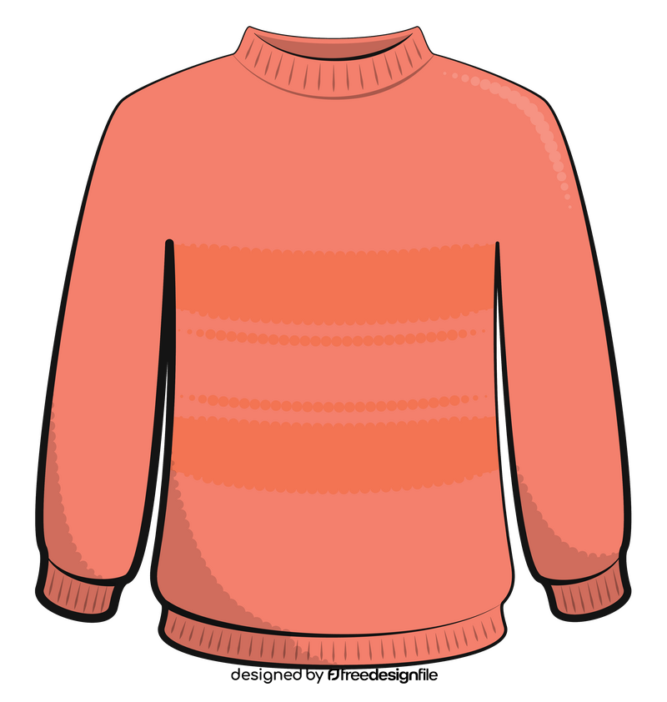 | 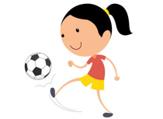 | 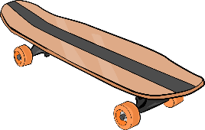 | 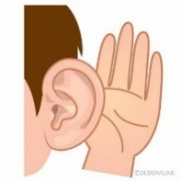

  - Circle the odd word:
1- Days: Sunday – Tuesday – September – Friday
2- Meals: breakfast – green – lunch – dinner

- Orthography:
/ 5
  - Choose the correct missing letters:
  __ __arf |  | 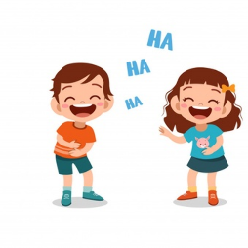  lau__ __ |  | 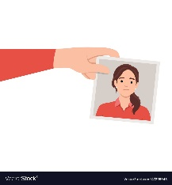  __ __oto |  |   sa__ __ |  | 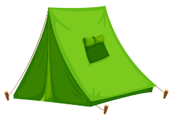  te__ __
sk | sc | ph | gh | ph | gh | nd | nt | nd | nt
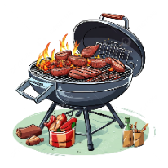  barbec__ __ |  | 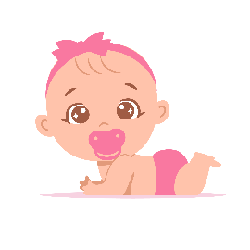  c__t__ |  | 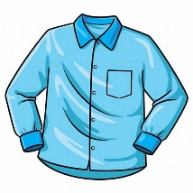  sh__ __t |  | 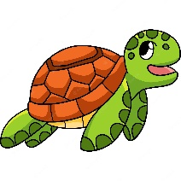  t__ __tle |  | 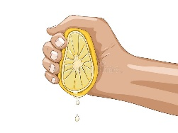  __ __ueese
ue | ou | o_e | u_e | ir | ur | ir | ur | sc | sq

END OF QUESTIONS
BEST OF LUCK
Ms. Tahani AlGhamdi




وزارة التعليم
الإدارة العامة للتعليم بمنطقة ......................
مدرسة .........................................
التاريخ: / / 1447هـ
الصف: الثالث الابتدائي
الزمن: ساعتان
المادة: اللغة الإنجليزية

أسئلة اختبار مادة اللغة الانجليزية للصف الثالث الابتدائي
للعام الدراسي 1447 هـ
الفصل الدراسي الثاني
عدد الأوراق : 4

اسم الطالبة : ........................................................................
رقم الجلوس : .........................................................................
اليوم : ...............................................
التاريخ : .......... / ........... / 1447 هـ
الزمن : ...........................

 | Questions | Mark | Student's mark
Q1 | General Questions | 8
Q2 | Controlled Writing | 7
Q3 | Reading Short Sentences | 5
Q4 | Grammar | 7
Q5 | Vocabulary | 8
Q6 | Orthography (spelling) | 5
Total : |  | 40
المصححة : ...............................................................التوقيع :.....................................
المراجعة : ...............................................................التوقيع :.....................................

معلمة المادة :

......................................................

وزارة التعليم
الإدارة العامة للتعليم بمنطقة ......................
مدرسة .........................................
التاريخ: / / 1447هـ
الصف: الثالث الابتدائي
الزمن: ساعتين
المادة: اللغة الإنجليزية

الدرجة رقماً |  | الدرجة كتابة |  | اسم المصحح | توقيعه | اسم المراجع | توقيعه
الدرجة رقماً | 40 | الدرجة كتابة | درجة فقط
اختبار اللغة الإنجليزية نهائي – الدورالاول – للصف الثالث – الفصل الدراسي الثاني 1447هـ

8
General Questions:
- What did you do over the weekend? |  | Yes, it does. It has a big yellow bus.
- Where did you go with your family? |  | I should do some exercise.
- What’s the matter? |  | It takes about two hours.
- What time does your school start? |  | I’m going to the candy store.
- Where are you going? |  | It starts at 7:00
- How long does it take to get there? |  | I have a stomachache.
- What should you do to live a healthy life? |  | We went to an adventure park.
- Does your school have a school bus? |  | I cooked a big breakfast.
  - Match the questions with the correct answers:

- Controlled Writing:

7
  - Rearrange the words to form sentences:
    - some – I – cakes – want
……………………………………………..
    - opposite – It’s – bus stop – the
……………………………………………..
    - to – Listen – teacher – the
……………………………………………..
  - B. Read and write. Use the words in the box:
very sleepy – very hungry – very thirsty – so cute
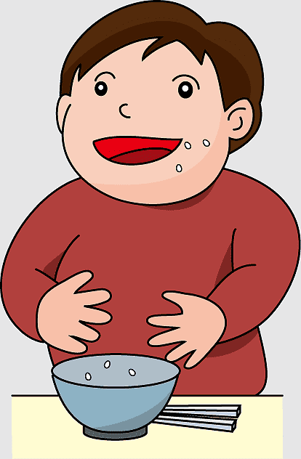  Why did you eat all the soup?  Because I was  ………………….…. |   Why did you drink all the juice?  Because I was  ………………….…. |   Why did you take my panda?  Because It’s  ………………….…. | 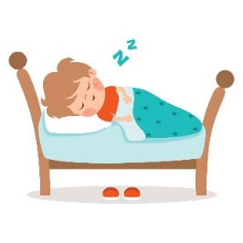  Why did you sleep in my bed?  Because I was  ………………….….
III. Reading Short Sentences:

5
  - Read the sentences then match them with the correct pictures:
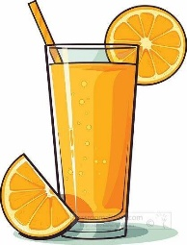 |  | 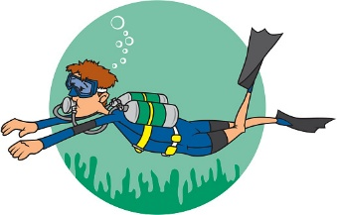
a-_I’d like apple juice.  b-_I’d like orange juice. |  | a-_I’m going skiing.  b-_I’m going diving. |  | a-_I eat breakfast.  b-_I brush my teeth.
 | 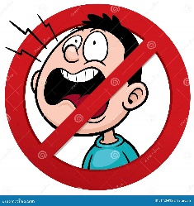 |  | 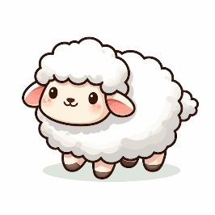
 | a-_Don’t shout  b-_Listen to your teacher |  | a-_I had a little cat.  b-_I had a little lamb.

- Grammar:
  - Choose the correct answer:

7
    - I (was – am) sick last weekend.
    - How (many – much) milk do you drink?
    - I’m going to (shop – to shop) for new clothes.
    - Did you (get up – got up) early this morning?
    - There (is – was – are) books on the desk.
    - He (am – is – are) going to the supermarket.
    - You (should – shouldn’t) eat three meals a day.

8
- Vocabulary:
  - Write the words under the correct pictures:
- trampoline 2- projector 3- meat 4- sleepy
5- skateboard 6- rainbow 7- PE 8– rock climbing

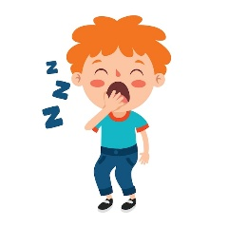 | 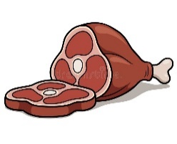 | 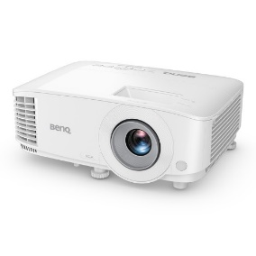 | 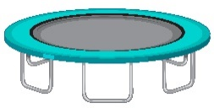
 |  |  | 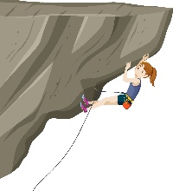

5
- Orthography:
ir – gh – nd – sc - ur
  - Fill in the missing letters:
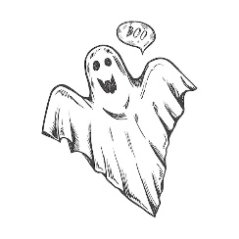
 |  | 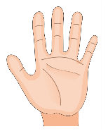 |  | 
b__ __ger | __ __ary | ha__ __ | lau__ __ | b__ __d

Q1:General Questions:
/ 8
A) Choose the correct answer:
1/ What did you do over the weekend?
- I cleaned my room. | b- 2 cups of flour .
2/What good thing happened to you last year ?
- I made a rocket . | - I live in Abha..
3/ What should you do to live a healthy life?.
a- I should do some exercises . | - I like math.
4/ What time does your school start ?.
- It starts at 7:00. | - Yes , we do.
B) Match the correct answer to the correct question:
a/ What’s the name of your school ? |  | 1-I am in the 3rd grade .
b/ Did you brush your teeth ? |  | 2- I going to Dubai.
c/ Where are you going? |  | 3- Yes , I did.
d/ Which grade are you in this year ? |  | 4- 36th elementary school .
/ 7
Q2: Controlled writing :
- Copy the sentence:
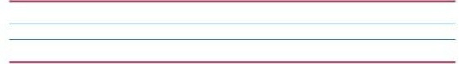
My school is in Abha city .

- Choose the correct order
1 | like / I’d / juice / apple.
A | I’d like apple juice . | B | Apple like I’d juice. | C | Like juice I’d apple.
2 | r / e / d / a / m
A | dream | B | madre | C | remad
- Choose
1 | I want some candy. I’m going to………store. | candy | DVD | book
2 | I should drink a lot of…………... | bus | water | TV
3 | We ………………… computer games . | cooked | stayed | played

Q3 : Reading Short Sentences:
/ 5
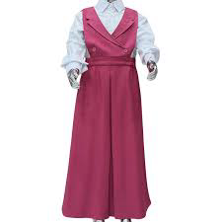
- We have a school uniform .
- I should get up early.

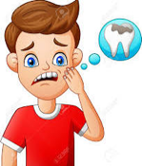

- I have a toothache .
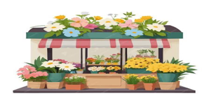
- Flower store sells flowers.

- He stayed home.


A) Put (✔️) or ( ✖️

Q4 : Grammar :
/ 7
- Write the past form ( ed ):

- Watch

- Like

- Choose the correct word:

- …………………eggs do we need?
- How much | - How many | - How
- I …………… going to the bakery.
- am | - will | - there
- There …………… a red car 🚗 .
- was | - an | - have
- There …………… boxes 📦 📦 📦 on the table.
- were | - was | - am
- She …………… going to diving.
a- is | - have | - are

Q5 :Vocabulary:
A ) Circle the correct word :
 |  |  | 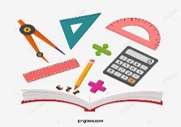 | 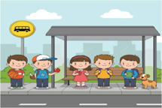 |  | 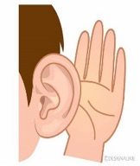 | / 8
  a-flour  b-onion | 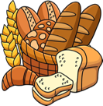  a-bread b-hat | 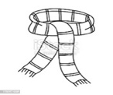  a-scarf b-shoes | a-math  b-Arabic | a-bus stop  b-office | 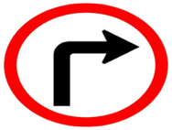  a-turn right  b-stop | a-sleep  b-listen | 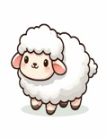  a-cat  b-lamb

Q6 : Orthography
- Choose the correct missing letters:
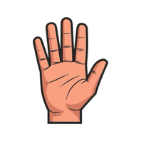  han_ |  | 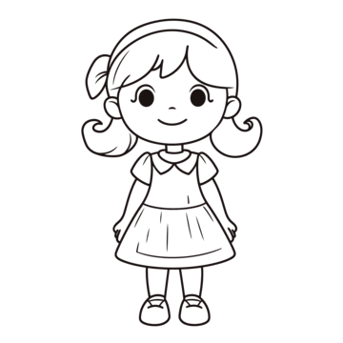  G _ rl |  | 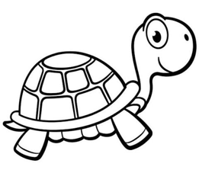  tu _ tle |  | 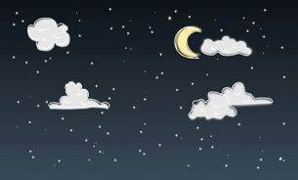  s__ y |  |   / 5  c_ te
d | f | i | v | r | g | l | k | m | u
End of Questions

