
المملكة العربية السعودية الصف: الخامس الابتدائي
وزارة التعليم الفترة الدراسية: الثانية
المدرسة الابتدائية ............. العام الدراسي 1447 هـ
الزمن: ساعتان
الاختبار النهائي لمادة اللغة الإنجليزية – الصف الخامس الابتدائي – الفترة الدراسية الثانية (الدور الأول) لعام 1447 هـ
عزيزتي الطالبة:
- استعيني بالله ثم اجيبي عن الأسئلة
- فضلا تأكدي من كتابة اسمك الرباعي ورقم الجلوس
- الإجابة باللون الأزرق فقط

اسم الطالبة رباعيا
رقم الجلوس: |  | الصف: الخامس الابتدائي | المادة: اللغة الإنجليزية
اليوم: | التاريخ: / 1 / 1448 هـ

المدققة وتوقيعها | المراجعة وتوقيعها | المصححة وتوقيعها | الدرجة كتابة | الدرجة رقما | السؤال
 |  |  | فقط |  | General  Questions
 |  |  | فقط |  | Guided  Composition
 |  |  | فقط |  | Reading  Short Sentence
 |  |  | فقط |  | Grammar
 |  |  | فقط |  | Vocabulary
 |  |  | فقط |  | Orthography
 |  |  | فقط | 40 | المجموع


Kingdom of Saudi Arabia 5th Elementary Grade
Ministry of Education Time: Two Hours
………..Elementary School Number of papers: 3 . Final Exam – Second Term – 1447 AH
- General Questions:
/ 7
  - Match the questions with the correct answers:
A |  | B
1. What were you doing at 6 o’clock? |  | I need fishing rod for fishing.
2. What items do you need for fishing? |  | I have used a car and a bus.
3. Have you bought a new umbrella? |  | I was sleeping.
4. What kind of transportation have you used? |  | No, I haven’t.

  - Choose the correct answer:
1- What are the people in stories called?
a- places | b- characters
2- Did you have fun on your trip?
a- Yes, I was. | b- Yes, I did.
3- What do kings and queens wear that is made of gold?
a- belt | b- crown
/ 7
- Guided Composition:
  - Complete the paragraph about Your Last Outdoor Activity. Use the words from the box.
felt – camping – clothes – weekend – cooked – tent – took
My Last Outdoor Activity
Last ……………, I went ……………with my family. We put up a …………… and …………… food outside. I …………… a flashlight and warm …………… with me. It was fun and I …………… happy.

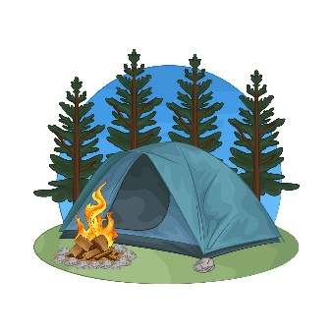

- Reading Short Sentences:
/ 7


  - Read the sentences then match them with the correct pictures:
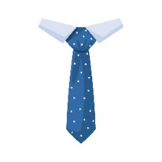 | 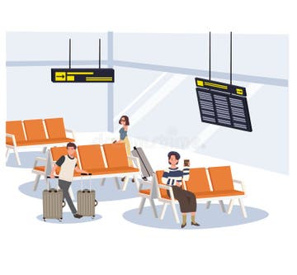 |  | 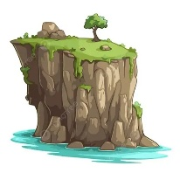
a- It’s a spotted tie.  b- It’s a striped tie. | a-_It is a platform.  b-_It is a terminal. | a-_The plane lands.  b-_The plane takes off. | a-_That is a cliff.  b-_That is a forest. | a-_It is a cartoon.  b-_It is a horror story.

  - Read the passage and answer the questions below.
Little Red Riding Hood
Little Red Riding Hood had a basket of food for her sick grandma. She walked through the forest and met a big, hungry wolf. The wolf ran to Grandma’s house and tried to eat her. A kind woodcutter came and saved both Little Red Riding Hood and her grandma.
- Choose the correct answer:
1.Who was Little Red Riding Hood visiting?  a- her friend.  b- her grandma.  c- her teacher. | 2. What did she carry in her basket?  a- toys  b- food  c- clothes

- Grammar:
/ 7
  - Choose the correct answer:
    - The belt (is make – is made – are made) of leather and metal.
    - We have (take – took – taken) a tour before.
    - The plane hasn’t departed (just – yet – already).
    - They didn’t (see – saw – seeing) the snake.
    - (Who – When – While) Jack was rafting, his raft hit a rock.
    - He was (watch – watched – watching) a movie.
    - How about (see – saw – seeing) a horror movie?

- Vocabulary:
/ 7
  - Write the words under the correct pictures:
rope – necklace – play – traffic – wool
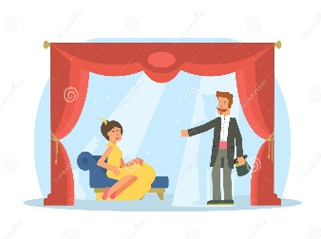
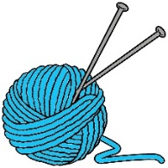 |  | 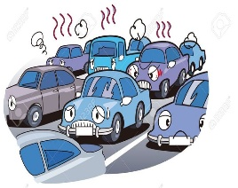 | 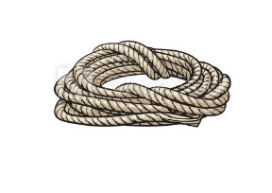

  - Fill in the blanks with the words from the box.
passport – comedy – uniform
1- You wear it at school. (………………….)
2- A document you need to travel abroad. (………………….)

- Orthography:
/ 5
  - Choose the correct missing letters:
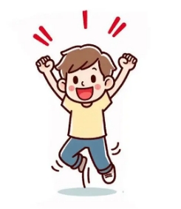  ex__ited |  | 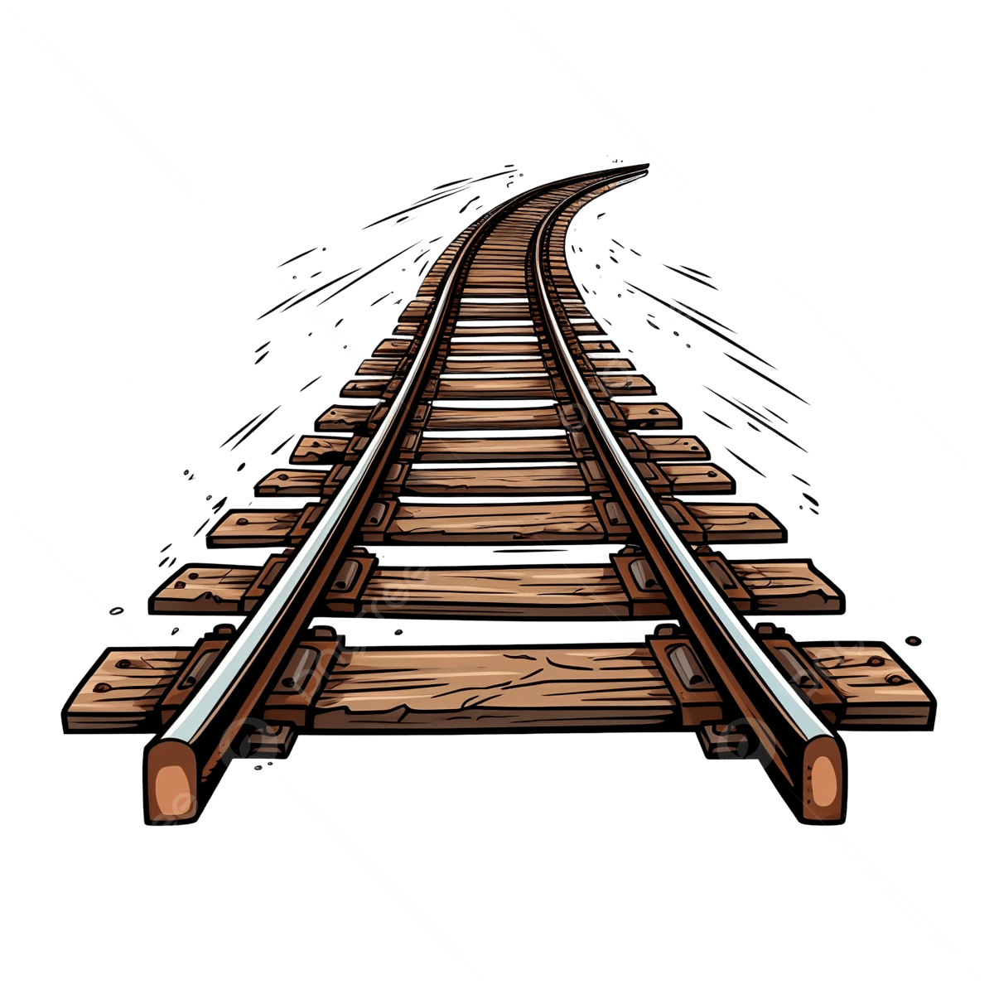  rai__road |  | 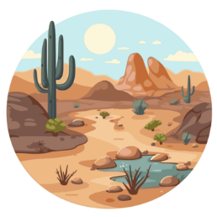  de__ert |  |   s__lk |  | 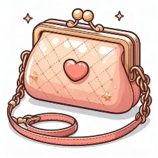  pur__e
c | s | r | l | s | z | e | i | s | c
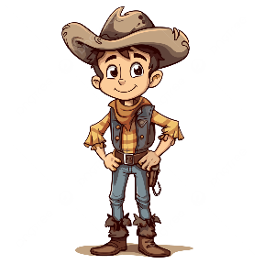  cow__oy |  | 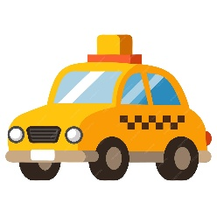  ta__i |  |   a__ree |  | 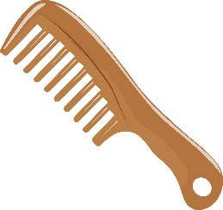  __omb |  | 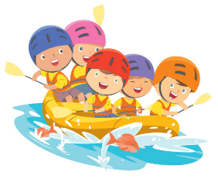  ra__ting
b | d | k | x | g | j | c | k | f | v

END OF QUESTIONS
BEST OF LUCK
Ms. Tahani AlGhamdi
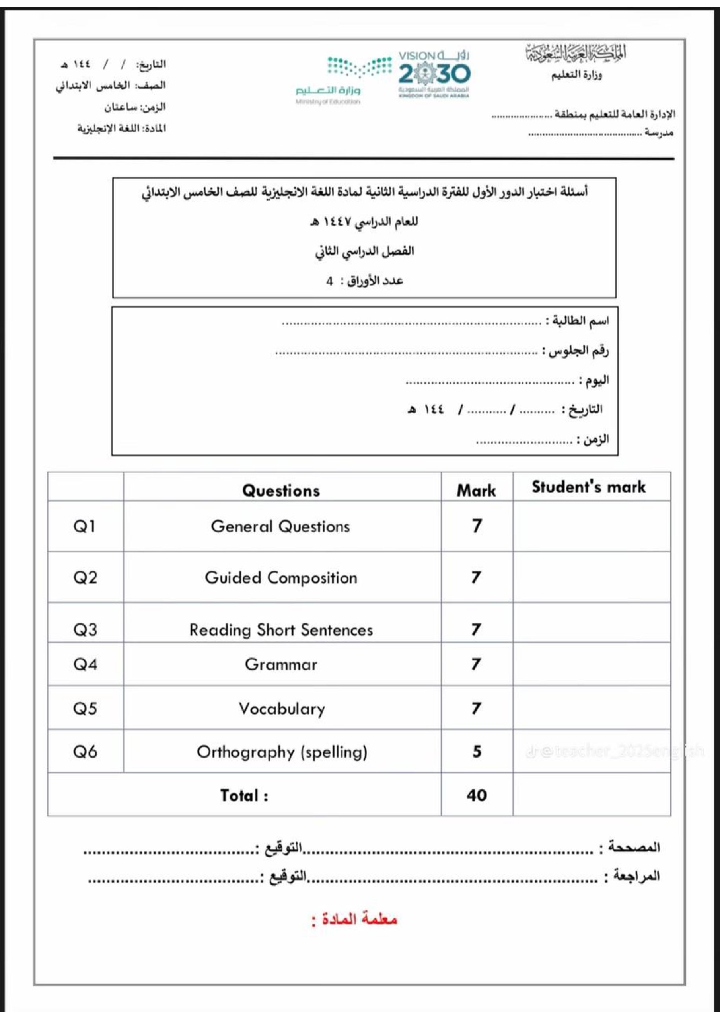

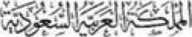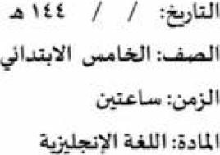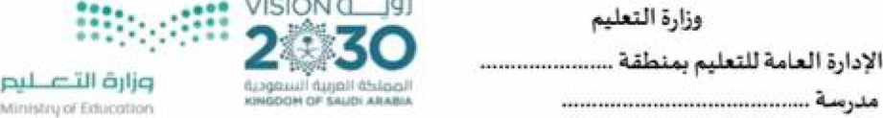
VISION
CJ4J
40
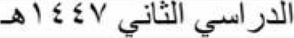J,ÄII —
I. General Ouestions:
A- Match the questions with the correct answers:
 |  |  |  | 7
 | 1. What's your favourite kind of story? |  | Yes, I would. I feel happy.
 | 2. What items do you need for fishing? |  | Go climbing in the mountains.
 | 3. Would you like to travel? How would you feel? |  | I need fishing rod for fishing.
 | 4. What activities do you do outside? |  | My favourite story is sci-fi.
 | 5. What clothes do you like to wear? |  | That's a good idea.
 | 6. What kind of transportation have you used? |  | I like to wear my uniform.
 | 7. How about watching a movie? |  | I have used a car and a bus.
7
Il. Guided Composition:
A- Use the following word bank to write a post about A Field Trim
 | 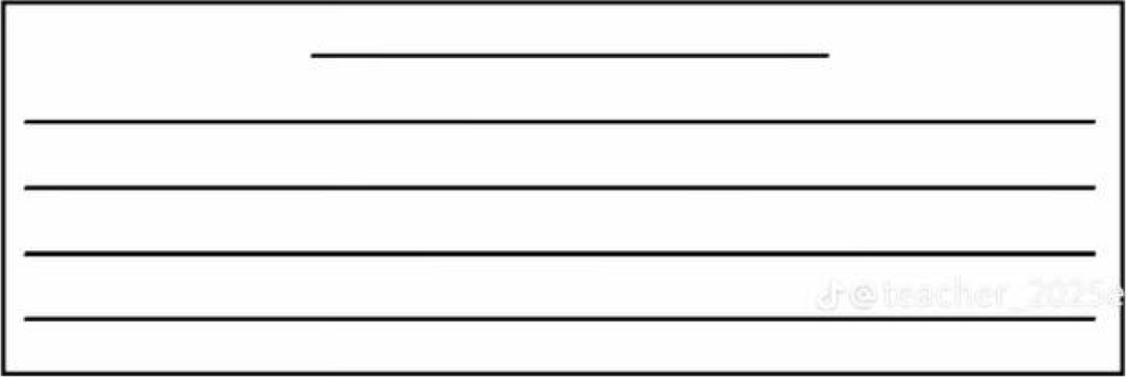
  went animals plants interesting learned nice

Ill. Reading Short Sentences:
A- Read the sentences then match them with the correct pictures;
a- It is a comedy story. | a- A comb made of plastic . | a- The plane lands. | a- It is a life jacket.
b- It is a drama. | b- He was fishing. | b- The plane takes off. | b- It is a backpack.
a- Hurry to the platform. a- I wear a belt. | a- It is an animation.
b- Put everything in a suitcase. b- Listen to your teacher  IV. Grammar:  A- Choose the correct qnswer:  1. He was (watch — watched — watching) a movie. | b- It is a mystery movie.
2. took |  | 7
We have (take — — taken) a tour before.
- They didn't (see — saw — seeing) the snake.
- How long ( has — have — is ) she liked rings?
- I haven't found my suitcase (just — yet ) .
- She (was — were — are) singing in the musical.
- Have you ( buy - buyed— bought) a costume this year?
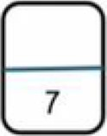
V. Vocabulary:
A- Write the words under the correct pictures:
detective — rock climbing— tie — crown —traffic — platform — mountain biking
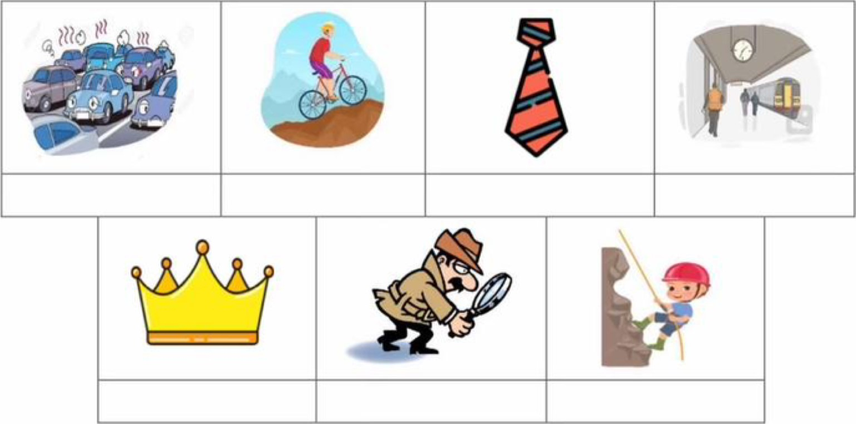
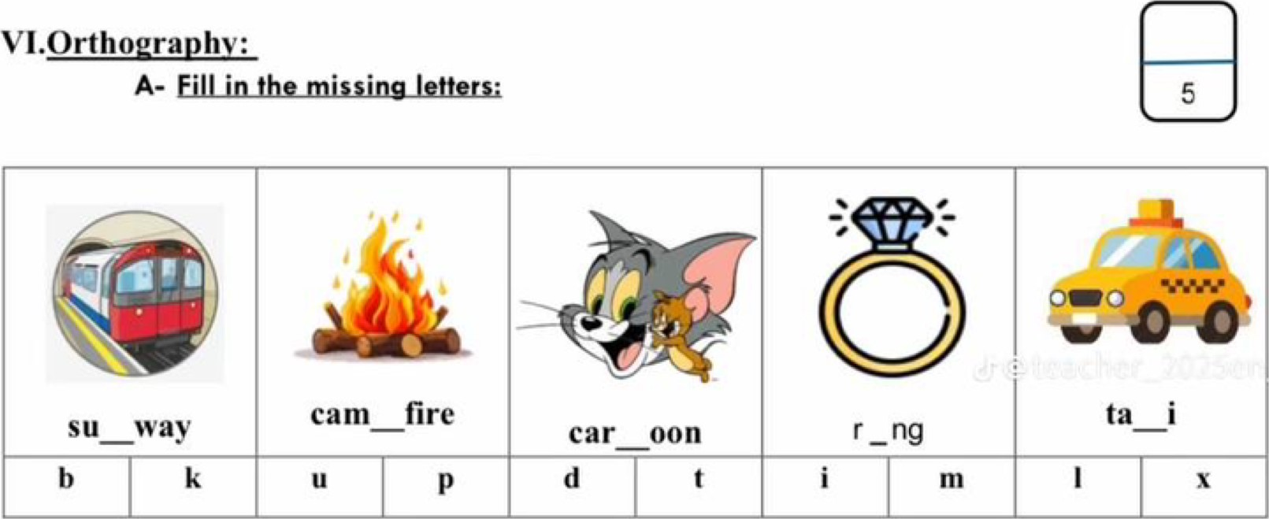

40

اختبار نهاية الفصل الثاني( الدور الأول)
للعام الدراسي 1447هـ
المادة /اللغة الانجليزية
الصف :خامس وسادس (.......)
زمن الإجابة / ساعتان
التاريخ : 12/7/1443 هـ

المملكة العربية السعودية
وزارة التعليم
الإدارة العامة للتعليم بالمنطقة .....
مدرسة .....

الدرجة كتابة :

اسم الطالب ……………………………………………………………………….……………………………………………رقم الجلوس …………………………


Circle the correct answer:

1- What's your favorite kind of story? a comedy b traffic
2- Which kinds of stories do you dislike? a pizza b drama
3- What activity do you do outside? a sea b fishing
4- Which activity can make you tired? a hiking b watching TV
5- What different ways to travel do you know? a ticket b bus and train
6- What clothes do you like to wear? a silver b blue jeans
7- Rings are made of …… a silk b gold

Write a post about a field trip:
Useful Expressions

1 I have planned … 2 They have just … 3 You can … 4 The directions...

……………………………………………………………………………………………………………………………………………………………………………………………………………………………………………………………………………………………………

………………………………………………………………………………………………………………………………………………………………………………………………………………………………………………………………………………………………….

…………………………………………………………………………………………………………………………………………………………………………………………………………………………………………………………………………………………………

……………………………………………………………………………………………………………………………………………………………………………………………………………………………………………………………………………………………….

………………………………………………………………………………………………………………………………………………………………………………………………………………………………………………………………………………………………..

Circle the correct answer:

1. Sci-fi stories events are not real. 4. Riley was feeling nervous. 7. The purse is made of leather.
Are Sci-fi story events real? How was Riley feeling? What is the purse made of?
a Yes, they are. a happy a cotton
b No, they aren't. b nervous b leather

2. Connor and Kai were arguing. 5. Riley was afraid of the dark.
What were Connor and Kai doing? What was Riley afraid of?
a arguing a dark.
b fighting b spiders
3.Kai took a book from the bookcase. 6.Riley was climbing so quickly.

Who took the book? How was Riley climbing?
a Kai a quickly
اقلب الورقة
b Connor b slowly

Choose the correct answer:
- We were……… homework. a do b doing
- ……… she talking on the phone? a Was b Were
- You cooked ……… you were camping. a while b when
- He has ………. his suitcase. a pack b packed
- They ……. bought a car. a has b have
- She hasn’t studied for the exam ……. a already b yet
- How ……have we had this house? a much b long

Match the words to the correct pictures:

1 helmet 2 raft 3 mystery 4 earring 5 passenger 6 security 7 purse

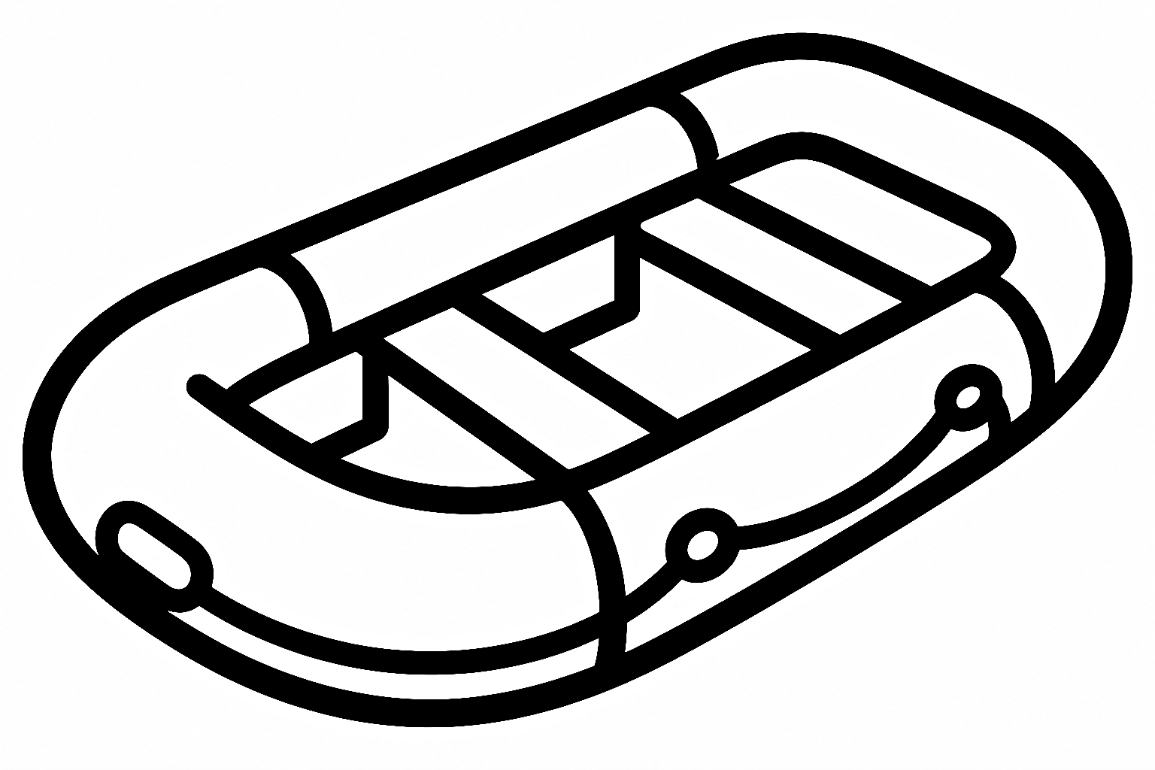


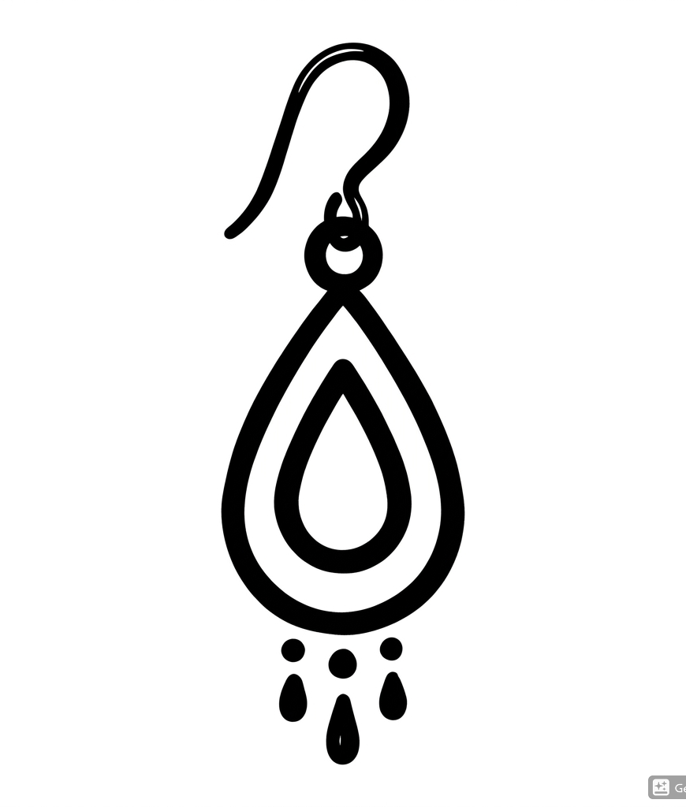
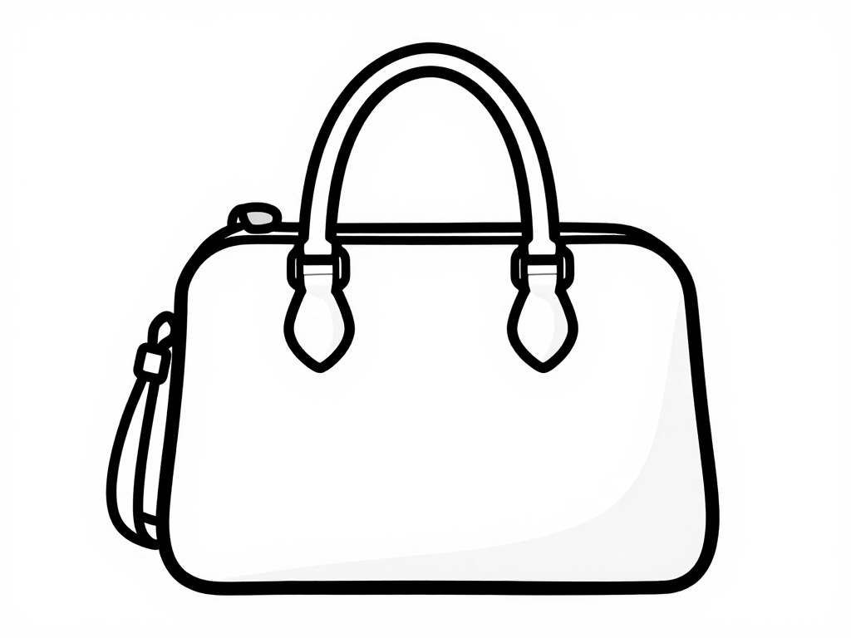
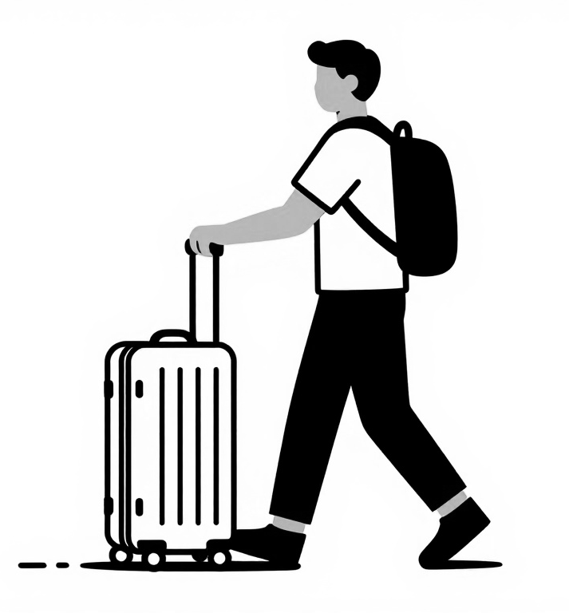

Circle the missing letter:

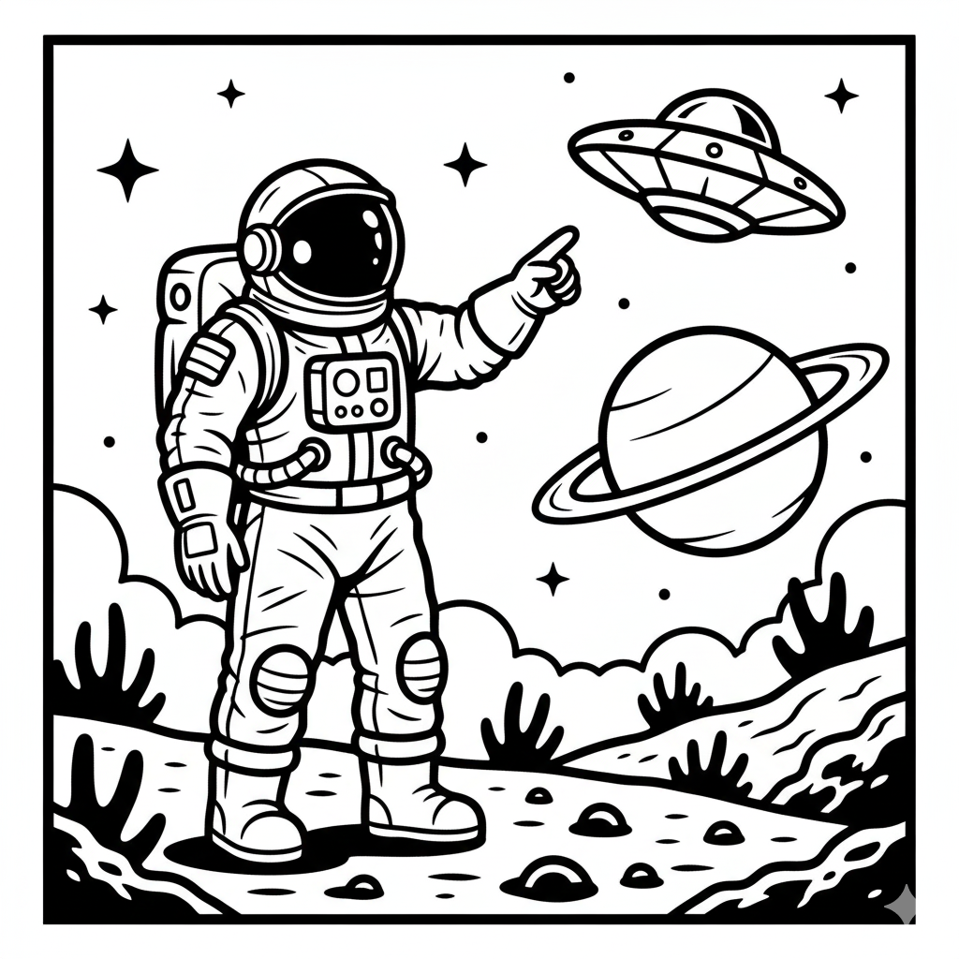  Sci-f_  o  i | 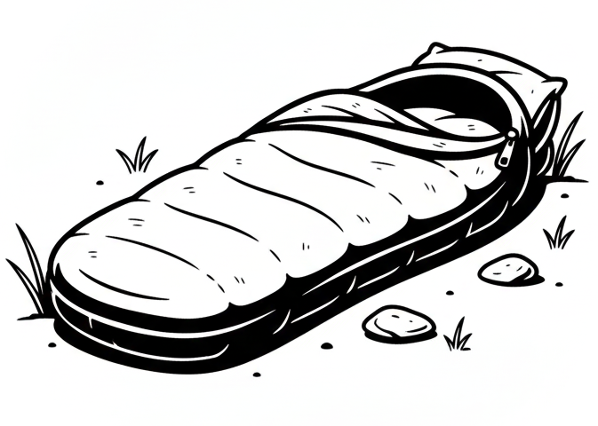  slee_ing bag  k  p | 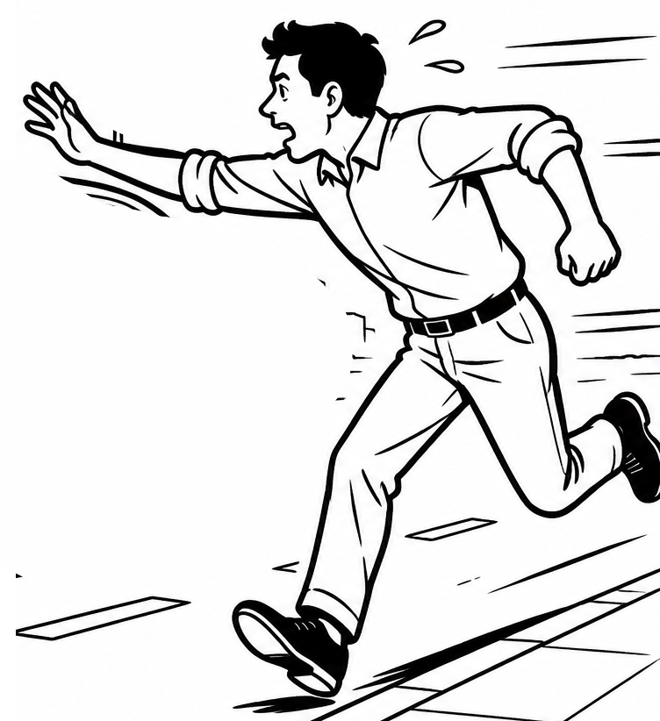  h_rry  u  i | 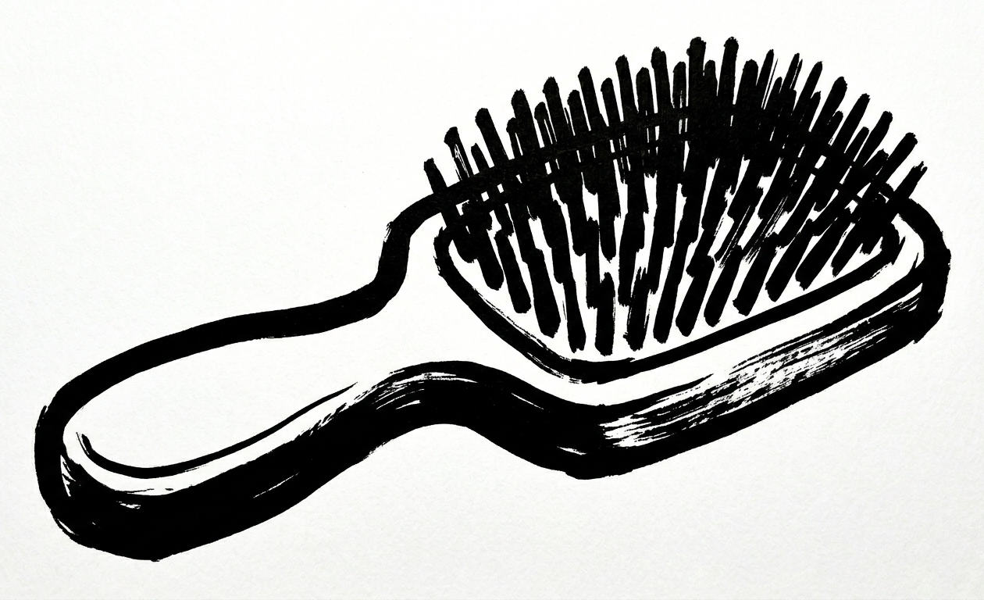  b_ush  r  n | 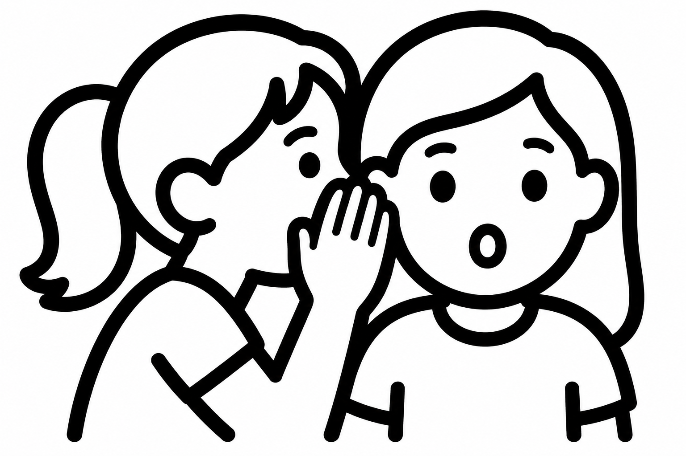  whi__per  s  z

انتهت الأسئلة

أ....................................

