
اختبار تشخيصي
وزارة التعليم
المملكة العربية السعودية
الصف السادس الابتدائي
مدرسة ............. الابتدائية
إدارة التعليم بــ
الفصل الدراسي الاول1448 هـ
20
الدرجة: /
الصف:
اسم الطالب :
Match the sentence to the picture:
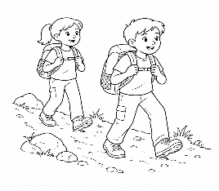
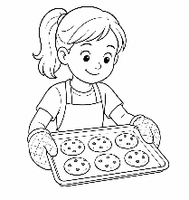
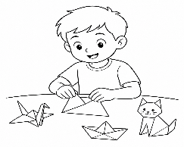
- They are hiking
- I make origami
- She is baking cookies
Choose the correct spelling:
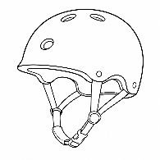

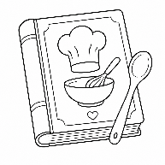
◯
◯
◯
◯
passport
helmit
recipe
◯
◯
pasport
helmet
recipy
Circle the correct word:
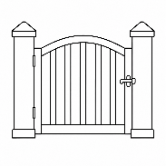
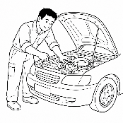
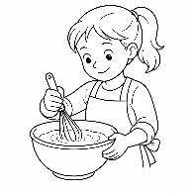
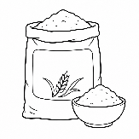
 | 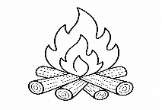 |  |  | 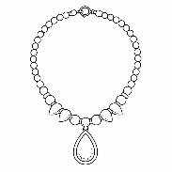 |  | 
flour  cookies | tent  campfire | mechanic diver | stairs  gate | necklace crown | ingredients ticket | comedy  mystery
Circle the correct word:
- Mom has (already / yesterday) printed the tickets.
- Last week, I ( visit / visited ) my grandfather.
- He (may / was) be a pilot because he likes flying.
- I (will / am) look for the key .
Match each question with the correct answer:

- What do you want to be? |  | Yes, I have
- How long have you lived here? |  | I want to be a journalist
- Have you tried the new uniform? |  | For two years


اختبار تشخيصي
وزارة التعليم
المملكة العربية السعودية
الصف السادس الابتدائي
مدرسة ............. الابتدائية
إدارة التعليم بــ
الفصل الدراسي الاول1448 هـ
20
الدرجة: /
الصف:
اسم الطالب :
Match the sentence to the picture:
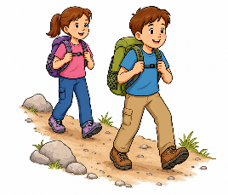
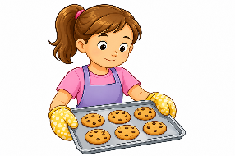
1-They are hiking
2-I make origami
3-She is baking cookies
Choose the correct spelling:

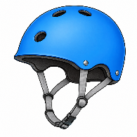

recipe
◯
◯
◯
◯
passport
helmit
◯
◯
pasport
helmet
recipy
Circle the correct word:
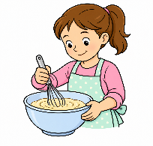
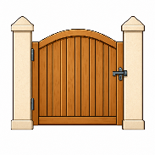
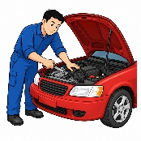
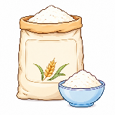
 |  |  |  | 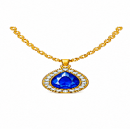 |  | 
flour  cookies | tent  campfire | mechanic diver | stairs  gate | necklace crown | ingredients ticket | comedy  mystery
Circle the correct word:
- Mom has (already / yesterday) printed the tickets.
- Last week, I ( visit / visited ) my grandfather.
- He (may / was) be a pilot because he likes flying.
- I (will / am) look for the key .
Match each question with the correct answer:

- What do you want to be? |  | Yes, I have
- How long have you lived here? |  | I want to be a journalist
- Have you tried the new uniform? |  | For two years

